MASS & SERVICE TIMES THIS WEEK

SUNDAY 12TH APRIL 2026
SECOND SUNDAY OF EASTER

PARISH MASS
10 AM

TUESDAY 14TH APRIL Mass 11 am

Afternoon Tea and Cakes 2-4 pm

Morning Prayer at 9 am Monday to Thursday
Evening Prayer at 6 pm Monday to Thursday

SUNDAY 19TH APRIL 2026
THIRD SUNDAY OF EASTER

Parish Mass: 10 am

Parish Priest
Father Emmanuel Nazir SSC
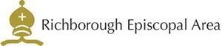



Tel: 07949 817487

Email: marshfarmholycross@gmail

