NEWSLETTER NUMBER 318
Well done to Helena Power and her team of helpers, cake providers and servers for the free Fun day for local children. Here are some photographs of items the children produced on the day. Helen’s report is under Other information
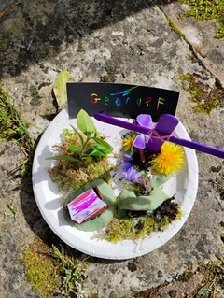
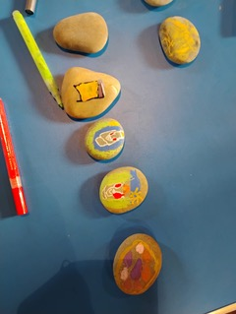
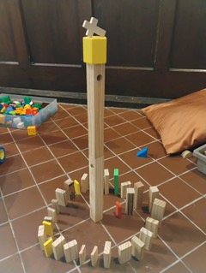
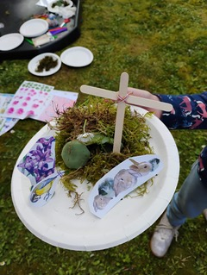

OUR SERVICE ON SUNDAY 26TH APRIL 2026 – 4TH SUNDAY OF EASTER
There will be a Sung Eucharist starting at 10.30 a.m. on Sunday 26TH April 2026. The celebrant will be Rev Andy Barton. There will be refreshments served after the service. There will also be the service Families@4, aimed at families with primary school aged children which will involve, craft, singing and refreshments.

LOOKING FORWARDS – REV ANDY
Nothing received this week.

ROTA FOR SUNDAY 26TH APRIL 2026
Sidesmen:- Alison Toogood and Charlotte Pringle Kosikowsky
Reader:- Sioned Barton
Coffee:- Alison Toogood and Charlotte Pringle Kosikowsky
Flowers:- Jacquie Hockaday

READINGS FOR SUNDAY 26TH APRIL 2026 – 4TH SUNDAY OF EASTER
Collect:- Almighty God, whose Son Jesus Christ is the resurrection and the life: raise us, who trust in him, from the death of sin to the life of righteousness, that we may seek those things which are above, where he reigns with you in the unity of the Holy Spirit, one God, now and for ever. Amen

Readings:-
Acts Chapter 2, vv 42 – end
1ST Peter Chapter 2, vv 19 – end
John Chapter 10, vv 1 – 10

PRAYER LIST
Elizabeth Miles
Eunice Durrance
Hazel Ware
Ian Sansom
John Wilkie
Mike Toogood
Pam Wilkie
Paul Tatnall
Stephen Daley
Susan Dobson

YEARS MIND FOR APRIL/MAY
APRIL
27TH Frederick Hine
27TH Leslie Birch
29TH Rev Andrew Philip Allan
29TH Frederick Joseph Rogers
29TH Clarice Slade
MAY
1ST Mary Holderness
2ND Ernest Herbert Darch
3RD Roy James John Hine

BIRTHDAY LIST FOR APRIL
30TH Pam Wilkie
We hope you have a good celebration of your special day.

OUTREACH GROUPS
Churchyard Group
If you are willing to help, the next meeting will be at 10.00 a.m. on Tuesday 28th April 2026 if anyone is free. We now need to get a watering can and some fill-in plants and wonder if anyone has any of the following that they would be willing to donate:- White aubretia, white mini periwinkle, white iberis, white omphaloides, tête-a- tête daffodil bulbs (if not, we will plant them in the autumn), small green/yellow or green/white hostas and small ferns.

Recycled Teenagers
The next meeting will take place on Tuesday, 28th April 2026 at 2.30 p.m. Come along and enjoy cups of tea plus sandwiches and cakes along with some conversation.
Knit, Sew and Natter
The next meeting will be on Thursday, 7th May 2026 at 2.00 p.m. It will be the usual meeting with lots of chat and refreshments.

Shanty Singing
The next meeting of this group will be at 6.00 p.m. on Sunday 3RD May 2026. You do not have to have been to any previous meeting to join any session of shanty singing.

Soup ‘n’ a Bite
This will be on Saturday 9th May 2026 at 12.00 noon. It will be the normal fare of soup, bread, cheese and fruit combined with lots of conversation!

OUR NEXT SERVICE
The next service at All Saints’ will start at 10.30 a.m. on Sunday 3rd May 2026. This will be a Sung Eucharist with Rev Stephen Bowen as the celebrant. Please stay and chat after the service over the usual refreshments.

FORTHCOMING EVENTS
Next Two Fund Raising Committee event
9th May 2026 – Easy Quiz Night with jacket potato supper
This will be held in the Lang Room with a start time of 7-00 p.m. and follow the normal format i.e. teams of up to 6 members, five rounds of questions before supper and five rounds afterwards, bring your own drink. The cost will be £10-00 per head.

23rd May – Rogationtide walk with pasty and cider10.30 a.m.
The annual Rogationtide walk will start at 10.30 a.m. and use a circular walk to get back to the church for the wonderful Tim Potter pasties and cider. Start praying for good weather!
OTHER INFORMATION
ELECTORAL ROLL
We are now in the statutory period for the Electoral Roll. You must be on the Roll to be able to be at and/or speak at the Annual Parochial Church Meeting. If you are not on the Roll, you need to complete one of the forms on the table by the church door and give it to Sheila Rabson by 26th April 2026 at the latest.

Report from Helena Power re the Free Crafts and Games afternoon
On Thursday 16th April we had a lovely afternoon of crafts and games at church. There was sunshine for the egg hunt, egg and spoon challenge and making Easter gardens to take home. Inside church there was beautiful craft work going on and very careful tower building, and a delicious chocolate cake to eat. The families who came really enjoyed themselves and stayed all afternoon. Eight adults and 19 children attended, most of whom go to the local school. Thank you very much to all who sponsored this event and to the wonderful team who made it possible

16th May – Bathealton Plant Sale
This will be the final Plant Sale at Hellings Farm. This will be the final plant sale here. See the poster attached – this has been taken from the Ashbrittle monthly magazine.

From Rev Andrew Norris
The “Home Service” which is broadcast on 105.3 FM on Wednesdays at 11.00. It is also available via the internet at any time on www.10radio.org .
This week: As we celebrate the life of St George this week, Adam Green Lay reader in the Wivey Benefice shares what we might learn from his life in our own Christian journey. We also hear about some of the exciting activities in which Churches Together in Wellington are engaged or looking to engage in, in the future

FUN CORNER



