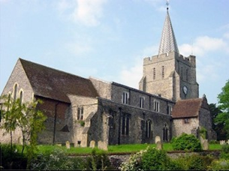
Please visit our website for information about our churches, services & events www.elhamvalleygroupofchurches.co.uk

Every Tuesday at St. Mary’s…

Traditional Morning Prayer at 8.30am in the Jesus Chapel. Download the free Church of England app or use the red book. A good way to begin the day. https://play.google.
com/store/apps/details?id=com.aimermedia.dailyprayer&pli=1


Every Monday at the Methodist Hall …
Coffee and cake, a warm welcome and friendship, 10.30am –
12pm

Churches Together in Elham Valley March
Please contact -: Ruth Collie (01303 840773) for information

Easter Week
29th March - Palm Sunday
10.00 – Benefice Palm Sunday Service at Postling
Lectionary readings:
Isaiah 50:4-9a; Psalm: 31:9-16; Philippians 2:5-11; Matthew 26:14-end of 27;

2nd April – Maundy Thursday
18.00 Benefice Maundy Thursday Service at Stanford
Lectionary readings:
Exodus 12:1-4; 11-14; Psalm 116:1, 10-end; 1 Cor 11:23-26; John 13:1-17; 31b-35

3rd April – Good Friday
09.30 Benefice Good Friday Walk of Witness Churches Together (Elham)
Lectionary readings:
Isaiah 52:13– 53:12; Psalm 22; Hebrews 10:16-25; John 18:1 – 19:42

5th April – Easter Day
09.30 Sung Eucharist with Baptism
Lectionary readings:
Acts 10.34-43; Psalm 118.1-2,14-24*; Colossians 3.1-4 or Jeremiah 31.1-6; John 20.1-18

12th April – 2nd Sunday of Easter
09.30 Morning Service

Lectionary readings:
Acts 2.14a,22-32; Psalm 16; 1 Peter 1.3-9 or Exodus 14:10-end, 15:20,21 ; John 20.19-end;

19th April – 3rd Sunday of Easter
09:30 Sung Eucharist

Lectionary readings:
Acts 2.14a,36-41; Psalm 116.1-3,10-17*; 1 Peter 1.17-23; or Zeph 3:14-end; Luke 24.13-35

26th April – 4th Sunday of Easter
09:30 Morning Service

Lectionary readings:
Acts 2.42-47; Psalm 23; 1 Peter 2.19-end; or Genesis 7; John 10.1-10

Events for the May Notice sheet Please send to Margaret Keeble by 5th of each preceding month. m.keeble@outlook.com

Elham Methodist Church
(all at 9.30am unless otherwise stated)
Services for April
5th Rev Malcolm Preach (HC Valley United Service 10.15am)
12th Tim James
19th Rev Gordon Newton
26th Rev Gill Songer

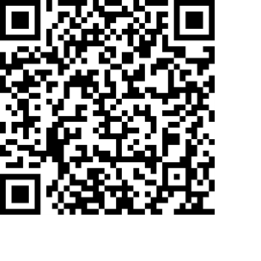
Donations
We would greatly appreciate your help to continue our work for God in the village of Elham and surrounding areas. If you can, please consider making a donation. This is our QR code for St Mary’s Elham. To donate using this code, open up the camera on a mobile phone - point the camera at the QR code – follow the instructions.
The offertory plate will go round in the service, during one of the hymns. There is also the opportunity to donate by card using the PAYAZ machine by the North door.

Safeguarding / ‘A Safe Church’:
If you ever have any concerns, contact our Parish Safeguarding Officer:
Susannah Pallot : susannahpallot@gmail.com

Paper Copies of Notices
Some copies are available on back table in church. Please take a copy to give to those unable to access the internet.

