
SPIRE & LIGHT United Churches
United Benefice of St Keverne, St Ruan with St Grade & St.Wynwallow (The Lizard)

*If you do not wish to receive these notices, please let your Churchwarden know*

5th April 2026

GOOD FRIDAY

10am – St.Peter’s, Coverack – service followed by building of cross on beach
2-3pm – St.Keverne – Devotional hour
2-3pm – St.Wynwallow, The Lizard – An Hour by the Cross

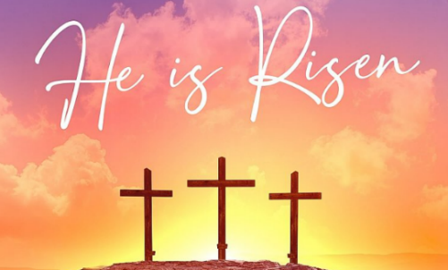
EASTER SUNDAY
Readings
Acts 10:34-43
Psalm 118:1-2,14-24
Colossians 3:1-4
John 20:1-18 OR Matthew 28:1-10

9.30am – Holy Communion - St.Peter’s, Coverack
10am – Holy Communion - St.Ruan, Ruan Minor (joint with St.Wynwallow)
10am – Holy Communion – St.Keverne

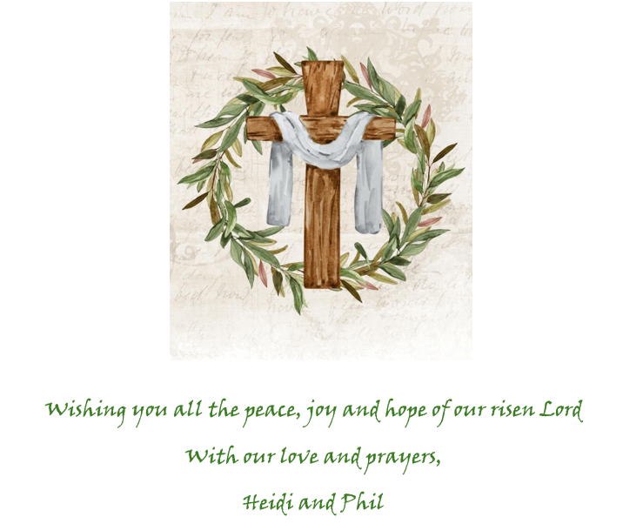

Next week – Sunday 12th April
9.30am – Morning Prayer - St.Peter’s, Coverack
9.30am – Holy Communion - St.Ruan, Ruan Minor
11am – Holy Communion – St.Keverne
11.15am – Café Church – St.Wynwallow, The Lizard
6pm – Evensong – St.Grade


The Prayer Spot

Heavenly Father, as we come to pray to you today, remind us of the love you have given us to share with others, that love given to us by you. Remind us we are a Benefice of four churches brought together by you to share with each other God's love and to remember we are all brothers and sisters brought to faith by the same God and his Son Jesus Christ who gave his life on the Cross for all of us.
Help us to remember those in need within our churches and community and how we can be there for them - it may just need an act of kindness to show you really care.

It says in 1 Peter 1 ‘Therefore prepare your minds for action, be self-controlled, set your hope fully on grace to be given to you when Jesus Christ was revealed to you. As obedient children of God, do not conform to evil desires you had when you lived in ignorance but just as he who called you is Holy so be Holy in all you do, for it is written to be Holy because I am Holy.’

Remember God has given you gifts to use in the need of others, use them well because everyone needs your help in our times of trouble. Be generous and full of God’s love, pray for all those in need of hospital treatment, that God will be present with them and for those who have the job of taking them and caring for them.

We praise you for your kindness shown to us all, for your endless willingness to forgive us when we fail you. We thank you for the love shown to us all as members of your flock, for being the shepherd who guides us through each day giving us all the help we need to care for others. Thank you for those wonderful gifts given to us of forgiveness, kindness, generosity and peace and of course that great joy of knowing your presence in our lives.

As I always tell you, God will be ever present in your prayer time and will answer all your prayers in the name of his son Jesus Christ. Be blessed by all you do in his wonderful name.

O God our father, grant that whatever happens to us today we may take it to you, if we have decisions to make, help us to ask for your guidance and grant us humility and obedience to take what you give to us. If we have problems to solve, help us to ask for you to shine your light upon them so we may see our way through them. If we have difficult things to do, help us to ask for strength so that we maybe enabled to do which we could not do ourselves. If we face temptations, help us to seek thy grace and remember that Jesus was tempted and is able to help us who are tempted. Help us to decide everything by thy will and to test everything by thy presence so that we may come to the days end without mistakes and without regrets through Jesus Christ our Lord. Amen

Maker of heaven and earth, you rule over all nations. As we think 0f your unfailing, eternal, enduring love, we look forward to the day when we will worship you in eternity. Your throne will be surrounded by people of every tribe, tongue and nation, and all testifying that you remained faithful, we will see that you have kept every promise you made, we will see your goodness and grace, we will be transformed by your glory, we would ask that we glimpse that glorious future as we pray today. Through the God the Father God the Son and God the Holy Spirit. Amen
Sam Buchanan

The Diocese of Truro’s Prayer Diary for this week

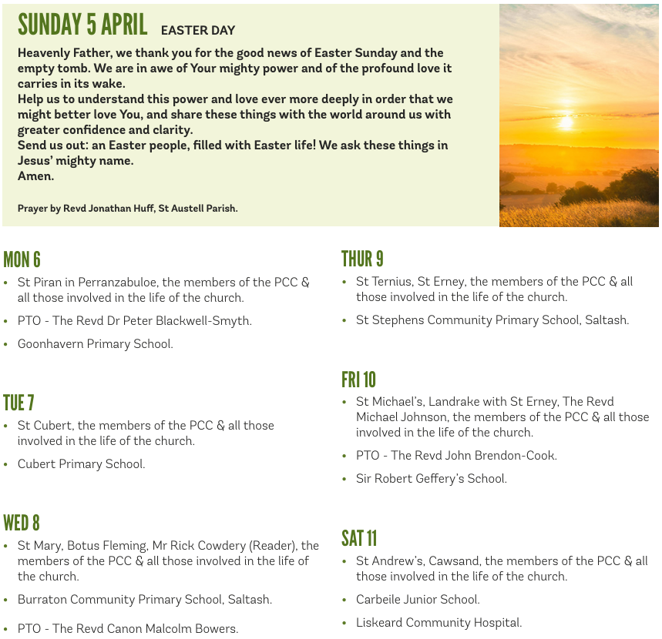

On the Way Prayers

The Celts describe Holy week as a thin place – a place where the gap between earth and heaven is very thin, when there is hardly any difference between earth and heaven. Let us pray that each one of us, over this week will experience that closeness of heaven.

Cornwall is often described as a place where heaven and earth meet – where the boundary is very thin. So, Father we give you thanks that you have placed us in such a beautiful, holy place. May we always treat it with the reverence it deserves. We pray for each one of our churches as we prepare for this Easter Weekend, and for all our priests who will be rushing here and there taking services. Let us pray now for any special events or services that we have coming up.

You called each one of us to watch and pray. Even on the night before you died you washed your disciples’ feet and then shared food and wine with them. We give thanks that you showed us of the importance of hospitality. Teach us to always be hospitable, to always share what we have and as we do so, to remember you.

On Good Friday may we carry your cross in your hearts through the whole day.
Blessed Lord, you bore on the shameful cross an undeserved punishment, and forgave even those who nailed you there. You spoke comfort to those who were dying beside you, even during your own agony. Teach us your love and compassion.

On Saturday may we prepare our churches, as Joseph of Arimathea and the women prepared your body, with love, with generosity, with hope and with prayers. And they didn’t know what we do! So may we arrange our flowers, prepare our altars, bake our hot cross buns, and hide eggs, not with tears of sadness, but with tears of joy, as we look forward to the great celebration of Easter Day.

And now let’s pray for anyone known to us, who needs the strength that our collective prayers can give them. We take a moment now to pray for this broken world – for peace – particularly Iran and the Gulf, in the Holy Land, in Ukraine and anywhere else where war is raging. Prince of Peace, visit these places and help sense to prevail.

You, who lift the lowly and strengthen the frail, who in your weakness raised a fallen world and let sinners lift you on to a cross, we thank you. Lift each one of us on your shoulders like a shepherd who does not neglect one sheep. Lift us from earth to heaven. And may we all have a very happy and blessed Easter. Amen.

