Palm 31: 1 to 5, 15 to 16
Please stand, if able, and join in with the verses in bold italics

In you, O Lord, I seek refuge;
do not let me ever be put to shame;
in your righteousness deliver me.
Incline your ear to me; rescue me speedily.
Be a rock of refuge for me,
a strong fortress to save me.

You are indeed my rock and my fortress;
for your name’s sake lead me and guide me,
take me out of the net that is hidden for me,
for you are my refuge.
Into your hand I commit my spirit;
you have redeemed me, O Lord, faithful God.

My times are in your hand;
deliver me from the hand of my enemies and persecutors.
Let your face shine upon your servant;
save me in your steadfast love.

Glory be to the Father and to the Son and to the Holy Spirit,
as it was in the beginning, is now and ever shall be,
world without end. Amen

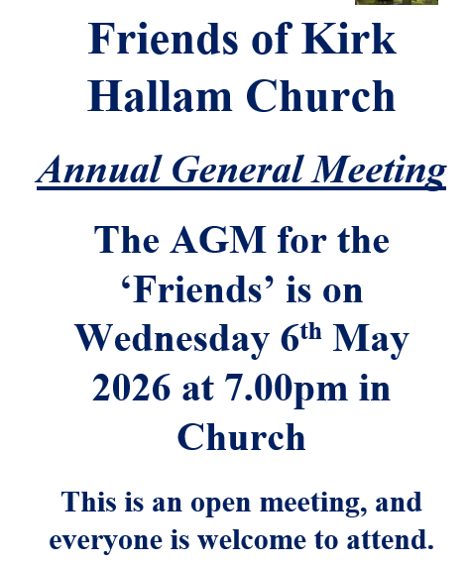
Mothers’ Union –
2pm on Wednesday 6th May in church.
Guest speaker is Georgie Pryer from ‘Kirk Hallam Sport England & Community. All welcome.

In our weekly prayers for our parish
This week we pray for God’s blessing on Ridgeway Drive, Rowan Close & Sandringham Place.
Fr Julius & Esther will be coming to Kirk Hallam on Sunday 10th May to join our 10am service, It would be lovely to have a ‘bring & share’ light lunch after the service,
so please do bring some nibbles to share.
Distribution of Communion –currently the Priest will dip the communion wafer in the wine while we discern a safe way to bring the common cup back into worship, as we want everyone to feel included and safe. We also have gluten free wafers available.
Refreshments After the Morning Service
Please stay seated after the service and a hot drink will be brought to you in the pews. Do not get up and head to the back of church, it is becoming a hazard, and a risk as trays of hot drinks could be knocked over.

All Saints Church
Church contact information
Contact: Rev’d Christine - revchristine@outlook.com
The Rectory, The Village, West Hallam, DE7 6GR
Landline 0115 646 1497
Rev’d Ailsa -revailsahunt@gmail.com
Tel - 07356064856

Churchwardens – Mrs Janet Wheeldon, -Tel: 0115 8771593
Mrs Linda Gregory – linda.gregory3@icloud.com
https://www.achurchnearyou.com/church/13402/
https://www.facebook.com/allsaintskirkhallam
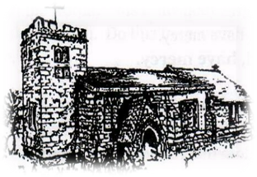
Kirk Hallam
Disabled Toilet in Friendship House.
Disabled Toilet in Friendship House.

Working with God to transform lives & communities.
Please can you ensure your mobile is on silence, or off during the service, it is affecting people with hearing aids and the loop system.
3rd May – Fourth Sunday After Easter
10.00am CW Communion Service with Rev’d Jan
6.00pm BCP Evening Prayer in church with Rev’d Christine

Forthcoming Events
Tues 5th 1.00pm Funeral for Ann Stevenson with burial
Tues 5th 6.30pm Home Group in Friendship House
Weds 6th 9.30am Morning Prayer at UCAS
Weds 6th 2.00pm Mothers’ Union in church
Weds 6th 7.00pm Friends Meeting in church
Fri 8th 6.00pm Choir in Friendship House
Sat 9th 10.00am Prayer Meeting in Friendship House

10th May – Fifth Sunday After Easter
10.00am CW Communion Service with Fr Julis & Rev’d Christine
6.00pm Iona Evening Prayer with Julie
“Do not be anxious about anything, but in every situation, by prayer and petition, with thanksgiving, present your requests to God’ Philippians 4: 6
It’s Good to Talk! If you spot that someone is missing, please pop a news sheet through their door, & if you’ve time, call for a chat - just to check they’re OK & to let them know that they are not forgotten!

