WEEKLY NOTES - 26th April 2026
100 years of 1st Ewell Brownies

YOU CAN FIND US ON “A CHURCH NEAR YOU” AT
St Mary’s Ewell - A Church Near You
As part of our ongoing commitment to be inclusive and welcoming to all,
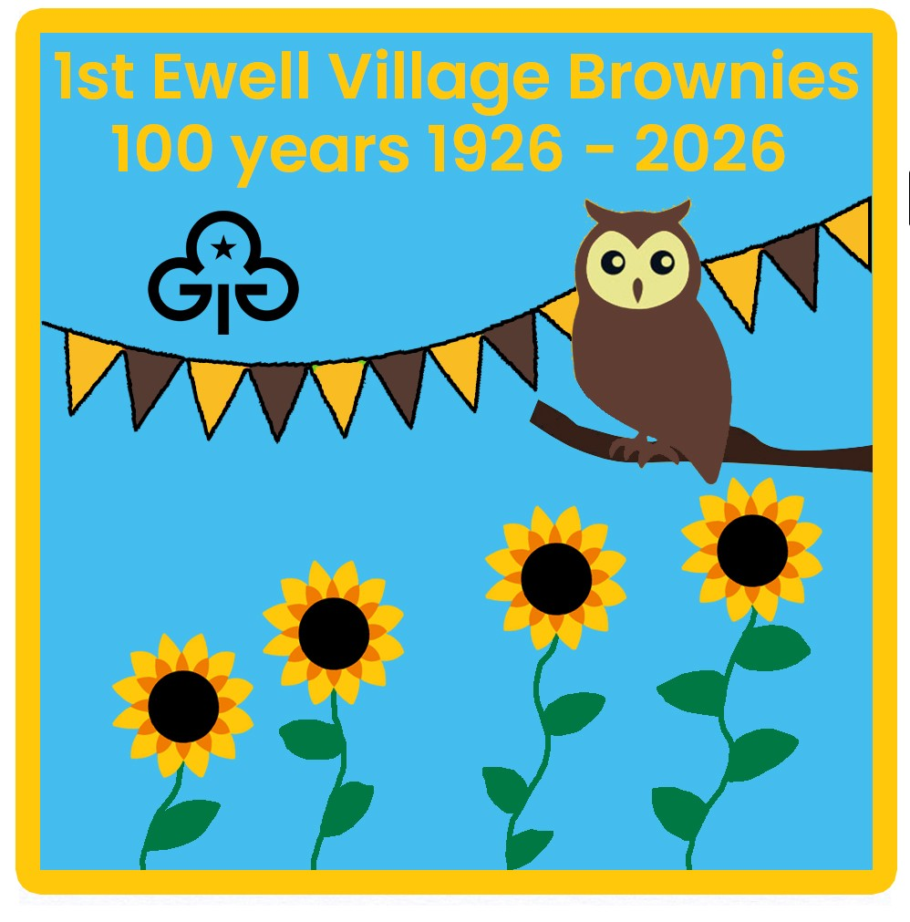we use ALCOHOL FREE WINE at all our services (0.05%).

All our Hymns today are in the Blue Book.
Opening Hymn: 251 All Things Bright and Beautiful Sunday school tune
First reading: Acts 2.42-47
Gradual Hymn: 433 Give Me Joy in My Heart
The Holy Gospel: John 10.1-10
Hymn of preparation: 260 Morning Has Broken
Final Hymn: 468 Lord of the Dance

Future events at St Mary’s
30th April – Boys’ Night Out at Dhansiri.
Tuesday 5th May 1:05pm Bach and Couperin.
Saturday 16th May – 10:00am Spring Market in Ewell Hall.
Saturday 23rd May 1:05pm Choral Music from St Mary’s Parish Choir including Chilcott Jazz Mass.
Saturday 11th July – Ewell Village Fair in and around the Church.
Saturday 26th September – A Day for all in and around the Church.

Welcome to St Mary’s
Welcome to St Mary’s Church. We are so pleased to see you and hope that you have a great time with us today as we celebrate 100 years of St Mary’s Brownies.
St Mary’s Ewell is first and foremost a parish church for the local community. We offer something for everyone, including a very varied range of worship, children’s activities, music, social activities, and more.
We are a diverse community of different backgrounds, ages, and beliefs. Our church includes people who have been churchgoers for a long time, and those who are exploring Christianity for the first time. Some come to church weekly, some to a monthly service, others join us on special occasions.
If you would like to know more about our church, you can look at our website, find our Facebook page or ask someone at this service
WHAT’S ON AT ST MARY’S
:
Sunday 8am Holy Communion – A simple said service
Sunday 9:30am Sung Eucharist - A choral celebration.
Sunday 9:30 Jesus and Me! – our weekly family service in Ewell Hall (Term time)
We have a range of community events and services so please add us as a friend on Facebook or look at our website and join our mailing list, or look at our “A Church Near You” page online to find out more!
www.facebook.com/stmarysewell www.stmarysewell.com

Contact Information

For safeguarding queries - safeguardingofficer@stmarysewell.com

Parish Office – 020 8393 2643 parishoffice@stmarysewell.com

Fr Mark Stafford SCP – Vicar 020 8393 1297 vicar@stmarysewell.com
Revd Sue Ayling – Assistant Priest 020 8337 6347 assistantpriest@stmarysewell.com‬‬‬‬‬‬‬‬‬‬‬‬‬‬‬‬‬‬‬‬‬‬‬‬‬‬‬‬‬‬‬‬‬‬‬‬‬‬‬‬‬‬‬‬‬‬‬‬‬‬‬‬‬‬‬‬‬‬‬‬‬‬‬‬‬‬‬‬‬‬‬‬‬‬‬‬‬‬‬‬‬‬‬‬‬‬‬‬‬‬‬‬‬‬‬‬‬‬‬‬‬‬‬‬‬‬‬‬‬‬‬‬‬‬‬‬‬‬‬‬‬‬‬‬‬‬‬‬‬‬‬‬‬‬‬‬‬‬‬‬‬‬‬‬‬‬‬‬‬‬‬‬‬‬‬‬‬‬‬‬‬‬‬‬‬‬‬‬‬‬‬‬‬‬‬‬‬‬‬‬‬‬‬‬‬‬‬‬‬‬‬‬‬‬‬‬‬‬‬‬‬‬‬‬‬‬‬‬‬‬‬‬‬‬‬‬‬‬‬‬‬‬‬‬‬‬‬‬‬‬‬‬‬‬‬‬‬‬‬‬‬‬‬‬‬‬‬‬‬‬‬‬‬‬‬‬‬‬‬‬‬‬‬‬‬‬‬‬‬‬‬‬‬‬‬‬‬‬‬‬‬‬‬‬‬‬‬‬‬‬‬‬‬‬‬‬‬‬‬‬‬‬‬‬‬‬‬‬‬‬‬‬‬‬‬‬‬‬‬‬‬‬‬‬‬‬‬‬‬‬‬‬‬‬‬‬‬‬‬‬‬‬‬‬‬‬‬‬‬‬‬‬‬‬‬‬‬‬‬‬‬‬‬‬‬‬‬‬‬‬‬‬‬‬‬‬‬‬‬‬‬‬‬‬‬‬‬‬‬‬‬‬‬‬‬‬‬‬‬‬‬‬‬‬‬‬‬‬‬‬‬‬‬‬‬‬‬‬‬‬‬‬‬‬‬‬‬‬‬‬‬‬‬‬‬‬‬‬‬‬‬‬‬‬‬‬‬‬‬‬‬‬‬‬‬‬‬‬‬‬‬‬‬‬‬‬‬‬‬‬‬‬‬‬‬‬‬‬‬‬‬‬‬‬‬‬‬‬‬‬‬‬‬‬‬‬‬‬‬‬‬‬‬‬‬‬‬‬‬‬‬‬‬‬‬‬‬‬‬‬‬‬‬‬‬‬‬‬‬‬‬‬‬‬‬‬‬‬‬‬‬‬‬‬‬‬‬‬‬‬‬‬‬‬‬‬‬‬‬‬‬‬‬‬‬‬‬‬‬‬‬‬‬‬‬‬‬‬‬

‬‬‬‬‬‬‬‬‬‬‬‬‬‬‬‬‬‬‬‬‬‬‬‬‬‬‬‬‬‬‬‬‬‬‬‬‬‬‬‬‬‬‬‬‬‬‬‬‬‬‬‬‬‬‬‬‬‬‬‬‬‬‬‬‬‬‬‬‬‬‬‬‬‬‬‬‬See www.stmarysewell.com for other contact information.
Regular e-mail updates- If you'd like to know what's happening at St Mary's it's easy to sign up. Go to the church website https://www.stmarysewell.com/ and click on 'KEEP IN TOUCH' in the top left-hand corner. Fill in the form and sign up.
‬‬‬‬‬‬‬‬‬‬‬‬‬‬‬‬‬‬‬‬‬‬‬‬‬‬‬‬‬‬‬‬‬‬‬‬‬‬‬‬‬‬‬‬‬‬‬‬‬‬‬‬‬‬‬‬‬‬‬‬‬‬‬‬‬‬‬‬‬‬‬‬‬‬‬‬‬‬‬‬‬‬‬‬‬‬‬‬‬‬‬‬‬‬‬‬‬‬‬‬‬‬‬‬‬‬‬‬‬‬‬‬‬‬‬‬‬‬‬‬‬‬‬‬‬‬‬‬‬‬‬‬‬‬‬‬‬‬‬‬‬‬‬‬‬‬‬‬‬‬‬‬‬‬‬‬‬‬‬‬‬‬‬‬‬‬‬‬‬‬‬‬‬‬‬‬‬‬‬‬‬‬‬‬‬‬‬‬‬‬‬‬‬‬‬‬‬‬‬‬‬‬‬‬‬‬‬‬‬‬‬‬‬‬‬‬‬‬‬‬‬‬‬‬‬‬‬‬‬‬‬‬‬‬‬‬‬‬‬‬‬‬‬‬‬‬‬‬‬‬‬‬‬‬‬‬‬‬‬‬‬‬‬‬‬‬‬‬‬‬‬‬‬‬‬‬‬‬‬‬‬‬‬‬‬‬‬‬‬‬‬‬‬‬‬‬‬‬‬‬‬‬‬‬‬‬‬‬‬‬‬‬‬‬‬‬‬‬‬‬‬‬‬‬‬‬‬‬‬‬‬‬‬‬‬‬‬‬‬‬‬‬‬‬‬‬‬‬‬‬‬‬‬‬‬‬‬‬‬‬‬‬‬‬‬‬‬‬‬‬‬‬‬‬‬‬‬‬‬‬‬‬‬‬‬‬‬‬‬‬‬‬‬‬‬‬‬‬‬‬‬‬‬‬‬‬‬‬‬‬‬‬‬‬‬‬‬‬‬‬‬‬‬‬‬‬‬‬‬‬‬‬‬‬‬‬‬‬‬‬‬‬‬‬‬‬‬‬‬‬‬‬‬‬‬‬‬‬‬‬‬‬‬‬‬‬‬‬‬‬‬‬‬‬‬‬‬‬‬‬‬‬‬‬‬‬‬‬‬‬‬‬‬‬‬‬‬‬‬‬‬‬‬‬‬‬‬‬‬‬‬‬‬‬‬‬‬‬‬‬‬‬‬‬‬‬‬‬‬‬‬‬‬‬‬‬‬‬‬‬‬‬‬‬‬‬‬‬‬‬‬‬‬‬‬‬‬‬

