The Winterbournes and Compton Valence

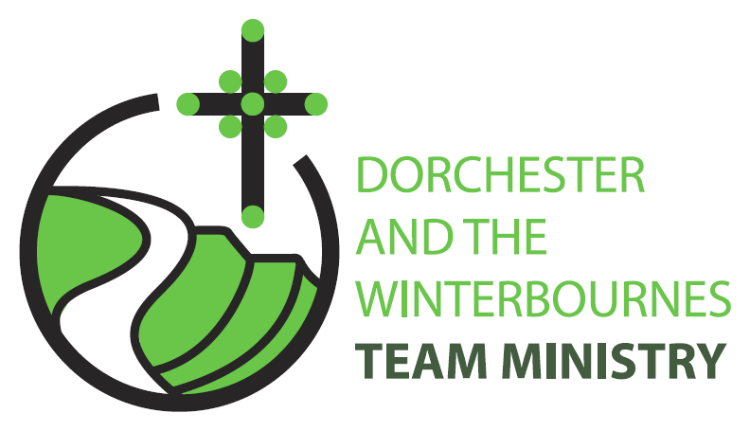

Easter 4
26th April 2026

Welcome to this service for the Easter season. Alleluia Christ is Risen!
It’s lovely to see you especially if you're here for the first time or are a visitor to the Winterbourne Valley. Our theme this Sunday is our common life together as Easter people guided by Jesus the Good Shepherd. So we continue to pray for peace across our world, for the communities afflicted by war and for the continued peace processes in Iran and Israel . In this Easter season, we remember especially the Christian communities of Palestine and Israel, Russia and Ukraine.

Collect
Risen Christ,
faithful shepherd of your Father’s sheep:
teach us to hear your voice
and to follow your command,
that all your people may be gathered into one flock,
to the glory of God the Father.
All: Amen

Reading: Acts 2: 42-47

42 They devoted themselves to the apostles teaching and fellowship, to the breaking of bread and the prayers.
43 Awe came upon everyone, because many wonders and signs were being done by the apostles.
44 All who believed were together and had all things in common;
45 they would sell their possessions and goods and distribute the proceeds to all, as any had need.
46 Day by day, as they spent much time together in the temple, they broke bread at home and ate their food with glad and generous hearts,
47 praising God and having the goodwill of all the people. And day by day the Lord added to their number those who were being saved.
This is the word of the Lord.
All: Thanks be to God.

Gospel Reading: John 10:1-10

Hear the Gospel of our Lord Jesus Christ according to John.
All: Glory to you, O Lord.

10 Very truly, I tell you, anyone who does not enter the sheepfold by the gate but climbs in by another way is a thief and a bandit.
2 The one who enters by the gate is the shepherd of the sheep.
3 The gatekeeper opens the gate for him, and the sheep hear his voice. He calls his own sheep by name and leads them out.
4 When he has brought out all his own, he goes ahead of them, and the sheep follow him because they know his voice.
5 They will not follow a stranger, but they will run from him because they do not know the voice of strangers.
6 Jesus used this figure of speech with them, but they did not understand what he was saying to them.
7 So again Jesus said to them, Very truly, I tell you, I am the gate for the sheep.
8 All who came before me are thieves and bandits; but the sheep did not listen to them.
9 I am the gate. Whoever enters by me will be saved, and will come in and go out and find pasture.
10 The thief comes only to steal and kill and destroy. I came that they may have life and have it abundantly.

This is the Gospel of the Lord.
All: Praise to you, O Christ.

Post Communion Prayer
Merciful Father,
you gave your Son Jesus Christ to be the good shepherd,
and in his love for us to lay down his life and rise again:
keep us always under his protection,
and give us grace to follow in his steps;
through Jesus Christ our Lord.
All: Amen
NOTICES:
Compton Valence APCM 5th May 6pm @ Village Hall
Everyone is welcome to come along
Ascension Day Thursday 14th May: 9am Holy Communion @ St Martin

Fundraising event for The Winterbourne Valley Churches: 14th June
A Message from Tom Webb “This is a "save the date" notice for the 14th June.
Phil and Roelie Newman are opening their garden in Martinstown as part of the National Garden Scheme. The scheme itself raises money for a cancer charity but they have expressed a willingness that we provide, tea, coffee, cake, sausage rolls and other refreshments of our choosing to raise money for the valley churches.

Closer to the time I will be seeking 🙂....
- Cake and sausage roll donations for delivery on the 13th June. We will need a lot, as people travel a long way to come to these open gardens, especially new ones. You may claim for ingredients if you wish.
- Volunteers to man/woman the stand on the day. Bits of the day would be welcome. 09.30 to 16.30
I`ll be asking again closer to the time but if you could put these dates in your diary and let me know if you`re going to be able to help,

Best wishes, Tom Webb

PRAYERS FOR THE WEEK

Lord, you are our Shepherd and we pray that you will protect us from all danger by keeping watch over us, guide us towards green pastures where we can be nourished by your word and lead us to pure still waters where we can be refreshed by your love.

Lord you are our Shepherd, and care for all of your flock. Look with compassion on all who are affected by the present conflict in Isreal, Palestine, Iran and the gulf states. Grant insight to hardened hearts, comfort to the fearful,
protection to those in danger,
and hope to those who are despairing,
Lord, you are our Shepherd and we pray for the world that was given to us as an inheritance, on the understanding that we would care for it as shepherds care for their flocks. Teach us to look after our beautiful planet and care for it wisely, whilst sharing its gifts more fairly and working together with all of its inhabitants to ease its sufferings.

Lord, you are our Shepherd who seeks out the lost and the sick. We pray for those we know who are lost in illness and ask you to reassure them with the knowledge that you are watching over them in their suffering and that many are praying for their recovery..
We pray for: Bruce Robertson and Maggie, Andreas, Clare Rootham, John Reed, Di Honeybun

Lord, you are our Shepherd so we pray for those who have died and for those who ache with sorrow in their loss of a loved one. May those we now name before you find rest in the Spirit’s embrace as you welcome them into the great sheepfold, safe in your keeping for ever. We pray for: John Dyer, Phyllis Lacy-Smith, Marion Hanger, Doreen Pritchard, Richard Hyde (whose year’s mind occurs this month)

