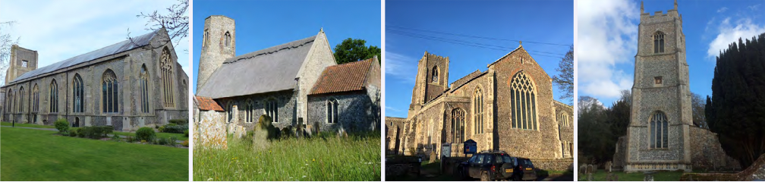

N.E.W.
North Walsham
Edingthorpe
Worstead and Westwick
NEWS
The Magazine for the North Walsham Benefice May 2026 40p
Transformed by Christ: Prayerful, Pastoral, Prophetic

Editor’s Bit

Contents in this issue:
- Vicar’s Page
- From the assistant curate
- Dates from the Diary
- May 2026 service Dates
- Upcoming Events

We hope to see you at our services; you are all welcome.

Please note the date for items to go in the June edition of NEWS needs to be at the Parish office by 20th May 2026 latest.

This magazine is published by the North Walsham Benefice. We reserve the right to edit or decline any material submitted for publication. While reasonable efforts are made to ensure that the contents of the magazine are accurate, no responsibility can be taken for errors and omissions or changes after publication. The material printed does not necessarily represent the views of the Benefice. In accepting advertisements for publication, no recommendation of products or services is implied and we cannot accept responsibility for any unsatisfactory transactions.

Financial Information

Please may we remind you, that if you are giving us a cheque for any of the Churches, they need to be made payable to the following:
St Nicholas’ Church – North Walsham PCC
All Saints’ – Edingthorpe PCC
St Mary’s – Worstead PCC
St Botolph’s – Diocesan Churches Trust
Please may we ask if you are sending any payments to us via an online service that you put a meaningful reference on the payment to ensure we know where the payment should go to.

Live-streamed services are available on YouTube - please search St Nicholas North Walsham. Do you participate in our live-streamed services - we would love to hear your feedback: contact David on 07506 723946 or davidnorthwalsham@gmail.com

If you are considering a change to your Committed Giving for St. Nicholas, please inform Chris Sherman (Committed Giving Officer)
Please support St. Nicholas Church, North Walsham on #easyfundraising, you can raise FREE donations when you shop online with over 5,000 retailers. It is simple and only takes 2 minutes to sign up! Plus, once you have raised your first £15, easy fundraising will match it!
Sign up now: https://www.easyfundraising.org.uk/causes/stnicholaschurchnw/

The Vicar’s page:
The month of May has much to commend it - longer days and hopefully warmer ones. May is traditionally celebrated as 'Mary's month' as the new life we see around us reminds us of the life found in Jesus.

May is also the month for Annual Parochial Church Meetings (APCM)! Goodness Vicar, I hear you cry, how ghastly, bureaucratic and pointless - we should be all about worship, mission, outreach and service to our community! Well, dear reader, we are, but bear with me!

An APCM is a legal requirement, and is essentially the AGM for the board of trustees of the charity. So we receive reports from the Parochial Church Councils and their treasurers, the churchwardens (as 'keepers of the fabric' of the churches), church related groups, and the Vicar as the person in whom responsibility for so much of it is vested.

APCMs are a time to look back and review, and look forward - we are trustees and stewards of great heritage, as well as the great generosity of those who continue to give in so many ways to support our life.

APCMs are where churchwardens are elected (by ancient custom for 1 year terms), and where other members of the PCC are elected (for 3 year terms) and members of the Deanery Synod (also for 3 year terms), the most junior of the three ranks of Synod (Greek meaning assembly or meeting), the others being Diocesan and General.

I will do so again, but I thank all who offer themselves as churchwardens and PCC members. I am grateful for each and all who give of themselves to support our life together. Please, if you feel moved and called to offer yourself in this way, speak to me: please don't assume that others will come forward and do it all for you.

I hope you're enthused by the idea of an APCM! Ours will be held on 3rd (Worstead), 10th (Edingthorpe) and 31st (North Walsham) this year.

David

The Curate’s Page
Alleluia, Christ is Risen!
He is Risen indeed, Alleluia!

As I write this, we are entering into the 4th week of Eastertide.
But the memories of Holy Week and Paschal Triduum are still very fresh in my memory.
It was an immense privilege and joy to experience my first Holy Week and Paschal Triduum in ministry in the churches of our great Benefice. I had the honour of preaching, which in itself was a great experience, as I was able to share my love for this time of year and the significance of these Paschal Mysteries in our lives.

Maundy Thursday was one of the most profound days in my life, with the washing of feet and then the Festal celebration of the Eucharist. It was at the moment of Consecration, when I had to hold back my tears (a situation which was rectified later on during Keeping of the Watch, where I had a good old sob). I'm still not quite sure if it was due to this being my first Maundy Thursday in ministry, the fact that IT WAS INDEED the night that Jesus gave us His Body and Blood, or the realisation that next year it may as well be me who will celebrate this Eucharist. Maybe it was the mix of all these (and more) that made me more emotional than ever before.

Good Friday will forever remain my favourite day of the year.
Lying on the floor at the beginning of the service, I was reminded of how low Jesus went for our salvation; with veneration of the Cross, I was reminded of His immense Love for us that led Him to this Sacrifice and with the bare altar and empty aumbry I felt the deeper longing for the Christ in my life.

Easter Vigil was at first a terrifying prospect as it was my duty, as a deacon, to sing the Exultet, this song above all others, and bring in the Light of Christ into the darkness of our lives at this time.
In the end, it was the service I will never forget, a moment when yet again I had to hold back my tears while singing ‘Alleluia’ with all might and strength.

And then of course Easter Sunday, with the church busier than ever, with happiness and joy bursting out of each person’s heart. The sight of our cross full of colours from ribbons, a sign of the witness to the Resurrection of Christ, will forever stay in my heart and mind.

I hope that your experience of this past Holy Week and Paschal Triduum was as extraordinary as mine, and that together, we will forever more say:

Alleluia, Christ is Risen!
He is Risen indeed, Alleluia!

Dan

All Saints Church Edingthorpe
Services
10th May Holy Communion 9.15am
24th May Morning Prayer 9.15am

Our Easter Flower Day was very well supported and thanks go to all who came and those who helped in any way. Over £800 was raised for the Church.
We have some dates for your diaries:
Saturday 6th June A Quiz at St Benet Hall, North Walsham. Doors open at 6.30pm and quiz at 7.00pm. Tickets £10. per person to include a ploughman’s supper with pudding.
Saturday 18th July at 6pm Summer Concert with Jane Everard and Joseph Ballard. Tickets £12.50 per person with refreshments after the performance.
Tickets for both events available from June Hannant 01692 402337 or Chris Martin 07787561850 or wardenallsaints@gmail.com .
All events and information about the Church are available on the website www.achurchnearyou.com/church/10076/ or the village website: www.edidngthorpe.village.org.uk.

June Hannant 01692 402337

Edingthorpe’s Silver Eco Church journey
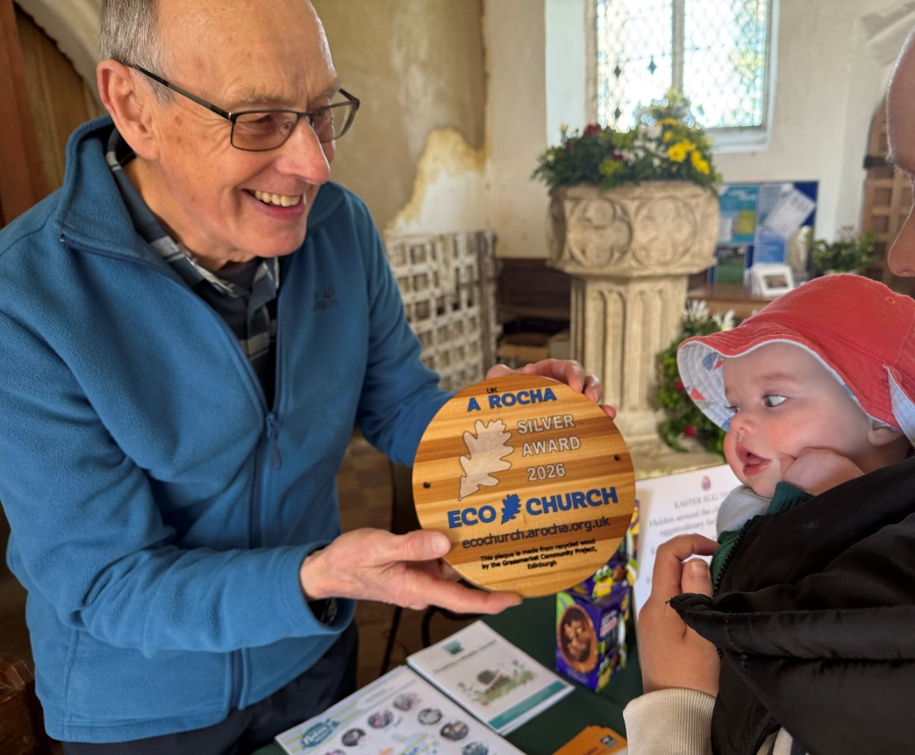
David Beecroft, Eco Church Rep at All Saints in Edingthorpe enthuses about their creation care journey.

Collectively, we all talk about our Eco Church journey; starting the programme surveys and working to an award. For All Saints, Edingthorpe, I think we were already on that journey and I suspect that is the same for many other churches. The realisation came when I attended one of the Norfolk Wildlife Trust and Diocese of Norwich “Holy Habitats” listening workshops and talked to others. A suggestion to the PCC added the role of Eco Church Parish Rep to my existing Churchyard Officer role!
Aiming for Bronze seemed sensible; we could already achieve that in the Land & Nature mission. It was September 2025 and it was evident that all PCC members cared and were supportive of this challenge. Together, we worked through the mission surveys. Any question we couldn’t answer quickly was left unanswered – we moved on; this worked well as we brought the individual surveys up to Bronze level and then we carried on… all of sudden Silver was within our grasp.
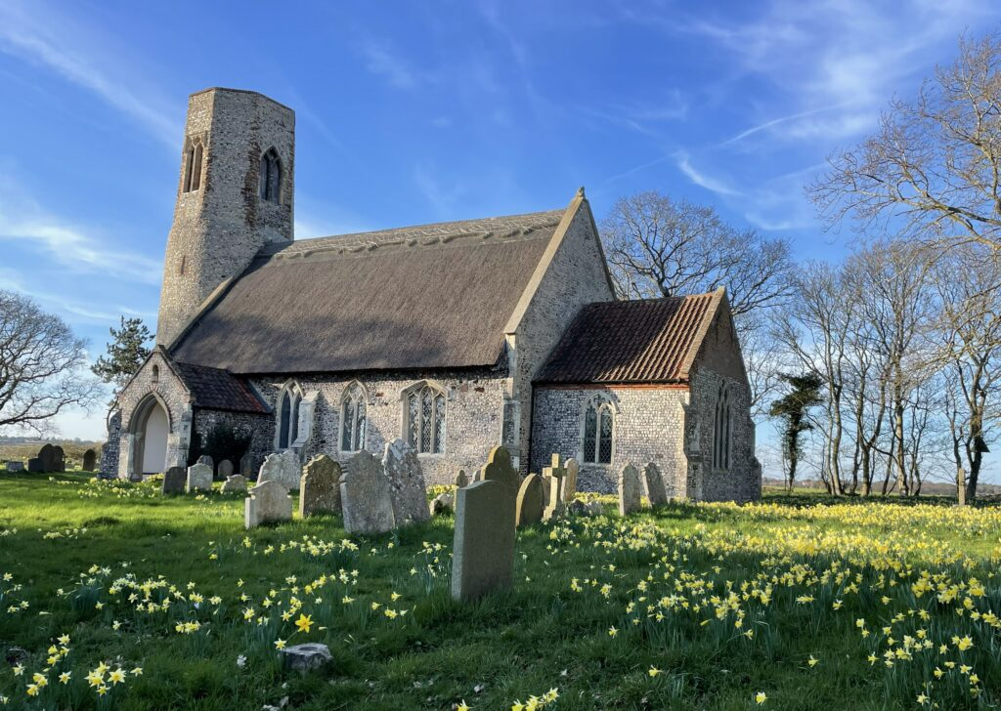
My observations about the surveys. The wording is aimed at urban, Victorian edifices that are in frequent use. This means you have to think laterally to answer some questions, particularly when considering a small, C14th, rural church that isn’t in daily use. “No” is a valid answer so don’t be overly concerned; it either means it is not applicable or you have not done it yet. The one question that caught us out was Q3 of Buildings & Energy; it is compulsory for the CO₂ calculation to be done for submission of the surveys.
Yes, we had done it! The Silver award level was achieved. I had the pleasure of receiving the plaque on behalf of All Saints from Master James Warner (our vicar’s son); he made a group of hard-working people very happy.
This programme stops you ‘hiding your light under a bushel’. Work at it, complete it and you’ll be surprised how good the recognition for caring for God’s creation feels.

ST MARY’S, WORSTEAD - May 2026
A quiet start to our year but gathering pace rapidly.
With an ancient building like ours (14th century) there’s always something
which needs repairing or replacing. So far, we’ve been able to refit our ageing,
and woefully out of date, kitchen with new units, cupboards, work surface, hot
water provision and much needed wall heaters. It’s always cold in a Church,
especially when the walls are three feet thick!

Much-needed repairs have been carried out on the Organ, a very intricate, and
costly, instrument. Many of the Organ pipes were removed and taken to
specialist repairers up in Leeds. Years of accumulated dust and dirt were
removed whilst being repaired, refined and re-tuned.

Both of these projects were made possible by the outstanding generosity of
the Worstead Festival, to whom we are most grateful.

Our next project (there’s always another one!) is to renew the structure of the
porch roof over the main entrance. Over the years it has suffered from the
ravages of gales, rain and frost with the result that the elements have found a
way in and rotted the supporting timber framework. Both masonry and lead
covering have also suffered.
The likely cost, overall, will be in the region of £30,000.

In the midst of all this, the life of your Church goes on. The Easter Day service
was well attended, with visiting tourists joining us for the occasion. Our
fundraising activities, of necessity, have been getting under way again. We are
indebted to the small, but intrepid band who, once again, harvested armfuls of
daffodils which so many of you bought, thereby contributing to our efforts.
We recently welcomed, for the very first time, East Anglia’s premier Brass Band,
The Cawston Band, all 25 of them. We were supremely entertained by music
from Hollywood and the West End Stage. In a building as large as ours, the
acoustics were outstanding. If you weren’t there, you missed a treat.
They enjoyed our company as much as we enjoyed theirs. In consequence, they
will probably be back in the autumn.
Don’t worry, we’ll keep you fully informed.

Next up, as the saying goes, is the annual extravaganza known as the Worstead
Festival. As usual, your Church will be a hive of activity and exhibition with our
traditional Flower Festival,(celebrating 60 years of the Festival), and, of course,
the Worstead Weavers and the Clothing and Textile Association, all displaying
their crafts and talents. We’ll also be providing our ever popular ‘pit-stop’
refreshments for the weary Festival-Goers, together with the opportunity to
try your luck on the Tombola Stall. Not to be missed.

In recent years, St Mary’s has evolved and re-invented itself, becoming, once
again, a community asset. That does not detract, in any way, from the fact that
it is, first & foremost, a place of worship, open to everyone, regardless of their
faith, beliefs or otherwise. Come and see us some time. You will always be
welcome.
God Bless
Dates for your Diaries
3rd May – Holy Communion at 9:15 am
17th May – Morning Prayer at 9.15 am

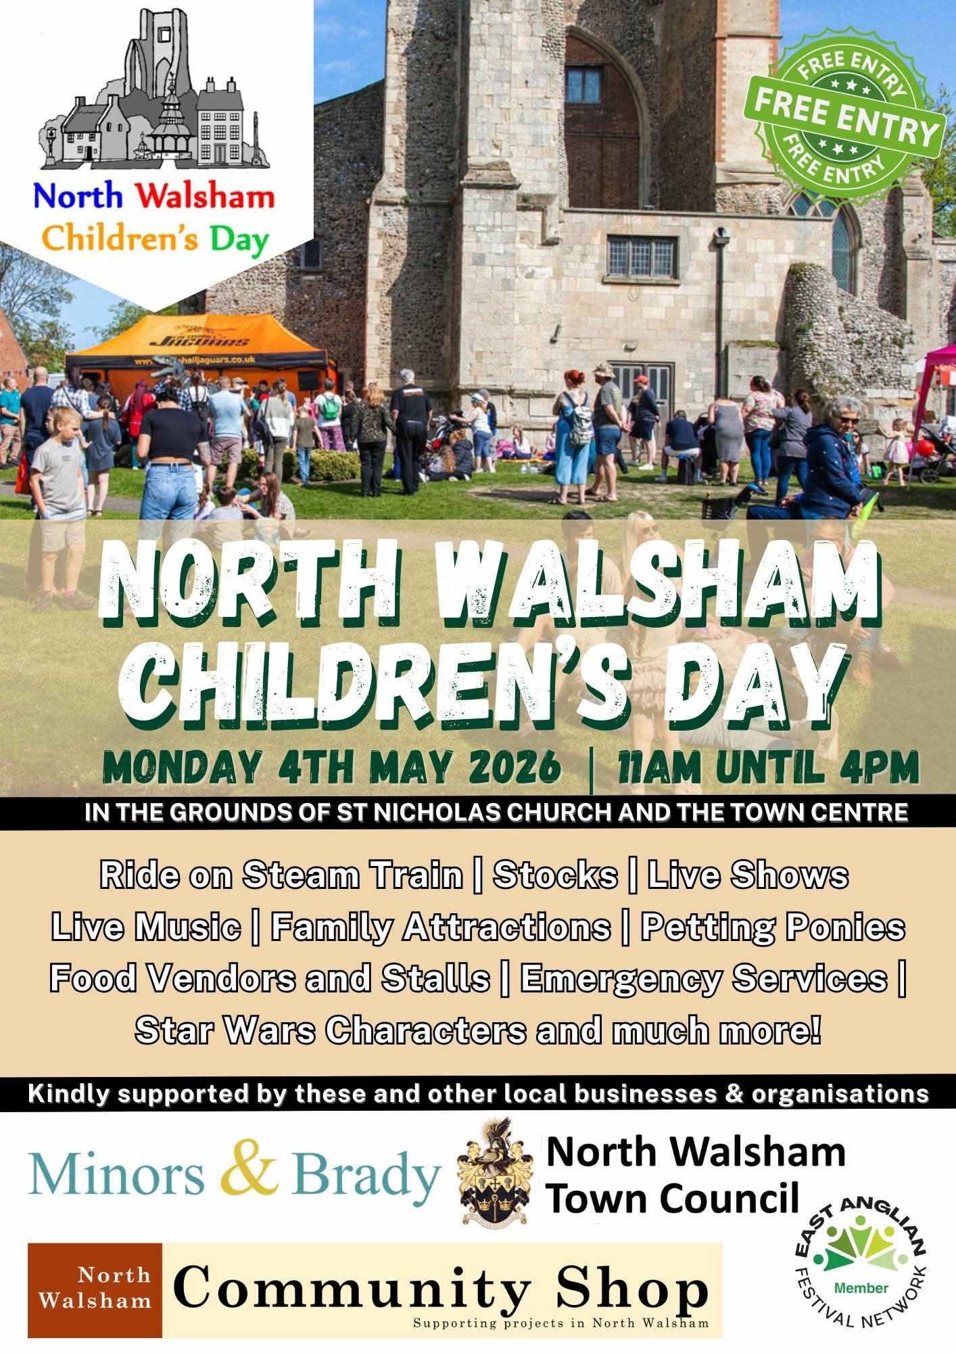

2026 Electoral Roll Review for St Nicholas, North Walsham – Sequence of Events
27th March 2026 – notice displayed for 14 days before electoral roll review begins
18th April 2026 – electoral roll review begins (15 days minimum)
8th May 2026 – electoral roll review completed
9th May 2026 – display reviewed electoral roll (14 days minimum)
31st May 2026 – Annual Parochial Church meeting (APCM)
Contact Chris Sherman (Electoral Roll Officer), Churchwardens or Ministry Team for Church Electoral Roll application forms.

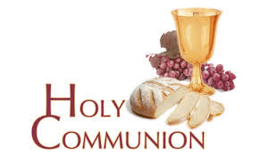
You may have read items in the press relating to the use of 'gluten free' wafers at Holy Communion - for those who require them, we use wafers which are approved and recommended for use by Coeliac UK - more information here. If you need a gluten free wafer, please advise the churchwardens/welcomers when you arrive for the service, and please indicate to the clergy distributing Holy Communion.
The Church teaches that receiving Holy Communion in both kinds (wafer and wine), or in one kind (the wafer or the wine) are acceptable and contain the fulness of the Sacrament. There are many reasons why this will be the case at different times in our lives, and there will be times when we cannot physically receive but join in an Act of Spiritual Communion (as those who watch online do - see below).

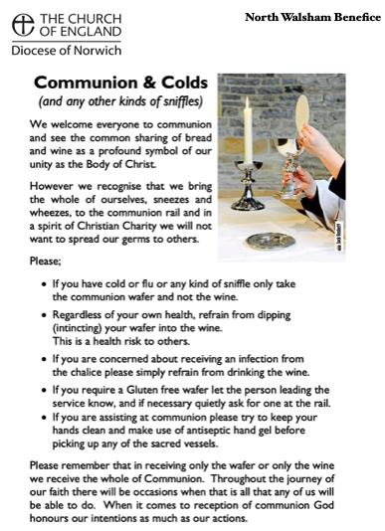
​Intinction (that is, dipping your wafer into the wine) is not permitted, both for hygiene reasons and because it might introduce gluten to the wine, which could be consumed by someone who is allergic to it.
If you wish to discuss any of this, please speak to David.

An Act of Spiritual Communion
In union, O Lord, with the faithful at every altar of your Church, where the Holy Eucharist is celebrated, I desire to offer you praise and thanksgiving. I present to you my soul and body with the earnest wish that I may always be united to you. And since I cannot now receive you sacramentally, I ask you to come spiritually into my heart.
I unite myself to you and embrace you with all the affections of my soul. Let nothing ever separate you from me. May I live and die in your love. Amen.



Why not come along to Sunday Kids and find out how to learn about what we do? We meet on the 1st and 3rd Sunday of the month at St Nicholas Church during the 10.30am service. You are most welcome.



North Walsham Mothers’ Union. We meet in St Nicholas Room on the second Tuesday of the month at 2.00 p.m. Following a short act of worship and a few notices our speaker then takes the floor, after which, over tea and biscuits, there is an opportunity to ask questions and socialise. We usually finish about 3.30 pm.

Thanks to all who’ve provided tealights for prayer stations at St Nicholas!
All donations of white, unscented tealights gratefully received!

Services for May 2026

Friday 1st May
9am Morning Prayer at North Walsham
9.30 – 1130 am Cuddles and Catch Up in the St Benet Hall
Sunday 3rd May - Easter 5
8am Holy Communion (1662) at North Walsham
9.15am Morning Prayer at Worstead followed by the APCM
10.30am Holy Communion at North Walsham
5pm Choral Evensong at North Walsham

Monday 4th May
Children’s Day
Tuesday 5th May
9am Morning Prayer at North Walsham
Wednesday 6th May
9am Morning Prayer at North Walsham
Thursday 7th May
9am Morning Prayer at North Walsham
9.30am Market Day coffee morning in the St Nicholas Room
10.30am Holy Communion at North Walsham
Friday 8th May
9am Morning Prayer at North Walsham
9.30am Quiet Prayer at North Walsham
9.30 – 1130am Cuddles and Catch Up in the St Benet Hall
Sunday 10th May – Easter 6
8am Holy Communion (1662) at North Walsham
9.15am Holy Communion at Edingthorpe
10.30am Holy Communion at North Walsham
5pm Evensong at North Walsham
Tuesday 12th May
2pm Mothers’ Union at North Walsham
Wednesday 13th May
10am Knitting group in St Nicholas
Thursday 14th May – Ascension Day
9am Morning Prayer at North Walsham
9.30am Market Day coffee morning in the St Nicholas Room
10.30am Holy Communion at North Walsham
7pm Holy Communion at Westwick

Friday 15th May
9am Morning Prayer at North Walsham
9.30am Quiet Prayer at North Walsham
9.30 – 1130 am Cuddles and Catch Up in the St Benet Hall
Sunday 17th May – Sunday after Ascension
8am Holy Communion (1662) at North Walsham
9.15am Holy Communion at Worstead
10.30am Holy Communion at North Walsham
5pm Evening Prayer at North Walsham
Monday 18th May
9am Morning Prayer at North Walsham
Wednesday 20th May
9am Morning Prayer at North Walsham
Thursday 21st May
9am Morning Prayer at North Walsham
9.30am Market Day coffee morning in the St Nicholas Room
10.30am Holy Communion at North Walsham
Friday 22nd May
9am Morning Prayer at North Walsham
9.30am Quiet Prayer at North Walsham
9.30 – 1130 am Cuddles and Catch Up in the St Benet Hall

Sunday 24th May – Pentecost
8am Holy Communion (1662) at North Walsham
9.15am Morning Prayer at Edingthorpe
10.30am Holy Communion at North Walsham
5pm Choral Evensong at North Walsham
Monday 25th May
9am Morning Prayer at North Walsham

Tuesday 26th May
9am Morning Prayer at North Walsham
Wednesday 27th May
9am Morning Prayer at North Walsham
10am Knitting group in St Nicholas
Thursday 28th May
9am Morning Prayer at North Walsham
9.30am Market Day coffee morning in the St Nicholas Room
10.30am Holy Communion at North Walsham
Friday 29th May
9am Morning Prayer at North Walsham
9.30 – 11.30 am Cuddles and Catch Up in the St Benet Hall
Sunday 31st May – Trinity Sunday
8am Holy Communion (1662) at North Walsham
10.30am Holy Communion at North Walsham followed by the APCM
5pm Choral Evensong at North Walsham

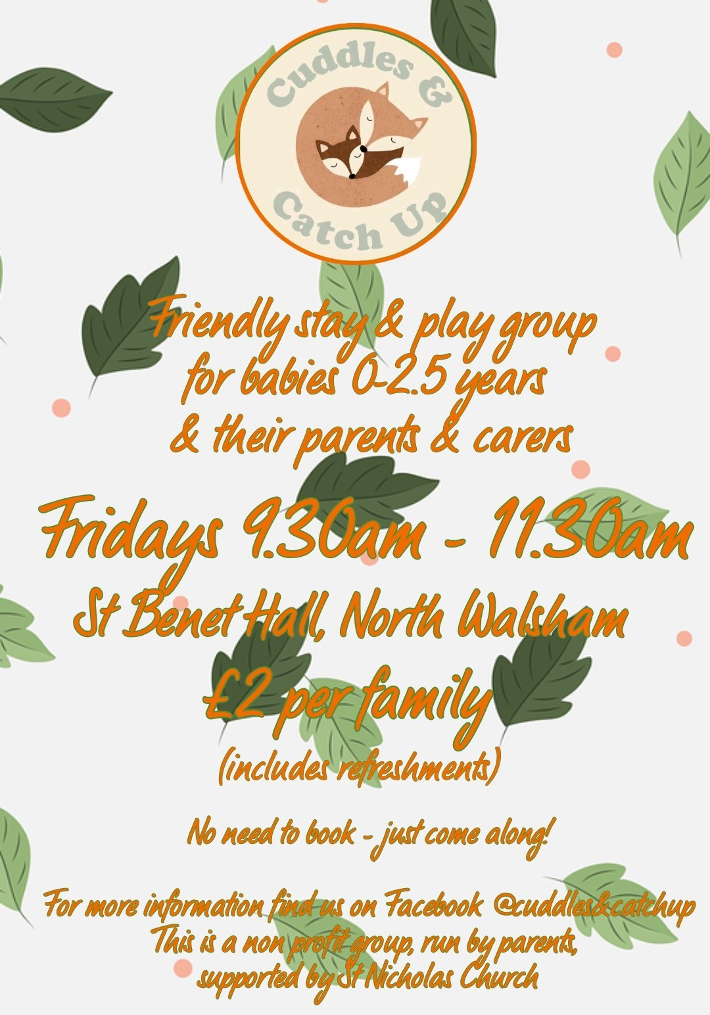
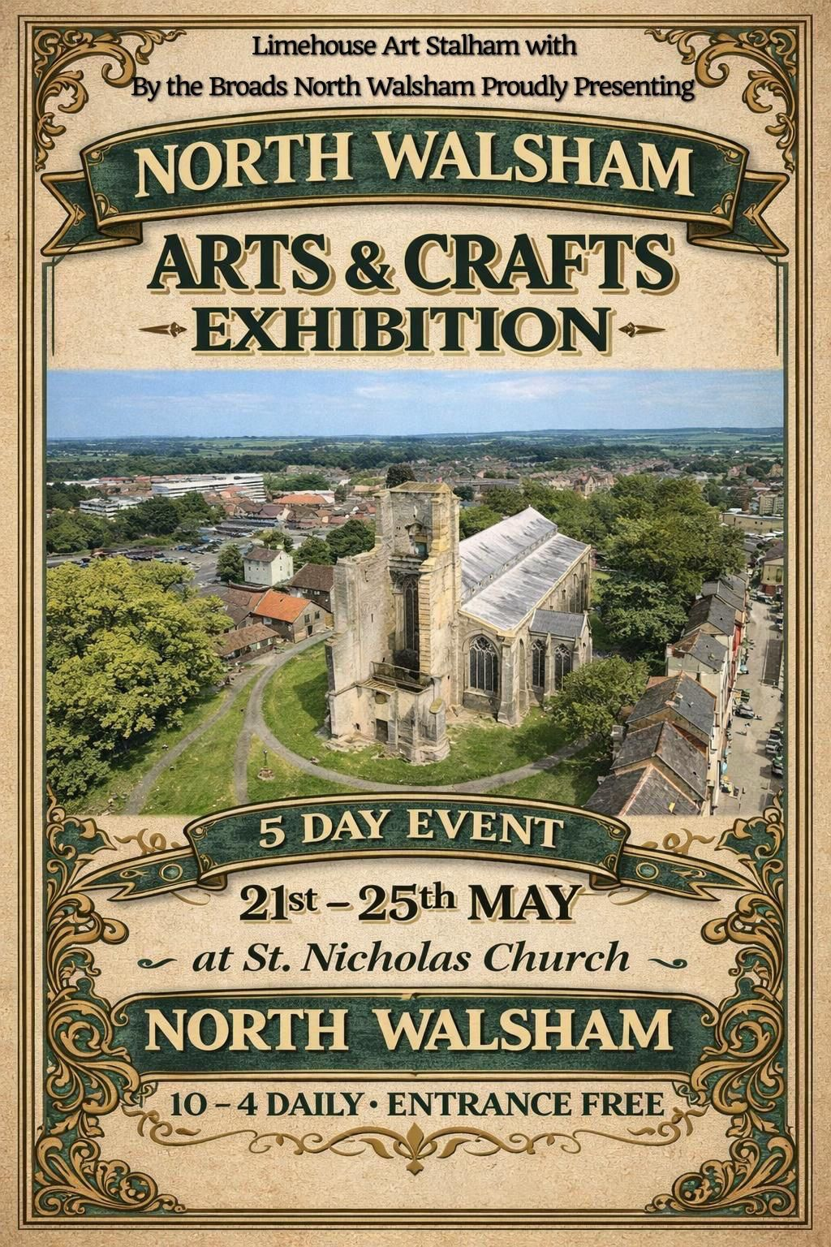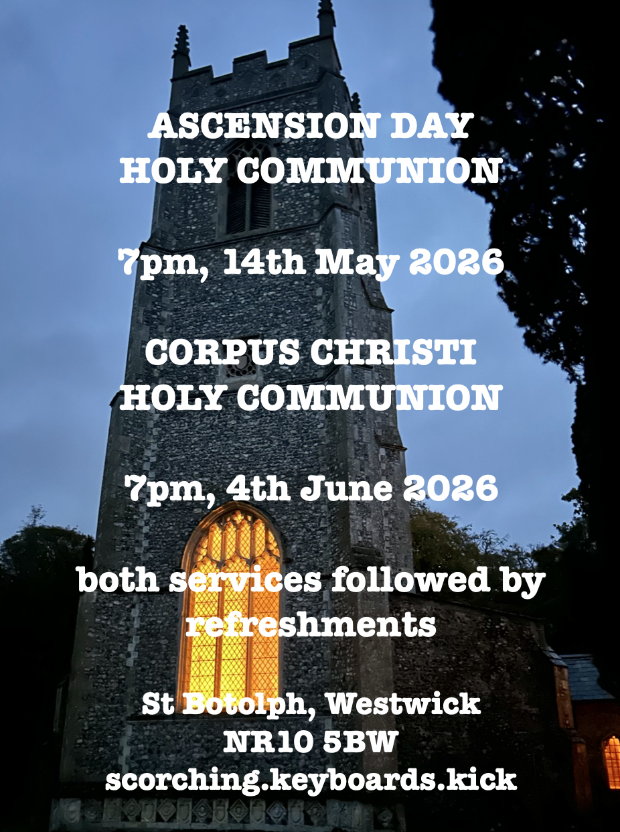

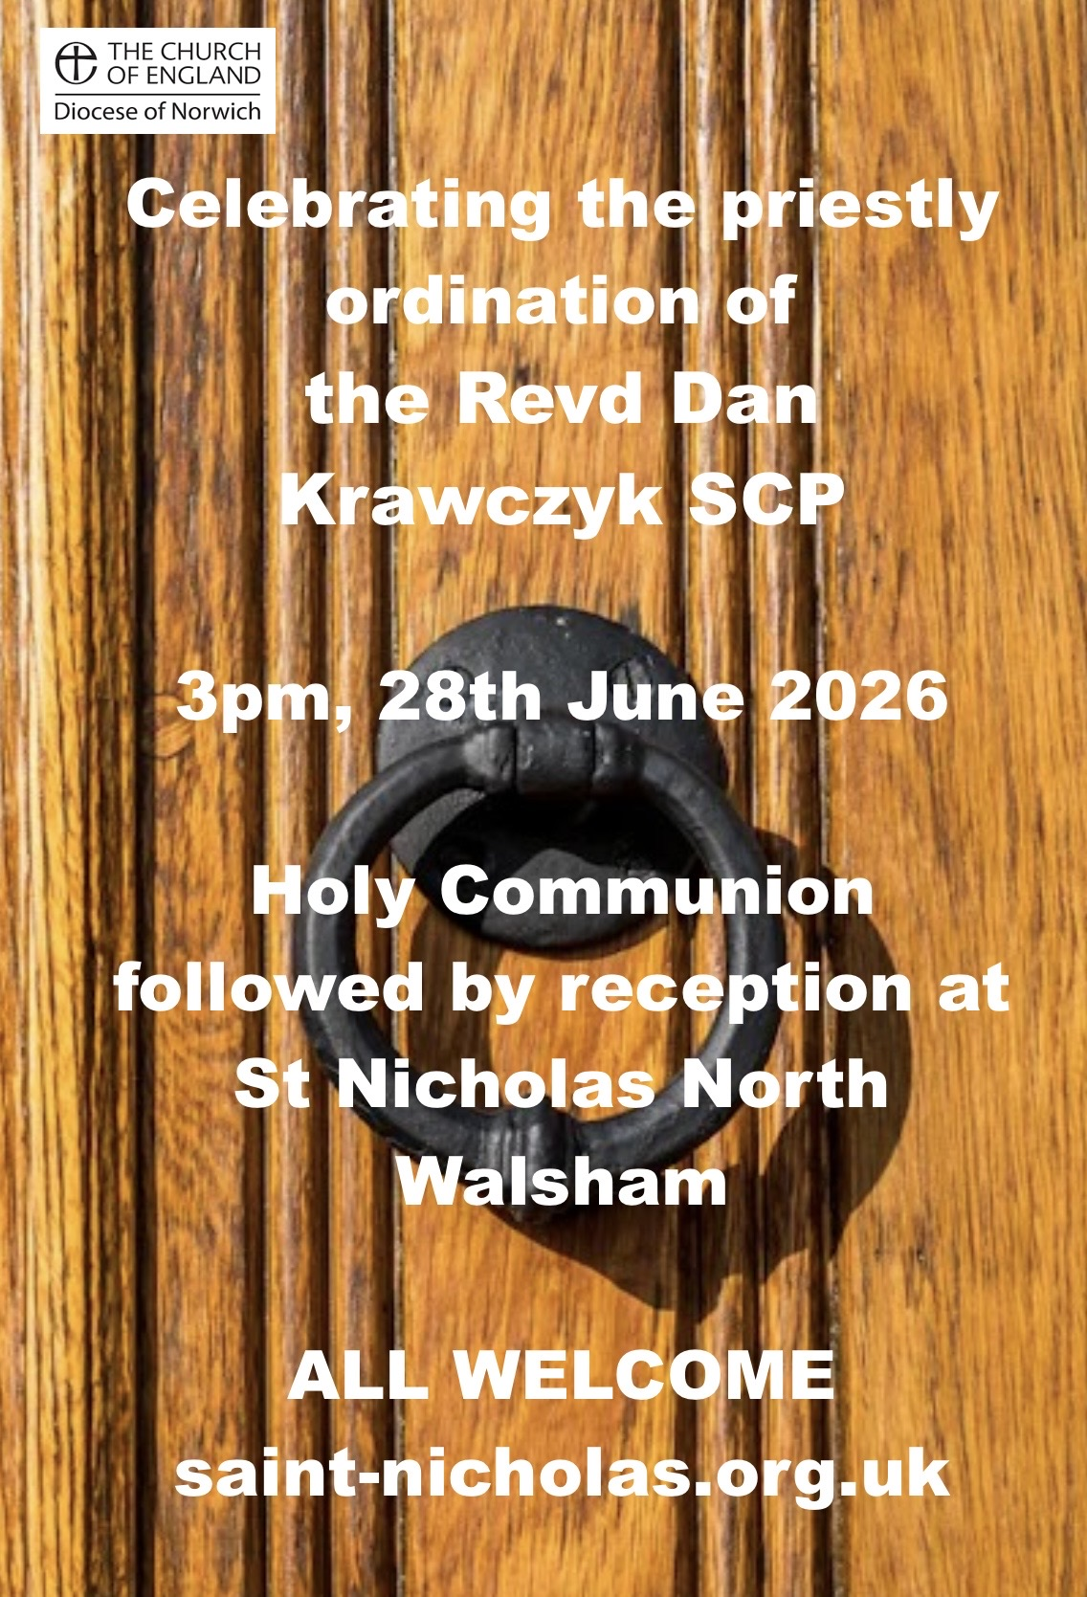
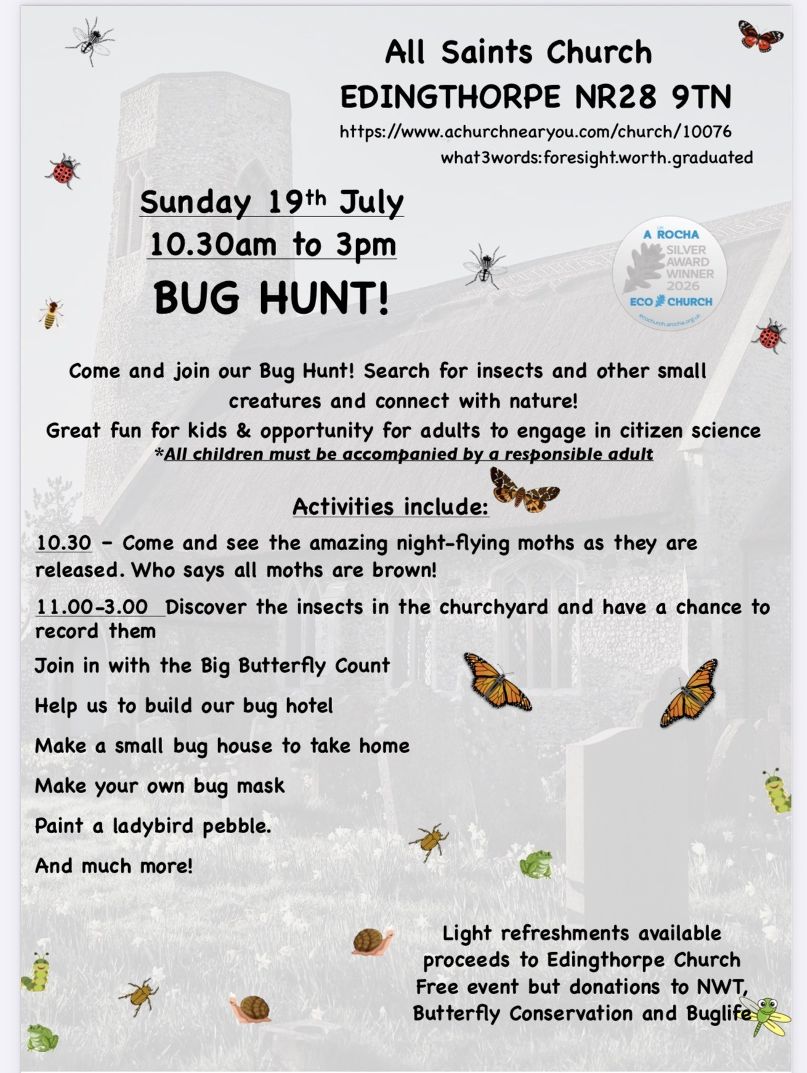

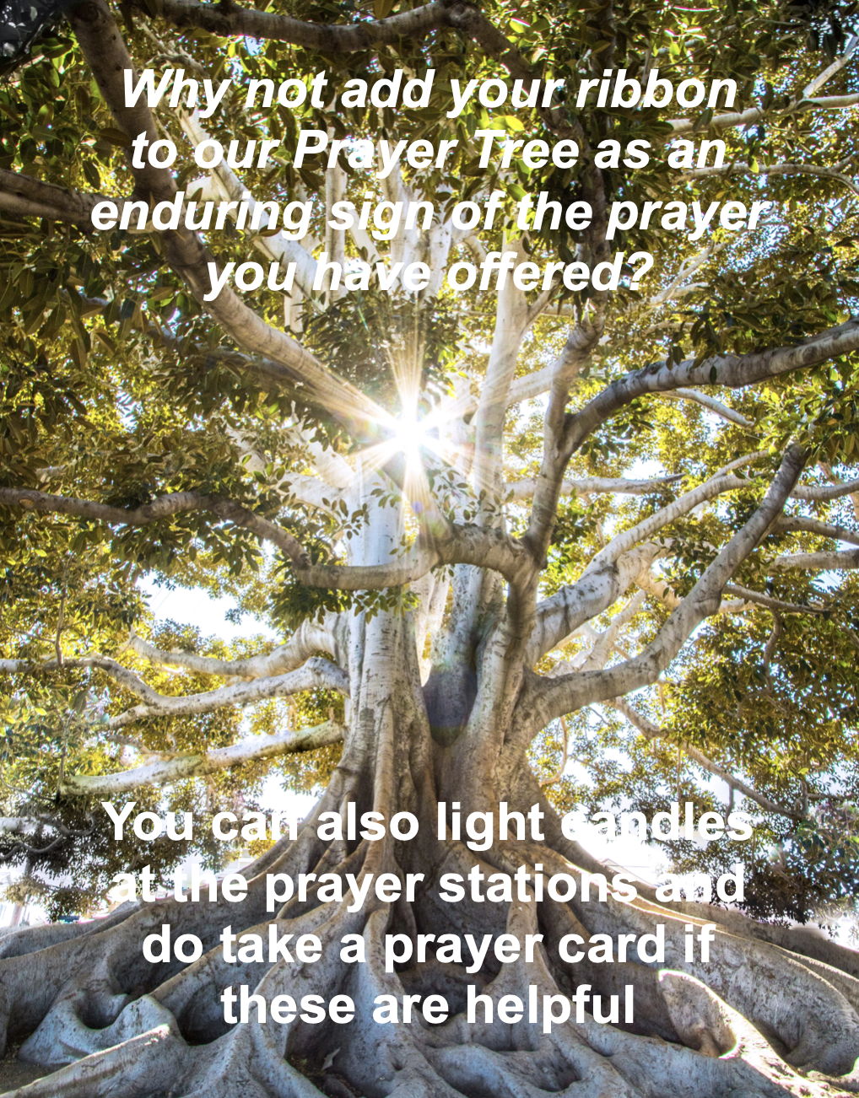

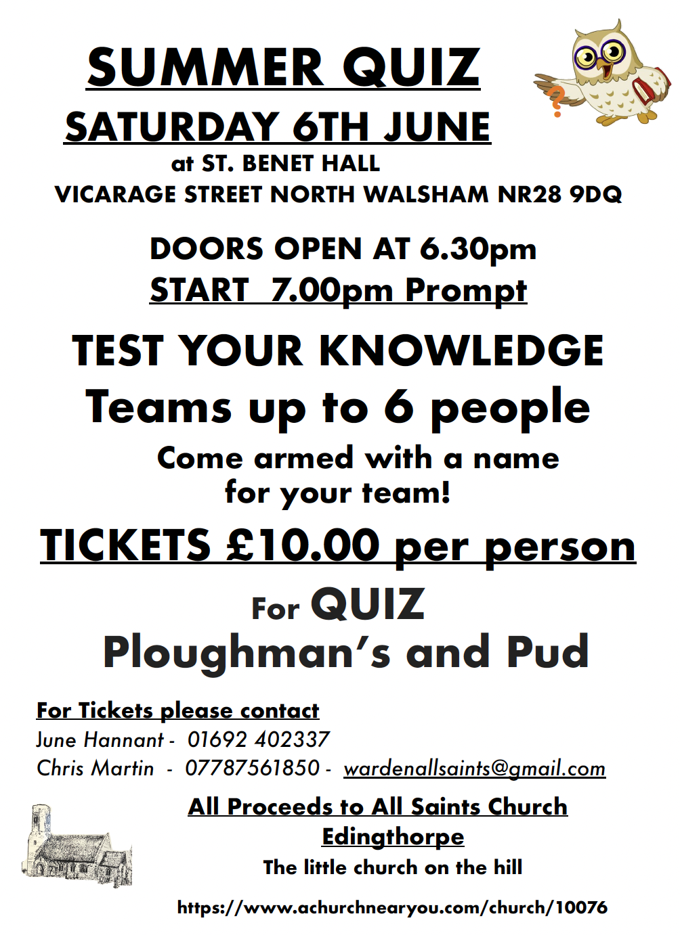

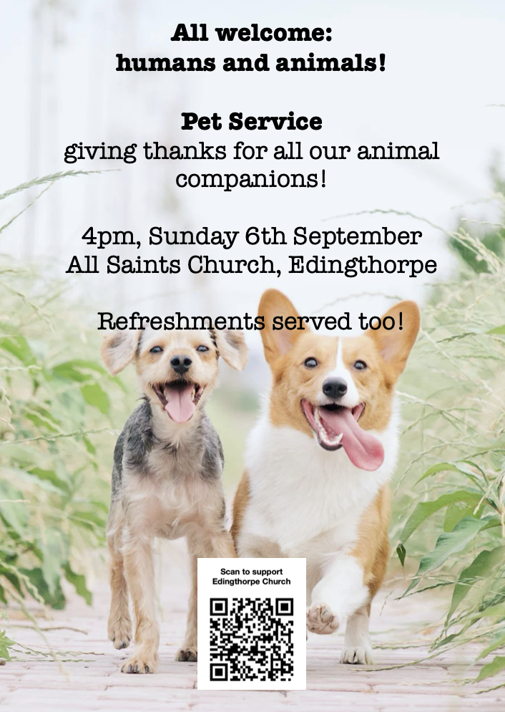

We are privileged to hold special
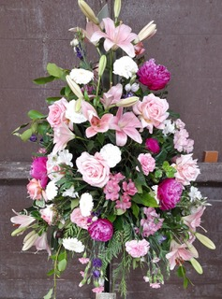
services at any of our churches
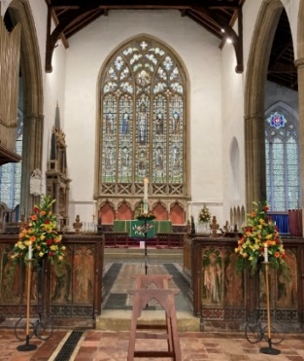
All who live in the benefice are entitled to a baptism, wedding or funeral service in church, and our clergy can officiate at the crematorium and cemeteries too. The church is here for you, through every moment of life.
************************************************************************************


Dates from the Diary

Baptisms
George Cushion
Wedding
Carlie Wittred and Brent Stojanovic
Funerals
Daniel Doyle
Peter Tofts

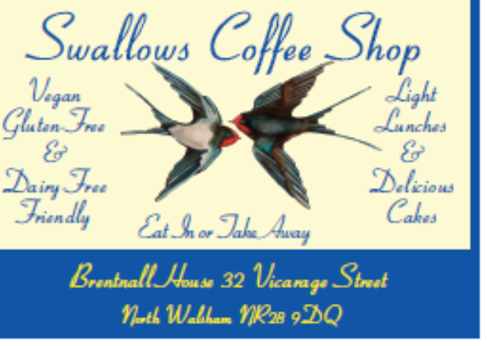




We're pleased that our weekly coffee mornings at North Walsham and Worstead are now registered with Warm Welcome Spaces
North Walsham Market Day Coffee Morning
Thursdays 9.30 – 12.00noon
The space is open to all (and their well-behaved dogs on leads), every Thursday! A warm welcome and refreshments available

Thank you to everyone for raising donations for St. Nicholas Church, North Walsham with #easyfundraising! If you have not signed up yet, it is easy and completely FREE. 8,100 brands will donate to us when you use easy fundraising to do your everyday online shopping - at no extra cost to you! Every donation you raise makes a difference to us so please sign up & share today. https://join.easyfundraising.org.uk/stnicholaschurchnw/XT7MPH/at/TSX8RX7z/RTND2/facebook/



Please support the work of our Churches, by using the contactless giving point at St Nicholas or St Mary’s, leaving your gift on the offering plates or in the wall safes, or through these QR codes. Thank you.

Do you have a Business you would like to advertise in this magazine?
Whole, half or quarter page space is available.
Full Page £ 150.00
Half Page £ 75.00
Quarter Page £ 50.00
Please contact the Benefice office on 01692 408971
or email saintnicholasnw@gmail.com
for details and prices

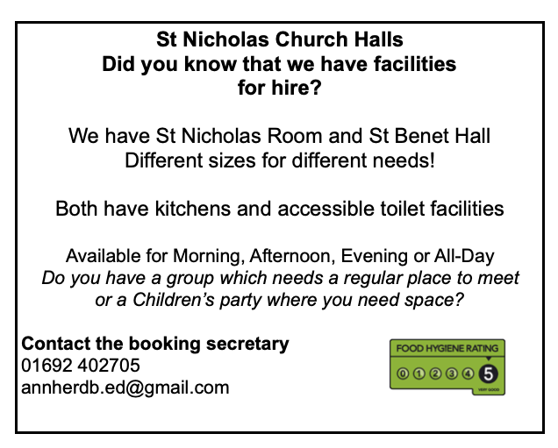
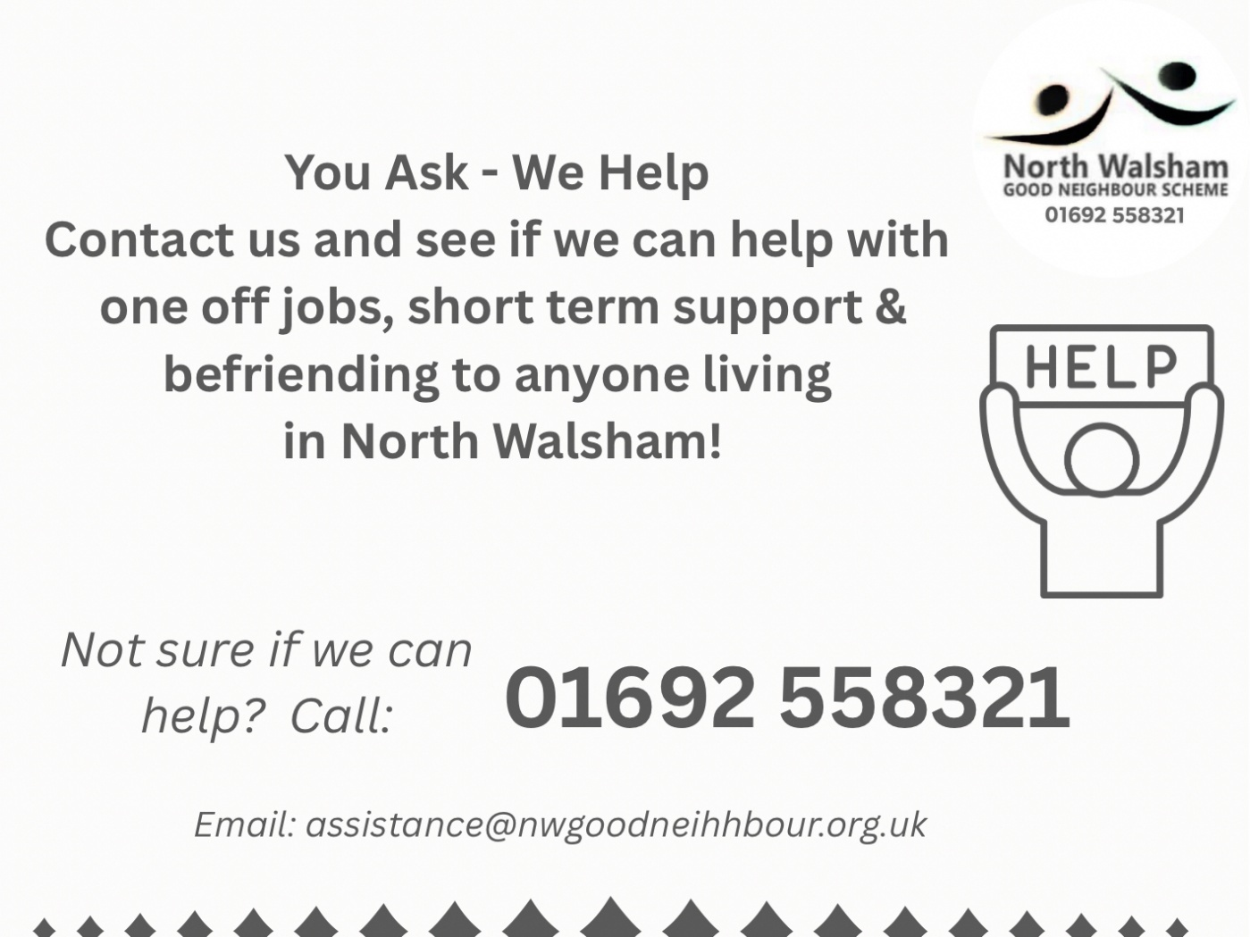

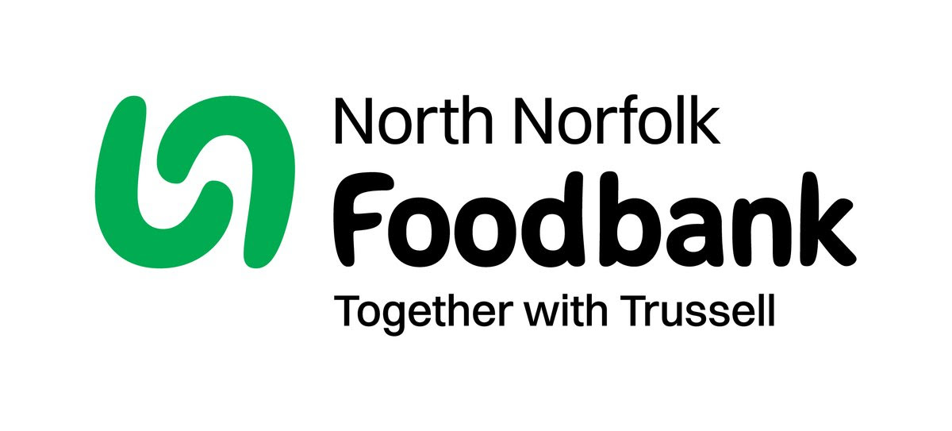
Dear Foodbank supporter,
Thank you for your donation
Receipt and thank you.
Dear Foodbank supporter,
Thank you for your donation from St Nicholas Church
last month of 44.10 kg.
As a small charity we rely on food and financial donations to operate, and we are extremely grateful when people choose to support us.
During the 24/25 year we gave out 2012 food parcels, providing food for 4,520 people; 2,843 adults and 1,677 children.
Whilst Trussell campaigns to end the need for foodbanks, we will be here helping those who need us right now. But that can only be done with kind donations from our supporters.
To see what we need most right now, our wish list is published on our website and social media, and the list gets updated throughout the month on our donation page https://northnorfolk.foodbank.org.uk/give-help/donate-food/
Thank you for thinking of us and enabling us to serve the people facing hardship across our district.
Kind regards
Julie and the Foodbank team
North Norfolk Foodbank
Cromer Methodist Church Hall, West Street, Cromer, NR27 9DT
07826 376343
Ready to tick off your list – Will Made?

"The Church of England have teamed up with Farewills to provide a free will writing service: Online Will Writing Service | Legal Will In 15 Minutes . Anyone can use this service and it is not compulsory to leave something to your church, but it would be nice if you did. It is important for each one of us to leave our earthly matters in good order so why not take advantage of this opportunity now? It is good to remember a gift in your will to a charity is tax free. If you already have a will, you could consider leaving a legacy to the church by adding a codicil. https://farewill.com/norwich-diocese

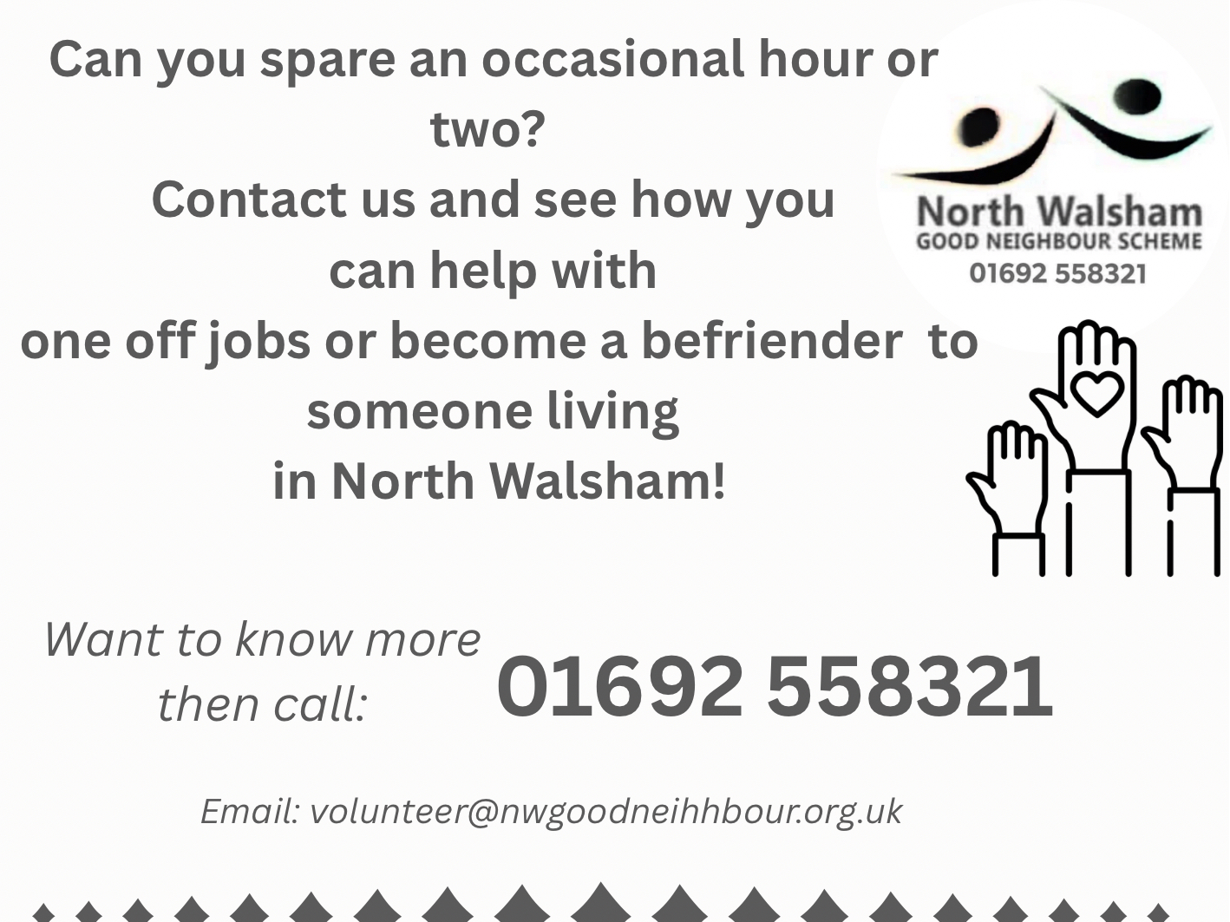

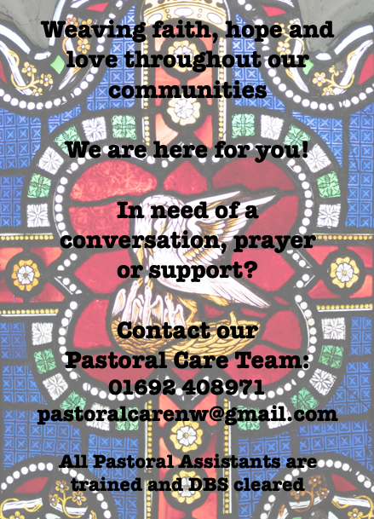

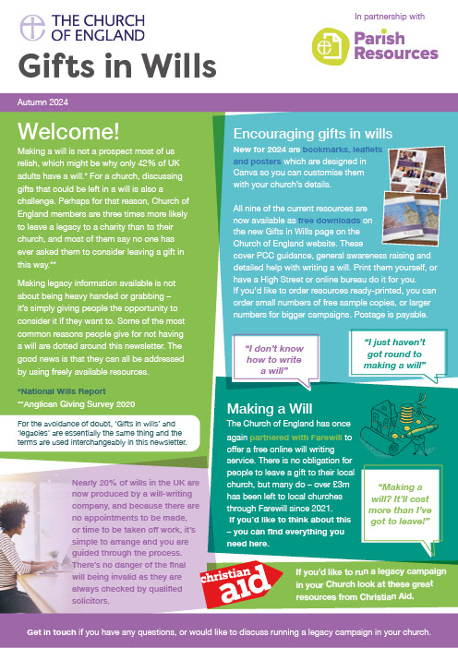
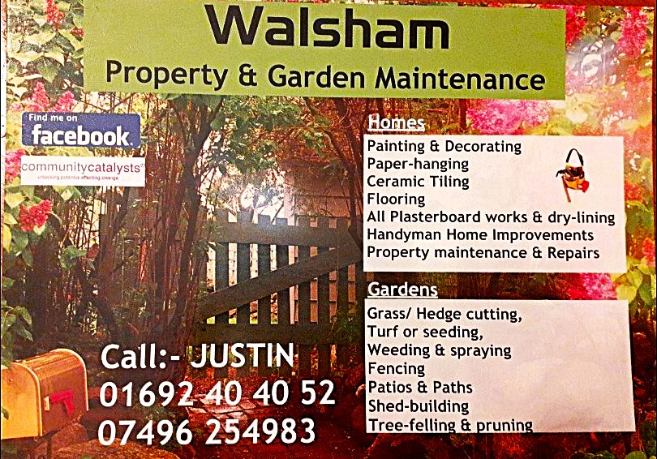

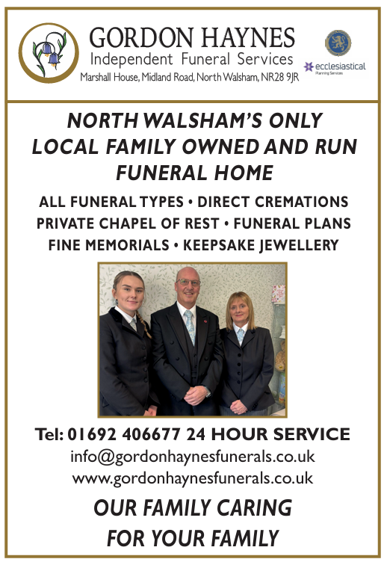
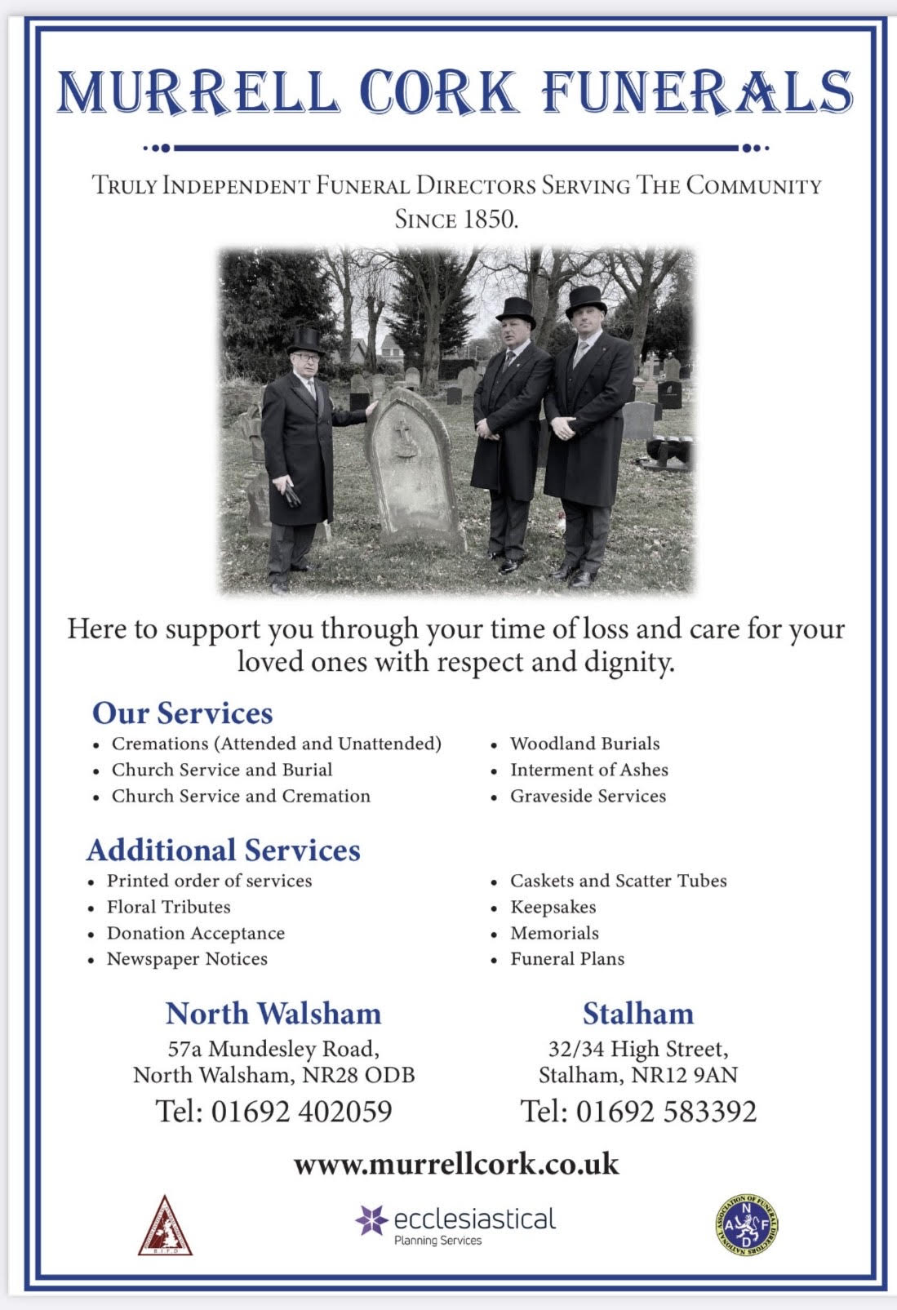
r Sale and Wants Page

Money Matters …
A regular report for our readers written by James Reginald Drake at ClearView Financial Consultants
Burgh Road, Aylsham - 01263 734859, Station Road, Hoveton - 01603 273590 and North Walsham 07773 626662

Lasting Powers of Attorney – Why are they so Important?
Lasting Powers of Attorney (LPA’s) are documents that give an individual you trust (your attorney) the legal authority to make decisions on your behalf should you either lose the mental capacity to make them, or you no longer wish to make these decisions yourself. Lasting Powers of Attorney come in 2 forms, these coming under the heading of ‘Property & Financial Affairs’ and ‘Health & Welfare’
So, how can they help?
The Property & Financial Affairs LPA covers things such as running your bank and savings accounts, making or selling investments, paying bills, buying or selling property and applying for benefits.
The Health & Welfare LPA covers things such as the type of health care and medical treatment you receive (including decisions on life sustaining treatment), where you live, as well as the type of care that you receive in areas such as diet and daily routine.
Given the wide range of areas that these documents cover, it becomes quite obvious as to why they are so important. However, according to ‘The Office of the Public Guardian’ via an article produced in 2022, less than 1% of the UK population have a Lasting Powers of Attorney in place.
So, why do so few people have them in place? One of the most commonly mentioned reasons is that people assume that their spouse will automatically have the right to make decisions for them should they ever reach the stage where they are unable to. This however is a common misconception and it is very often discovered far too late that they actually have no legal authority at all. Cost is another reason people put it off, I can assure you are costs for this type of work are minimal, in the hope this is not a reason to delay.
What should you do?
Well, the answer to this one is quite simple……. get on and set up both types of LPA as soon as you can. It is never too soon to set one up, but it certainly can be too late. By law, once your mental capacity has gone, so has your opportunity to appoint attorneys to act on your behalf. At this point your loved ones will be required to go down a different route and apply to the Court of Protection for a Deputyship order. This requires more forms, more cost and more time, which can all be easily avoided with a bit of forward planning.
So, if setting up Lasting Powers of Attorney(s) is something that you think would benefit you and your loved ones, please feel free to contact me and we can discuss how they can be put in place in a way that is best suited to your own personal requirements.
This short article in no way should be taken by readers as advice.
James can be contacted on either of the above landline numbers or via email at support@smithifa.co.uk
ClearView Financial Consultants is a trading name of Martin Smith Independent Financial Adviser Ltd, a company registered in England
under number 11439150 and authorised and regulated by the Financial Conduct Authority under number 944677.



