SUNDAY MORNING READING SHEET 12th April 2026 2nd Sunday of Easter

A reading from the Acts of the Apostles

Peter, standing with the eleven, raised his voice and addressed them: ‘Men of Judea and all who live in Jerusalem, let this be known to you, and listen to what I say. ‘You that are Israelites, listen to what I have to say: Jesus of Nazareth, a man attested to you by God with deeds of power, wonders, and signs that God did through him among you, as you yourselves know— this man, handed over to you according to the definite plan and foreknowledge of God, you crucified and killed by the hands of those outside the law. But God raised him up, having freed him from death, because it was impossible for him to be held in its power. For David says concerning him,
“I saw the Lord always before me, for he is at my right hand so that I will not be shaken;
therefore my heart was glad, and my tongue rejoiced; moreover, my flesh will live in hope.
For you will not abandon my soul to Hades, or let your Holy One experience corruption.
You have made known to me the ways of life; you will make me full of gladness with your presence.” ‘Fellow Israelites, I may say to you confidently of our ancestor David that he both died and was buried, and his tomb is with us to this day. Since he was a prophet, he knew that God had sworn with an oath to him that he would put one of his descendants on his throne. Foreseeing this, David spoke of the resurrection of the Messiah, saying, “He was not abandoned to Hades, nor did his flesh experience corruption.” This Jesus God raised up, and of that all of us are witnesses. Acts 2: 14a, 22-32

GOSPEL READING

When it was evening on that day, the first day of the week, and the doors of the house where the disciples had met were locked for fear of the Jews, Jesus came and stood among them and said, ‘Peace be with you.’ After he said this, he showed them his hands and his side. Then the disciples rejoiced when they saw the Lord. Jesus said to them again, ‘Peace be with you. As the Father has sent me, so I send you.’ When he had said this, he breathed on them and said to them, ‘Receive the Holy Spirit. If you forgive the sins of any, they are forgiven them; if you retain the sins of any, they are retained.’ But Thomas (who was called the Twin), one of the twelve, was not with them when Jesus came. So the other disciples told him, ‘We have seen the Lord.’ But he said to them, ‘Unless I see the mark of the nails in his hands, and put my finger in the mark of the nails and my hand in his side, I will not believe.’ A week later his disciples were again in the house, and Thomas was with them. Although the doors were shut, Jesus came and stood among them and said, ‘Peace be with you.’ Then he said to Thomas, ‘Put your finger here and see my hands. Reach out your hand and put it in my side. Do not doubt but believe.’ Thomas answered him, ‘My Lord and my God!’ Jesus said to him, ‘Have you believed because you have seen me? Blessed are those who have not seen and yet have come to believe.’ Now Jesus did many other signs in the presence of his disciples, which are not written in this book. But these are written so that you may come to believe that Jesus is the Messiah, the Son of God, and that through believing you may have life in his name. John 20:19-31


If you wish to make a donation to the church, then please hold
Your phone’s camera over this image then touch the link that
appears:
Royston Parish Church
Where all are welcome and God’s love is shared
Sunday 12th April - 2nd Sunday of Easter
Sunday 19th April – 3rd Sunday of Easter
If you would like regular copies of the Notice Sheet emailed to you please email the Parish Office at admin@roystonparishchurch.org.uk

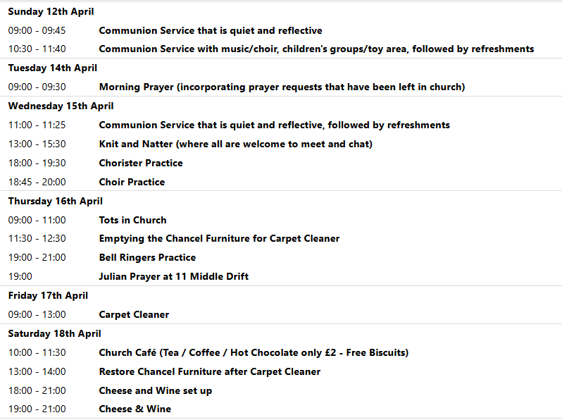
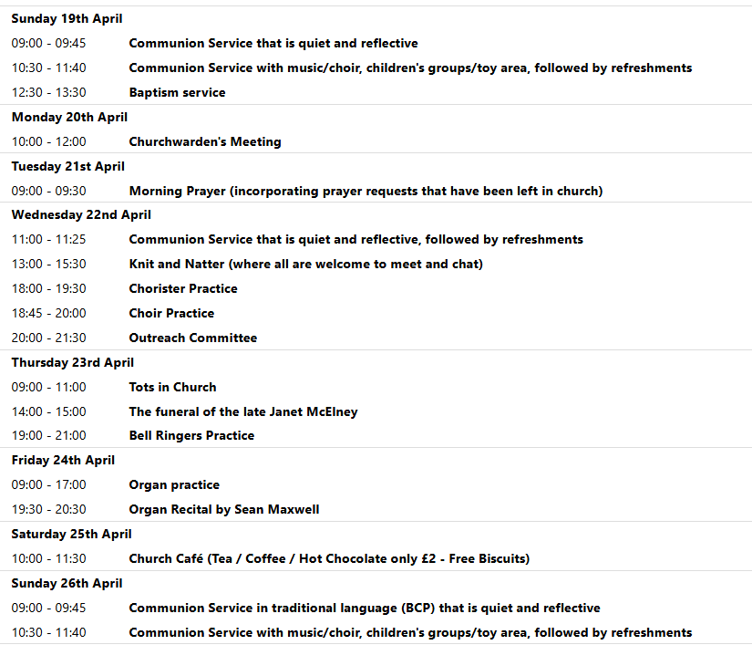

We pray for all Christians worldwide:
For all Christians in Bulgaria, Hungary, Romania
For all who worship at Royston Catholic Church: Fr. Philip Knights
For the work of our mission partners: Vietnamese Church: Pastor Na
Pray for the community of Royston:
For our local health centres
For all who volunteer and make use of The Barn in Royston
We pray for our world and ECO projects:
We pray that Earth Day being held on 22nd April might encourage people to be more caring for the environment and our beautiful, fragile planet.
We pray for the sick and suffering:
5th April 12th April 19th April 26th April
Emma Thompson Ted Rayment Val Brown Peter Coates Pat Pritchard Pat Tidey Angie & Ken Rushall Margaret Green
Jackson Herbert Mike Brown Paula Walker Peter Foster Marion Keith & Elaine Edwards Gwen Simmons
Laura O’nyamul (On-Ya-Mul) Maria Turi Katie
Peggy Dawes George N. Susan Bowles
We pray for those who have died in the faith of Christ:
Deceased | Bereaved
Paul Tidey | Pat, family and friends
Janet McElney | Family and friends

We pray for those whose anniversaries fall at this time:
Bruce Symes, Peter Nightingale, Colin Willingale
NOTICES
DEAR MEMBER OF THE CONGREGATION: We have become aware that a member of the church has had an email hack which means that some members of the church will have received an email saying that the person is "unable to speak over the phone due to a serious throat pains caused by laryngitis, Just wanted to ask if you shop with Amazon?” If you receive an email such as this then it is highly likely to be a scam, which it was in this case. Please be vigilant and never reply via email to a person with such a request. Also, if you received this email and replied, we advise that you change your email password as soon as possible and explore a multi-factor sign in for your email account. If you have any other concerns about this then please contact either the Vicar or a Churchwarden. Steven.
ORGAN RECITAL: By Sean Maxwell. Friday 24th April 7.30 pm. The Organist, Sean Maxwell, released a new CD at the end of last year entitled ‘Pipes and Port’ and is touring this country. We are very fortunate that he has chosen to give a free recital here in Royston.
THANK YOU: to everyone who donated Easter Eggs and towards the Easter flowers, and thank you to everyone who organised the Easter Egg Hunt and arranged the flowers. It helped people have a really joyful celebration of Christ’s resurrection.
TOMATO PLANTS: I am growing tomato plants again this year. Currently they are looking quite healthy and barring any unforeseen setbacks they should be available from the first weekend in May. I plan to have a stall outside of the church to coincide with the Bookfair on May 2nd and May 4th. They will be competitively priced, and proceeds will be donated, as usual, to the church funds. It would be extremely helpful if you would bring bags/boxes if you intend to purchase any. They will then be available throughout May every Saturday morning. Thank you for your support. Chris Wallis
BOOK FAYRE- We have our annual 2nd hand book fayre on Saturday 2nd and Monday 4th May. We are seeking donations of good quality 2nd hand fiction books. Book donations can be left at the back of church from 11th April. We're also seeking donations of cakes for refreshments on both days, and for the cake stall on 4th May. There will be a chocolate tombola, and any donations of chocolate for this will be gratefully received. HELP WANTED to set up the book stall on Friday 1st May, and to man stalls and / or serve refreshments on both days of the book fayre, and to tidy up afterwards. If you're able to help, even for just an hour, please can you sign up on the sheet at the back of church, on the day / time slot or slots that you're able to offer your time. Thanks in advance from the Events committee.
CHEESE and WINE:SATURDAY 18th APRIL, 7:00PM ROYSTON PARISH CHURCH
Tickets £12 Tickets must be purchased in advance for catering purposes
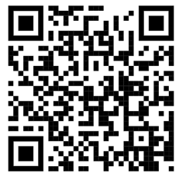
To book tickets scan the QR code, or visit the website below
https://tickets.myiknowchurch.co.uk/gb/NzcwMi0yNw/t
Ticket price includes cheese, crackers and a glass of wine or sparkling elderflower.
Additional drinks available for a charge. PROCEEDS IN AID OF CHURCH FUNDS

