Acrise Church News: April 2026
Benefice Service on Sunday 29th March
This will be at Postling at 10.00am. No service at Acrise.
Services for April
Friday 3rd April Good Friday Reflection 2.00pm Sharon
Sunday 5th April Easter Holy Communion 9.30am Sharon
Sunday 12th April Matins BCP 9.30am Janet
Sunday19th April Morning Prayer 9.30am Bill
Sunday 26th April Service of the Word 9.30am Diana

Internment of Ashes
On Monday 16th March the ashes of Terry and Pam Farley were interned in our Garden of Remembrance at St Martins. Terry, who was Church Warden at Hawkinge for some time, died twelve years ago and Pam died recently. They are now reunited. Their grandsons, Danny and Craig, other family members and friends were at the graveside. Danny spoke of the loving relationship with his grandparents and of happy family memories with them. The Rector, Carol Bates, conducted this moving service as Pam and Terry move on to a life of everlasting peace together.

Mothering Sunday Family Service on 15th March 2026
It was good to welcome back the families who had been to the Christingle Service at the end of January. The church was full, with 58 adults and 19 children. Thanks to Janet for leading this special service and to Irene for playing the organ; our hymns were ‘All Things Bright and Beautiful’, ‘He’s got the Whole World in his Hands’ and ’For the Beauty of the Earth’.
Thanks to all our readers: Fiona and Grace, Diana and Ivor for reading the passages from scripture and Teddy, Bella and Freddie for the children’s prayers. Daisy and Sue also read prayers. Daisy was one of our original readers from seven years ago when we started the Family Service. Freddie, aged six, is now our youngest reader. Well done Freddie. The readings and prayers reflected the importance of mothering and of relationships in family life, based on God’s love for us and our love for one another.
For the activity children decorated heart shaped outlines (see photograph) and those who could wrote messages to their mothers. Before distributing posies of flowers to mothers and grandmothers, Sue explained the long tradition at Acrise which has its origin from when girls in service were given the day off and picked wildflowers for their mothers on their way home. Thanks to Sue, Jean and Val for preparing the posies. At the end of the service the children who wanted to, queued up to ring the bell.
Thanks to Alison and the refreshment team who were kept busy making drinks and giving out food through the service. It was a lively, enjoyable and uplifting service and a good example of teamwork, with many church members supporting the Family Service Team.

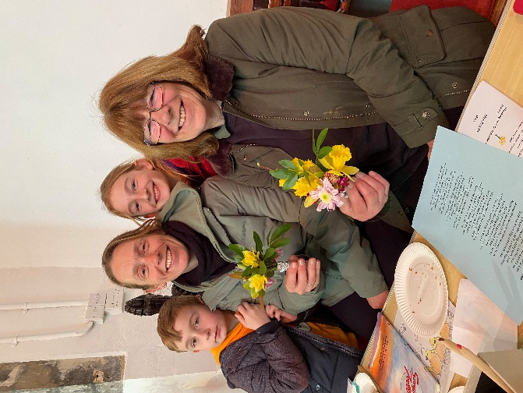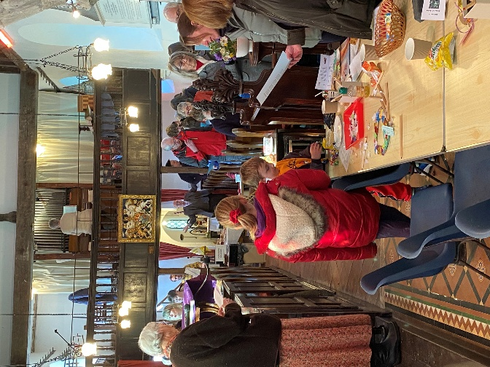

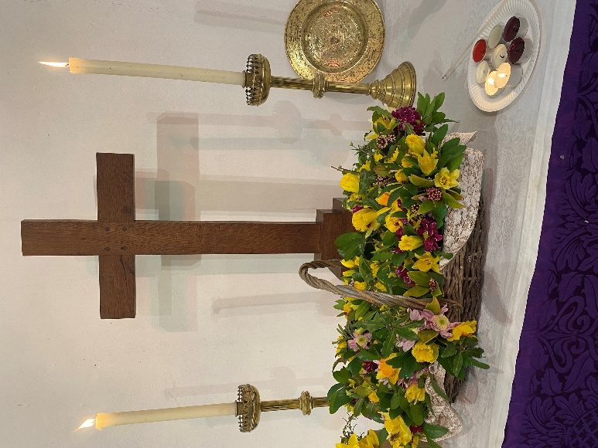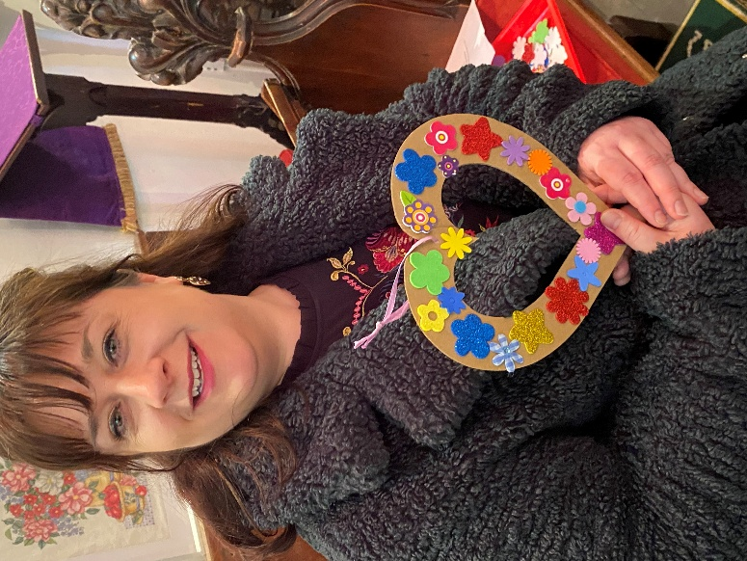

Acrise Environmental Group
Archeological Test Pit
On Thursday 12th March two members of Canterbury Archeological Trust dug a pit at the Ice House Hill Pond, Acrise. They had previously taken auger samples in several areas of this large pond, which suggested the possibility that its origin might date back to the Bronze Age.
They spent most of the morning digging a pit in a different area of the pond which was not too wet. By the time members of our environmental group arrived at around 1.00pm the pit was a metre deep with water in the bottom. At that point it was 19th Century and the archeologists had found mainly brick and stone artefacts, but they had not reached the bottom of the pond. Samples taken by the archeologists will be taken away for analysis and we will be informed of their results. Silt at the bottom of these old ponds has the potential to contain seeds dating back many centuries which may which give us information about farming and wildlife in the past.
Sarah-Harrington Jones from the Kent Downs National Landscape team attended. She mentioned how the chalkland areas had dried up over time and that after ecological and archeological work to gain information the next phase would be to restore as many ponds as possible to improve the water supply.
The possibility that the unique chalklands of Southern England and Northern France could be made a UNESCO Heritage Site has been discussed.
Heritage Pond Talk
Sarah will be giving a talk about the heritage ponds project and how it is developing, at Elham Village Hall in the Peggy Pike Room from 7.30 – 9.30am on Tuesday 28th April.
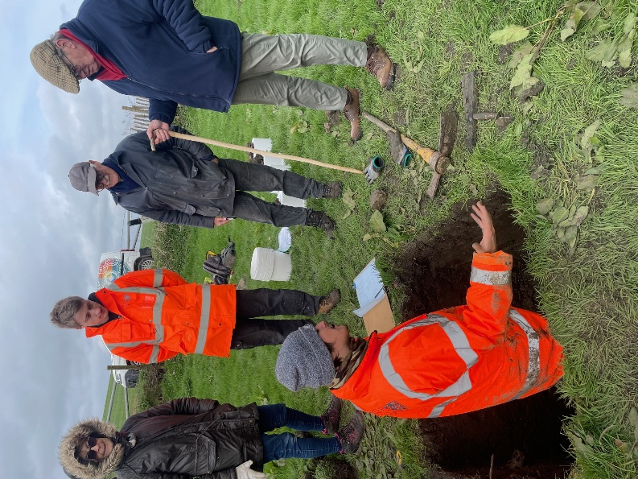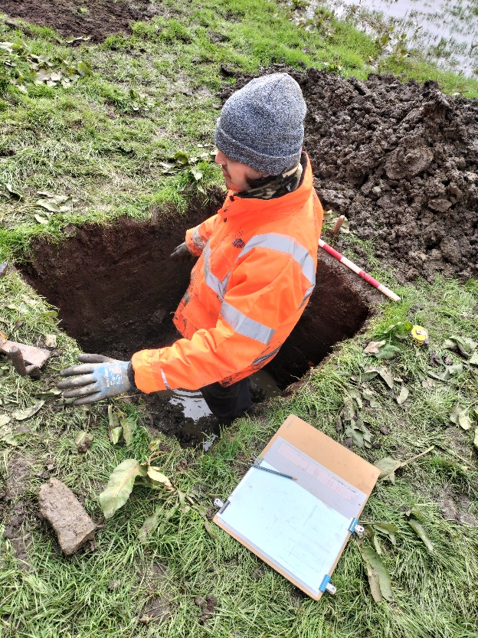
Clare Readman of Gingerly Green Flower Farm: Business Award
Clare set up her business at Newlands Farm, Selsted, just over two years ago and has recently won a Kent Women in Business Award. All nominations were judged by a professional panel, and the award ceremony was held at Ashford International Hotel on 7th March. Clare is to be congratulated on her achievement after such a relatively short time in business.
Clare is also an Ambassador for ‘Sustainable Church Flowers,’ an organisation which gives support and practical guidance to help church flower arrangers make small changes in their use, buying and arranging of flowers in order to move towards a more sustainable future.
St Martin’s has always used local flowers and foliage from people’s gardens and from the churchyard, but used to spend considerable sums of money on commercial flowers for the annual Flower Festival. The problem with the worldwide flower industry is the use of pesticides and herbicides to maintain the quality of flowers and the C02 emissions involved in importing flowers over long distances. We now use flowers from Gingerly Green, our local flower farm.
For nearly 60 years churches have used floral foam (oasis) for arrangements. We now know that it is a single use plastic produced from petroleum-based phenol with the addition of formaldehyde. It breaks down into microplastic which contaminates aquatic ecosystems. Phasing out the use of floral foam and replacing it with more sustainable techniques will reduce the use of single use plastics as part of tackling the climate crisis. Clare recently took photos of several arrangements at St Martin’s that she had made without floral foam. She will be happy to help our flower arrangers with this transition. We thank her for her support of St Martin’s.

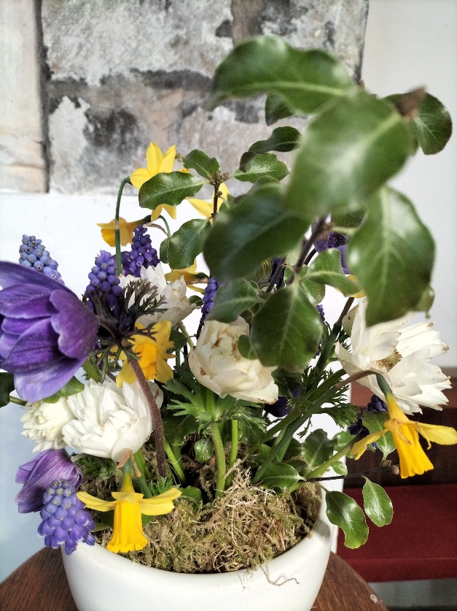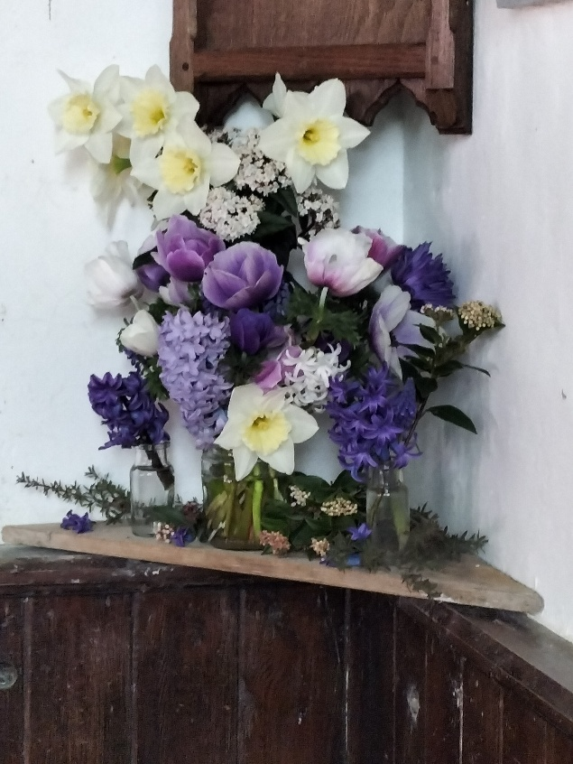
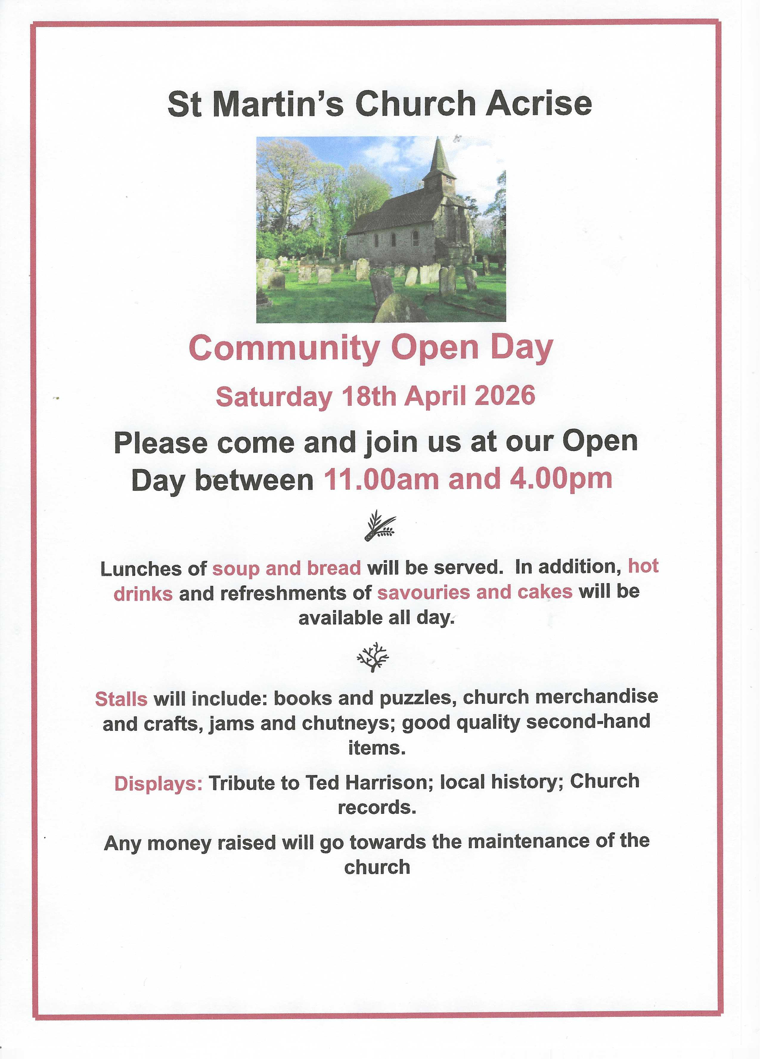
Decorating the Church for Easter on Saturday 4th April at 10.00am
We would be grateful for volunteers to help with decorating the church. Donations of spring flowers or foliage would also be appreciated. This is always an enjoyable time as we look forward to Easter and springtime. Anyone is welcome to join us.
As is traditional at Acrise, Sue will be ordering Easter lilies. If anyone would like to buy one in memory of a loved one please contact Sue on 01303844640.

St Martin’s Church 2026 Garage Sale and Grand Raffle
This will start on Saturday 27th June and continue until Saturday 4th July when the Grand Raffle Draw will take place that morning.
The Garage Sales Team, led by Richard, are involved with buying and selling secondhand items throughout the year, and not just at the Garage Sale or other fundraising events.
If you have any unwanted items that could be recycled to raise money for St Martin’s please contact Richard on:
01303 984 584 or 07919393302

Shepway Foodbank: Folkestone Rainbow Centre
If you can support the foodbank please leave items at the back of the church or in the porch if the church is shut.
Most needed items are: white cooking sauce, curry sauce, custard, long life milk and juice, pickles, coffee, cooking oil, noodles, mayonnaise.

