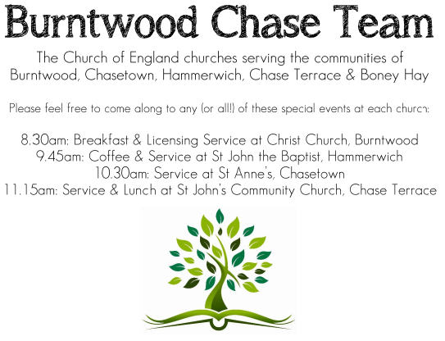
CHRIST CHURCH
Registered Charity Nos. 1217129

SERVICE ON SUNDAY 3rd May 2026 at 10am

Holy Communion

5th Sunday of Easter

Readings:
Acts 7: 55-60

⁵⁵ But filled with the Holy Spirit, he gazed into heaven and saw the glory of God and Jesus standing at the right hand of God. ⁵⁶ ‘Look,’ he said, ‘I see the heavens opened and the Son of Man standing at the right hand of God!’ ⁵⁷ But they covered their ears, and with a loud shout all rushed together against him. ⁵⁸ Then they dragged him out of the city and began to stone him; and the witnesses laid their coats at the feet of a young man named Saul. ⁵⁹ While they were stoning Stephen, he prayed, ‘Lord Jesus, receive my spirit.’ ⁶⁰ Then he knelt down and cried out in a loud voice, ‘Lord, do not hold this sin against them.’ When he had said this, he died.

John 14: 1-14
‘Do not let your hearts be troubled. Believe in God, believe also in me. ² In my Father’s house there are many dwelling-places. If it were not so, would I have told you that I go to prepare a place for you? ³ And if I go and prepare a place for you, I will come again and will take you to myself, so that where I am, there you may be also. ⁴ And you know the way to the place where I am going.’ ⁵ Thomas said to him, ‘Lord, we do not know where you are going. How can we know the way?’ ⁶ Jesus said to him, ‘I am the way, and the truth, and the life. No one comes to the Father except through me. ⁷ If you know me, you will know my Father also. From now on you do know him and have seen him.’
⁸ Philip said to him, ‘Lord, show us the Father, and we will be satisfied.’ ⁹ Jesus said to him, ‘Have I been with you all this time, Philip, and you still do not know me? Whoever has seen me has seen the Father. How can you say, “Show us the Father”? ¹⁰ Do you not believe that I am in the Father and the Father is in me? The words that I say to you I do not speak on my own; but the Father who dwells in me does his works. ¹¹ Believe me that I am in the Father and the Father is in me; but if you do not, then believe me because of the works themselves. ¹² Very truly, I tell you, the one who believes in me will also do the works that I do and, in fact, will do greater works than these, because I am going to the Father. ¹³ I will do whatever you ask in my name, so that the Father may be glorified in the Son. ¹⁴ If in my name you ask me for anything, I will do it.

COLLECT FOR TODAY
Almighty God,
who through your only-begotten Son of Jesus Christ
have overcome death and opened to us the gate of
everlasting life:
grant that, as by your grace going before us
you put into our minds good desires,
so by your continual help
we may bring them to good effect;
through Jesus Christ our risen Lord,
who is alive and reigns with you,
in the unity of the Holy Spirit,
one God, now and for ever.

WHAT’S GOING ON
Upcoming Services and Events
Monday 4th May Cameo Cafe 10-12noon Sunday 10th May Morning Worship 10am
Sunday 17th May Holy Communion 10am
Sunday 24th May Morning Worship 10am

DATES FOR YOUR DIARY
Saturday 16th May Spring Fayre
Saturday 27th June Cream Tea
Saturday 11th July Shelfield Choir Concert
Saturday 14th November Christmas Fayre

APCM Meeting
Please note the APCM meeting will be held in Church on Sunday 17th May after the 10am Communion Service. Further details nearer the date.
Cameo Cafe
Cameo Cafe will be open on Monday 4th May, 10-12 noon.
Come and join us for a cuppa and biscuits.

FLOODLIGHTING
If you think about commemorating a special occasion by floodlighting our Church. Please contact Chris Brown on 01543 683862 for details.

PRAYER CHAIN
Christ Church is blessed with a very active prayer chain. If you, or anyone you know, feel that they would like others to pray for them, please speak to Chris Brown on 01543 683862.

HOME COMMUNION
For anyone who is unable to attend church and would like a Home Visit and Communion, please contact the Vicar and he will be able to carry this out.

VICAR CONTACT DETAILS
Rev’d Stephen Morgan Tele: 07305 852152
CHURCH WARDENS CONTACT DETAILS
Judith Rogers Tele: 01543 324718
Mike Holmes Tele: 01543 672970
Church Office Tele: 01543 642187 [leave a message and we will respond]
Church Web Site:www.christchurchburntwood.org.uk
Church Email: christchurchburntwood15@gmail.com
Facebook: www.facebook.com/group/christchurchburntwood/

Other Contacts
Rev’d Matt Wallace St. John’s, Chase Terrace— Tele: 01543 670078

NEXT SUNDAY SERVICE
Sunday 10th May at 10am
Holy Communion
Acts 17: 22-31
John 14: 15-21
Easter 6

