NEWSLETTER NUMBER 316
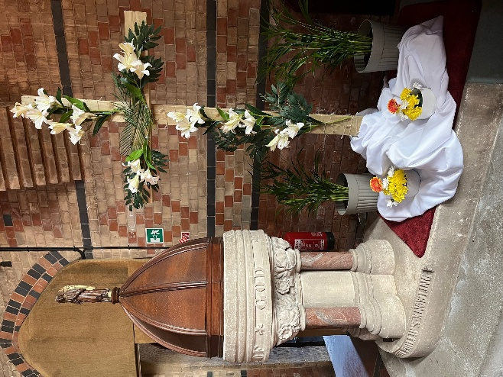
After the bleakness of Lent, it was wonderful to open the church on Sunday morning and see such joyful flowers. The plain wooden cross by the font had been transformed with white lilies and was delightful. The Easter Garden was outside for all to see and enjoy, well done to Melodie Lane and Charlotte Pringle Kosikowsky for all your hard work.

OUR SERVICE ON SUNDAY 12TH APRIL 2026 – 2ND SUNDAY OF EASTER
This will be a Sung Eucharist on Sunday 12th April 2026 starting at 10.30 a.m. The celebrant will be Rev Christopher Rowley. There will be refreshments served after the service. During the service, after the communion hymn, we will be treated to the violin playing of Anthony Knight. He will play Massenet’s “Meditation” from Thais. This is part of Anthony’s “Pilgrimage of Hope” which he will talk at the end of the service. He is raising money for UNICEF, so please remember to bring your purses, wallets and credit cards.

RABSON’S RAMBLE
In St Paul’s Epistle to the Ephesians Chapter 5, verse 19 we are told to speak “to yourselves in psalms and hymns and spiritual songs, singing and making melody to your heart in the Lord.” In his Epistle to the Colossians Chapter 3, verse 16 we are told “Let the word of Christ dwell in you richly in all wisdom; teaching and admonishing one another in psalms and hymns and spiritual songs, singing with grace in your hearts to the Lord.” It is very odd that he uses such similar words to two different communities as well as instructing new Christians to look back to writings in what is now known as the Old Testament. Obviously the Psalms would have been well known to early Christians but it was felt that there were valuable lessons still to be learned from maintaining the tradition of singing the Psalms. Somehow down through the ages, the use of the Psalms became confined to the services of either Morning Prayer or Evensong. With these two services having declined in use in ordinary churches, we now rarely hear the Psalms at all. There are certainly some problems with the language used e.g. “Moab is my washpot, over Edom will I cast out my shoe” Psalm 60, v 8. However other Psalms really hit home even in the 21st century e.g. Psalm 51 which is used on Ash Wednesday. Every Wednesday afternoon (and repeated on the following Sunday) on Radio 3 there is Choral Evensong, with a Cathedral or College choir intoning the Psalms set for the day. It is worth listening to the beautifully measured singing of the choir whilst having the words in front to you. It is also a chance to stop the loss of a tradition that has been going on for centuries and which was considered to be important for Christians.

ROTA FOR SUNDAY 12th APRIL 2026
Sidesmen:- Jacquie Hockaday and Ann Fry
Reader:- Melodie Lane
Coffee:- Ann Fry and Jacquie Hockaday
Flowers:- Philippa Deem
READINGS FOR 2ND SUNDAY OF EASTER
Collect:- Almighty Father, you have given your only Son to die for our sins and to rise again for our justification: grant us so to put away the leaven of malice and wickedness that we may always serve you in pureness of living and truth; through the merits of your Son Jesus Christ our Lord, who is alive and reigns with you, in the unity of the Holy Spirit, one God, now and for ever. Amen

Readings:-
Acts Chapter 2, vv 14a and 22 – 32
Ist Peter Chapter 1, vv 3 – 9
John Chapter 20, vv 19 – end

PRAYER LIST
Elizabeth Miles
Eunice Durrance
Hazel Ware
Ian Sansom
Jo Wilson
John Wilkie
Katie Candy
Mike Toogood
Pam Wilkie
Paul Tatnall
Stephen Daley
Susan Dobson
YEARS MIND FOR APRIL
12TH Thomas Harry Goss
12TH Rev Dudley Francis Goodfield
13TH Margaret Jean Spurway
14TH John Hopkins
19TH Ruby Edith Harris
19TH Patricia (Pat) Luxton
19TH Dilys Violet Thomas
19TH Linda James

BIRTHDAY LIST FOR APRIL
18TH Margaret Westaway
We all wish you a very Happy Birthday and hope the day lives up to the expectations you deserve. Have a great day.

OUTREACH GROUPS
Churchyard Group
We have made a start by weeding the raised beds, filling them with compost and putting in the shrubs. If you are willing to help, the next meeting will be at 10.00 a.m. on Tuesday 14th April 2026 if anyone is free. We now need to get a watering can and some fill-in plants and wonder if anyone has any of the following:-
White aubretia, white mini periwinkle, white iberis, white omphaloides, tête-a- tête daffodil bulbs (if not, we will plant them in the autumn), small green/yellow or green/white hostas and small ferns.

Soup ‘n’ a Bite
This will be on Saturday 11th April 2026 at 12.00 noon. It will be the normal fare of soup, bread, cheese and fruit combined with lots of conversation!

Recycled Teenagers
The next meeting will take place on Tuesday, 28th April 2026 at 2.30 p.m. Come along and enjoy cups of tea plus sandwiches and cakes along with some conversation.

Knit, Sew and Natter
The next meeting will be on Thursday, 7th May 2026 at 2.00 p.m. It will be the usual meeting with lots of chat and refreshments.

Shanty Singing
The next meeting of this group will be at 6.00 p.m. on Sunday 3RD May 2026. You do not have to have been to any previous meeting to join any session of shanty singing.

OUR NEXT SERVICE
This will be a Sung Eucharist starting at 10.30 a.m. on Sunday 19TH April 2026. The celebrant will be Rev David Burton. There will be refreshments served after the service.

FORTHCOMING EVENTS
Fund Raising Committee event
A Coffee morning with the added feature of a book sale will be held inside the church on Saturday 11TH April from 10.00 a.m. to 12.00 noon. We hope you will drop by and have a quick coffee with us. You could then move on to Soup ‘n’ a Bite afterwards!

OTHER INFORMATION
ELECTORAL ROLL
We are now in the statutory period for the Electoral Roll. You must be on the Roll to be able to be at or speak at the Annual Parochial Church Meeting. If you are not on the Roll, you need to complete one of the forms on the table by the church door and give it to Sheila Rabson by 26th April 2026.

Message from Helena Power
Please see the attached poster re the free craft and games day she is organising and pass it on to any local children you know.

FUN CORNER
Item from Lost in Translation re the rules for using a zipwire near the Great Wall, China
“Those who suffer from high blood pressure, mental disease, horrifying of highness and heads are refused.”

