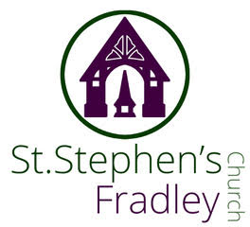
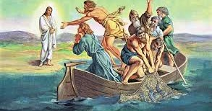

DOUBLE BULLETIN
19th and 26th April 2026
10.30am Family Communion
Welcome to our Worship today. If you are visiting for the first time, please introduce yourself so that we may welcome you personally. Refreshments are served after the service
ST. STEPHEN’S CHURCH IS OPEN 10am-3pm daily for Private Prayer and Reflection
19th April 2026  Collect  Risen Christ,  you filled your disciples with boldness and fresh hope:  strengthen us to proclaim your risen life  and fill us with your peace,  to the glory of God the Father.  Readings  Acts 2. 14a, 36-41 1 Peter 1. 17-23  Luke 24. 13-35  Post Communion  Living God,  your Son made himself known to his disciples  in the breaking of bread:  open the eyes of our faith,  that we may see him in all his redeeming work;  who is alive and reigns, now and for ever. | 26th April 2026  Collect  Risen Christ,  faithful shepherd of your Father’s sheep:  teach us to hear your voice  and to follow your command,  that all your people may be gathered into one flock,  to the glory of God the Father.  Readings  Acts 2. 42-end 1 Peter 2. 19-end  John 10. 1-10  Post Communion  Merciful Father,  you gave your Son Jesus Christ to be the good shepherd,  and in his love for us to lay down his life and rise again:  keep us always under his protection,  and give us grace to follow in his steps;  through Jesus Christ our Lord.
 | Thank you Thank you all for your generous gifts to me as I retire from full time ministry as a non-stipendiary priest. I have been quite overwhelmed! The house is full of flowers and plants and I did not expect such a lovely buffet at the end of the Service. It was truly a special day. I will miss you all, but I haven’t moved and now I have a full set of lovely china mugs to offer hospitality. Please do call for a cup of tea. When I grew up in Middlesbrough, we always offered open house. I hope to have the time now to continue that good Yorkshire tradition!  I will have Permission to Officiate shortly and so I hope to see you- after a bit of a rest! – at the occasional function or service.  Meanwhile, keep offering that wonderful Fradley welcome and hospitality as you live out the Gospel message so warmly and enthusiastically.  With love and prayers Elizabeth  APCM – our annual church meeting. 11.30am immediately after the service on Sunday 26th April  The Trustees Annual Report is available if anyone would like a copy before the APCM, please email-PCC Secretary calendarststephenfradley@gmail.com  Places of Welcome  St Stephen’s hosts a drop in for tea, coffee, cake and chat every Wednesday – 2-4pm. “Wednesday Welcome” ...and all are genuinely welcome. Come along and give it a try!  Plant Sale  2nd May 10am- 12 noon. Plants for sale . Bacon breakfast. Coffee and cake  SAVE THE DATE  Thursday 14th May 7.30pm  Heritage Talk ‘Fradley in 1861’  Free event. Wine and savouries served  Friday 22nd May 5pm  The Licensing of Revd Jonathan Nicholas to  Alrewas, Fradley and Wychnor  by The Rt Revd Dr Michael Ipgrave OBE  Saturday 13th June 11am  Dedication of the Memorial Light Box to all RAF Personnel Bishop Michael will officiate.
  Knitted ‘Britain at War’ comes to Lichfield
  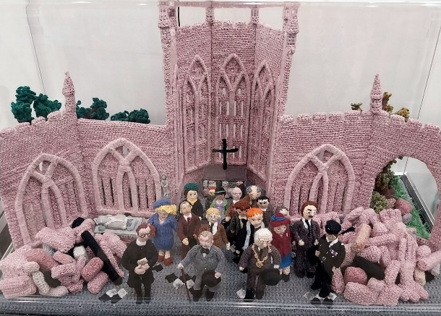
  ‘The Longest Yarn 2’ is a knitted 80-metre diorama created in knitting and crocheted scenes depicting the theme ‘Britain at War’. It is the successor to ‘The Longest Yarn’ created in 2024 to commemorate the 80th anniversary of D-Day.
  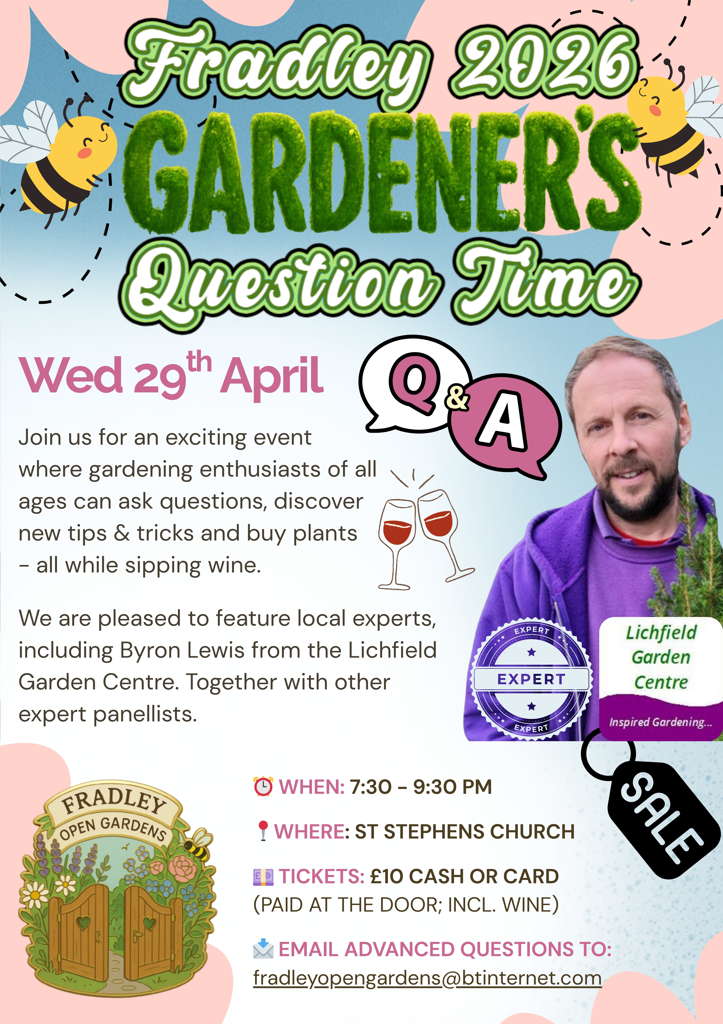
  Lichfield Cathedral: 1-31 May during cathedral opening hours. Entry free, donations welcome. \More Lichfield Cathedral’s website
ANNUAL LEAVE

THIS IS A DOUBLE BULLETIN AS I AM ON ANNUAL LEAVE FROM MONDAY 20TH APRIL UNTIL MONDAY 27TH APRIL INCLUSIVE. PLEASE EMAIL ME IF YOU WANT ITEMS TO GO IN THE NEXT BULLETIN WHICH WILL BE FOR SUNDAY 3RD MAY.
Di Cooper – Parish Administrator



Interested in getting married at St Stephen’s?
Please see our leaflet in Church or contact us –
details below.

Lichfield Cathedral's Dementia Champions Team
is hosting the following events during 2026:
The Dementia Champions Team warmly invite you to a music event in the Cathedral on

1 July | Songs of Praise Service
30 September | Harvest Thanksgiving Service
December | Christmas Service (tbc)

All of the above events will start at 10:45 and last approximately 40 minutes, followed by light refreshments.
We look forward to seeing you there.

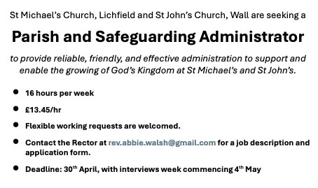

++++++++++++++++++++++++++

Notices for inclusion in the bulletin please email me by Tuesday of each week
Officeststephenfradley@gmail.com Please take bulletin away with you
If you would like to support St Stephen’s Church at this time donations can be made via our Just Giving Page. We are grateful for donations large or small
https://www.justgiving.com/fundraising/ststephensfradley

Contact us

Churchwarden
Marian Derry 01283 791573

St Stephen’s Administrator: Di Cooper
07930162991 officeststephenfradley@gmail.com

Find us on ACNY https://www.achurchnearyou.com/church/4123/
Facebook www.facebook.comststephensfradley

