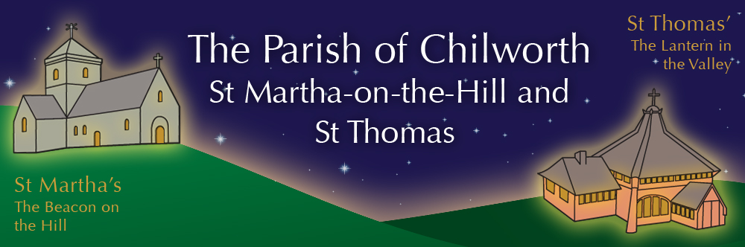

NOTICES: - 12th APRIL 2026
Priest David Oakden – Revdavid@parishofchilworth.org.uk - 01483 534293 (day off Friday)
Do let me know of anybody or anything that you would like to be prayed for.
www.parishofchilworth.org.uk and find us on https://www.achurchnearyou.com

************John 20:29(NRSVA)**********
Jesus said to him, ‘Have you believed because you have seen me? Blessed are those who have not seen and yet have come to believe.’
***********************************

Opportunities to pray together: -
Ecumenical Prayer Breakfast 1st Saturday of the month at the Vicarage, from 9am, prayer, coffee and croissant. Next is the 2nd May – Thursday evening at St Thomas at 6:00 pm for an hour every other week. 16th April 2026 & 7th May 2026.

This Sunday Services: – 2nd of EASTER
9:30 St Peter & St Paul Morning Worship inc Baptism.
11:15 St Martha’s Holy Communion.

Next Sunday Services: - 19th April
9:30 St Thomas Holy Communion.
11:15 St Martha’s Mattins.

Looking further ahead: -
Tots and Toddlers: St T’s Monday 9:15am
Cello Concert: St T’s 18th April 11:15am
ANZAC day: St M’s 25th April 4pm
Horseman’s Service: St M’s 26th April 2pm
Plant Sale: St T’s 16th May
APCM: St T’s 21st May at 7:30pm

Food & Hygiene Bank: -
The Foodbank Larder box is located in the porch of St Thomas Church. Suggested items: - Long life milk /tins tuna/ tins meat/ sachets microwaveable rice /pasta sauces/curry sauces/cereal/spreads/ tea/ coffee/ hot chocolate/ tins soup/ baked beans

Chilworth Tinies and Toddler Group: -
Mondays from 9:15 -10:45 meet in St Thomas, play chat, pray and support.

Prayer Stations in St Thomas: -
Pop in and pray - using the suggestions and materials provided.

18th April @ 11.15 Cello Concert with Coffee & Cake at St Thomas' Church
Come and hear talented young South African cellist, Seth Nel, playing favourite classics for cello including music by Elgar, Bach, Beethoven and Piazzolla accompanied by piano. Coffee and cake will be available both before and after the concert which will last approximately one hour. No need to book, donations welcome, put the date in your diary and join us with friends and family.

Broad Horizons Book Group: -
Our informal book discussion group, resumes in April (April 28th) and will meet monthly on Tuesday evenings (7-8:30pm) throughout the summer. All welcome to any or all of the sessions. Dress warmly, as we meet on the benches outside St Martha’s, to enjoy the view, a hot drink and the setting sun.

APCM: -
The APCM will be held on the 21st May at 7:30 in St Thomas Church. Please put this in your diaries as it is an important annual meeting.

