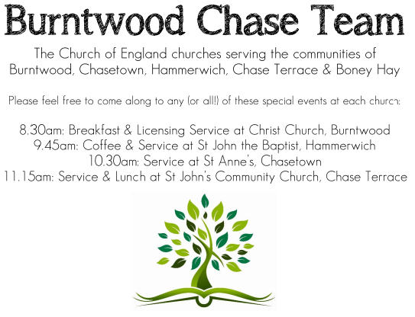
CHRIST CHURCH
Registered Charity Nos. 1217129

SERVICE ON SUNDAY 26th April 2026 at 10am

Morning Worship

4th Sunday of Easter

Readings:
Acts 2: 42-47

⁴² They devoted themselves to the apostles’ teaching and fellowship, to the breaking of bread and the prayers.
⁴³ Awe came upon everyone, because many wonders and signs were being done by the apostles. ⁴⁴ All who believed were together and had all things in common; ⁴⁵ they would sell their possessions and goods and distribute the proceeds to all, as any had need. ⁴⁶ Day by day, as they spent much time together in the temple, they broke bread at home and ate their food with glad and generous hearts, ⁴⁷ praising God and having the goodwill of all the people. And day by day the Lord added to their number those who were being saved.

John 10: 1-10
‘Very truly, I tell you, anyone who does not enter the sheepfold by the gate but climbs in by another way is a thief and a bandit. ² The one who enters by the gate is the shepherd of the sheep. ³ The gatekeeper opens the gate for him, and the sheep hear his voice. He calls his own sheep by name and leads them out. ⁴ When he has brought out all his own, he goes ahead of them, and the sheep follow him because they know his voice. ⁵ They will not follow a stranger, but they will run from him because they do not know the voice of strangers.’ ⁶ Jesus used this figure of speech with them, but they did not understand what he was saying to them.
⁷ So again Jesus said to them, ‘Very truly, I tell you, I am the gate for the sheep. ⁸ All who came before me are thieves and bandits; but the sheep did not listen to them. ⁹ I am the gate. Whoever enters by me will be saved, and will come in and go out and find pasture. ¹⁰ The thief comes only to steal and kill and destroy. I came that they may have life, and have it abundantly.

COLLECT FOR TODAY
Almighty God,
whose Son Jesus Christ is the resurrection and
the life:
raise us, who trust in him,
from the death of sin to the life of righteousness,
that we may seek those things which are above,
in the unity of the Holy Spirit,
one God, now and for ever.

WHAT’S GOING ON
Upcoming Services and Events
Sunday 26th April Morning Worship 10am
Wednesday 29th April Morning Prayer 9.30am
Sunday 3rd May Holy Communion 10am
Monday 4th May Cameo Cafe 10-12noon
Wednesday 6th May Morning Prayer 9.30am
Sunday 10th May Morning Worship 10am

DATES FOR YOUR DIARY
Saturday 16th May Spring Fayre
Saturday 27th June Cream Tea
Saturday 11th July Shelfield Choir Concert
Saturday 14th November Christmas Fayre

APCM Meeting
Please note the APCM meeting will be held in Church on Sunday 17th May after the 10pm Communion Service. Further details nearer the date.
Cameo Cafe
Cameo Cafe will be open on Monday 4th May, 10-12 noon.
Come and join us for a cuppa and biscuits.

FLOODLIGHTING
If you think about commemorating a special occasion by floodlighting our Church. Please contact Chris Brown on 01543 683862 for details.

PRAYER CHAIN
Christ Church is blessed with a very active prayer chain. If you, or anyone you know, feel that they would like others to pray for them, please speak to Chris Brown on 01543 683862.

HOME COMMUNION
For anyone who is unable to attend church and would like a Home Visit and Communion, please contact the Vicar and he will be able to carry this out.

VICAR CONTACT DETAILS
Rev’d Stephen Morgan Tele: 07305 852152
CHURCH WARDENS CONTACT DETAILS
Judith Rogers Tele: 01543 324718
Mike Holmes Tele: 01543 672970
Church Office Tele: 01543 642187 [leave a message and we will respond]
Church Web Site:www.christchurchburntwood.org.uk
Church Email: christchurchburntwood15@gmail.com
Facebook: www.facebook.com/group/christchurchburntwood/

Other Contacts
Rev’d Matt Wallace St. John’s, Chase Terrace— Tele: 01543 670078

NEXT SUNDAY SERVICE
Sunday 3rd May at 10am
Holy Communion
Acts 7: 55-60
John 14: 1-14
Easter 5

