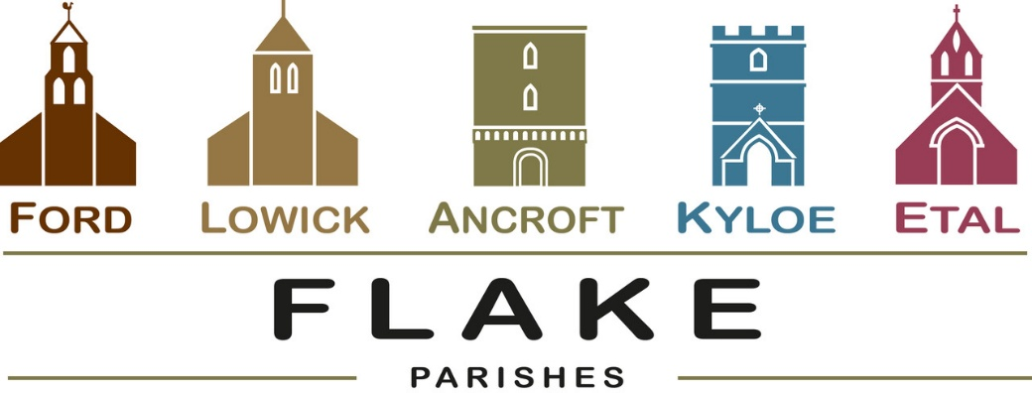
A very warm welcome to you, especially if you are visiting.
Please take this sheet home with you and use it as a basis for prayer.
Children may be at all our services.

Sunday 5th April 2026
Ancroft 5pm Easter Songs of Praise

Sunday 12th April 2026
Lowick 9.15 Holy Communion
Ford 11am Holy Communion

Sunday 19th April 2026
Lowick 9.15 Holy Communion
Ford 11am Holy Communion

Sunday 26th April 2026
Lowick 9.15 Holy Communion
Ford 11am Holy Communion

Revd Charlotte Osborn (Vicar) 01289 388591 ceosborn@mail.com 07957 367457
Revd Alex Firman (Assistant Curate) 07935 732811
alex_firman@hotmail.co.uk
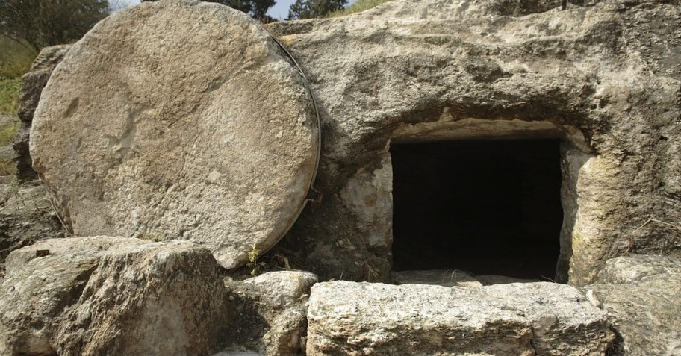

The women went to Jesus' tomb
On that Easter day
They found an angel had been there
To roll the stone away
They found that Jesus was alive
And still He lives today
For God has raised Him from the dead
And rolled the stone away
Don't let your heart be like a tomb
Empty dark and grey
Trust in Jesus He's the Rock
To roll your stone away

Now the 40 days of Lent are behind us, which we walked purposely yet ponderously, now 50 days of Easter stretch out joyfully before us. Last week’s careful journey to the cross culminates with the empty tomb, and we experience the risen Jesus present with us, just as when he appeared to the apostles in the upper room, on the road to Emmaus, and on the lake shore making breakfast. Don’t miss an opportunity to meet Him!

Parish Business
Electoral Rolls are being revised ahead of the Annual Parochial Church Meetings in all our parishes. If you would like to join, enrolment forms are available from Margaret Urwin at Lowick, Nici Gibb at Ford or Charlotte for Ancroft. These our Electoral Roll Officers will explain the benefits of your name being included on the roll.

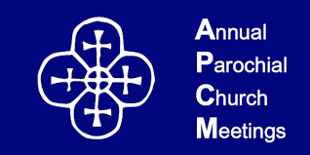
Annual Parochial Church Meetings 2026

Annual Reports are received and elections for Churchwardens and PCC members take place.

Ancroft – Friday 8th May in St Anne’s Church at 1.30pm
Ford – in the Estate Office on Tuesday 19th May 5.30pm
Lowick – Lowick Village Hall on Wednesday 20th May at 7pm


- 11th April 12-1.30 Lowick Soup Saturday – Lowick Village Hall
- Saturday 18th April 9am Churchwardens’ Meeting
- Tuesday 21st April Lowick PCC 7pm
- Wednesday 22nd April Middlemiss Lecture 6 for 6.30pm tbc
- Saturday 2nd May Lowick White Swan Men’s Breakfast
- Tuesday 5th May Licensing of Revd Paul Knox at Wooler
- Saturday 9th May Deanery Lay Training Holy Island 11am-3pm

For our prayers

Over the next few weeks, we shall be reading the banns of marriage for:

Annabel and John, to marry at Ancroft
Katkin and Alex to marry at Ford
Ian and Yvonne to marry at Ford

We joyfully pray for them as they prepare not just for their wedding day, but for their married life together

Please continue to pray for all who suffer in body, mind or spirit, especially Heather Piper, Chloe French, George Hall, Gail Calder, Revd Sam Quilty, David and Revd Judith Dobson. We give thanks for the news of Andrew Watson’s remission.
We remember all who have recently died, including Maragret Chisholm, and those who mourn, as we pray for all who mark anniversaries of death at this time of year: Milburn Jackson, Roy Cossar, James Mole, Heather Pentland, Grace Nesbit.

Parish Contacts

Ancroft Leigh Yorke 07716 116739
Etal Andrew Joicey 01890 820540
Ford Kathleen Holmes 07951 099668
Lowick Niall Cartlidge 07850 876246

Websites: www.achurchnearyou.com
Instagram: https://www.instagram.com/the_flake_churches/
Facebook: the_flake_churches

Other licensed clergy
Revd Margaret Sentamu 077871 204745, Canon Nick Sagovsky,
Revd Marion Penfold 01289 305664

