Palm 16
Please stand, if able, and join in with the verses in bold italics

Protect me, O God,
for in you I take refuge.
I say to the Lord, ‘You are my Lord;
I have no good apart from you.’

As for the holy ones in the land, they are the noble,
in whom is all my delight.

Those who choose another god multiply their sorrows;
their drink-offerings of blood I will not pour out
or take their names upon my lips.

The Lord is my chosen portion and my cup;
you hold my lot.
The boundary lines have fallen for me in pleasant places;
I have a goodly heritage.

I bless the Lord who gives me counsel;
in the night also my heart instructs me.
I keep the Lord always before me;
because he is at my right hand, I shall not be moved.

Therefore my heart is glad, and my soul rejoices;
my body also rests secure.
For you do not give me up to Sheol,
or let your faithful one see the Pit.

You show me the path of life.
In your presence there is fullness of joy;
in your right hand are pleasures for evermore.

Glory be to the Father and to the Son and to the Holy Spirit,
as it was in the beginning, is now and ever shall be,
world without end. Amen



Please can you bring in your jars full of change,
so we can send our donations to Water Aid.

Thank you – together we can make a difference
Last date is Sunday 19th April!

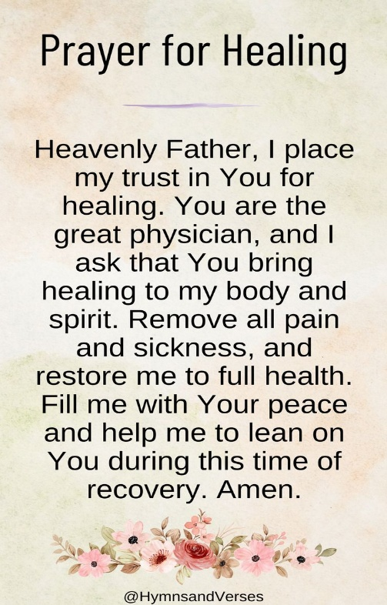

In our weekly prayers for our parish
This week we pray for God’s blessing on Nuthall Circle, Oak Apple Crescent and Oliver Road.
Kirk Hallam Community Hall Association has it’s Annual General Meeting on Monday 13th April at 6pm in the Café. All welcome
Distribution of Communion –currently the Priest will dip the communion wafer in the wine while we discern a safe way to bring the common cup back into worship, as we want everyone to feel included and safe. We also have gluten free wafers available.
Refreshments After the Morning Service
Please stay seated after the service and a hot drink will be brought to you in the pews. Do not get up and head to the back of church, it is becoming a hazard, and a risk as trays of hot drinks could be knocked over.

All Saints Church
Church contact information
Contact: Rev’d Christine - revchristine@outlook.com
The Rectory, The Village, West Hallam, DE7 6GR
Landline 0115 646 1497
Rev’d Ailsa -revailsahunt@gmail.com
Tel - 07356064856

Churchwardens – Mrs Janet Wheeldon, -Tel: 0115 8771593
Mrs Linda Gregory – linda.gregory3@icloud.com
https://www.achurchnearyou.com/church/13402/
https://www.facebook.com/allsaintskirkhallam
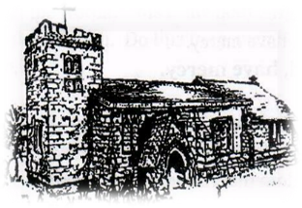
Kirk Hallam
Disabled Toilet in Friendship House.
Disabled Toilet in Friendship House.

Working with God to transform lives & communities.
Please can you ensure your mobile is on silence, or off during the service, it is affecting people with hearing aids and the loop system.
12th April – First Sunday After Easter
10.00am Iona Communion Service with Rev’d Alan
6.00pm Iona Evening Prayer –back in church

Forthcoming Events
Mon 13th 6.00pm AGM at Community Centre
Tues 14th 12noon Funeral for Peter Rayment in church
Tues 14th 6.00pm Home Group in Friendship House
Weds15th 9.30am Morning Prayer at UCAS
Fri 17th 6.00pm Choir in Friendship House
Sat 18th 10am Prayer Meeting in Friendship House

19th April – Second Sunday After Easter
10.00am CW Communion Service with Rev’d Neil
3.00pm Building Faith at Community Hall
6.00pm BCP Holy Communion with Rev’d Christine in church
“And we know that all things work together for good to them that love God, to them who are called according to his purpose’
Romans 8:28

It’s Good to Talk! If you spot that someone is missing, please pop a news sheet through their door, & if you’ve time, call for a chat - just to check they’re OK & to let them know that they are not forgotten!

