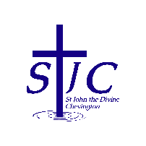
St John the Divine Welcome to our service today
Chevington 10th May 2026
Sixth Sunday of Easter

What’s on  = . = . = . = . = . = . = . = . = . = . = . = . = . = . = . = . = . = . = . Bingo – Wednesday May 13th  If anyone is available to help serve tea and coffee before the bingo session starts would you please speak to Jen Janetta. Jen and Doreen prepare everything but cannot be at the Community Centre to make the drinks; you do not need to wash up, they will take care of that, we just need 1 or 2 people to be there between 6:30pm and 7:00pm.  Rachael has already promised to be there.  = . = . = . = . = . = . = . = . = . = . = . = . = . = . = . = . = . = . =  Church contacts  Priest in charge Revd Rachael Dines  revd.rachael.dines@gmail.com 07763 211901  Churchwarden  Sheila Orgill (also Parish Safeguarding Officer) – 07484 825203  Reader Cynthia Bishop – 07498 182350  Website https://www.achurchnearyou.com/church/16282/  Facebook St John the Divine Chevington  Churchwardens St Cuthbert’s Amble  Richard Colson – 07724 687107  Linda Williams – 07720 716794 |  | This week, please pray for  We pray this week for all those who live in St John’s Estate, Grey Arms Court and Station Road and for the staff and customers of the Togston Club.  From the memorial book  = . = . = . = . = . = . = . = . = . = . = . = . = . = . = . = . = . = . = Ascension Day – May 14th  We are having a joint service with St Cuthbert’s at 7pm Thursday 14th May. If you need transport please speak to Sheila so lifts can be arranged.  If you would like to join the Alnwick Deanery service instead then that is also at 7pm at Brinkburn Priory; Helen O’Sullivan will be presiding.  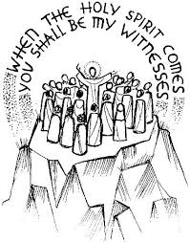  = . = . = . = . = . = . = . = . = . = . = . = . = . = . = . = . = . = . =  Sunday May 31st @ 10am – Joint Service HERE  This will be our next joint service with St Cuthbert’s.  After the service we hope you will all stay for a picnic lunch – bring your own food; we will provide drinks.  *** NOTE : EARLIER TIME FOR THIS SUNDAY ONLY ***
  Sunday May 10th  9:00am Holy Communion  10:30am Holy Communion  4:00pm Café Church | St Cuthbert’s  St John’s  Coquet tea rooms
  Wednesday May 13th  7:00pm Bingo | Community Centre
  Thursday May 14th  7:00pm Holy Communion for Ascension Day | St Cuthbert’s
  Sunday May 17th  9:00am Holy Communion  10:30am Holy Communion | St Cuthbert’s  St John’s
  Ella | Dixon | 2002
  John | Hall | 1945
  Sarah | Lee | 1981
  Betty | Murphy | 2007
  Thomas | Oliver | 1917
  James | Urwin | 1918

