St Thomas’ Church and Community Project
“A Place for You”
May Newsletter

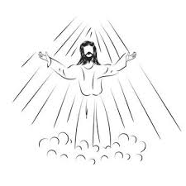

Designed by Burne-Jones and installed in 1885 the Ascension Window overlooks the chancel at the centre of the east end of Birmingham Cathedral. It was intended to be the only such window, but its beauty was so captivating that Burne-Jones subsequently decided to design another two shortly afterwards. Recently cleaned they are a stunning example of his work, and every Brummie should be proud to host them. The Ascension Window depicts Jesus surrounded by his disciples and ascending into heaven. It is one of the many images that can help us imagine the scene.
As Christians we sometimes might feel Ascension Day to be an overlooked feast falling forty days after Easter and ten days before Pentecost. Yet it is an important festival. It not only marks the conclusion of Jesus' earthly ministry but also the beginning of a new phase of God's work through the Holy Spirit. Ascension demonstrates Jesus’ triumph over death to live forever. He did not abandon his followers but took on a new ministry seated at God’s right hand; he now intercedes for us to God. Jesus knows and sees what is happening today. He is still leading and caring for his people, especially in the midst of our suffering and persecution. Jesus knows what it is like to be fully human, he understands our joys and our sorrows, and the pains we endure. Simply, if God had not returned to his father in heaven, he would not have been able to send the Holy Spirit to us. (more of the Holy Spirit next month).
The gospel is still unfolding. The ascension is a reminder that the victory of the gospel is secure, but it hasn’t yet been fully applied. We are living in between the victory over evil (the cross and resurrection) and Christ’s return and final judgment. Remembering Christ’s ascension should give us confidence that God’s work is still unfolding, his story continues. Why not read the first few verses of Acts 1 before bed tonight? Rev Sue Round

Confirmation
It is wonderful that we have a number of people wanting to confirm their faith in the Church of England before the Bishop. But what is Confirmation? Confirmation does not stand alone; it builds on something that must already be in place. That foundation is baptism. Baptism is the entry into the Body of Christ. It is where we are received into the Church, united with Christ and where we become part of the Christian family. Before anything else baptism comes first. Confirmation is the strengthening and affirmation of that baptismal faith.
It is a public declaration of faith, a personal ownership of what has begun in Baptism and a moment where the bishop lays hands on us and prays for the grace of the Holy Spirit.
If you are interested in being baptised or confirmed please contact Rev Sue Round sue.round@st-toms.com
It is not too late to join us. Each session takes the form of a short introductory video and discussion in a safe space. Having begun on Sunday 26th April after morning worship at 11.45am each session will last between just over an hour.

Sessions continue on 10th May 31st May 14th June 28th June 12th July, 13th September.

The Confirmation Service will be held at St Thomas on Sunday 13th September 4pm.

May church services
If you want to discover more, come and join us any Sunday morning or at any of our community activities throughout the week.
Sunday 3rd May 10am service with Holy Communion.
Sunday 10th May 10am morning prayer followed by our second Confirmation Session
Thursday 14th May 1pm – Ascension Day service with Holy Communion and joint service with St Richard’s
Sunday 17th May 10am service with Holy Communion
Sunday 24th May 10am – Pentecost – a celebration with Holy Communion
Sunday 31st May 10am – Trinity Sunday – Holy Communion followed by our third Confirmation Session

Children are always welcome and there is the opportunity for them to leave the main service for their own age-appropriate activities. And don’t worry if you arrive a bit late or need to leave before the end.

If you are on the rota to read during may please assume that you will be reading the gospel. These may be subject to change. The readings are listed here in case you want to practice:

Sunday 3rd May | John 14 vv 1-4
Sunday 10th May | John 14 vv 15-21
Sunday 17th May | John 17 vv 1-11
Sunday 24th May | John 19 vv 19-23
Sunday 31st May | Mathew 28 v 16 to end

Our Annual Parochial Church Meeting will take place during morning worship on Sunday 10th May. All on the electoral roll are eligible to vote. This meeting receives reports from the various activities that have happened during the year, as wells a finance report from the treasurer with the annual accounts.

Christian Outreach

Worship, prayer, teaching and Christian fellowship doesn’t just happen in church on Sunday mornings, the church is active out in the community throughout the week.

- Stay and Play group for babies and toddlers on Monday

- Children’s club with fun and games, crafts, cooking, activities, challenges and bible stories on Mondays from 4.00 till 5.30 and youth club 5.45 till 7.15

- Young Adults discipleship group – Monday evenings from 7.30 till 8.30

- A church service Heartlands Care home happens twice monthly

- Pastoral visits at West Hall Court every other Thursday morning and at Heartlands Care Home on Friday afternoons.

- Godly Play at Oasis Blakenhale Juniors on alternate Tuesdays – Christian teaching with classes from years 3 and 4

- The Open the Book team make monthly visits to the school assembly at Oasis Blakenhale Infants School.

- Activities for those over 50 on Thursday and Friday

Foodbank Update
The foodbank is open on Wednesday mornings from 10.00 till 11.00 p.m. and we have a wonderful team of volunteers from the church and community. We are very busy serving on average 25 people a week with food to feed around 60 people. With high demand all donations are very welcome; if you can provide occasional tins of beans, spaghetti, soup, vegetables etc please leave them in the collection tray at the back of the church or in the hall entrance. We now also provide fresh fruit and vegetables and there are usually some left after our Foodbank session so please help yourselves rather than letting them go waste. A small donation is welcome.
If you have any spare shopping bags, we will be very grateful for them and we are happy to re-use plastic carrier bags you may have. Please leave them in the donation boxes.
Thank you to everyone.

Prayer activity


Thy Kingdom Come (TKC) is a global ecumenical prayer movement that invites Christians around the world to pray from Ascension to Pentecost for more people to come to know Jesus.

Since it began in May 2016, God has grown TKC from a dream of possibility into a movement which unites more than a million Christians in prayer, in nearly 90% of countries worldwide, across 85 different denominations and traditions- so that friends and family, neighbours and colleagues might come to faith in Jesus Christ.

Every person, household and church are encouraged to pray during the 11 days in their own way.

It is the hope & prayer of this worldwide initiative, that those who have not yet heard the Good News of Jesus Christ and His love for the world, will hear it for themselves and respond and follow Him.

Specifically, each and every Christian across the globe is invited to pray that God’s Spirit might work in the lives of 5 people who have not responded with their ‘Yes’ to God’s call.

This year’s Thy Kingdom Come is all about the presence of God through His spirit.

The God who is with us in the everyday – in the joys and sorrows of life (and everything in between) and the One who, through His spirit, longs to reveal Himself to those who do not yet know Him.

Some resources have been ordered and will be made available in church to those who want them, as soon as they arrive. If anyone feels called to make more of this, speak to Rev Sue in the first instance.

Bedding Plant Sale

Manor House Lane Allotments
Every Saturday and Sunday throughout May (whilst stocks last)
Open from 10.30 till 3.00 p.m. Tea and coffee available
A tray of 6 plants - £3.00 Single assorted plants - £1.00

Everyone welcome

Thursday Club outing to Notcutts Garden Centre
As the church hall is being used as a Polling Station for local elections 7th May (don’t forget to vote) a trip has been planned to Notcutts Garden Centre in Solihull. We will leave St Thomas at 11am and return at 3pm.
If you need transport please contact Brian Round 0778 425 5044
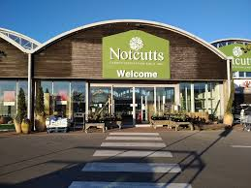

Community Experience Day at Digbeth in the Field
Monday May 4th 12.00 till 4.00
They are creating history boards celebrating the story of Digbeth-in-the Field from its beginnings 1900s to today. It will be an opportunity to learn more about the groups who meet there, and their worship life.
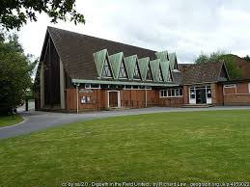

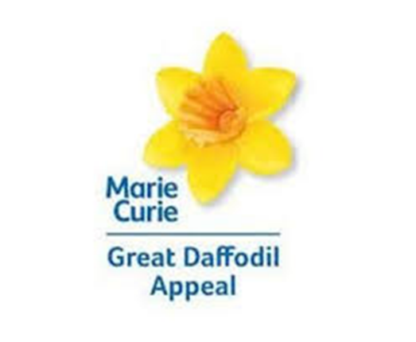

Our afternoon of tea and cakes raised £265 for the Marie Curie appeal. Thank you to everyone who baked, bought and ate and congratulations to the raffle winners!

Eco Church
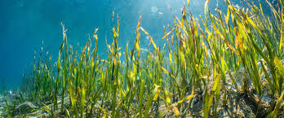
I’ve recently learnt that seagrass beds, when they are healthy, are capable of capturing carbon 35 times more quickly, from the atmosphere than tropical rainforests!
Seagrasses are the only flowering plants able to live in seawater and pollinate while submerged, giving the appearance of an underwater meadow. Apart from their role in capturing carbon, these beds are vital coastal ecosystems found worldwide except in Antarctica, covering up to 600,000 km².
Seagrass beds provide coastal protection; by reducing water velocity they help prevent coastal erosion and allow nutrients to settle. They are also biodiversity hotspots that provide vital food and habitat for fish, invertebrates, seabirds and marine mammals. They are home to seahorses, cuttlefish, cod, plaice, bass and herrings, crab and shrimp. Waterfowl such as wigeon and Brent geese graze on seagrass in the winter and it provides hunting grounds for seals and otters.
These beds, once common around our shores in sheltered areas such as harbours, estuaries, lagoons and bays. are declining rapidly, with an estimated 92% lost around the UK since the late 19th century. A wasting disease was the cause of a drastic reduction of seagrass in the UK in the 1930s and recovery has been hampered by pollution and physical disturbance from dredging, use of mobile fishing gear and coastal development. Sewage discharge high in nutrients is extremely toxic to seagrass and also acts to stimulate algae growth which can outcompete seagrass by reducing the available sunlight.
However, despite vast losses of this precious habitat around the UK and globally, there is cause for hope. When seagrasses are given the opportunity to thrive, they can be surprisingly resilient. Not only can seagrass meadows recover from disturbance, but they can spread and re-colonise areas of our coast in which they haven’t been recorded in decades. Research into how to protect and recover seagrass habitats has begun to yield positive results, showing that, whilst habitat management in the sea is not easy, it is possible!
As a nation we need to encourage the introduction of more marine protected areas and highly protected marine areas. You can find out more about the vital work being done to protect marine areas from the wildlifetrusts.org and mcsuk.org (Marine Conservation Society) websites.

Thank you
Linda Nugent (Deanery and Parish Environmental Champion)

Prayer Requests and Prayer Pointers

Prayer means putting ourselves into a communicating relationship with the divine God. Prayer is often used to build a relationship with God, offering thanksgiving, asking for help, and seeking forgiveness. It is described as a means to express gratitude and find comfort and strength. It is a gift for our own sense of identity as children of God, and for our own sense of purpose. It is often helpful to end or begin our prayer time with the prayer Jesus taught us:
Our Father in heaven,
hallowed be your name,
your kingdom come,
your will be done,
on earth as in heaven.
Give us today our daily bread.
Forgive us our sins
as we forgive those who sin against us.
Lead us not into temptation
but deliver us from evil.
For the kingdom, the power, and the glory are yours
now and for ever.
Amen.
In your prayers this month please consider including these pointers:
- Pray for all those who are currently unwell, receiving treatment, recovering from illness or surgery and those in residential care. Please include Ray receiving treatment for an eye condition, for Margaret recovering from hip surgery and Ann Barnes in Heartland’s Care Home, Joyce Greaves, Lijino from Church of South India recovering from emergency open heart surgery, for Tom one of the Oasis holiday club play workers who collapsed playing football.
- For Amber, a young teenager facing surgery and gruelling treatment for cancer.
- For those who work in nursing and caring roles in hospitals, residential homes and at home. For social workers and those who work in prisons.
- For those who are recently bereaved, continuing to remember the Twelftree family.
- For those with families affected by the troubles in the Middle East.
- For world leaders striving to negotiate peace.
- For our congregation to continue to grow in faith and numbers.
- For our work in local care homes and at Oasis Blakenhale School.
- For our Annual Parochial Church Meeting
- For those preparing to be confirmed in September, especially those from our own fellowship.
- For yourself, and your own family and friends.

Please also pray for the family of Clinton John McKenzie. He and his wife Brenda were active church members when Rev Nigel Hardcastle was our vicar (1970s/80s) His funeral is at Yardley Crematorium at 2.30 on Friday 15th May. Brenda McKenzie predeceased Clinton.

Malawi Praise and Prayer evening
13 May, 7.00pm at Birmingham Cathedral
"Bishop Esther invites us to join The Malawi Praise and Prayer evening. She has recently visited our link Diocese in Malawi for the very first time. This trip carries a particular personal resonance for her as she returns to the country of her birth in her role as Bishop of Aston.
Bishop Esther was accompanied by our very own Rev Paul Bracher, who is also the Diocesan Malawi Officer, this will be an opportunity to listen, learn, and deepen relationships with the church in Malawi and explore how our partnership might grow in the years ahead.
Bishop Esther said,
"..There will be an opportunity to hear a fuller report and to learn more about possible future trips at The Malawi Praise and Prayer Evening."

Website update
Our website is being updated to reflect everything that happens in church on Sundays, including other acts of worship and study groups, as well as what happens during the week, all in the name of St Thomas. Please have a look if you are able. If you have any comments, observations of additional thoughts, please contact Rev Sue. In future all our newsletters will also be available on the website so don’t worry if you lose it. If you would like your own copy emailed to you, again, please contact Rev Sue.

Our web address is www.st-toms.com

Remember we have two bank holidays in May
The Early May Bank Holiday in 2026 is on Monday, May 4, and is a standard statutory holiday in the UK. Established in 1978, it merges ancient spring celebrations with modern International Workers' Day/Labour Day traditions, providing a long weekend to improve work-life balance.
The Spring Bank Holiday in 2026 is on Monday, 25 May. It is an annual, fixed-date holiday observed across the UK on the last Monday of May, designed to provide a long weekend during spring. Originally, it was held the day after Pentecost (Whit Monday) before being fixed in 1971 to allow for more consistent planning

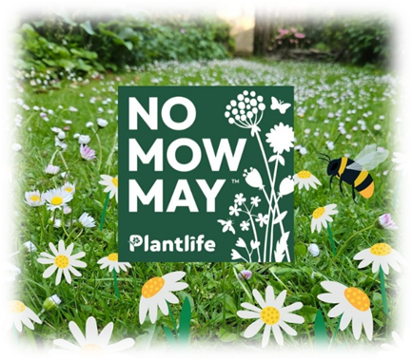

Items and articles for this newsletter are always welcome.

For the June Newsletter please send your articles and items of interest to
Revd Sue Round
Sue.Round@st-toms.com

For a quiet moment


Eeyore sat quietly as the stars began to twinkle, holding close the things that gave him comfort when the world felt a bit too vast. There were days when he felt like his own stitches were coming loose, like he was barely holding on by a single, frayed thread. But in the stillness, he realized that it didn’t matter how thin that thread was, as long as it was anchored to something much stronger than himself. He leaned back and closed his eyes, feeling a sense of peace wash over him, knowing that even when he felt most fragile, he was being held by a love that would never let him fall. It’s a wonderful thing, he thought, to realize that being okay doesn't mean having all the answers—it just means knowing who is holding the thread.

