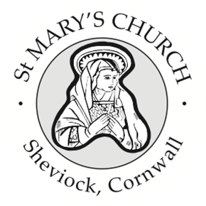

St Mary’s Church, Sheviock
Notices for Sunday 19 April 2026

- Our Annual Parish Meeting and Annual Parochial Church council Meeting will be on Sunday 3 May after the service. So – there is plenty of time to put forward nominations for Churchwardens – we need 2 - and Parochial Church Council members. This year we have 4 vacancies on the PCC – 3 are renewals and one is to fill a vacancy from last year. If you would like to know more about what this involves, please have a chat with any member of the PCC. Please ensure that all nominations are with me BEFORE the meeting.
- There are 3 hardcopy packs for the meetings available on the lectern – please can I ask that you do not remove them from the church. The Agendas and Annual Reports are also on our web pages on A Church Near You.
- On a more practical note, our next Church Care morning will be on Saturday 2 May, between 9am and 12 and we always welcome help with that.
- Our Book Club will be meeting again on Wednesday 20 May at 3pm in the Dawney Aisle when we will be discussing the Cof E booklet “God with Us” produced for the period of prayer, Thy Kingdom Come, between 14th – 24th May. Please do take a booklet or access via the Everyday Faith App on your phone. As always, the invitation is to come and join in the discussion or just come and enjoy a cup of tea while listening to others.
- There will be a short meeting of the current PCC after this service in the Dawney Aisle.

Weekly Services
A full list of weekly services and events for Rame & Rivers churches is published in the weekly Benefice Newsletter and Sunday services for St Mary’s and the Benefice are on our noticeboards.

Next Sunday 26 April at 10 am
Joint Benefice Holy Communion at Downderry

Next Service at St Mary’s
Sunday 3 May Holy Communion at 10 am

