GRATWICH NEWSLETTER  APRIL 2026  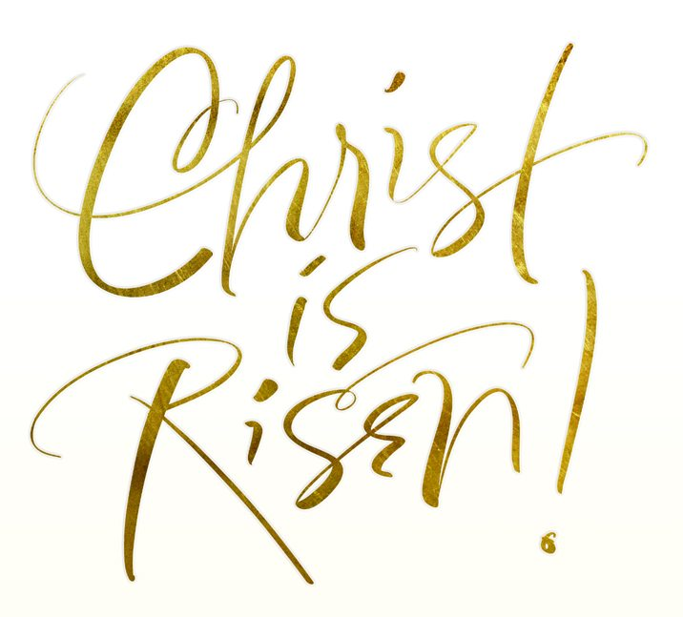  For further information please email: jenny477@btinternet.com  Facebook: St. Mary’s Church Gratwich  Village Questionnaire  As promised last month attached are the results of our village questionnaire.  Many thanks to all who filled theirs in and those who agreed to support  St. Mary’s either by giving their time or financially.  The PCC do appreciate the support offered by everyone as the costs of keeping the building and churchyard tidy and in good repair are substantial in both time and financially so any offers of help are most welcome.  St. Mary’s belongs to everyone in Gratwich (and beyond) – whether they come to church services, social events, pop in to sit in the quiet for a while (it is always unlocked during the day) or just admire it as they go past.  Some people also suggested that it would be helpful to have more information on the running of St. Mary’s. Whilst we are not able to circulate the minutes  of the PCC Meetings as a whole a summery from each meeting will be circulated with the newsletter so people can get an idea of things that have to be done, etc.  The PCC will also try to arrange some of the events suggested (with your help) and look into the possibility of different, more family themed services (to be discussed with Rev. Joe Cant & Rev Jules Walker)  St. Michael’s Church in Stramshall  Are having a Silent Auction on 10th April, 7.00pm in Stramshall Village Hall.  This is a brilliant evening - a chance to win one of many prizes.  You buy raffle tickets, put them in the pot in front of prizes you would like to win, hope for the best and if no-one else wants the ones that you do (or your ticket comes out anyway) - they are yours!  Tickets are £5.00 (£6 on the door) including 5 raffle tickets & tea/coffee & cake, children are free. Phone Pauline for tickets 07929300543  Quiz Evening – Kingstone Village Hall - 24th April - 7.00pm prompt  Kingstone Village Hall Committee are holding a quiz on the 24th April.  Tickets are £5 per person, teams of up to 6 people.  Cash prize & Raffle. Bring your own drink & snacks.  Phone Ann Mottram for tickets 07902 871167  St. Mary’s Church Gratwich Annual Parochial Church Meeting  Monday 18th May 7.30pm in St. Mary’s church, Gratwich | GRATWICH SERVICES IN APRIL/MAY  EASTER SUNDAY 5th April 7.00pm HOLY COMMUNION  SUNDAY 12th April 11.15am MORNING PRAYER  SUNDAY 26th April 7.00pm ROGATION SERVICE  (with refreshments afterwards)  SUNDAY May 10th 11.15am HOLY COMMUNION  THURSDAY May 14th 7.00pm ASCENSION DAY SERVICE  SUNDAY 24th 7.00pm EVENING PRAYER  We had a lovely Lent lunch last month – the church was full and the soup and  apple crumble were delicious. Many thanks to Carolyn and Rosemary for the  catering and everyone who came along.  Easter on the horizon this month and we have three services in St. Mary’s in April!  Please bring a posy of flowers to our EASTER SUNDAY SERVICE to decorate the cross with.  Gratwich Barn Dance - Saturday 18th April 7.00pm in Kingstone Village Hall  Come along and have a dance – music by The Weasel’s Revenge who will be bringing a caller with them to tell you the dance steps (nothing too difficult)  There will also be a raffle and lasagne for supper. Numbers by 8th April please  Tickets: £15 adult/£8 under 10 years (inc supper) from Jenny (01889 502471)  100 CLUB - March  1st Paul Linton (77) 2nd David & Colleen Woolley (36) 3rd Rev. John Lander (88)  April will be drawn after the Evening Service on the 26th April.  CHURCH CLEANING ROTA - Jenny Talbot & Carol Woolley  Dear Friends,  Hope for the future  The natural world is waking up from its winter sleep with renewed signs of life and vigour all around, promising hope for a good harvest and for the future, a sort of crossroad time for nature. This month sees the Easter celebrations quite early on in the month. It is a time of celebrating new life and hope as we recall and give thanks for the resurrection of our Lord Jesus Christ.  During Lent some of us have been using the Wild Bright Hope Lent Book, which focuses on a more hopeful perspective to our Christian life. One of the contributors writes about the feeling that the Church of England is at a crossroad and of the choices that need to be made to take the right direction of travel for the future, likening it to the image of the cross of Christ and of his passion and death.  Crossroads make us choose. They are places of discernment and decision-making in seeking the right way forward in getting where we want to be, or more appropriately where God wants us to be. In our life we often come to crossroads and have to choose which way to go. Sometimes this can be a painful and difficult experience and there can be feelings of hopelessness and loss. Alternatively, crossroads can lead us to positive change and transformative experiences, bringing bright hope for the future.  I’m sure that I’m not alone in thinking that the Uttoxeter Area of Parishes are at a crossroad at the moment with the need, through prayer and thoughtful conversation, to discern the way forward, in finding a bright hope for the future.  One theologian described hope as an active force that drives us towards the future not yet realised but promised by God and that to be a Christian means being a prisoner to hope (Jugen Moltmann). Zechariah says: ‘Return to your stronghold, O prisoners of hope’, suggesting there is security in God’s very presence and the promise of bright hope for the future, blessing us more than what we’ve known and experienced before. St. Paul writes in his letter to the Romans that ‘hope does not disappoint us, because God’s love has been poured into our hearts.’  I pray that you may find hope and love through God this Easter time as we journey with the risen Christ, not only in our personal lives but in the Uttoxeter Area of Parishes too.  Blessings  Charles (PTO – Uttoxeter Area)

