MASS & SERVICE TIMES THIS WEEK

SUNDAY 5TH APRIL 2026
EASTER DAY

PARISH MASS
10 AM

TUESDAY 7TH APRIL Mass 11 am

SUNDAY 12TH APRIL 2026
SECOND SUNDAY OF EASTER

Parish Mass: 10 am

Parish Priest
Father Emmanuel Nazir SSC
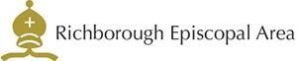



Tel: 07949 817487

Email: marshfarmholycross@gmail

