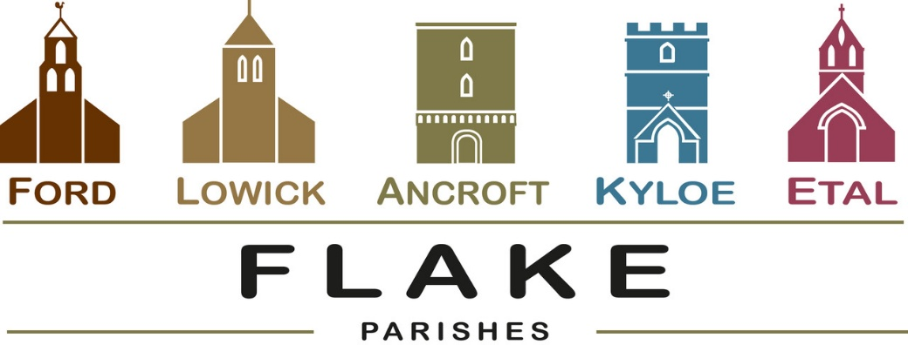
A very warm welcome to you, especially if you are visiting.
Please take this sheet home with you and use it as a basis for prayer.
Children may be at all our services.

Sunday 19th April 2026
Lowick 9.15 Holy Communion
Ford 11am Holy Communion

Sunday 26th April 2026
Lowick 9.15 Holy Communion
Ford 11am Holy Communion

Sunday May 3rd 2026
Lowick 9.15 Holy Communion
Ford 11am Holy Communion

Sunday May 10th 2026
Lowick 9.15 Holy Communion
Ford 11am Holy Communion

Revd Charlotte Osborn (Vicar) 01289 388591 ceosborn@mail.com 07957 367457
Revd Alex Firman (Assistant Curate) 07935 732811
alex_firman@hotmail.co.uk
‘Be present, be present Lord Jesus Christ and make yourself known in the breaking of bread’
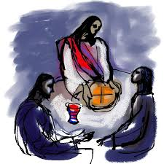
We pray this every Sunday before we share in the Eucharistic meal together, but why not resolve to pray this prayer before every meal this week – and notice how our meals, and our lives are transformed as we recognise Jesus as present in our daily lives.

Parish Business

Electoral Rolls are being revised ahead of the Annual Parochial Church Meetings in all our parishes. If you would like to join, enrolment forms are available from Margaret Urwin at Lowick, Nici Gibb at Ford or Charlotte for Ancroft. These our Electoral Roll Officers will explain the benefits of your name being included on the roll

Annual Parochial Church Meetings 2026

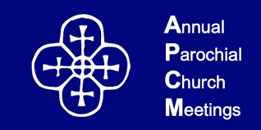
Annual Reports are received and elections for Churchwardens and PCC members take place.

Ancroft – Friday 8th May in St Anne’s Church at 1.30pm
Ford – in the Estate Office on Tuesday 19th May 5.30pm
Lowick – Lowick Village Hall on Wednesday 20th May at 7pm


- Tuesday 21st April Lowick PCC 7pm
- Wednesday 22nd April Middlemiss Lecture 6 for 6.30pm Tweedmouth
- Saturday 2nd May Lowick White Swan Men’s Breakfast 08.30
- Tuesday 5th May Licensing of Revd Paul Knox at Wooler 7.30pm
- Shepherds Law Hermitage Open Day 9th May see poster

The Middlemiss Lecture

will be given this year by Dr Helen Paterson, Chief Executive of Northumberland County Council, who will make the connection between her Christian faith and her work in local government as an agency for tackling inequality and poverty in our communities.

Christian Aid Week is May 10th – 16th
As benefices we support the work of Christian Aid with these 2 events:
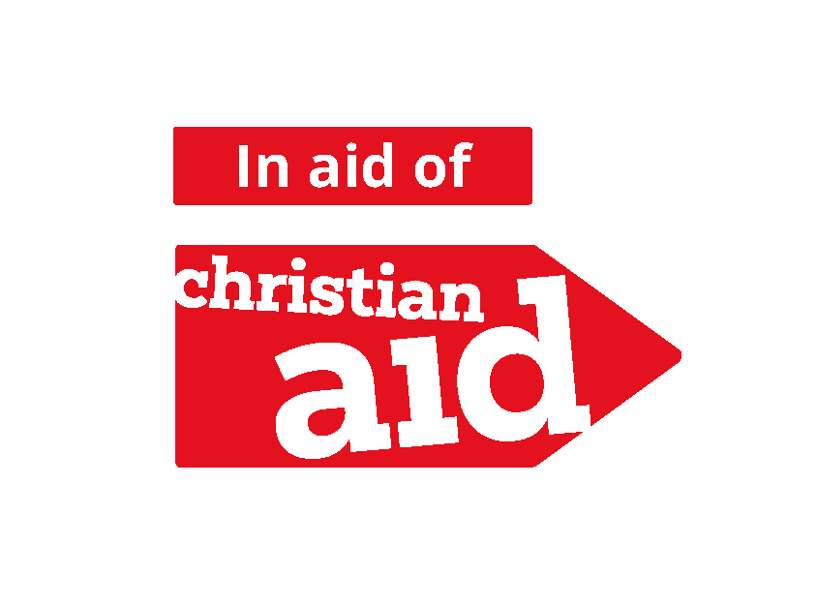
- Concert in Berwick Baptist Church on Wednesday
13th May at 7pm given by the Golden Square Singers, donations to Christian Aid.
- Quiz and Supper in Bowsden Village Hall on Saturday
16th May at 7pm. £10 per person. Come as a team of 4 or join with others on the night. Bar and Raffle.
Book with Diane, rumplecottage@yahoo.com

For our prayers

Over the next few weeks, we shall be reading the banns of marriage for

Annabel and John, to marry at Ancroft
Katkin and Alex, to marry at Ford
Ian and Yvonne, to marry at Ford

We joyfully pray for them as they prepare not just for their wedding day, but for their married life together

Please continue to pray for all who suffer in body, mind or spirit, especially Heather Piper, Chloe French, George Hall, Gail Calder, Revd Sam Quilty, David and Revd Judith Dobson, Alison Murray, Rachel Inglis.

We remember all who have recently died, including Colin Turnbull whose funeral will be at 1.30pm at Ford on 22nd April. We pray for those who mourn, and for all who mark anniversaries of death at this time of year.

Parish Contacts

Ancroft Leigh Yorke 07716 116739
Etal Andrew Joicey 01890 820540
Ford Kathleen Holmes 07951 099668
Lowick Niall Cartlidge 07850 876246

Websites: www.achurchnearyou.com
Instagram: https://www.instagram.com/the_flake_churches/
Facebook: the_flake_churches

Other licensed clergy
Revd Margaret Sentamu 077871 204745, Canon Nick Sagovsky,
Revd Marion Penfold 01289 305664

