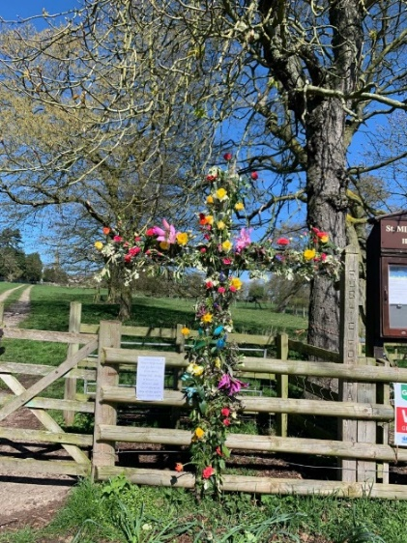
ST MICHAEL AND ALL ANGELS,
HAMSTALL RIDWARE

In the United Benefice of King’s Bromley, the Ridwares
and Yoxall

April 12th 2026
Easter 2
PARISH NOTICES

UNITED BENEFICE SERVICE ROTA
 | Hamstall Ridware  St Michael and All Angels | Yoxall  St Peter | King’s Bromley  All Saints | Mavesyn Ridware  St Nicholas
April 12th  Easter 2 | 5.00 pm  Holy Communion | 10.30 am  Parish Communion | 10.30 am  Holy Communion
April 19th  Easter 3 | 10.30 am  Service of the Word* | 5.00 pm  Holy Communion | 9.00 am  Holy Communion | 10.30 am  Parish Communion
April 26th  Easter 4 | 10.30 am  United Benefice Service of Holy Communion at St. Peter’s, Yoxall
May 3rd  Easter 5 |  | 10.30 am  Holy Communion | 5.00 pm  Holy Communion | 10.30 am  Morning Prayer
May 10th  Rogation Sunday | 5.00 pm  Holy Communion | 10.30 am  Holy Communion | 10.30 am  Holy Communion

Please note that services of Holy Communion at 9 am follow the Book of Common Prayer and are said. Services at 10.30 will include hymns and other singing.
There are services of Holy Communion at 10.00 every Wednesday at St Peter’s, Yoxall and on the first Thursday of each month at All Saints, King’s Bromley.
*******************
Rugeley Food Bank. Please do remember those who depend on Food Banks. They are needed now just as ever. If you wish to donate directly to Rugeley Foodbank at Rugeley Community Centre the Centre is open everyday to receive contributions. Alternatively, the Rugeley Food Bank welcomes financial contributions – see https://rugeley.foodbank.org.uk. Gifts can also be brought to St Michael’s and left in the box at the back of church near the font. If that is not convenient please contact Liz Carter on 07751 068181.
****************
Contact details: If you wish to contact the Rector, Jeremy Brading you can do so on revd@kbhmy.co.uk and Glenis Turner, the PCC Secretary and Benefice Administrator is on admin@kbhmy.co.uk. The churchwardens are Michael Elsom michael.elsom@btopenworld.com and John Ferguson clan.member1954@gmail.com Information about events at church can be found at our webpages at https://www.achurchnearyou.com/church/4451/ and https://kbhmy.co.uk/hamstall/
St Michael’s will continue to be open everyday (weather permitting) between 10.00 am until 6.00 pm. We will revert to shutting the church at 4.00 pm on October 25th 2026
Safeguarding of children and vulnerable adults. If you have any concerns please speak in complete confidence to the Parish Safeguarding Officer, Dr Paul Carter on 01889 504347 or the Diocesan Safeguarding Officer, Neil Spiring on 01543 306030.
PLEASE REMEMBER IN YOUR PRAYERS:
Those who are sick: Mary Mycock, Angela Perkin, Doug, David and Barbara Rudge, May Windley, Pam Payne, Frank and Margaret Finch, Chris Poole, Les Wood, Pat Lomax, Alison Scott and any known personally to you.
*The family and friends of Brenda Perkin who has died in her 90th year. Brenda was a regular worshipper and helper at St Michael’s for many, many years until she became housebound. She will be remembered at a special service on Sunday April 19th after which her ashes will be interred in the churchyard she loved.
Using the Archbishops’ prayer for Ukraine at this time let us remember the people of that war-torn land:
God of peace and justice, we pray for the people of Ukraine today. We pray for peace and the laying down of weapons. We pray for all those who fear for tomorrow, that your Spirit of comfort would draw near to them. We pray for those with power over war or peace, for wisdom, discernment and compassion to guide their decisions. Above all, we pray for all your precious children, at risk and in fear, that you would hold and protect them. We pray in the name of Jesus, the Prince of Peace. Amen
As the situation in the Middle East continues to see military action remember all those in all the countries affected by it – whether nationals or visitors, whether in those countries or elsewhere and concerned for loved ones. Pray for wisdom on the part of the leaders of the nations involved and that hostilities and suffering may come to an end soon.
As the time approaches for the Annual Meetings on May 17th please remember all those who have particular responsibility for any aspect of the life of St Michael’s and pray that people may be encouraged to come forward and stand for election to office.
From the Diocesan Prayer Diary:
Wednesday 15th:
Lord, we pray for today's Bishop's Staff Meeting. We pray for the people that will be making decisions. We pray for the people working behind the scenes to try to inform and implement those decisions. We pray that the decisions made will be the ones that you want made. We pray that you may guide and excite our diocesan leaders with the possibilities of working to follow you, and help more than five hundred churches do just the same.
Thursday 16th: (Isabella Gilmore, Deaconess, 1923)
Today we join with the Diocesan Evangelical Fellowship in 'Praying for the 34,000', as we start to analyse the 2025 Stats for Mission we thank you for all the encouragements within them of the evidence of you being at work across the diocese. We pray that this will include evidence of an increasing number of people choosing to follow you as best they can across churches of whatever form across this place and beyond. We also pray for this evening's online gathering with the Shropshire and Staffordshire Historic Churches Trusts, looking forward to the possibilities of this year's 'Ride and Stride' celebration in September. Lord, we thank you for the privilege of being able to enjoy so many beautiful and historic places of worship, and pray that you may guide us to make the very most of them in both present and future.
EASTER FLOWERS
Many thanks to everyone for their sterling work in decorating the church and to say that your creative hard work is greatly appreciated and much admired. St Michael’s still looks beautiful and – as Rev’d Deborah commented on Easter Day – the bouquet still hits you as much as the beauty greets your eyes. Thank you all very much indeed.
PCC MEETING
The next PCC meeting is this coming Thursday April 17th. If there are any matters you would like to ask the PCC to conside please contact Glenis Turner at admin@kbhmy.co.uk or the Rector at revd@kbhmy.co.uk
ADULT CONFIRMATION CLASSES!
Following on from the Lent Course, Rev’d Jeremy will be holding an Adult Confirmation Course on Wednesdays at 7 pm. These will start in May and anyone who is thinking of getting confirmed is welcome to contact him.
St Michael’s encourages donations by means of this QR code and it will appear (all being well) on all our publications as an invitation to contribute to the important work of the church both
as a place of worship and a community asset where all can share in the wonderful place we have
inherited and wish to pass on to those who come after us.

