Readings & News: 26th April 2026: Easter 4
St Mary’s Todmorden, St Michael’s Cornholme and St Peter’s Walsden

1 Peter 2: 19-end ¹⁹ For it is to your credit if, being aware of God, you endure pain while suffering unjustly. ²⁰ If you endure when you are beaten for doing wrong, where is the credit in that? But if you endure when you do right and suffer for it, you have God’s approval. ²¹ For to this you have been called, because Christ also suffered for you, leaving you an example, so that you should follow in his steps. ²² ‘He committed no sin,
and no deceit was found in his mouth.’ ²³ When he was abused, he did not return abuse; when he suffered, he did not threaten; but he entrusted himself to the one who judges justly. ²⁴ He himself bore our sins in his body on the cross, so that, free from sins, we might live for righteousness; by his wounds you have been healed. ²⁵ For you were going astray like sheep, but now you have returned to the shepherd and guardian of your souls.

Acts 2: 42-end ⁴² They devoted themselves to the apostles’ teaching and fellowship, to the breaking of bread and the prayers. ⁴³ Awe came upon everyone, because many wonders and signs were being done by the apostles. ⁴⁴ All who believed were together and had all things in common; ⁴⁵ they would sell their possessions and goods and distribute the proceeds to all, as any had need. ⁴⁶ Day by day, as they spent much time together in the temple, they broke bread at home and ate their food with glad and generous hearts, ⁴⁷ praising God and having the goodwill of all the people. And day by day the Lord added to their number those who were being saved.

John 10: 1-10 10 ‘Very truly, I tell you, anyone who does not enter the sheepfold by the gate but climbs in by another way is a thief and a bandit. ² The one who enters by the gate is the shepherd of the sheep. ³ The gatekeeper opens the gate for him, and the sheep hear his voice. He calls his own sheep by name and leads them out. ⁴ When he has brought out all his own, he goes ahead of them, and the sheep follow him because they know his voice. ⁵ They will not follow a stranger, but they will run from him because they do not know the voice of strangers.’ ⁶ Jesus used this figure of speech with them, but they did not understand what he was saying to them. ⁷ So again Jesus said to them, ‘Very truly, I tell you, I am the gate for the sheep. ⁸ All who came before me are thieves and bandits; but the sheep did not listen to them. ⁹ I am the gate. Whoever enters by me will be saved and will come in and go out and find pasture. ¹⁰ The thief comes only to steal and kill and destroy. I came that they may have life and have it abundantly.

Hymns: 26th April: from Hymns O&N
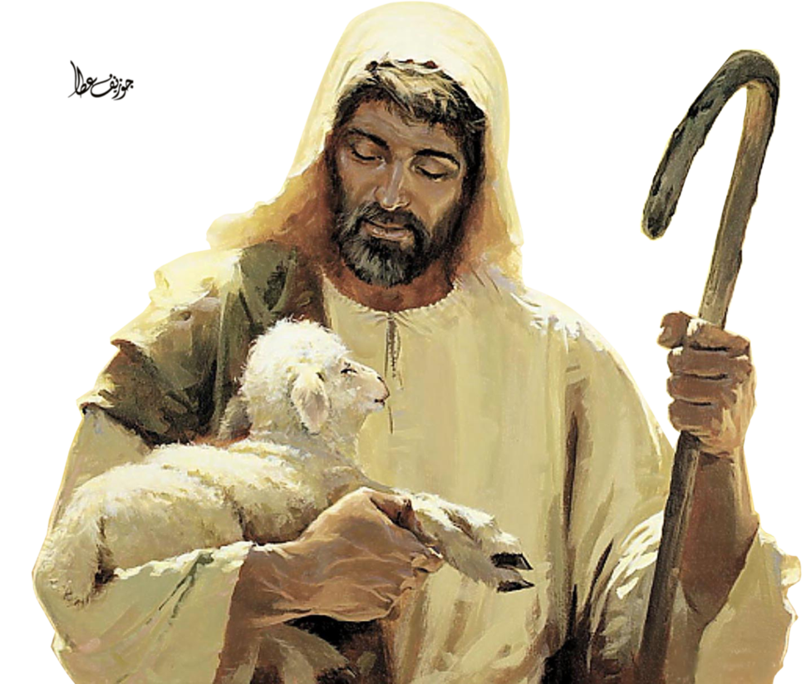
Introit: The king of love my shepherd is - 649
Gradual: The Lord’s my shepherd: 654
Offertory: The Lord’s my shepherd - by Stuart Townend - On a Sheet
Communion: The Lord’s my shepherd - Brother James’ Air - 654
Communion Anthem: The Lord’s my shepherd by Howard Goodall
Recessional: Faithful shepherd, lead me - 156

Collect: Risen Christ, faithful shepherd of your Father’s sheep: teach us to hear your voice and to follow your command, that all your people may be gathered into one flock, to the glory of God the Father. Amen

Post Communion:
Merciful Father, you gave your Son Jesus Christ to be the good Shepherd and in his
love for us to lay down his life and rise again: keep us always under his protection and give us grace to follow in his steps; through Jesus Christ our Lord. Amen

TODAY: Sunday 26th April 2026, 2pm - Three Valleys Gospel Choir 18th Birthday raising funds for the Foodbank - all the old favourites and some new ones

Creative Group @ St Mary’s: ALL WELCOME Next session: Monday 27th April 10.30
No skill or previous experience needed; come and learn, share and enjoy…

Tod Folk Festival - 1st to 3rd May 2026 - 10th Anniversary Exhibition at St Mary’s from 20th April to 3rd May and Folk Festival Mass with visiting musicians, Cobalt Tales

Plus Folk Festival 10th Anniversary exhibition all weekend and concert Sunday 3rd May at St Mary’s in the afternoon Volunteers needed for Exhibition especially on Saturday 2nd May and to help with refreshments on 3rd May, for the concert.

Annual Meeting (APCM) 10th May 2026 – please sign up for the electoral roll to vote for Deanery Synod reps who will elect GENERAL SYNOD reps. We will also elect PCC members and Churchwardens. Nomination forms at the back of Church.

10th May at 7pm - Churches Together for Christian Aid at Roomfield Baptist Church

Next BIBLE STUDY: Tuesday 5th May at 10.30am and Wednesday 6th May at 7.30pm

Feast of the Ascension: Service on Thursday 14th May at 7pm and Thy Kingdom Come, Ascension to Pentecost: help yourself to a copy of Archbishop Sarah’s reflections

For notices, weddings, funerals, baptisms and volunteering please contact:
- Rev Catherine: 07711 611201 / Catherine.Shelley@leeds.anglican.org

We continue to pray for: Gwen Mills, Jacob Howarth, Roy Yearsley, Viv Hawksworth, Mandy Fielden, Norman Cruikshank, Margaret McArdle; Sarah Battershell, Robert Scholey, Glynys Radnzic, Joyce Campion, Trevor Smith, Meg Kennedy, Jeffrey Hunter, Caroline Van den Brut, Jerzy Browne, Nigel Bentley, Rita, Lisa and Michael Kenyon, Helena Cook, Natasha McArdle, Ann Mason, Zoe Beesley, Lorna and Peter Shackleton, Roger & Pat Dale, Maureen Marshall, Val Cottam, Christine, Rowena, Archdeacon Bill Braviner, David, Funeral Director; Middle East, Ukraine, Somalia, Sudan and the Yemen

Recently Departed Edith Thomas, Beatrice Baron, Mary Widdup, Margaret Blackburn, Maureen Fielden, Barry Boon, Mick Blanche, Lawrie Stead, Christine Sutcliffe

In Memory: Tom Hodgins, Jack Clegg, Helen Hartley, Neil A. Helliwell, Geoffrey
Warburton, Daniel Overall, Robert Ormerod, Elizabeth Cockroft, Douglas Duddell, Norman Endley, Anne Barnes, Annette Ibbetson, Lee Gordon Thornton, Alan Colclough, Helen Gray, Kathleen Hudson, Joan Allen, Walter Clegg, William Greenwood, Olive Noble, Graham Lindsey, Patricia (Ann) Midgley
