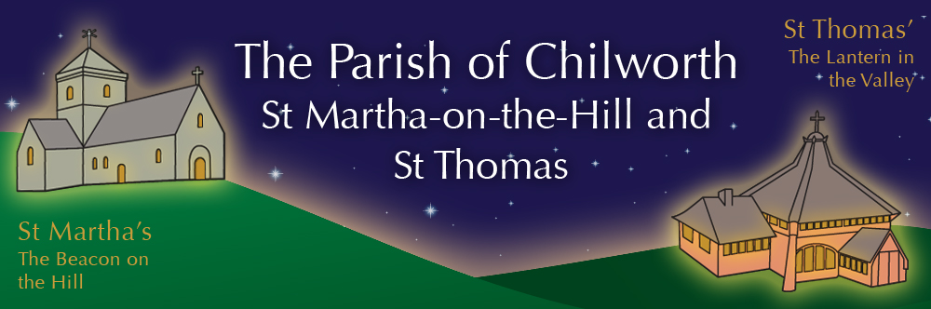

NOTICES: - 5th APRIL 2026
Priest David Oakden – Revdavid@parishofchilworth.org.uk - 01483 534293 (day off Friday)
Do let me know of anybody or anything that you would like to be prayed for.
www.parishofchilworth.org.uk and find us on https://www.achurchnearyou.com

************John 20:18(NRSVA)**********
Mary Magdalene went and announced to the disciples, ‘I have seen the Lord’; and she told them that he had said these things to her. ***********************************

Opportunities to pray together: -
Ecumenical Prayer Breakfast 1st Saturday of the month at the Vicarage, from 9am, prayer, coffee and croissant. Next is the 2nd May – Thursday evening at St Thomas at 6:00 pm for an hour every other week. 16th April 2026 & 7th May 2026.

This Sunday Services: – EASTER
06:00 St Martha’s Sunrise Service.
9:30 St Thomas Holy Communion.
11:15 St Martha’s Holy Communion.

Next Sunday Services: - 12th April
9:30 St Peter & St Paul Morning Worship.
11:15 St Martha’s Holy Communion.

Looking further ahead: -
Tots and Toddlers: St T’s Monday 9:15am
Hilltop Memories: St M’s 6th April 1-2pm
Cello Concert: St T’s 18th April 11:15am

Food & Hygiene Bank: -
The Foodbank Larder box is located in the porch of St Thomas Church. Suggested items: - Long life milk /tins tuna/ tins meat/ sachets microwaveable rice /pasta sauces/curry sauces/cereal/spreads/ tea/ coffee/ hot chocolate/ tins soup/ baked beans

Chilworth Tinies and Toddler Group: -
Mondays from 9:15 -10:45 meet in St Thomas, play chat, pray and support.

Prayer Stations in St Thomas: -
Pop in and pray - using the suggestions and materials provided.

18th April @ 11.15 Cello Concert with Coffee & Cake at St Thomas' Church
Come and hear talented young South African cellist, Seth Nel, playing favourite classics for cello including music by Elgar, Bach, Beethoven and Piazzolla accompanied by piano. Coffee and cake will be available both before and after the concert which will last approximately one hour. No need to book, donations welcome, put the date in your diary and join us with friends and family.

Holy Week and Easter Services: -
EASTER DAY 5th April
06:00 St Martha’s Sunrise Service
08:00 St James – BCP Communion
09:30 St Peter and St Paul – Easter Sunday Communion
09:30 St Thomas – Easter Sunday Communion
10:00 St James – Easter Sunday Communion
10:00 St Marks’ – Easter Sunday Communion
11:15 St Martha’s – Easter Sunday Communion

Hilltop Memories – Music Recital: -
6th April 1pm to 2pm A recital of Musical Moments.
Works by Bach, Brahms, Faure, Elgar and the Beatles, admission is free and Tea and Cake will be available.

Broad Horizons Book Group: -
Our informal book discussion group, resumes in April (April 28th) and will meet monthly on Tuesday evenings (7-8:30pm) throughout the summer. All welcome to any or all of the sessions. Dress warmly, as we meet on the benches outside St Martha’s, to enjoy the view, a hot drink and the setting sun.

Palm Sunday Procession: -
Over sixty people met at the carpark on Sunday, they received their palm crosses and we then followed two donkeys, CJ and Dolly up the hill, where we had a short lively service outside the East window, sang a couple of songs accompanied by a squeezebox and a violin, and then some bravely stayed for a picnic despite the cold wind. A great time was had by all.

