St John the Evangelist Church, Trent Vale
Newsletter Spring 2026

It is Easter with warm sunny weather and the cherry trees along the A34 are laden with blossom; the pavements are scattered with dandelions, shy bunches of violets peep from old garden walls and a long drift of pale blue forget-me-nots border the corner of Ronson Ave.
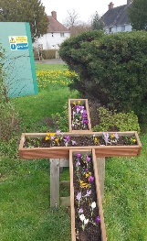
It is a wonderful contrast from the dark wet days of Lent but a carpet of thousands of golden daffodils and crocuses in the cross planter in the church grounds brightened stark chilly days. Whatever the weather, St John’s continues to lift spirits with inspiring worship and warm fellowship.
We have enjoyed a huge community event and been intrigued by an outdoor mystery.
Lent began with the Ash Wednesday morning service. Revd Liz led the service with the Imposition of the Ashes, where she made a cross on our foreheads made from last year’s Palm Crosses and oils with the words “Remember that you are dust and to dust you shall return. Turn away from sin and be faithful to Christ”.
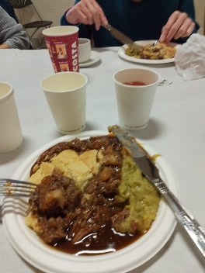
Unable to have the centre on Shrove Tuesday, our Pie and Pea lunch was held on the first Thursday in Lent on 19th February and seventy people had put their names on Eileen’s list. I had never attended one before and to be honest wasn’t over excited at the prospect of a pie and a dollop of peas! How wrong could I be!!
A butcher arrived from Leek with huge homemade pies. These were sliced and we received portions with melt-in-the-mouth pastry topping with chunks of meat in rich thick gravy. A vegetarian option of potato and cheese and onion was available.
Some looked astonished and said, “I can’t manage to eat all of that”, others tucked in with relish and soon asked for seconds.
Steve arranged a quiz and a raffle.
Councillor Waseem Akbar attended although unable to eat as it was Ramadan. We were very grateful for his generous contribution from his Ward Budget as everyone praised the community event and asked when the next one would be.
On Sunday Revd Liz led the service speaking on temptation. She asked young Loxie what she was giving up and she said “Lasagne because I don’t like it” which made us laugh.
The mornings songs were sung with great enthusiasm and from my front row seat, I could hear that ‘Nello’ and John Capewell were in with their strong voices behind me.
On Tuesday 24th February Revd Liz led an informal worship at Springfield Manor Care Home. A large number of residents enjoyed their choice of hymns which staff member Meg brought up on the large TV screen.
We were sorry to hear the sad news of the passing of our former Rector Sandy Dutton and fond memories were exchanged.
Revd Terry Bloor had compiled a five-week Lent course on the theme of creation and God. With Revd Liz the meetings were well attended at our centre on a Wednesday evening and Penkhull on Thursday afternoon, with time for discussion and prayer. I personally like the Night Prayer (Compline). Lovely words that were calming and a form of prayer we don’t often use.
Now for the Mystery.
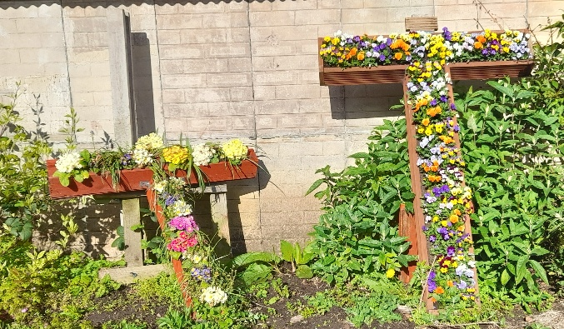
On 2nd March on the Church WhatsApp page, Eileen put a picture of the cross shaped planter with the following text. “I remain convinced that there are more good people in this troubled world than bad. At the weekend someone completely destroyed our planter cross at the centre and caused much upset. After spending most of today getting the CCTV footage for the police, some very kind soul has replaced the cross, replanted our bulbs and added more plants at their own expense. How lovely is that? If anyone knows who this is, please extend our heartfelt thanks. God bless”.
None of us recognised the gentleman on the CCTV. At the time of writing all we know is that it is a member of St Teresa R.C. Church. How kind indeed.
Trevor has also made a planter from the rescued wood from the original cross and these are very uplifting for passers-by.
On Sunday 15th March it was Mothering Sunday. We had an All-Age service with Action Songs. Revd Liz piled Nick’s arms high with boxes representing the many skills a mother needs as suggested by the congregation. The prayers spoke of the many different situations that people are in on this day.
Moira had made up a hundred and twenty bunches of daffodils that were distributed by the children.
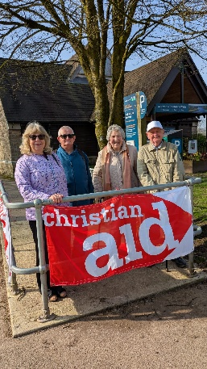
On Saturday 21st March it was a beautiful, sunny day for the annual Christian Aid Walk around Tittesworth Reservoir. Charles and Richard were sponsored for the walk, Chris Glover organised all with Moira supporting.
Bishop Matthew gave an amusing speech and with a blessing sent them off.
The walk raised £371 and £63 of Gift Aid, £71 more than last year. Well done everyone.
Palm Sunday was on 29th March, and a Benefice service led by Revd Liz was held in the centre. With adults and children there were over seventy people from the three churches present.
Everyone raised their crosses to be blessed before they left through the main doors to process along the roads that would return them to the rear entrance singing “All Glory Laud and Honour” as they went.
During the service members of the congregation went forward to take on the characters of the Passion, the events leading up to Good Friday. This was very moving. The service continued with Sam taking the Prayers with Communion by Revd Liz.
Times of Reflection were held in each church during Holy Week.
It was a bright sunny morning on Maundy Thursday as we boarded the free coach to Lichfield Cathedral.
On arrival we found a copy of “God with Us” written by the new Archbishop of Canterbury Sarah Mullally and a Prayer Journal on our seat.
After seeking refreshments, we returned for the service, beginning with “I will sing the wondrous story”.
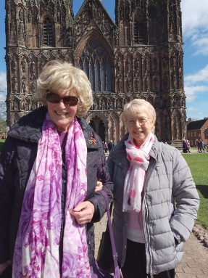
We were welcomed by the Bishop of Lichfield, Revd Dr. Michael Ipgrave O.B.E. The sermon was by the Rt Revd Tim Wambunya telling of Samuel’s calling. During the service the jars of oils were carried forward to be blessed by the Bishops of Shrewsbury, Wolverhampton and Lichfield and the vows of Renewal of Commitment to Ministry were made.
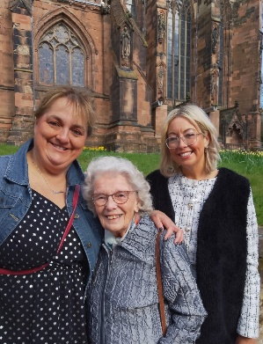
The table was prepared for the Eucharist and after prayers we were directed to stations to receive Communion. With so many queuing, hymns including “My song is love unknown”, “Be still”, “When I survey the Wondrous Cross” were sung. After the Dismissal we sang “Hope of our calling”. Revd Liz went to collect our oils to be used in our church in the coming year.
Leaving we were met outside the Cathedral by the Bishops, then made our way to the coach feeling we had been to a very special service. We headed home, looking forward to a very different service in the evening at the centre.
As their Servant King, Jesus washed the Disciples feet and, on her knees, Revd Liz did the same for us and one of us washed hers. We took Communion, receiving the bread and wine with the words that Jesus spoke to his friends.
It always seems that we can feel the connection with them on this same night two thousand years later. Of course, unlike the Disciples, we knew that would be their last meal together before Jesus’s betrayal and crucifixion.

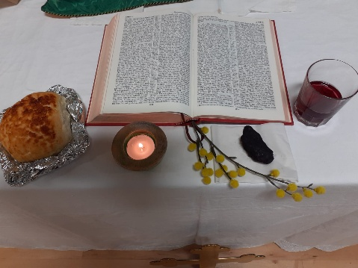
At the end of the service, in silence, the table was cleared, the candles taken to a small candle-lit table where in the centre is the blessed bread representing Christ’s body and we would sit for an hour keeping watch, unlike the Disciples who fell asleep in the Garden of Gethsemane.
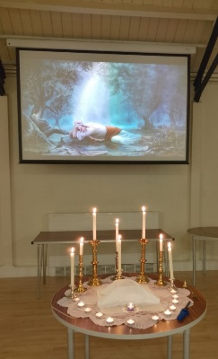
The candles barely flickered in the stillness before the large screen showing Jesus’s face down in agony.
Tonight we felt part of a precious experience that was taking place throughout the world with Christians in very different circumstances.
Earlier in the day we had sat in an ancient Cathedral where you could breathe in history of over a thousand years. The sun had shone through the many beautiful stained-glass windows and heard divine music soaring up to the high vaulted ceiling.
Tonight I gazed at a cream wooden ceiling down to plain cream walls and a cream wooden floor. This building was built a hundred years ago in a quiet village on a country road. Many of us can remember cows crossing over the road from the farm.
It has been the centre of social events and in the last four years it has also become our church where we have known a warmth of fellowship and a commitment to worship. This is where important milestones in this community life have taken place with Baptisms, Confirmation services and funerals being held here. Bishop Matthew in resplendent robes has held services here.
Soon we will return to our church across the road and our time here will become a fond memory.
We left in silence after the watch.
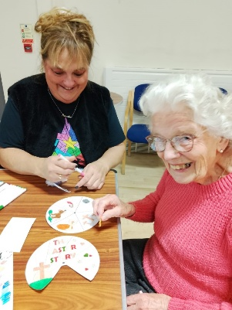
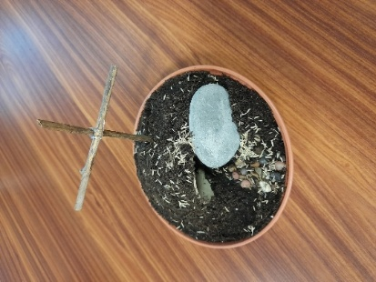
The following morning saw a very different activity as a craft morning for all ages was held with Good Friday crafts. A colourful set of bunting with the words “He is Risen”, a small garden with an empty tomb and a Last Supper scene were being made. We enjoyed singing and hot cross buns were served. Soon it was time for home, to return at 2pm to the centre looking very still, its rows of chairs facing the screen for the Stations of the Cross. With readings for each scene, the final events leading to the death of Jesus would be shown. We left in silence carrying our own thoughts into a noisy world.
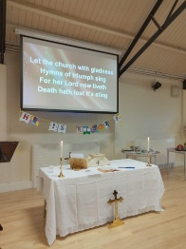
Easter Sunday morning saw us in church and with smiles exchanged Easter greetings. Mark lit the tall Pascal Candle with its colourful decoration and incense-filled brass studs. We sang “See what a morning”. Revd Liz led the joyful service inviting us to go forward to the font to renew our Baptism vows.
We received Communion, finally singing “Thine be the Glory” and the children distributed Easter Eggs.
It has been a thought-provoking Lent and jubilant Easter with its message of hope and assurance. We have been blessed that so many have worked so hard to make this a meaningful journey with work preparing the centre for our services as well as changing it for community use and those who each Sunday spend time with the children making crafts and sharing Bible Stories.
A wall that held the Christus Rex is being removed to make way for a staircase that will lead to a glass-walled mezzanine meeting room.
Many planning meetings continue to be held plus Prayer Workshops and church business.
We continue to hold many in our prayers including Revds. Fran and Mike. Cards continue to be sent for various occasions; birthdays and some of these are special ones.

Nello with twenty-two friends including Den and Josie Ankers attended Gandy’s Circus at Trentham, after which the circus provided an 80th birthday buffet.
Ray Tizely celebrated his 90th birthday and enjoys his fellowship at our church. We appreciate his lovely cards that are sent from our church.
My thanks to those who congratulated me on the birth of my first great-grandchild.
Congratulations to Alan and Josie on their engagement.
Penkhull Village Brass held a Poptastic 7 years at the Jubilee Club with new music including “Running up that hill”. Messages of thanks and appreciation are coming in for a wonderful evening. It was an opportunity for church members to be offered transport to attend an evening with friends and to enjoy wonderful music.

Eileen’s friends were aware she had been searching for some time for a “Brown Betty” teapot for the church. So it was a lovely surprise when she arrived home after church to find one on the dining-room table with the attached message attached:
“This teapot is affectionately known as ‘Maud’ after my maternal grandmother – she was the wife of Joseph Cartlidge Cliff who was the Town Hall Keeper in Hanley. The teapot was in use on ‘court’ days to make and serve tea to the Judge and Solicitors which was served in Grandad’s office or The Lord Mayor Parlour. Hope it has a new ‘life’ and use in your church.
Love Angie xx and Sue xx”.
On 20th April a mobile vaccination team working for M.P.F.T., part of the NHS, and who visit community hubs etc., came to the centre to offer Covid jabs and this was well attended. They hope to return in the Autumn with both Covid and flu vaccinations.
We have an update on progress on the church from Church Warden Eileen as follows:
“Things are progressing swiftly with the reordering and repairs to our church. The contractors, “Rosslee Construction Ltd”, have reported several significant milestones. The initial electrical wiring (first fix) has been completed, ceiling decorations are almost finished, and internal wall replastering is now approximately 70% done. Encouragingly, they remain on schedule to complete their work by October this year.
The manufacture of the beautiful new East stained glass windows is underway, alongside the surrounding stonework.
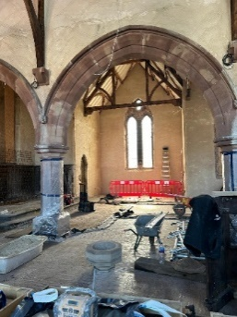
A pressing concern has emerged regarding the stained glass window and the surrounding stonework on the South side of the church. This particular window, previously located behind the organ and now fully visible, requires immediate attention as both the stained glass and the stonework need complete replacement. The church council was taken aback by this news, especially as this window is not covered by the insurance claim. In response, efforts are underway to secure the necessary funds—£48,000—through grant applications and generous donations.
Additionally, to raise part of the funds for the stained glass, Reverend Liz has organised a sponsored bike ride from Trent Vale to Canterbury Cathedral. While not a literal ride, it will be done on an exercise bike, possibly within the vicarage grounds in May. Volunteers are invited to help cover the 241 miles, and names are currently being taken for those willing to participate in our “Tour de Trent Vale”!
Reflecting on the past four years since the fire, and all that has been achieved, we now look forward with excitement and anticipation. Our shared vision of making a positive difference in the lives of others is only made possible by your continued support and generosity.
We fully understand that not everyone is in a position to contribute financially, and we respect that wholeheartedly. However, if you are able and willing, we kindly ask that donations, no matter how small, be made via the following methods:
. justgiving link is https://www.justgiving.com/crowdfunding/tour-de-trent-vale. Bank Account NatWest. Acct 25485156 Sort code 01-01-38 St John the Evangelist Church
. Cheque made payable to St Johns Church
. Cash on the collection plate at either the Sunday or Wednesday services.
We remain deeply grateful for your unwavering support, generosity, and most importantly, your continued prayers. May God bless you all. Eileen”
We hope you have enjoyed our Newsletter and we thank everyone for their generous giving to St John’s as we send you our love and hope you can enjoy the coming summer.

Bobbie and all your friends at St John’s.



(Spring Newsletter 27 April 2026)

