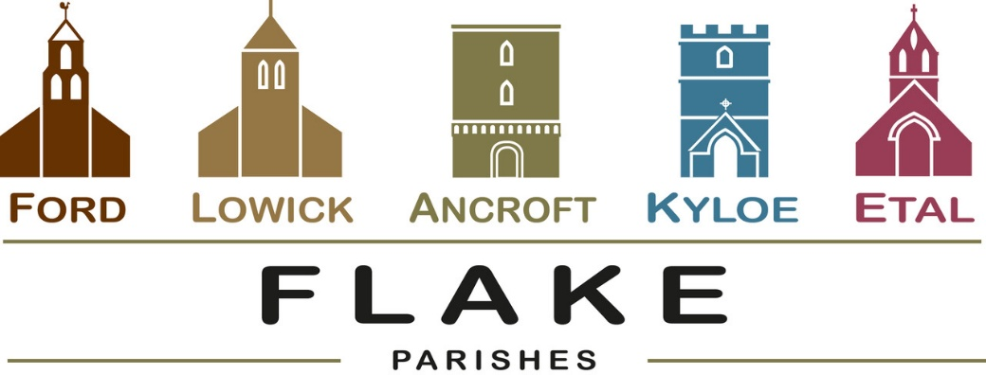
A very warm welcome to you, especially if you are visiting.
Please take this sheet home with you and use it as a basis for prayer.
Children may be at all our services.

Sunday 26th April 2026
Lowick 9.15 Holy Communion
Ford 11am Holy Communion

Sunday May 3rd 2026
Lowick 9.15 Holy Communion
Ford 11am Holy Communion

Sunday May 10th 2026
Lowick 9.15 Holy Communion
Ford 11am Holy Communion

Sunday 17th May 2026
Lowick 9.15 Holy Communion
Ford 11am Holy Communion

Revd Charlotte Osborn (Vicar) 01289 388591 ceosborn@mail.com 07957 367457
Revd Alex Firman (Assistant Curate) 07935 732811
alex_firman@hotmail.co.uk

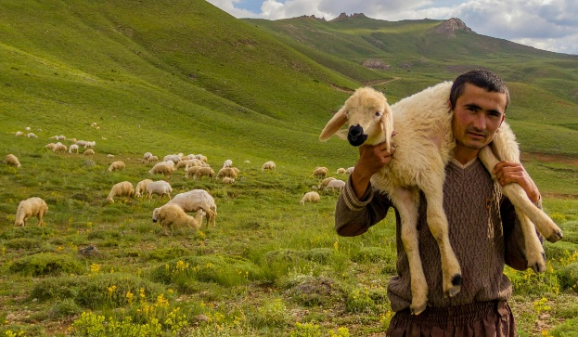
The image of Jesus as the Good Shepherd tenderly carrying a sheep on his shoulders was one of the earliest images of Jesus in Christian art. It was found in the Roman catacombs, the ancient cemeteries outside the city of Rome where the early Christian martyrs were buried. It has remained a much-loved image of Jesus throughout the centuries, and is the image upon which the wearing of the priest’s stole is based.

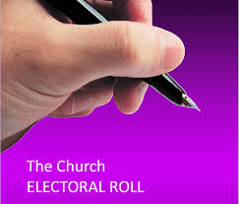
Parish Business
Electoral Rolls are being revised ahead of the Annual Parochial Church Meetings in all our parishes. If you would like to join, speak to Nici Gibb at Ford or Charlotte for Ancroft.

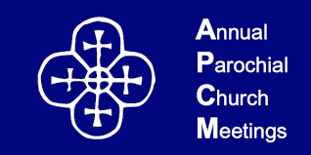
Annual Parochial Church Meetings 2026
Annual Reports are received and elections for Churchwardens and PCC members take place.

Ancroft – Friday 8th May in St Anne’s Church at 1.30pm
Ford – in the Estate Office on Tuesday 19th May 5.30pm
Lowick – Lowick Village Hall on Wednesday 20th May at 7pm


- Saturday 2nd May Lowick White Swan Men’s Breakfast 08.30

- Tuesday 5th May Licensing of Revd Paul Knox at Wooler 7.30pm

- Thursday 7th May DDG Holy Island Vicarage

- Shepherds Law Hermitage Open Day 9th May see poster

- Tuesday 12th May Lowick Standing Committee Vicarage 3pm

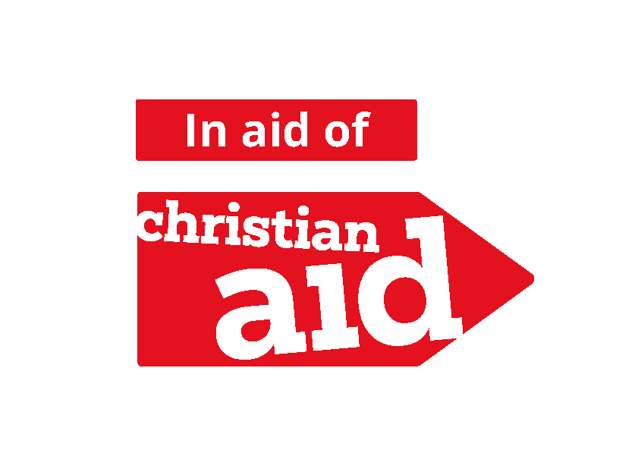
Christian Aid Week is
May 10th – 16th

As benefices we support the work of Christian Aid with these 2 events:

- Concert in Berwick Baptist Church on Wednesday 13th May at 7pm given by the Golden Square Singers, donations to Christian Aid.

- Quiz and Supper in Bowsden Village Hall on Saturday 16th May at 7pm. £10 per person. Come as a team of 4 or join with others on the night. Bar and Raffle. Book with Diane
rumplecottage@yahoo.com

For our prayers

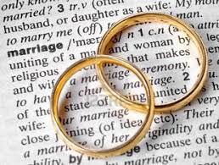
Over the next few weeks, we shall be reading the banns of marriage for

Annabel and John, to marry at Ancroft
Katkin and Alex to marry at Ford
Ian and Yvonne to marry at Ford

We joyfully pray for them as they prepare not just for their wedding day, but for their married life together

Please continue to pray for all who suffer in body, mind or spirit, especially Heather Piper, Chloe French, George Hall, Gail Calder, Don and Sam Quilty, David and Judith Dobson, Alison Murray, Rachel Inglis, Edward Younger, Sandra Hall.

We remember all who have recently died and we pray for those who mourn, and for all who mark anniversaries of death at this time of year.

Parish Contacts

Ancroft Leigh Yorke 07716 116739
Etal Andrew Joicey 01890 820540
Ford Kathleen Holmes 07951 099668
Lowick Niall Cartlidge 07850 876246

Websites: www.achurchnearyou.com
Instagram: https://www.instagram.com/the_flake_churches/
Facebook: the_flake_churches

Other licensed clergy
Revd Margaret Sentamu 077871 204745, Canon Nick Sagovsky,
Revd Marion Penfold 01289 305664

