
ST. ANN’S, BELFIELD NEWS LETTER
WORSHIP

Church open
St Ann’s is open for public worship Sundays and Wednesdays at 10.30am

Streamed service
On-line via twitch.tv/revdgill and for 1 week after. Downloads on request.

Prayers for the sick
Ghislaine Glover, Cath Boon, Roger, Lilian.

Prayers for home members
Bob (in Mona Cliffe Care Home), Dorothy (in Braeside)

The anniversary of the dearly departed
Samuel Dearden, Mary Baron, Mary Thorpe, Thomas Kelly and Roy Tomlinson


Scan this with your phone to contribute to St Ann’s mission and ministry

Benefice Motto, 2026
“In everything by prayer and supplication… let your requests be made known to God. And the peace of God which surpasses all understanding, will guard your hearts and your minds in Christ Jesus.”

St Ann’s
Back in church from 3rd May.


Lviv Children's Art Project, 11th - 28th May in Riverside
Ukraine’s children tell their stories through art.

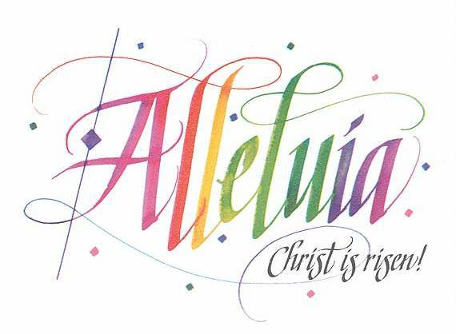

26th April 2026
Fourth Sunday of Easter
Eucharist
Rev. Richard McEwan

Hymns All NEH
110 Jesus Christ is risen to-day
121 This joyful Eastertide
117 The Day of Resurrection
115 Now the green blade riseth
120 Thine be the glory

NOTICES
Quiz Night
St Ann’s, Belfield, 24th April, 7pm

Icons on Ammo Boxes
A powerful and deeply moving collection features Ukrainian icons painted on repurposed ammunition boxes from the frontlines of the war in Ukraine. St Edmund’s Church, Wed 13th May, 7pm.

Christian Aid Week
Café Church, Christ Church, 10am

Breathe
7pm, 10th May

New Service
A new, quiet, said communion service at Christ Church, 2nd Sunday every month over the summer – for those for whom morning services are a bit too much. A traditional, said, Common Worship Communion Service, 2pm:10th May; 14th June; 12th July; 9th August; 13th Sept; 11th Oct. Please share this invitation with those who like a bit of p&q!

