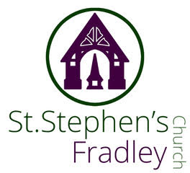

DOUBLE BULLETIN
5th April EASTER DAY 10.30am Family Communion and Blessing of the Easter Garden
12th April 10.30am Family Communion Service 2nd Sunday of Easter
Welcome to our Worship today. If you are visiting for the first time, please introduce yourself so that we may welcome you personally. Refreshments are served after the service
ST. STEPHEN’S CHURCH IS OPEN 10am-3pm daily for Private Prayer and Reflection
Easter Sunday  Collect  God of glory,  by the raising of your Son  you have broken the chains of death and hell:  fill your Church with faith and hope;  for a new day has dawned  and the way to life stands open  in our Saviour Jesus Christ.  Readings  Colossians 3.1-4 Acts 10. 34-43 John 20. 1-18  Post Communion  God of Life,  who for our redemption gave your only-begotten Son  to the death of the cross,  and by his glorious resurrection  have delivered us from the power of our enemy:  grant us so to die daily to sin,  that we may evermore live with him in the joy of his risen life; through Jesus Christ our Lord. | 12th April 2026  Collect  Risen Christ,  for whom no door is locked, no entrance barred:  open the doors of our hearts,  that we may seek the good of others  and walk the joyful road of sacrifice and peace,  to the praise of God the Father.  Readings  Acts 2. 14a 22-32 1 Peter 1. 3-9  John 20. 19-end  Post Communion  Lord God our Father,  through our Saviour Jesus Christ  you have assured your children of eternal life  and in baptism have made us one with him:  deliver us from the death of sin  and raise us to new life in your love,  in the fellowship of the Holy Spirit,  by the grace of our Lord Jesus Christ.
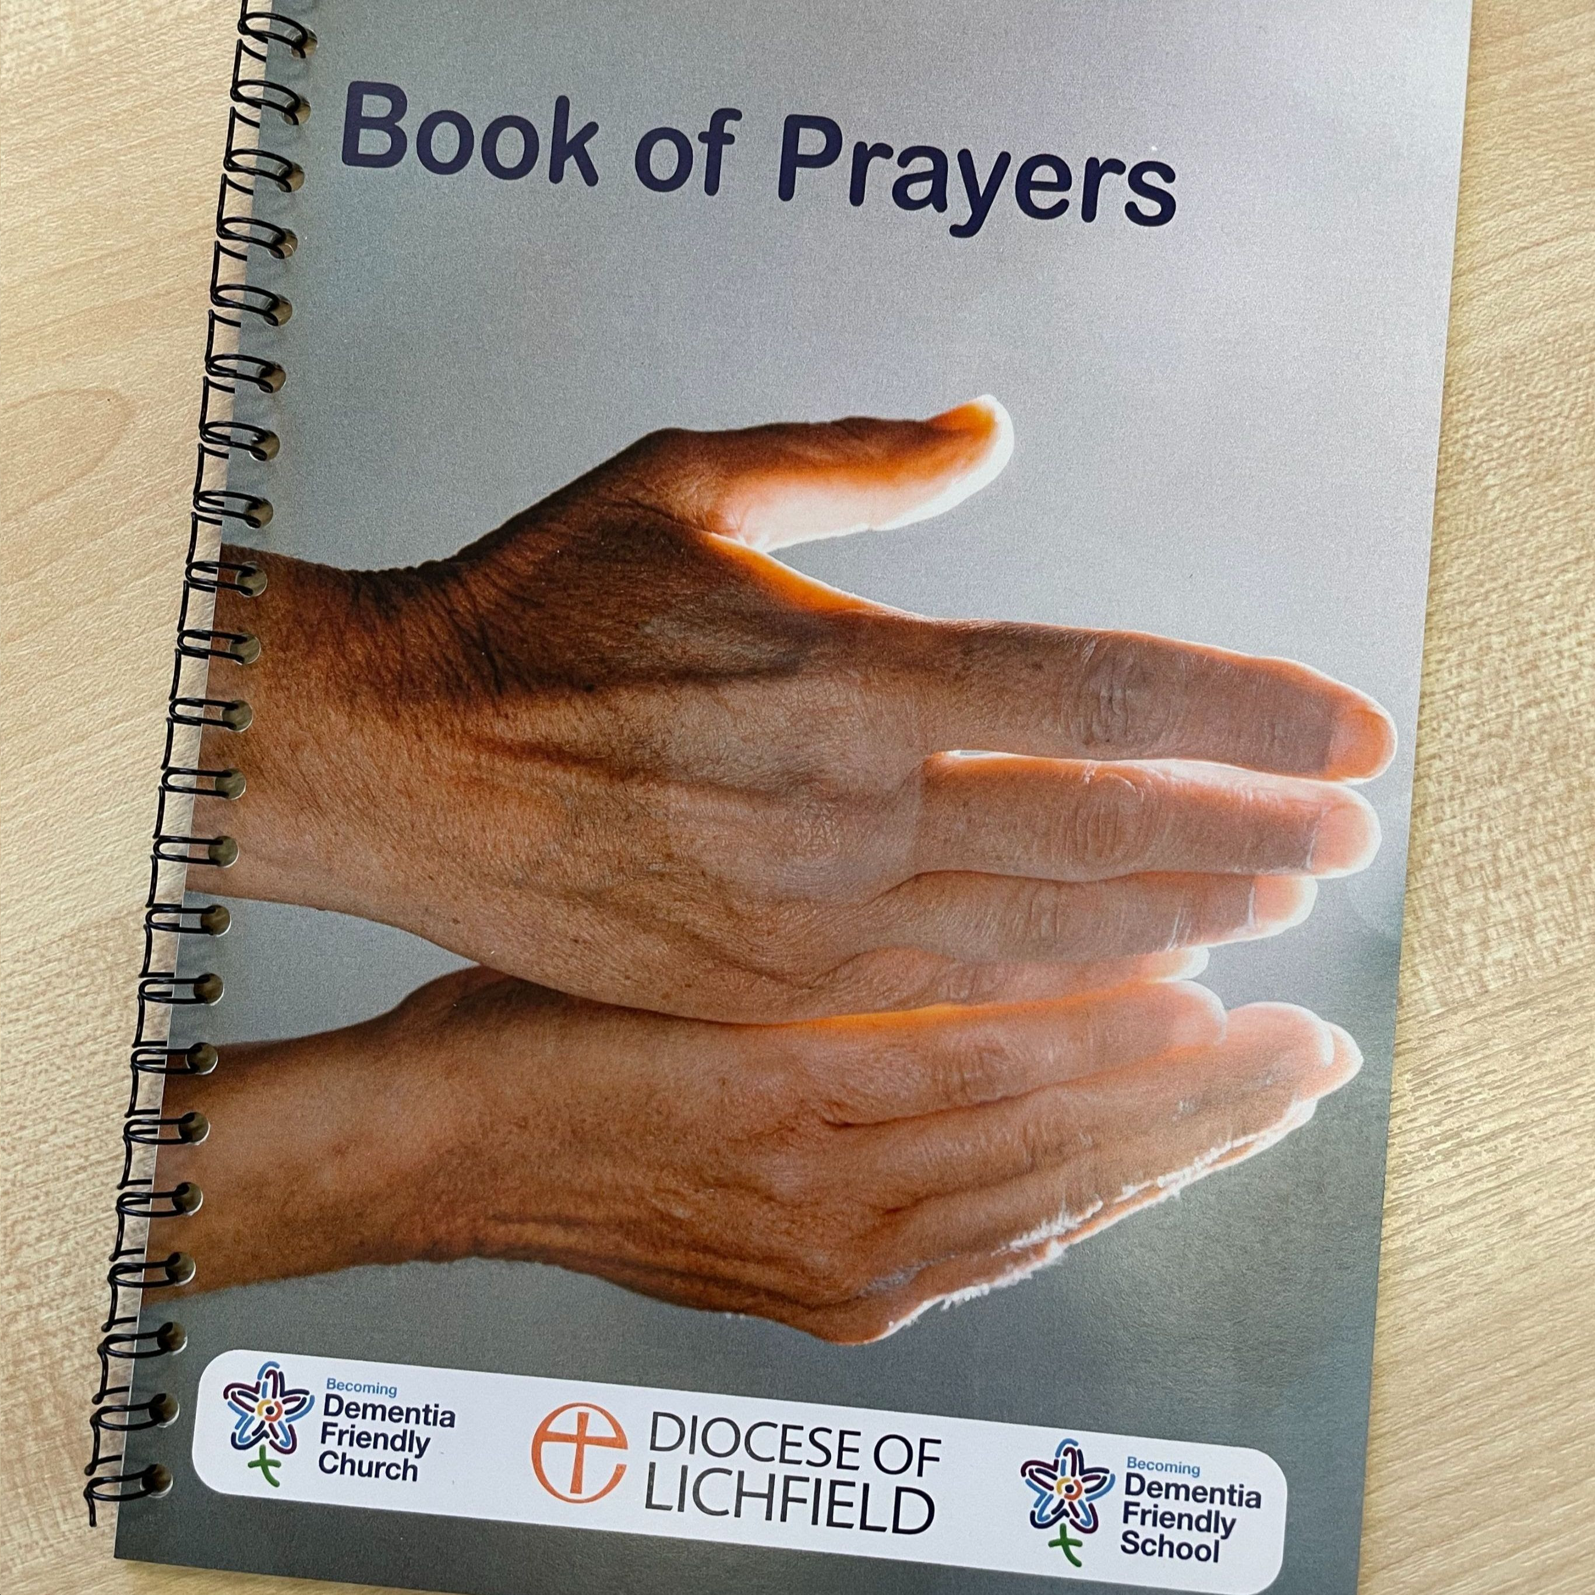  Dementia Friendly Prayers  20 page spiral bound ‘Book of Prayers’, with an illustration on one page and a prayer on the facing page is available for anyone who wants a copy. If you can make a donation, it gives the opportunity to ‘pay it forwards’, so that it can continue to print and share copies of these books. Please see our Dementia Champion, Jenny Summers.  Lichfield Cathedral's Dementia Champions Team is hosting the following events during 2026:  29 April | Easter Service  1 July | Songs of Praise Service  30 September | Harvest Thanksgiving Service  December | Christmas Service (tbc)  All of the above events will start at 10:45 and lasts approximately 40 minutes, followed by light refreshments.  We look forward to seeing you there.  SAVE THE DATE  Saturday 2nd May 10am-12 noon  Plant Sale and Refreshments  Thursday 14th May 7.30pm  Heritage Talk ‘Fradley in 1861’  Free event. Wine and savouries served  Friday 22nd May 5pm  The Licensing of Revd Jonathan Nicholas to  Alrewas, Fradley and Wychnor  by The Rt Revd Dr Michael Ipgrave OBE  Saturday 13th June 11am  Dedication of the Memorial Light Box to all RAF Personnel Bishop Michael will officiate. | Au Revoir!  I had the task (a pleasant one! And a privilege) many years ago, of giving a ‘farewell sermon’ for one of my colleagues at St Chad’s. Several of us ‘learned our trade’ there – our high aspirations and theological training hadn’t really equipped us for ‘servant’ ministry! Reality did kick in very soon!!  We became movers-in- chief of heavy objects as we carried paschal candles round the church, filled fonts with buckets of water. emptied bins; fancy ideas about what it meant to be ordained went out of the window. And rightly so, because ordained ministry is about enabling, humble, sacrificial service. Now I know that not everyone agrees with me but I think this is ‘Jesus’ ministry. He washed people’s feet. and he developed collaborative ministry! In my view this is the only way church grows. It is an ‘every member’ ministry because everything helps and everyone has a gift  or talent to offer.  But this is a farewell day….the end of my 25 years with a Common Tenure Licence.  I hope that this is not the last time I will see you all- in short, I have good reason- very many good reasons to hold you all in great affection. I will no doubt miss these churches, their busyness and activity... (although one acknowledges that at my age 60 hours a week is a bit much!) and I will miss you greatly.  But, the church is a pilgrim community and pilgrims must travel on for time to time.  May God bless all of you in your journey of faith and thank you for allowing me to travel with you for the last 12 years.  Yours, Elizabeth

Thank you to our Team of Flower Arrangers who have decorated the church for Easter. A real uplifting touch of spring! And thank you to all who have cleaned and beautified our lovely building for the occasion and the churchyard gang who have tidied the Churchyard. It all looks superb!
Annual Parish Church Meeting
The Annual Parochial Church Meeting will be held in church on Sunday 26th April at 11.30am, straight after morning service. This is the meeting where the Churchwardens are appointed and PCC members are elected. The Annual Report is presented which focuses on all that has happened in the previous year. There is an update about the financial situation.
Copies of the Trustees Annual Report will be available.

Quiz Night and Fish & Chips
Saturday 18th April 7pm – an imaginative quiz!!
Tickets only £10 available from Carole Griffiths
Teams of 4. If you haven’t got a team we will find you one! Tickets are going fast!

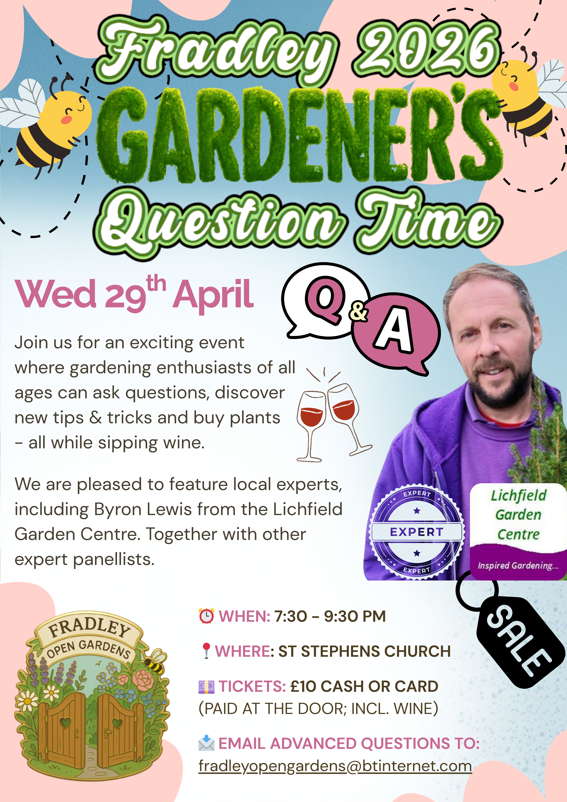

Diary Dates

Tuesday 7th April 3.30pm Bowbrook Easter Service at Bowbrook Care Home
Wednesday 8th April 2-4pm Wednesday Welcome Drop in for Tea and cakes and chat
Sunday 12th April 10.30am Family Communion (2nd Sunday of Easter)
Tuesday 14th April 7.30pm Fradley Community Choir rehearsal (In church)
Saturday 18th April 7pm Quiz Night with Fish & Chip Supper
Sunday 19th April 10.30am Family Communion
Sunday 26th April 10.30am Family Communion
11.30am Annual Parish Church Meeting
* * * * * * * * * *

 Interested in getting married at St Stephen’s?
Please see our leaflet in Church or contact us – details below.

* * * * * * * * * *

Notices for inclusion in the bulletin please email me by Tuesday of each week
Officeststephenfradley@gmail.com Please take bulletin away with you
If you would like to support St Stephen’s Church at this time donations can be made via our Just Giving Page. We are grateful for donations large or small
https://www.justgiving.com/fundraising/ststephensfradley

Contact us
Revd Elizabeth Wall 01543 254891
Email: ayton265@gmail.com
Churchwarden
Marian Derry 01283 791573
St Stephen’s Administrator: Di Cooper
07930162991 officeststephenfradley@gmail.com

Find us on ACNY https://www.achurchnearyou.com/church/4123/
Facebook www.facebook.comststephensfradley

