St James the Great  Wrightington with Heskin  www.stjamesthegreat.net | 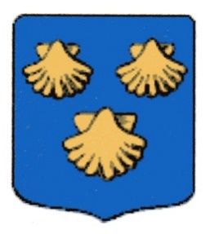 | 92 Church Lane  Wrightington  WN6 9SP  Phone: 07769 462502  vicar@stjamesthegreat.net

12th April – 2nd Sunday after Easter
09.00am Holy Communion - Pat Belshaw
10.30am Holy Communion – David Ward
5.00pm No 30@5

If you are interested in your child being Confirmed this year, or, if you as an adult are considering Confirmation, please look out for the information at the back of Church and complete the application form.

Parents – please ensure that you complete an Attendance Form each time you come to a service (slips are in the box on the back table). This will inform me and is essential information when the time comes for Faith References.

If you would like to support the fundraising event on Saturday 18th April – Parkside Colliery
Male Voice Choir please see either Joan Crompton, Anne Sharples or Sue Wild for tickets.

*+*+*+*+*+*+*+*+*
Mon 13th April 9.00am Heskin School opens following Easter Break
Tues 14th April 7.30pm Mothers Union with Stuart & Kay Kirkman
Wed 15th April 10.30am Play & Praise Toddler Group
Sat 18th April 7.30pm Parkside Colliery Male Voice Choir in Church (Tickets available)

*+*+*+*+*+*+*+*+*
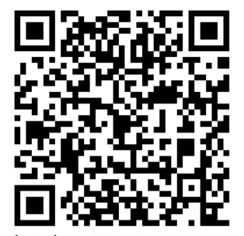
19th April 3rd Sunday of Easter
09.00am Holy Communion - Alex Baker
10.30am Holy Communion -with Holy Baptism – Alex Baker
5.00pm 30@5

