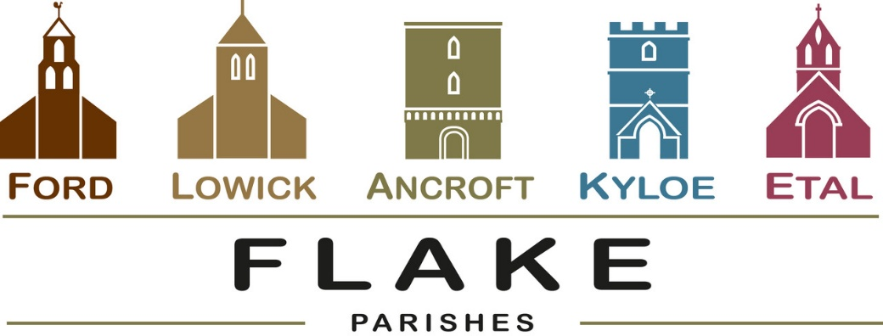
A very warm welcome to you, especially if you are visiting.
Please take this sheet home with you and use it as a basis for prayer.
Children may be at all our service and a special welcome today to all mothers, grandmothers, midwives, carers, all who mother us.

Sunday 15th March 2026
Mothering Sunday
Lowick 9.15 Holy Communion
Etal 11am Holy Communion

Sunday 22nd March 2026
Lowick 9.15 Holy Communion
Etal 11am Holy Communion with Baptism

Sunday 29th March 2026
Palm Sunday
All congregations worshipping together as Flake Churches
Ford 10.30am Palm procession meets in Ford Village
Ford 11am Holy Communion

Sunday 5th April 2026
Easter Day
See inside for details of services

Revd Charlotte Osborn (Vicar) 01289 388591 ceosborn@mail.com 07957 367457
Revd Alex Firman (Assistant Curate) 07935 732811
alex_firman@hotmail.co.uk
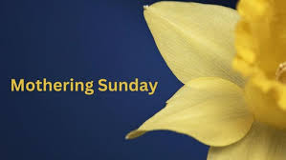
What questions do you wrestle with this Mothering Sunday?
Traditionally the church has kept this Sunday as a time of refreshment during the rigours and the wilderness of Lent.
May you find the refreshment you seek as together we remember how deeply Mary loved Jesus, and how deeply Jesus loves us, his children.
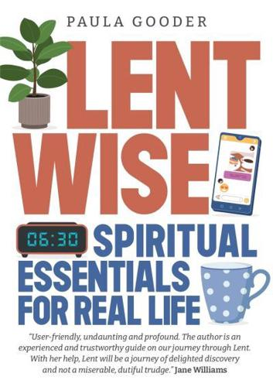
Lent Study Group continues in Lowick Vicarage tomorrow from 7-8.30pm. We are using ‘Lentwise’ by Paula Gooder, Canon Chancellor of St Paul’s Cathedral London. Tomorrow’s session will consider places of security and sanctuary for us
- 16th March
- 23rd March

Middlemiss Lecture will take place on 22nd April 2026. Details soon.

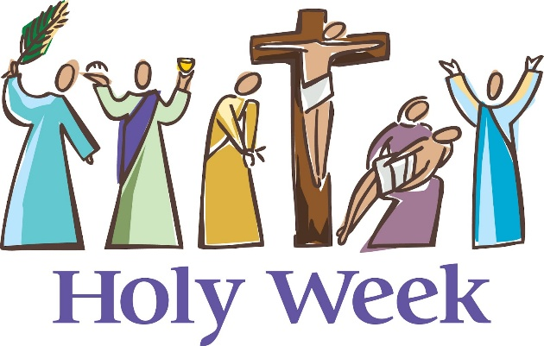
During Holy Week this year we will be following our traditional pattern of offering something every evening by way of a devotional journey to Good Friday and Easter Day.
Monday to Wednesday will be in the evenings in Lowick Vicarage and consist of a series of short talks followed by Compline.

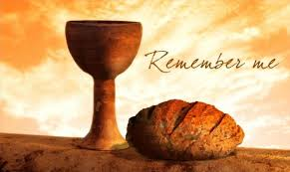
7pm Thursday April 2nd
Holy Communion with
Foot Washing
St Anne’s Church, Ancroft


Good Friday
12 noon Lowick Common
An Outdoor Presentation
‘Dying to Know You’
2pm Lowick Church
An Hour at the Cross


Holy Saturday: Easter Vigil
Ford Church 8pm
Easter Sunday
6am Sunrise Service West Kyloe
9.15am Lowick Holy Communion
11am Ford Holy Communion
5pm Ancroft Easter Songs of Praise



Palms to Passion
P 2 P is a 2hr contemporary musical. The music ranges from classical light opera to jazz ballads, soul and blues to rock and pop bringing together full chorus, duets, solos and ‘a capella’ singing
A narrator takes the audience through the performance, linking the music, with a ‘big screen’ media production offering a visual backdrop to the show. The story reflects on the last 7 days of Jesus’ life
Set in context between events over 2000 years ago and with music and media which represents the present day, Pilgrim Voice welcomes everyone to share in this unique musical experience.
Admission by ticket £10
Sunday 29th March 2026
St Aidan’s Parish Church,
Bamburgh, NE69 AE

For our prayers

Please continue to pray for all who suffer in body, mind or spirit, especially Andrew Watson, Heather Piper, Chloe French, George Hall, Gail Calder, Revd Sam Quilty, David and Revd Judith Dobson, Alison Murray.

We remember all who have recently died including Ivan Black from Bowsden, Jean Evans and those who mourn.
We pray for all who mark the anniversaries of death at this time of year, for Robert Blyth, James Thompson Younger and James Skeen.

Parish Contacts

Ancroft Leigh Yorke 07716 116739
Etal Andrew Joicey 01890 820540
Ford Kathleen Holmes 07951 099668
Lowick Niall Cartlidge 07850 876246

Websites: www.achurchnearyou.com
Instagram: https://www.instagram.com/the_flake_churches/
Facebook: the_flake_churches

Other licensed clergy

Revd Margaret Sentamu 077871 204745, Canon Nick Sagovsky,
Revd Marion Penfold 01289 305664

