Psalm 95
Please stand, if able, and join in the verses in bold

O come, let us sing to the Lord;
let us make a joyful noise to the rock of our salvation!
Let us come into his presence with thanksgiving;
let us make a joyful noise to him with songs of praise!
For the Lord is a great God,
and a great King above all gods.
In his hand are the depths of the earth;
the heights of the mountains are his also.
The sea is his, for he made it,
and the dry land, which his hands have formed.

O come, let us worship and bow down,
let us kneel before the Lord, our Maker!
For he is our God, and we are the people of his pasture,
and the sheep of his hand.

O that today you would listen to his voice!
Do not harden your hearts, as at Meribah,
as on the day at Massah in the wilderness,
when your ancestors tested me,
and put me to the proof, though they had seen my work.
For forty years I loathed that generation
and said, ‘They are a people whose hearts go astray,
and they do not regard my ways.’
Therefore in my anger I swore,
‘They shall not enter my rest.’

Glory be to the Father and to the Son and to the Holy Spirit,
as it was in the beginning, is now and ever shall be,
world without end. Amen


Once again, we are asking everyone if they could please collect their change over Lent and then bring it in on Easter Day.
If you need a jar, there are some spare ones in church.

Thank you – together we can make a difference

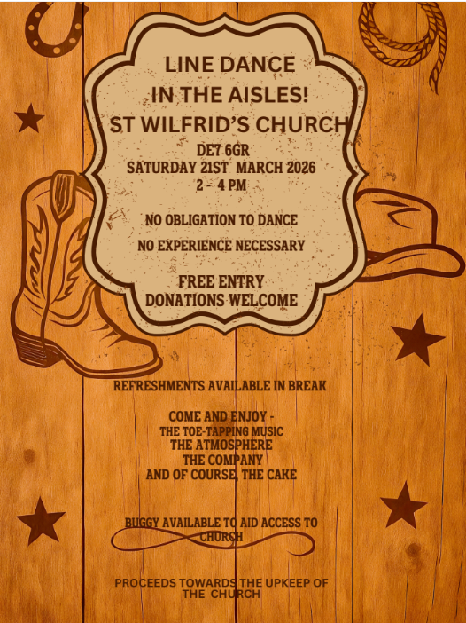

In our weekly prayers for our parish
This week we pray for God’s blessing on Ladywood Road, Limetree Rise & Limetree Court.
Our 4pm services are now in Friendship House
until the end of March.
Distribution of Communion –currently the Priest will dip the communion wafer in the wine while we discern a safe way to bring the common cup back into worship, as we want everyone to feel included and safe. We also have gluten free wafers available.
Refreshments After the Morning Service
Please stay seated after the service and a hot drink will be brought to you in the pews. Do not get up and head to the back of church, it is becoming a hazard, and a risk as trays of hot drinks could be knocked over.
Church contact information
Contact: Rev’d Christine - revchristine@outlook.com
The Rectory, The Village, West Hallam, DE7 6GR
Landline 0115 646 1497
Rev’d Ailsa -revailsahunt@gmail.com
Tel - 07356064856

Churchwardens – Mrs Janet Wheeldon, -Tel: 0115 8771593
Mrs Linda Gregory – linda.gregory3@icloud.com
https://www.achurchnearyou.com/church/13402/
https://www.facebook.com/allsaintskirkhallam
All Saints Church
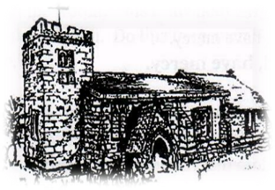
Kirk Hallam
Disabled Toilet in Friendship House.
Disabled Toilet in Friendship House.

Working with God to transform lives & communities.
Please can you ensure your mobile is on silence, or off during the service, it is affecting people with hearing aids and the loop system.

8th March – Third Sunday of Lent
10.00am Iona Communion Service with Rev’d Alan Fitch
11.15am Social Committee Meeting – all welcome
4.00pm Iona Evening Prayer with Rev’d Christine

Forthcoming Events
Mon 9th 10.00am Funeral at St Andrew’s, Stanley of
Michael Robinson
Tues 10th 6.00pm Home Group in Friendship House
Weds 11th 9.30am Morning Prayer at UCAS
Weds 11th 6.30pm Lent Group at UCAS
Thurs 12th 3.30pm Internment of ashes of Clifford Johnson
Fri 13th 6.00pm Choir Practise in Friendship House
Sat 14th 10.00am Prayer Meeting in Friendship House

15th March – Mothering Sunday
10.00am CW Communion Service with Rev’d Christine & Eileen
3.00pm Building Faith at Community Centre
4.00pm Iona Holy Communion with Rev’d Christine
“For where your treasure is, there will your heart be also” Luke 12:34
It’s Good to Talk! If you spot that someone is missing, please pop a news sheet through their door, & if you’ve time, call for a chat - just to check they’re OK & to let them know that they are not forgotten!

