
Lent 5
Passion Sunday

Sunday 22nd March
10.30am Parish Eucharist
The Gathering Stand when the entrance bell is rung
Hymn 65 Christian, dost thou see them
In the name of the Father, and of the Son, and of the Holy Spirit. Amen

The Lord be with you
and also with you

Prayers Of Penitence
The priest invites the people to call their sins to mind, and to repent of them. A pause for silent reflection follows
Show mercy to us loving Father. We have sinned against you, please make us anew. In your love and your grace you forgive us.
Lord have mercy, Lord, have mercy.

Look not on our failings, Lord Jesus. We have sinned against you, please make us anew. By your life and your death you redeem us.
Christ have mercy. Christ, have mercy.

Come fill our hearts, Holy Spirit, We have sinned against you, please make us anew, Forgive us and heal us and save us,
Lord have mercy. Lord, have mercy.

May almighty God, have mercy on us, Forgive us our sins, and bring us to everlasting life. Amen.

The Collect
By your help, we beseech you, Lord our God, may we walk eagerly in that same charity with which, out of love for the world, your Son handed himself over to death. Through our Lord Jesus Christ, your Son, who lives and reigns with you in the unity of the Holy Spirit, God, for ever and ever. Amen

The Liturgy of the Word
The first reading is taken from the book of the prophet Ezekiel (37:12-14)
‘I will put my spirit within you, and you shall live.’
Thus says the Lord God: Behold, I will open your graves and raise you from your graves, O my people. And I will bring you into the land of Israel. And you shall know that I am the Lord, when I open your graves, and raise you from your graves, O my people. And I will put my Spirit within you, and you shall live, and I will place you in your own land. Then you shall know that I am the Lord; I have spoken, and I will do it, declares the Lord.
This is the word of the Lord. Thanks be to God.
Psalm 130
Response: 'Out of the depths have I cried to you, O Lord'.

Out of the depths I cry to you, O Lord. Lord, hear my voice!
Let your ears be attentive to the voice of my supplications.
Response
If you, O Lord, should mark iniquities, Lord, who could stand?
But there is forgiveness with you, so that you may be revered.
Response
I wait for the Lord, my soul waits, and in his word I hope;
my soul waits for the Lord more than those who watch for the morning,
more than those who watch for the morning.
Response
O Israel, hope in the Lord! For with the Lord there is steadfast love,
and with him is great power to redeem.
It is he who will redeem Israel from all its iniquities.
Response

The second reading is taken from St Paul’s letter to the Romans (8:8-11)
‘The Spirit of him who raised Jesus from the dead dwells in you.’
Brothers and Sisters: Those who are in the flesh cannot please God. You, however, are not in the flesh but in the Spirit, if in fact the Spirit of God dwells in you. Anyone who does not have the Spirit of Christ does not belong to him. But if Christ is in you, although the body is dead because of sin, the Spirit is life because of righteousness. If the Spirit of him who raised Jesus from the dead dwells in you, he who raised Christ Jesus from the dead will also give life to your mortal bodies through his Spirit who dwells in you.

This is the Word of the Lord Thanks be to God.

(Stand)
Gospel Acclamation:
Praise to you O Christ, King of endless glory! Glory and praise to you!
I am the resurrection and the life, says the Lord; whoever believes in me
will never die.
Praise to you O Christ, King of endless glory! Glory and praise to you!

The Gospel
The Lord be with you
And also with you
A reading from the gospel of our Lord Jesus Christ according to John (11:1-45)
Glory to you, O Lord.
‘I am the resurrection and the life.’
At that time: A certain man was ill, Lazarus of Bethany, the village of Mary and her sister Martha. It was Mary, who anointed the Lord with ointment and wiped his feet with her hair, whose brother Lazarus was ill. So the sisters sent to him, saying, ‘Lord, he whom you love is ill.’ But when Jesus heard it he said, ‘This illness does not lead to death. It is for the glory of God, so that the Son of God may be glorified through it.’
Now Jesus loved Martha and her sister and Lazarus. So, when he heard that Lazarus was ill, he stayed two days longer in the place where he was. Then after this he said to the disciples, ‘Let us go to Judea again.’ The disciples said to him, ‘Rabbi, the Jews were just now seeking to stone you, and are you going there again?’ Jesus answered, ‘Are there not twelve hours in the day? If anyone walks in the day, he does not stumble, because he sees the light of this world. But if anyone walks in the night, he stumbles, because the light is not in him.’ After saying these things, he said to them, ‘Our friend Lazarus has fallen asleep, but I go to awaken him.’ The disciples said to him, ‘Lord, if he has fallen asleep, he will recover.’ Now Jesus had spoken of his death, but they thought that he meant taking rest in sleep. Then Jesus told them plainly, ‘Lazarus has died, and for your sake I am glad that I was not there, so that you may believe. But let us go to him.’ So Thomas, called the Twin, said to his fellow disciples, ‘Let us also go, that we may die with him.’
Now when Jesus came, he found that Lazarus had already been in the tomb four days. Bethany was near Jerusalem, about two miles off, and many of the Jews had come to Martha and Mary to console them concerning their brother. So when Martha heard that Jesus was coming, she went and met him, but Mary remained seated in the house. Martha said to Jesus, ‘Lord, if you had been here, my brother would not have died. But even now I know that whatever you ask from God, God will give you.’ Jesus said to her, ‘Your brother will rise again.’ Martha said to him, ‘I know that he will rise again in the resurrection on the last day.’ Jesus said to her, ‘I am the resurrection and the life. Whoever believes in me, though he die, yet shall he live, and everyone who lives and believes in me shall never die. Do you believe this?’ She said to him, ‘Yes, Lord; I believe that you are the Christ, the Son of God, who is coming into the world.’
When she had said this, she went and called her sister Mary, saying in private, ‘The Teacher is here and is calling for you.’ And when she heard it, she rose quickly and went to him. Now Jesus had not yet come into the village, but was still in the place where Martha had met him. When the Jews who were with her in the house, consoling her, saw Mary rise quickly and go out, they followed her, supposing that she was going to the tomb to weep there. Now when Mary came to where Jesus was and saw him, she fell at his feet, saying to him, ‘Lord, if you had been here, my brother would not have died.’ When Jesus saw her weeping, and the Jews who had come with her also weeping, he was deeply moved in his spirit and greatly troubled. And he said, ‘Where have you laid him?’ They said to him, ‘Lord, come and see.’ Jesus wept. So the Jews said, ‘See how he loved him!’ But some of them said, ‘Could not he who opened the eyes of the blind man also have kept this man from dying?’
Then Jesus, deeply moved again, came to the tomb. It was a cave, and a stone lay against it. Jesus said, ‘Take away the stone.’ Martha, the sister of the dead man, said to him, ‘Lord, by this time there will be a smell, for he has been dead four days.’ Jesus said to her, ‘Did I not tell you that if you believed you would see the glory of God?’ So they took away the stone. And Jesus lifted up his eyes and said, ‘Father, I thank you that you have heard me. I knew that you always hear me, but I said this on account of the people standing around, that they may believe that you sent me.’ When he had said these things, he cried out with a loud voice, ‘Lazarus, come out.’ The man who had died came out, his hands and feet bound with linen strips, and his face wrapped with a cloth. Jesus said to them, ‘Unbind him, and let him go.’
Many of the Jews therefore, who had come with Mary and had seen what he did, believed in him.
This is the gospel of the Lord. Praise to you, O Christ.

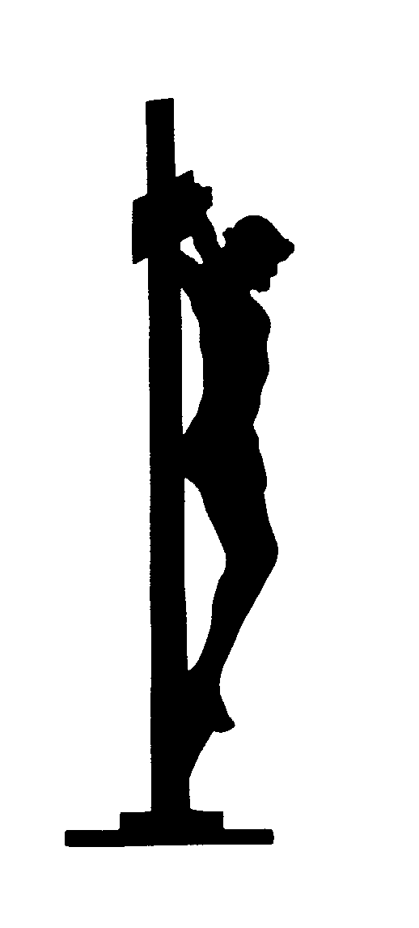
The Sermon

The Creed (Stand)
We believe in one God, the Father,
the Almighty, maker of heaven and earth,
of all that is, seen and unseen.
We believe in one Lord, Jesus Christ,
the only Son of God, eternally begotten of the Father,
God from God, Light from Light,
true God from true God, begotten, not made,
of one Being with the Father.
Through him all things were made.
All Bow For us and for our salvation he came
down from heaven, and was incarnate from the Holy Spirit
and the Virgin Mary and was made man
For our sake he was crucified under Pontius Pilate;
he suffered death and was buried.
On the third day he rose again in accordance with the Scriptures;
he ascended into heaven
and is seated at the right hand of the Father.
He will come again in glory to judge the living and the dead,
and his kingdom will have no end.
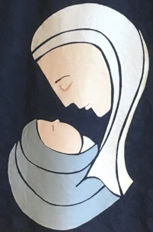
We believe in the Holy Spirit, the Lord, the giver of life,
who proceeds from the Father and the Son,
who with the Father and the Son is worshipped and glorified,
who has spoken through the prophets.
We believe in one holy catholic and apostolic Church.
We acknowledge one baptism for the forgiveness of sins.
We look for the resurrection of the dead,
and the life of the world to come. Amen.

The Prayers of the Faithful
Lord, hear us. Lord, graciously hear us.
The Priest concludes the prayers At the end Amen

The Liturgy of the Sacrament
The Peace (Stand)
Since we are justified by faith, we have peace with God through our Lord Jesus Christ, who has given us access to his grace and
The peace of the Lord be always with you
and also with you.

Hymn 95 When I survey the wondrous cross

Preparation of the Gifts
Pray my brothers and sisters that my sacrifice
and yours may be acceptable to God, the almighty Father.
May the Lord accept the sacrifice at your hands for the praise and glory of his name, for our good, and the good of all his Holy Church.

The Prayer over the gifts

Hear us, almighty God, and, having instilled in your servants the teachings of the Christian faith, graciously purify them by the working of this sacrifice. Through Christ our Lord.
Amen

The Eucharistic Prayer

The Lord be with you

and also with you.
Lift up your hearts
We lift them to the Lord.
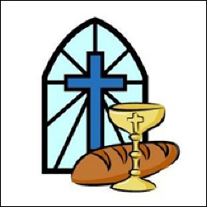
Let us give thanks to the Lord our God.

It is right to give him thanks and praise.

After the preface
Holy, holy, holy Lord,
God of power and might,
heaven and earth are full of your glory.
Hosanna in the highest.
Blessed is he who comes
in the name of the Lord.
Hosanna in the highest.
(Kneel)
After the words of institution
Jesus Christ is Lord:
Lord, by your cross and resurrection you have set us free.
You are the Saviour of the World
At the end Amen.

The Lord’s Prayer
Our Father, who art in heaven,

Breaking Of The Bread
We break this bread to share in the body of Christ.
Though we are many, we are one body, because we all share in one bread.

Lamb of God
Jesus, source of everlasting life:
Jesus, source of reconciling love:
Hear our prayer, have mercy;
hear our prayer, have mercy;
give us your peace.

Jesus, by whose suffering we are healed:
Jesus, man of sorrows, friend of grief:

Jesus, crucified transcending time:
Jesus, Saviour, by whose death we live

Behold the Lamb of God Behold him who takes away the sins of the world.
Blessed are those who are called to the supper of the Lamb.

Lord, I am not worthy to receive you, but only say the word, and I shall be healed.

The Priest and people receive communion. Communion is in two kinds if you wish. If you would rather just receive the bread go back to your seat when you have received. Communicant members of all churches are welcome to share in communion. If you would rather receive a blessing please come and bow your head and the priest will bless you with the sacrament.
The body of Christ. Amen The blood of Christ. Amen

Choir Anthem: O God of mercy’ - Simon Lole

Hymn 342 Breathe on me breath of God – (remain seated).

(Stand)
Post Communion Prayer:
We pray, almighty God, that we may always be counted among the members of Christ, in whose Body and Blood we have communion. Who lives and reigns for ever and ever.
Amen

St Richard’s Prayer
Lord Jesus Christ, we thank you for all the benefits you have won for us, for all the pains and insults you have borne for us. Most merciful redeemer, friend and brother, may we know you more clearly, love you more dearly, and follow you more nearly, day by day. Amen

The Dismissal

The Lord be with you

And also with you

Christ give you grace to grow in holiness, to deny yourselves, take up your cross, and follow him; and the blessing of God the Almighty Father, and the Son, and the Holy Spirit, Amen.

Go in peace to love and serve the Lord.
Thanks be to God.

Hymn
Refrain:
Lift high the cross, the love of Christ proclaim
till all the world adore his sacred Name.
Come, brethren, follow where our Captain trod,
our King victorious, Christ the Son of God. Refrain
Led on their way by this triumphant sign,
the hosts of God in conquering ranks combine. Refrain
Each newborn soldier of the Crucified
bears on the brow the seal of him who died. Refrain
This is the sign which Satan's legions fear
and angels veil their faces to rever. Refrain
Saved by this Cross whereon their Lord was slain,
the sons of Adam their lost home regain. Refrain
From north and south, from east and west they raise
in growing unison their songs of praise. Refrain
O Lord, once lifted on the glorious tree,
as thou hast promised, draw the world to thee. Refrain
Let every race and every language tell
of him who saves our souls from death and hell. Refrain
From farthest regions let their homage bring,
and on his Cross adore their Savior King. Refrain
Set up thy throne, that earth's despair may cease
beneath the shadow of its healing peace. Refrain
For thy blest Cross which doth for all atone
creation's praises rise before thy throne. Refrain

Organ voluntary: Prelude in E minor BWV 548 (‘The Wedge’) J S Bach

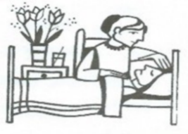
The Sick We pray for the residents of Rotherlea and Petworth
Cottage Nursing Home, and those on our daily prayer list and all of those known to us.
Recently Departed: Victoria Bray, Andrew Watson (bp), and
Charles Hedley (pr)
Years Mind: Alfred Peacock, Sybil Goodall, Meg Watkins, Eva Woollcombe.

Services this week

Tuesday 9.00am Mass

Wednesday 9.00am Mass

Thursday 9.00am Mass

Friday 9.00am Mass

Services next Sunday 29th March
Palm Sunday
8.00 Holy Eucharist
9.00am Passion Eucharist
10.30am Procession & Passion Eucharist
Procession from the Lych-gate
3.00pm PACT Walk of Witness from the Sacred Heart.

HELENA written by Evelen Waugh. Is this year’s lent book at Egdean. Helena was Waugh's most intentional statement about the truth of Christianity and about vocation as the heart of Christian discipleship -- George Weigel.
We will meet on Thursday, 26th March 7 pm Lenten Supper and opportunity to discuss our Lent Book.
Please sign up in Church

Holy Week and Easter Services
Monday 31st 10.00am Mass & Stations of the Cross
Tuesday 30th, 10.00am Mass & Stations of the Cross
Wednesday 1st April
12noon The Bishop of Chichester will preside at the Eucharist and bless the oils at The Cathedral (All welcome)
2nd April Maundy Thursday
Evening Eucharist of the Lord’s Supper. 7.30pm
3rd April Good Friday
The Liturgy of the Cross 2pm
4th April Easter Eve
Easter Vigil And First Mass Of Easter – 7.30pm
5th April Easter Day
Holy Eucharist 8.00am
Easter Family Eucharist At Egdean 9.00am
Easter Family Eucharist 10.30am

Do not forget that the clocks go forward 1Hour this coming Saturday.

If you have any notices that you would like to share with your friends here in church, please send them to the following email address by Wednesday each week on stmaryspetworth@gmail.com

Please note the new email address



Common Worship: Services and Prayers for the Church of England, material from which is included here, is copyright © The Archbishops' Council 2000 and published by Church House Publishing

