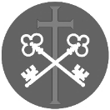
St Peter and the Holy Apostles, Plymouth- Sunday 22nd March 2026
The Fifth Sunday of Lent- Passiontide Begins (Year A)
Welcome to the Parish Mass
Welcome to St Peters Church. This sheet provides all that you will need for today’s Mass. If you need any assistance before, during or after the service or need a large print copy of this order of service please speak to one of our welcome team. (identifiable by a lanyard)
Please respond to the words in non-italic Bold, The Hymns are sung by all. Please inform the people on the door when you enter if you require a Gluten Free Host
…………………………………………………………………………………
We Stand for The Entrance Hymn
Cantor- Hear us, O Lord, have mercy upon us: for we have sinn’d against thee.
All- Hear us, O Lord, have mercy upon us: for we have sinn'd against thee.
1. To thee, Redeemer, on thy throne of glory:
lift we our weeping eyes in holy pleadings:
listen, O Jesu, to our supplications. Hear us, O Lord…
2. O thou chief Corner-stone, Right Hand of the Father
Way of Salvation, Gate of Life Celestial
cleanse thou our sinful souls from all defilement. Hear us, O Lord…
3. God, we implore thee, in thy glory seated
bow down and hearken to they children
pity and pardon all our grievous trespasses. Hear us, O Lord…
4. Sins oft committed now we lay before thee
with true contrition, now no more we veil them
grant us, Redeemer, loving absolution. Hear us, O Lord…
5. Innocent, captive, taken unresisting
falsely accused, and for us sinners sentenced,
save us, we pray thee, Jesu our Redeemer. Hear us, O Lord.

The Introductory Rite
In the name of the Father and of the Son and of the Holy Spirit. Amen.
Following the greeting we respond.
And with your spirit.
The Priest introduces the Mass
The Penitential Rite
Brothers and sisters, let us acknowledge our sins,
and so prepare ourselves to celebrate the sacred mysteries.

I confess to almighty God and to you, my brothers and sisters, that I have greatly sinned, in my thoughts and in my words, in what I have done and in what I have failed to do, through my fault, through my fault, through my most grievous fault; therefore I ask blessed Mary ever-Virgin, all the Angels and Saints, and you, my brothers and sisters, to pray for me to the Lord our God.

May almighty God have mercy on us, forgive us our sins, and bring us to everlasting life. Amen.

Either:
Lord, have mercy. Lord, have mercy.
Christ, have mercy. Christ, have mercy.
Lord, have mercy. Lord, have mercy.
Or:
Kyrie, eleison. Kyrie, eleison.
Christe, eleison. Christe, eleison.
Kyrie, eleison. Kyrie, eleison.

The Collect
Let us pray.
By your help, we beseech you, Lord our God, may we walk eagerly in that same charity with which, out of love for the world, your Son handed himself over to death. Through our Lord Jesus Christ, your Son, who lives and reigns with you in the unity of the Holy Spirit, God, for ever and ever. Amen.

We sit for The First Reading- Ezekiel 37:12-14

Thus says the Lord God: Behold, I will open your graves and raise you from your graves, O my people. And I will bring you into the land of Israel. And you shall know that I am the Lord, when I open your graves, and raise you from your graves, O my people. And I will put my Spirit within you, and you shall live, and I will place you in your own land. Then you shall know that I am the Lord; I have spoken, and I will do it, declares the Lord.
The word of the Lord. Thanks be to God.
The Responsorial Psalm- Ps 130(129):1-2. 3-4. 5-6b. 6c-8. ℟7bc

Response- With the Lord there is mercy, in him is plentiful redemption.

Out of the depths I cry to you, O Lord; Lord, hear my voice!
O let your ears be attentive to the sound of my pleadings. R

If you, O Lord, should mark iniquities, Lord, who could stand?
But with you is found forgiveness, that you may be revered. R

I long for you, O Lord, my soul longs for his word.
My soul awaits the Lord more than watchmen for daybreak. R

More than watchmen for daybreak, let Israel hope for the Lord.
For with the Lord there is mercy, in him is plentiful redemption.
It is he who will redeem Israel from all its iniquities. R

The second Reading- Romans 8:8-11

Brothers and Sisters: Those who are in the flesh cannot please God. You, however, are not in the flesh but in the Spirit, if in fact the Spirit of God dwells in you. Anyone who does not have the Spirit of Christ does not belong to him. But if Christ is in you, although the body is dead because of sin, the Spirit is life because of righteousness. If the Spirit of him who raised Jesus from the dead dwells in you, he who raised Christ Jesus from the dead will also give life to your mortal bodies through his Spirit who dwells in you.

The word of the Lord. Thanks be to God.

We Stand for- The Gospel Procession and Acclamation- John 11:25a, 26

Glory to you, O Christ, Glory to you O Christ, you are the Word of God, the Word of God, Glory to You O Christ.
Glory to you, O Christ, Glory to you O Christ, you are the Word of God, the Word of God, Glory to You O Christ.

I am the resurrection and the life, says the Lord.
Everyone who believes in me shall never die.
Glory to you, O Christ, Glory to you O Christ, you are the Word of God, the Word of God, Glory to You O Christ.

The Gospel- John 11:3-7, 17, 20-27, 33b-45

The Lord be with you. And with your spirit.
A reading from the holy Gospel according to N. Glory to you, O Lord.
At that time: The sisters of Lazarus sent to Jesus, saying, ‘Lord, he whom you love is ill.’ But when Jesus heard it he said, ‘This illness does not lead to death. It is for the glory of God, so that the Son of God may be glorified through it.’
Now Jesus loved Martha and her sister and Lazarus. So, when he heard that Lazarus was ill, he stayed two days longer in the place where he was. Then after this he said to the disciples, ‘Let us go to Judea again.’
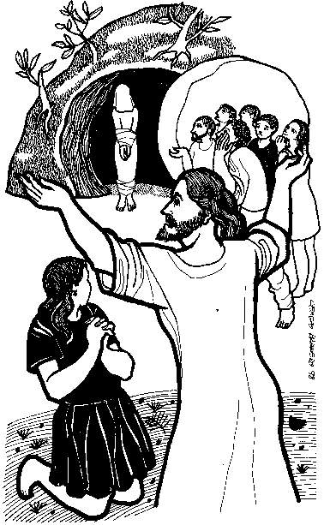
Now when Jesus came, he found that Lazarus had already been in the tomb four days. So when Martha heard that Jesus was coming, she went and met him, but Mary remained seated in the house. Martha said to Jesus, ‘Lord, if you had been here, my brother would not have died. But even now I know that whatever you ask from God, God will give you.’ Jesus said to her, ‘Your brother will rise again.’ Martha said to him, ‘I know that he will rise again in the resurrection on the last day.’ Jesus said to her, ‘I am the resurrection and the life. Whoever believes in me, though he die, yet shall he live, and everyone who lives and believes in me shall never die. Do you believe this?’ She said to him, ‘Yes, Lord; I believe that you are the Christ, the Son of God, who is coming into the world.’
Jesus was deeply moved in his spirit and greatly troubled. And he said, ‘Where have you laid him?’ They said to him, “Lord, come and see.” Jesus wept. So the Jews said, ‘See how he loved him!’ But some of them said, ‘Could not he who opened the eyes of the blind man also have kept this man from dying?’
Then Jesus, deeply moved again, came to the tomb. It was a cave, and a stone lay against it. Jesus said, ‘Take away the stone.’ Martha, the sister of the dead man, said to him, ‘Lord, by this time there will be a smell, for he has been dead four days.’ Jesus said to her, ‘Did I not tell you that if you believed you would see the glory of God?’ So they took away the stone. And Jesus lifted up his eyes and said, ‘Father, I thank you that you have heard me. I knew that you always hear me, but I said this on account of the people standing around, that they may believe that you sent me.’ When he had said these things, he cried out with a loud voice, ‘Lazarus, come out.’ The man who had died came out, his hands and feet bound with linen strips, and his face wrapped with a cloth. Jesus said to them, ‘Unbind him, and let him go.’
Many of the Jews therefore, who had come with Mary and had seen what he did, believed in him.

The Gospel of the Lord. Praise to you, Lord Jesus Christ.
We sit for The Homily

We stand The Creed
I believe in one God, the Father almighty, maker of heaven and earth,
of all things visible and invisible.
I believe in one Lord Jesus Christ, the Only Begotten Son of God, born of the Father before all ages. God from God, Light from Light, true God from true God, begotten, not made, consubstantial with the Father; through him all things were made. For us men and for our salvation he came down from heaven,
At the words that follow, up to and including ‘and became man’, all bow.
and by the Holy Spirit was incarnate of the Virgin Mary, and became man.
For our sake he was crucified under Pontius Pilate, he suffered death and was buried, and rose again on the third day in accordance with the Scriptures.
He ascended into heaven and is seated at the right hand of the Father. He will come again in glory to judge the living and the dead and his kingdom will have no end.
I believe in the Holy Spirit, the Lord, the giver of life, who proceeds from the Father and the Son, who with the Father and the Son is adored and glorified, who has spoken through the prophets.
I believe in one, holy, catholic and apostolic Church. I confess one Baptism for the forgiveness of sins and I look forward to the resurrection of the dead and the life of the world to come. Amen.
……………………………………………………………………………………………………..

We remain standing for The Prayers of the Faithful

Each biding concludes with the following said or sung-

Lord have mercy, Lord have mercy,
Lord have mercy on your people

The Priest Concludes the Prayers of the Faithful
No collection is taken during the Mass, but there is a collection box at the back of church for you to give your financial contribution. All money collected helps towards the mission and ministry of our churches. If you would prefer, a card reading machine is available at the back of the church for your contribution.

The Offertory Hymn
1. ‘I am the Bread of life. Those who come to me shall not hunger;
those who believe in me shall not thirst.
No one can come to me unless the Father draws them.
‘And I will raise them up, and I will raise them up,
and I will raise them up on the last day.’
2. ‘The bread that I will give is my flesh for the life of the world,
and those who eat this bread they shall live for ever, they shall live for ever.
‘And I will raise them up, and I will raise them up,
and I will raise them up on the last day.’
3. ‘Unless you eat of the flesh of the Son of Man and drink of his blood,
and drink of his blood, you shall not have life within you.
‘And I will raise them up, and I will raise them up,
and I will raise them up on the last day.’
4. ‘I am the Resurrection, I am the life.
those who believe in me; even though they die they shall live for ever.
‘And I will raise them up, and I will raise them up,
and I will raise them up on the last day.’
5. Yes, Lord, I believe that you are the Christ,
the Son of God, who has come into the world.
‘And I will raise them up, and I will raise them up,
and I will raise them up on the last day.
The Liturgy of the Eucharist
Pray, brethren (brothers and sisters), that my sacrifice and yours may be acceptable to God, the almighty Father.
May the Lord accept the sacrifice at your hands for the praise and glory of his name, for our good and the good of all his holy Church.

The Lord be with you. And with your spirit.
Lift up your hearts. We lift them up to the Lord.
Let us give thanks to the Lord our God. It is right and just.
The Priest continues with the Preface. The Sanctus is the said or sung:
Holy, Holy, Holy Lord God of hosts.
Heaven and earth are full of your glory. Hosanna in the highest.
Blessed is he who comes in the name of the Lord. Hosanna in the highest.

The Priest continues the Eucharistic prayer. The following is said or sung
The mystery of faith…. Save us Saviour of the world, Save us Saviour of the world, for by your cross and resurrection, you have set us free.
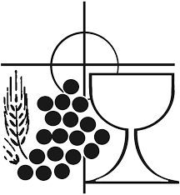
The Priest concludes the Eucharistic prayer.

Through him, and with him, and in him, O God, almighty Father, in the unity of the Holy Spirit, all glory and honour is yours, for ever and ever. Amen.

The Lord’s Prayer
At the Saviour’s command and formed by divine teaching, we dare to say:
Our Father, who art in heaven, hallowed be thy name; thy kingdom come, thy will be done on earth as it is in heaven. Give us this day our daily bread, and forgive us our trespasses, as we forgive those who trespass against us; and lead us not into temptation, but deliver us from evil.
Deliver us, Lord, we pray… and the coming of our Saviour, Jesus Christ.
For the kingdom, the power and the glory are yours now and for ever.

The Peace
Lord Jesus Christ, who said to your Apostles: Peace I leave you, my peace I give you,
look not on our sins, but on the faith of your Church, and graciously grant her peace and unity in accordance with your will. Who live and reign for ever and ever. Amen.
The peace of the Lord be with you always: And with your spirit.
Let us offer each other the sign of peace.
All are invited to make an acknowledgement to each other to mark the sign of the peace.

The Agnus Dei
All say or sing:
Lamb of God, you take away the sins of the world, have mercy on us.
Lamb of God, you take away the sins of the world, have mercy on us.
Lamb of God, you take away the sins of the world, grant us peace.
The Invitation to Communion

Behold the Lamb of God, behold him who takes away the sins of the world. Blessed are those called to the supper of the Lamb.
Lord, I am not worthy that you should enter under my roof, but only say the word and my soul shall be healed.
All who are regular communicants in their own tradition are welcome to receive the sacrament if you are not a communicant you are welcome to come forward at this point in the service to receive a blessing To indicate that it is just a blessing you require, please take this service sheet up with you. We have returned to offering the chalice at the time of communion but please do not feel any pressure to receive from the common cup as the church teaches that the sacrament is received fully in one kind. We request that you do not intinct (dip) your host in the Chalice but either take a sip from the cup or return directly to your seat. This is for reasons of good hygiene.

The Communion Hymn

1. Christ triumphant, ever reigning,
Saviour, Master, King!
Lord of heaven, our lives sustaining,
hear us as we sing:
Yours the glory and the crown,
the high renown, the eternal name.
2. Word incarnate, truth revealing,
Son of Man on earth!
power and majesty concealing
by your humble birth:
Yours the glory and the crown,
the high renown, the eternal name.
3. Suffering servant, scorned, ill - treated,
victim crucified!
death is through the cross defeated,
sinners justified:
Yours the glory and the crown,
the high renown, the eternal name.
4. Priestly king, enthroned for ever
high in heaven above!
sin and death and hell shall never
stifle hymns of love:
Yours the glory and the crown,
the high renown, the eternal name.

5. So, our hearts and voices raising
through the ages long,
ceaselessly upon you gazing,
this shall be our song:
Yours the glory and the crown,
the high renown, the eternal name.

We stand for The Prayer After Communion
Let us pray. We pray, almighty God, that we may always be counted among the members of Christ, in whose Body and Blood we have communion. Who lives and reigns for ever and ever. Amen.
The priest may give some brief notices

The Concluding Rites and The Dismissal

The Lord be with you. And with your spirit.
And may the blessing of almighty God, the Father, and the Son, ✠ and the Holy Spirit, come down on you and remain with you for ever. Amen.
Go forth, the Mass is ended. Thanks be to God

The Final Hymn
Lift high the cross, the love of Christ proclaim,
Till all the world adore His sacred Name.
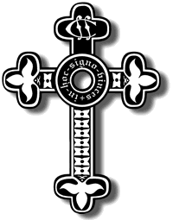
1. Come, brethren, follow where our Captain trod,
our King victorious, Christ the Son of God.
Lift high the cross, the love of Christ proclaim,
Till all the world adore His sacred Name.
2. Led on their way by this triumphant sign,
The hosts of God in conquering ranks combine.
Lift high the cross, the love of Christ proclaim,
Till all the world adore His sacred Name.
3. O Lord, once lifted on the glorious tree,
as thou hast promised, draw the world to thee.
Lift high the cross, the love of Christ proclaim,
Till all the world adore His sacred Name.
4. Let every race and every language tell
of him who saves our souls from death and hell.
Lift high the cross, the love of Christ proclaim,
Till all the world adore His sacred Name.
5.Set up thy throne, that earth's despair may cease
beneath the shadow of its healing peace.
Lift high the cross, the love of Christ proclaim,
Till all the world adore His sacred Name.
6. For thy blest Cross which doth for all atone
creation's praises rise before thy throne.
Lift high the cross, the love of Christ proclaim,
Till all the world adore His sacred Name.
The Angelus
The Angel of the Lord declared unto Mary. And she conceived of the Holy Spirit.

Hail Mary, full of grace, The Lord is with Thee; Blessed art thou among women,
And blessed is the fruit of thy womb, Jesus.
Holy Mary, Mother of God, Pray for us sinners,
Now and at the hour of our death.

Behold the handmaid of the Lord.
Be it done to me according to thy word. Hail Mary. . .

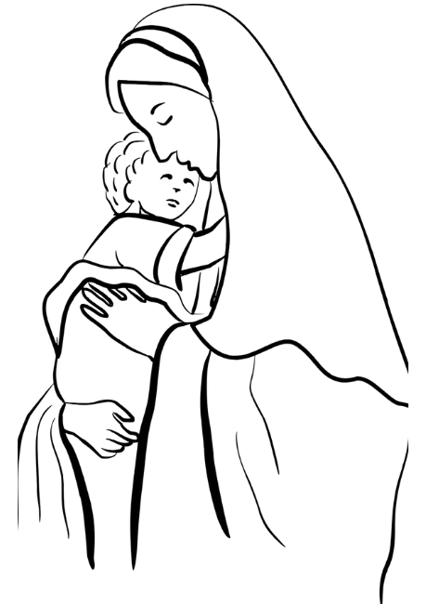
And the Word was made flesh.
And dwelt among us. Hail Mary…

Pray for us, O holy Mother of God.
That we may be made worthy of the promises of Christ.

Let us pray: Pour forth, we beseech Thee, O Lord, Thy grace into our hearts, that we to whom the Incarnation of Christ Thy Son was made known by the message of an angel, may by His Passion and Cross be brought to the glory of His Resurrection. Through the same Christ Our Lord. Amen.

……………………………………………………………………

The Notices

Lent 2026
Stations of the Cross- Sunday Evenings 6pm (please see service times for weekly locations
Holy Week is Sunday 29th March – 5th April,
Holy Monday- St Peter’s 10.00am St Batholomew 7.00pm
Holy Turesday St Peter’s 10.00am St Francis 7.00pm
Holy Wednesday St Peter’s 10.00am St Gabriel 7.00pm
Maunday Thursday St Peter’s 7.30pm
Good Friday 10.00am Outdoor Stations of The Cross 3.00pm Liturgy
Holy Saturday Vigil & First mass 8.00pm
Easter Day 10.00am

Monday to Wednesday of Holy Week church cleaning from 11.00 -12.00
Holy Saturday from 10.00am All Hands on Deck! to get the church clean and ready for Easter

Bible Study at St Francis- Monday evenings through lent at 6pm at St Francis- lead by Ben Otley- we will be studying the Book of Exodus

Chrism Mass Thursday 26th March at 11.00 Exeter Cathedral.

Easter cards are available on the table in Cloisters, donations in the wooden box

Annual Parochial Church Meeting is on Sunday 19th April at 12.00noon

Easter Flowers for Church- Julian is happy to receive donations for flowers for Easter and/or any offers of help with the flowers on holy Saturday.

For Prayer

Those who have asked for our prayers…. Denise, Janice Allin, Leslie Porch,
Sheila Tucker, Tina Smart, Bobby Lilicrap, June Brock, Emma Addison, Georgie Maher, Ian Craggs, Brenda Alderson, Lois Tobin, Brenda Steed, Anne Lewis, Jenny Harvey, Jackie Morrison, Anna, Gwen Lamb, Anna Lynch, Helen Lewis, Val Bradden, Cynthia Way, Pauleen Stewart, Amelia Coughlan, Roger Lewis, Shaun Carrie, Fr Jon Bielawski, Catherine Samuel, Julian Davies, Fr Michael Brown.

Recently Departed- Kathy Haydon

Anniversaries of Death-
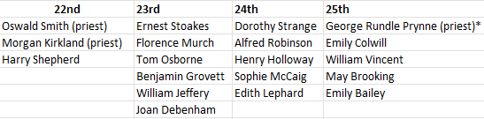
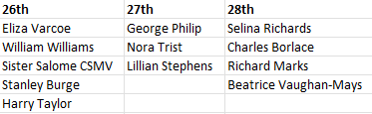

The Mission Community of St Peter and the Holy Apostles
St Peter, Wyndham Square + St Thomas, Royal Navy Avenue + St James-the-Less, Ham Drive
A Church of England Parish in the care of the Bishop of Oswestry
Parish Priest Fr. David Way SSC: 01752 240119 fr.davidway@gmail.com
.com
Mission Development Minister/ LLM/ Parish Ordinand: Ben Otley 07939800544 benotley.mission.plym@gmail.com

Parish Website: plymouthstpeter.co.uk ~ FOR MUCH MORE INFORMATION ON EVENTS, ETC.

This week’s services
Sunday 22nd-  The Fifth Sunday/Week  in Lent  Passiontide begins | 8.30am St Thomas Fr DW  10.00am St Peter Fr DW  6.00pm St Batholomew | Mass with Hymns  Sung Mass  Stations of the Cross
Monday 23rd- Weekday of Lent | St Peter 10.00am Fr PL | Mass
Tuesday 24th- Weekday of Lent | St Peter 10.00am Fr DW | Mass
Wednesday 25th-  The Annunciation of the Lord | St Peter 10.00am Fr DW | Mass
Thursday 26th- Weekday of Lent | St Peter 12.00 noon Fr DW | Mass
Friday 27th- Weekday of Lent | St Peter 6.00pm Fr DW | Mass
Saturday 28th- Weekday of Lent | St Peter 10.00am Fr DW | Mass
Sunday 29th9  Palm Sunday of the Passion of the Lord  (Holy Weed Begins) | 8.30am St Thomas Fr DW  10.00am St Peter Fr DW | Mass with Hymns  Sung Mass
St Peters is open daily 8.30am- 12noon- Place of Welcome, Place of Prayer.

Safeguarding: If you have any concerns regarding the safety of children and others who are vulnerable, regardless of age, you must tell the Duty Priest or our parish Lay Safeguarding Representative- Jackie Morrison- email randj49@gmail.com Tel 07848859124.
For online donations please scan the QR code

