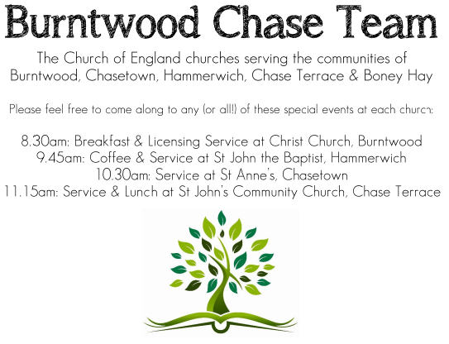
CHRIST CHURCH
Registered Charity Nos. 1217129

SERVICE ON SUNDAY 5th April 2026 at 10am

Holy Communion

Easter Sunday

Readings:
Acts 10: 34-43

³⁴ Then Peter began to speak to them: ‘I truly understand that God shows no partiality, ³⁵ but in every nation anyone who fears him and does what is right is acceptable to him. ³⁶ You know the message he sent to the people of Israel, preaching peace by Jesus Christ—he is Lord of all. ³⁷ That message spread throughout Judea, beginning in Galilee after the baptism that John announced: ³⁸ how God anointed Jesus of Nazareth with the Holy Spirit and with power; how he went about doing good and healing all who were oppressed by the devil, for God was with him. ³⁹ We are witnesses to all that he did both in Judea and in Jerusalem. They put him to death by hanging him on a tree; ⁴⁰ but God raised him on the third day and allowed him to appear, ⁴¹ not to all the people but to us who were chosen by God as witnesses, and who ate and drank with him after he rose from the dead. ⁴² He commanded us to preach to the people and to testify that he is the one ordained by God as judge of the living and the dead. ⁴³ All the prophets testify about him that everyone who believes in him receives forgiveness of sins through his name.’

Matthew 28: 1-10

After the sabbath, as the first day of the week was dawning, Mary Magdalene and the other Mary went to see the tomb. ² And suddenly there was a great earthquake; for an angel of the Lord, descending from heaven, came and rolled back the stone and sat on it. ³ His appearance was like lightning, and his clothing white as snow. ⁴ For fear of him the guards shook and became like dead men. ⁵ But the angel said to the women, ‘Do not be afraid; I know that you are looking for Jesus who was crucified. ⁶ He is not here; for he has been raised, as he said. Come, see the place where he lay. ⁷ Then go quickly and tell his disciples, “He has been raised from the dead, and indeed he is going ahead of you to Galilee; there you will see him.” This is my message for you.’ ⁸ So they left the tomb quickly with fear and great joy, and ran to tell his disciples. ⁹ Suddenly Jesus met them and said, ‘Greetings!’ And they came to him, took hold of his feet, and worshipped him. ¹⁰ Then Jesus said to them, ‘Do not be afraid; go and tell my brothers to go to Galilee; there they will see me.’

COLLECT FOR TODAY
Lord of all life and power,
who through the mighty resurrection of your Son
overcame the old order of sin and death
to make all things new in him:
grant that we, being dead to sin
and alive to you in Jesus Christ,
may reign with him in glory;
to whom with you and the Holy Spirit
be praise and honour, glory and might,
now and in all eternity.

WHAT’S GOING ON
Upcoming Services and Events
Monday 6th April Cameo Cafe 10-12 noon
Sunday 12th April Morning Worship 10am
Wednesday 15th April Morning Prayer 9.30am
Sunday 19th April Holy Communion 10am

DATES FOR YOUR DIARY
Saturday 16th May Spring Fayre
Saturday 27th June Cream Tea
Saturday 11th July Shelfield Choir Concert
Saturday 14th November Christmas Fayre

FLOODLIGHTING
If you think about commemorating a special occasion by floodlighting our Church. Please contact Chris Brown on 01543 683862 for details.

PRAYER CHAIN
Christ Church is blessed with a very active prayer chain. If you, or anyone you know, feel that they would like others to pray for them, please speak to Chris Brown on 01543 683862.

HOME COMMUNION
For anyone who is unable to attend church and would like a Home Visit and Communion, please contact the Vicar and he will be able to carry this out.

VICAR CONTACT DETAILS
Rev’d Stephen Morgan Tele: 07305 852152
CHURCH WARDENS CONTACT DETAILS
Judith Rogers Tele: 01543 324718
Mike Holmes Tele: 01543 672970
Church Office Tele: 01543 642187 [leave a message and we will respond]
Church Web Site:www.christchurchburntwood.org.uk
Church Email: christchurchburntwood15@gmail.com
Facebook: www.facebook.com/group/christchurchburntwood/

Other Contacts
Rev’d Matt Wallace St. John’s, Chase Terrace— Tele: 01543 670078

NEXT SUNDAY SERVICE
Sunday 12th April at 10am
Morning Worship
Acts 2: 14a, 22-32
John 20: 19-31
2nd Sunday of Easter

