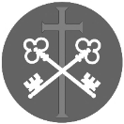
St Peter and the Holy Apostles, Plymouth- Sunday 8th March 2026
The Third Sunday of Lent (Year A)
Welcome to the Parish Mass
Welcome to St Peters Church. This sheet provides all that you will need for today’s Mass. If you need any assistance before, during or after the service or need a large print copy of this order of service please speak to one of our welcome team. (identifiable by a lanyard)
Please respond to the words in non-italic Bold, The Hymns are sung by all. Please inform the people on the door when you enter if you require a Gluten Free Host
…………………………………………………………………………………
We Stand for The Entrance Hymn

1. Glorious things of thee are spoken,
Zion, city of our God;
He whose word cannot be broken
Formed thee for His own abode.
On the Rock of Ages founded,
What can shake thy sure repose?
With salvation's walls surrounded,
Thou may'st smile at all thy foes.
2. See, the streams of living waters,
Springing from eternal Love,
Well supply thy sons and daughters,
And all fear of want remove.
Who can faint while such a river
Ever flows their thirst to assuage?
Grace which like the Lord, the Giver,
Never fails from age to age!
3. Blest inhabitants of Zion,
Washed in the Redeemer's blood!
Jesus, whom their souls rely on,
Makes them kings and priests to God.
'Tis his love his people raises
Over self to reign as kings,
And as priests, his solemn praises
Each for a thank-offering brings.
4. Saviour, since of Zion's city
I through grace, a member am,
Let the world deride or pity;
I will glory in your name.
Fading is the worldlings pleasure,
All its boasted pomp and show;
Solid joys and lasting treasures
None but Zion's children know.

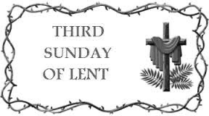
The Introductory Rite
In the name of the Father and of the Son and of the Holy Spirit. Amen.
Following the greeting we respond.
And with your spirit.

The Priest introduces the Mass
The Penitential Rite
Brothers and sisters, let us acknowledge our sins,
and so prepare ourselves to celebrate the sacred mysteries.

I confess to almighty God and to you, my brothers and sisters, that I have greatly sinned, in my thoughts and in my words, in what I have done and in what I have failed to do, through my fault, through my fault, through my most grievous fault; therefore I ask blessed Mary ever-Virgin, all the Angels and Saints, and you, my brothers and sisters, to pray for me to the Lord our God.

May almighty God have mercy on us, forgive us our sins, and bring us to everlasting life. Amen.

Either:
Lord, have mercy. Lord, have mercy.
Christ, have mercy. Christ, have mercy.
Lord, have mercy. Lord, have mercy.
Or:
Kyrie, eleison. Kyrie, eleison.
Christe, eleison. Christe, eleison.
Kyrie, eleison. Kyrie, eleison.

The Collect
Let us pray.

O God, author of every mercy and of all goodness, who in fasting, prayer and almsgiving have shown us a remedy for sin, look graciously on this confession of our lowliness, that we, who are bowed down by our conscience, may always be lifted up by your mercy. Through our Lord Jesus Christ, your Son, who lives and reigns with you in the unity of the Holy Spirit, God, for ever and ever. Amen.

We sit for The First Reading- Exodus 17:3-7

In those days: The people thirsted for water, and the people grumbled against Moses and said, ‘Why did you bring us up out of Egypt, to kill us and our children and our livestock with thirst?’ So Moses cried to the Lord, ‘What shall I do with this people? They are almost ready to stone me.’ And the Lord said to Moses, ‘Pass on before the people, taking with you some of the elders of Israel, and take in your hand the staff with which you struck the Nile, and go. Behold, I will stand before you there on the rock at Horeb, and you shall strike the rock, and water shall come out of it, and the people will drink.’ And Moses did so, in the sight of the elders of Israel. And he called the name of the place Massah and Meribah, because of the quarrelling of the people of Israel, and because they tested the Lord by saying, ‘Is the Lord among us or not?’

The word of the Lord. Thanks be to God.

The Responsorial Psalm- Ps 95(94):1-2. 6-7b. 7c-9. ℟7c, 8a

O that today you would listen to his voice!
‘Harden not your hearts.’

Come, let us ring out our joy to the Lord; hail the rock who saves us.
Let us come into his presence, giving thanks; let us hail him with a song of praise. R

O come; let us bow and bend low. Let us kneel before the Lord who made us,
for he is our God, and we the people, the people of his pasture, the flock of his hand. R

O that today you would listen to his voice! ‘Harden not your hearts as at Meribah,
as on that day at Massah in the desert when your forebears put me to the test;
when they tried me, though they saw my work.’ R

The second Reading- Romans 5:1-2, 5-8

Brothers and Sisters: Since we have been justified by faith, we have peace with God through our Lord Jesus Christ. Through him we have also obtained access by faith into this grace in which we stand, and we rejoice in hope of the glory of God, and hope does not put us to shame, because God’s love has been poured into our hearts through the Holy Spirit who has been given to us.
For while we were still weak, at the right time Christ died for the ungodly. For one will scarcely die for a righteous person — though perhaps for a good person one would dare even to die — but God shows his love for us in that while we were still sinners, Christ died for us.

The word of the Lord. Thanks be to God

We Stand for- The Gospel Procession and Acclamation- Romans 5:1-2, 5-8

Glory to you, O Christ, Glory to you O Christ, you are the Word of God, the Word of God, Glory to You O Christ.
Glory to you, O Christ, Glory to you O Christ, you are the Word of God, the Word of God, Glory to You O Christ.

Lord, you are indeed the Saviour of the world;
give me living water, so that I will not be thirsty.
Glory to you, O Christ, Glory to you O Christ, you are the Word of God, the Word of God, Glory to You O Christ.

The Gospel- John 4:5-42

The Lord be with you. And with your spirit.
A reading from the holy Gospel according to N. Glory to you, O Lord.
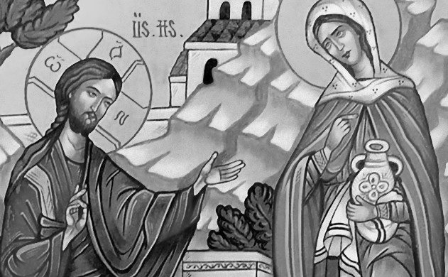
At that time: Jesus came to a town of Samaria called Sychar, near the field that Jacob had given to his son Joseph. Jacob’s well was there; so Jesus, wearied as he was from his journey, was sitting beside the well. It was about the sixth hour.
A woman from Samaria came to draw water. Jesus said to her, ‘Give me a drink.’ (For his disciples had gone away into the city to buy food.) The Samaritan woman said to him, ‘How is it that you, a Jew, ask for a drink from me, a woman of Samaria?’ (For Jews have no dealings with Samaritans.) Jesus answered her, ‘If you knew the gift of God, and who it is that is saying to you, “Give me a drink”, you would have asked him, and he would have given you living water.’ The woman said to him, ‘Sir, you have nothing to draw water with, and the well is deep. Where do you get that living water? Are you greater than our father Jacob? He gave us the well and drank from it himself, as did his sons and his livestock.’ Jesus said to her, ‘Everyone who drinks of this water will be thirsty again, but whoever drinks of the water that I will give him will never be thirsty again. The water that I will give him will become in him a spring of water welling up to eternal life.’ The woman said to him, ‘Sir, give me this water, so that I will not be thirsty or have to come here to draw water.’
Jesus said to her, ‘Go, call your husband, and come here.’ The woman answered him, ‘I have no husband.’ Jesus said to her, ‘You are right in saying, “I have no husband”; for you have had five husbands, and the one you now have is not your husband. What you have said is true.’ The woman said to him, ‘Sir, I perceive that you are a prophet. Our fathers worshipped on this mountain, but you say that in Jerusalem is the place where people ought to worship.’ Jesus said to her, ‘Woman, believe me, the hour is coming when neither on this mountain nor in Jerusalem will you worship the Father. You worship what you do not know; we worship what we know, for salvation is from the Jews. But the hour is coming, and is now here, when the true worshippers will worship the Father in spirit and truth, for the Father is seeking such people to worship him. God is spirit, and those who worship him must worship in spirit and truth.’ The woman said to him, ‘I know that Messiah is coming — he who is called Christ. When he comes, he will tell us all things.’ Jesus said to her, ‘I who speak to you am he.’
Just then his disciples came back. They marvelled that he was talking with a woman, but no one said, ‘What do you seek?’ or, ‘Why are you talking with her?’ So the woman left her water jar and went away into town and said to the people, ‘Come, see a man who told me all that I ever did. Can this be the Christ?’ They went out of the town and were coming to him.
Meanwhile the disciples were urging him, saying, ‘Rabbi, eat.’ But he said to them, ‘I have food to eat that you do not know about.’ So the disciples said to one another, ‘Has anyone brought him something to eat?’ Jesus said to them, ‘My food is to do the will of him who sent me and to accomplish his work. Do you not say, “There are yet four months, then comes the harvest”? Look, I tell you, lift up your eyes, and see that the fields are white for harvest. Already the one who reaps is receiving wages and gathering fruit for eternal life, so that sower and reaper may rejoice together. For here the saying holds true, “One sows and another reaps.” I sent you to reap that for which you did not labour. Others have laboured, and you have entered into their labour.’
Many Samaritans from that town believed in him because of the woman’s testimony, ‘He told me all that I ever did.’ So when the Samaritans came to him, they asked him to stay with them, and he stayed there two days. And many more believed because of his word. They said to the woman, ‘It is no longer because of what you said that we believe, for we have heard for ourselves, and we know that this is indeed the Saviour of the world.’

The Gospel of the Lord. Praise to you, Lord Jesus Christ.

We sit for The Homily

We stand The Creed
I believe in one God, the Father almighty, maker of heaven and earth,
of all things visible and invisible.
I believe in one Lord Jesus Christ, the Only Begotten Son of God, born of the Father before all ages. God from God, Light from Light, true God from true God, begotten, not made, consubstantial with the Father; through him all things were made. For us men and for our salvation he came down from heaven,
At the words that follow, up to and including ‘and became man’, all bow.
and by the Holy Spirit was incarnate of the Virgin Mary, and became man.
For our sake he was crucified under Pontius Pilate, he suffered death and was buried, and rose again on the third day in accordance with the Scriptures.
He ascended into heaven and is seated at the right hand of the Father. He will come again in glory to judge the living and the dead and his kingdom will have no end.
I believe in the Holy Spirit, the Lord, the giver of life, who proceeds from the Father and the Son, who with the Father and the Son is adored and glorified, who has spoken through the prophets.
I believe in one, holy, catholic and apostolic Church. I confess one Baptism for the forgiveness of sins and I look forward to the resurrection of the dead and the life of the world to come. Amen.
……………………………………………………………………………………………………..

We remain standing for The Prayers of the Faithful

Each biding concludes with the following said or sung-

Lord have mercy, Lord have mercy,
Lord have mercy on your people

The Priest Concludes the Prayers of the Faithful
……………………………………………………………………………………………………..
No collection is taken during the Mass, but there is a collection box at the back of church for you to give your financial contribution. All money collected helps towards the mission and ministry of our churches. If you would prefer, a card reading machine is available at the back of the church for your contribution.
The Offertory Hymn
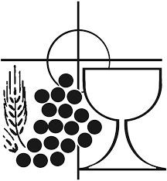
1. I heard the voice of Jesus say,
'Come unto me and rest;
Lay down, thou weary one, lay down
Thy head upon my breast:'
I came to Jesus as I was,
Weary, and worn, and sad;
I found in him a resting place,
And he has made me glad.
2. I heard the voice of Jesus say,
'Behold, I freely give
The living water, thirsty one;
Stoop down, and drink, and live:
I came to Jesus, and I drank
Of that life-giving stream;
My thirst was quenched, my soul revived,
And now I live in him.
3. I heard the voice of Jesus say,
'I am this dark world’s Light;
Look unto me, thy morn shall rise,
And all thy day be bright:'
I looked to Jesus, and I found
In him my Star, my Sun;
And in that light of life I’ll walk
Till travelling days are done.

The Liturgy of the Eucharist
Pray, brethren (brothers and sisters), that my sacrifice and yours may be acceptable to God, the almighty Father.
May the Lord accept the sacrifice at your hands for the praise and glory of his name, for our good and the good of all his holy Church.

The Lord be with you. And with your spirit.
Lift up your hearts. We lift them up to the Lord.
Let us give thanks to the Lord our God. It is right and just.

The Priest continues with the Preface. The Sanctus is the said or sung:

Holy, Holy, Holy Lord God of hosts.
Heaven and earth are full of your glory. Hosanna in the highest.
Blessed is he who comes in the name of the Lord. Hosanna in the highest.

The Priest continues the Eucharistic prayer. The following is said or sung
The mystery of faith…. Save us Saviour of the world, Save us Saviour of the world, for by your cross and resurrection, you have set us free.

The Priest concludes the Eucharistic prayer.

Through him, and with him, and in him, O God, almighty Father, in the unity of the Holy Spirit, all glory and honour is yours, for ever and ever. Amen.

The Lord’s Prayer
At the Saviour’s command and formed by divine teaching, we dare to say:
Our Father, who art in heaven, hallowed be thy name; thy kingdom come, thy will be done on earth as it is in heaven. Give us this day our daily bread, and forgive us our trespasses, as we forgive those who trespass against us; and lead us not into temptation, but deliver us from evil.
Deliver us, Lord, we pray… and the coming of our Saviour, Jesus Christ.
For the kingdom, the power and the glory are yours now and for ever.

The Peace
Lord Jesus Christ, who said to your Apostles: Peace I leave you, my peace I give you,
look not on our sins, but on the faith of your Church, and graciously grant her peace and unity in accordance with your will. Who live and reign for ever and ever. Amen.
The peace of the Lord be with you always: And with your spirit.
Let us offer each other the sign of peace.
All are invited to make an acknowledgement to each other to mark the sign of the peace.

The Agnus Dei
All say or sing:
Lamb of God, you take away the sins of the world, have mercy on us.
Lamb of God, you take away the sins of the world, have mercy on us.
Lamb of God, you take away the sins of the world, grant us peace.

The Invitation to Communion

Behold the Lamb of God, behold him who takes away the sins of the world. Blessed are those called to the supper of the Lamb.
Lord, I am not worthy that you should enter under my roof, but only say the word and my soul shall be healed.

All who are regular communicants in their own tradition are welcome to receive the sacrament if you are not a communicant you are welcome to come forward at this point in the service to receive a blessing To indicate that it is just a blessing you require, please take this service sheet up with you. We have returned to offering the chalice at the time of communion but please do not feel any pressure to receive from the common cup as the church teaches that the sacrament is received fully in one kind. We request that you do not intinct (dip) your host in the Chalice but either take a sip from the cup or return directly to your seat. This is for reasons of good hygiene.

The Communion Hymn

1. Rock of ages, cleft for me,
Let me hide myself in thee;
Let the water and the blood,
From thy riven side which flowed,
Be of sin the double cure,
Cleanse me from its guilt and power.
2. Not the labours of my hands
Can fulfil thy law's demands;
Could my zeal no respite know,
Could my tears for ever flow,
All for sin could not atone;
Thou must save, and thou alone.
3. Nothing in my hand I bring,
Simply to thy cross I cling;
Naked, come to thee for dress;
Helpless, look to thee for grace;
Foul, I to the fountain fly;
Wash me, Saviour, or I die.
4. While I draw this fleeting breath,
When mine eyes are closed in death,
When I soar through tracts unknown,
See thee on thy judgement throne;
Rock of ages, cleft for me,
Let me hide myself in thee.

We stand for The Prayer After Communion

Let us pray.

As we receive the pledge of things yet hidden in heaven and are nourished while still on earth with the Bread that comes from on high, we humbly entreat you, O Lord, that what is being brought about in us in mystery may come to true completion.
Through Christ our Lord. Amen.

The priest may give some brief notices

The Concluding Rites and The Dismissal

The Lord be with you. And with your spirit.
Bow down for the blessing.
May bountiful blessing, O Lord, we pray, come down upon your people, that hope may grow in tribulation, virtue be strengthened in temptation, and eternal redemption be assured. Through Christ our Lord. Amen.
And may the blessing of almighty God, the Father, and the Son, ✠ and the Holy Spirit, come down on you and remain with you for ever. Amen.
Go forth, the Mass is ended. Thanks be to God

The Final Hymn

1. Guide me, O thou great Redeemer,
Pilgrim through this barren land;
I am weak, but thou art mighty,
Hold me with thy powerful hand:
Bread of heaven,
Feed me till I want no more.
2. Open now the crystal fountain
Whence the healing stream doth flow;
Let the fire and cloudy pillar
Lead me all my journey through:
Strong Deliverer,
Be thou still my strength and shield.
3. When I tread the verge of Jordan,
Bid my anxious fears subside;
Death of death, and hell's Destruction
Land me safe on Canaan's side:
Songs of praises
I will ever give to thee.

The Angelus
The Angel of the Lord declared unto Mary. And she conceived of the Holy Spirit.

Hail Mary, full of grace, The Lord is with Thee; Blessed art thou among women,
And blessed is the fruit of thy womb, Jesus.
Holy Mary, Mother of God, Pray for us sinners,
Now and at the hour of our death.

Behold the handmaid of the Lord.
Be it done to me according to thy word. Hail Mary. . .
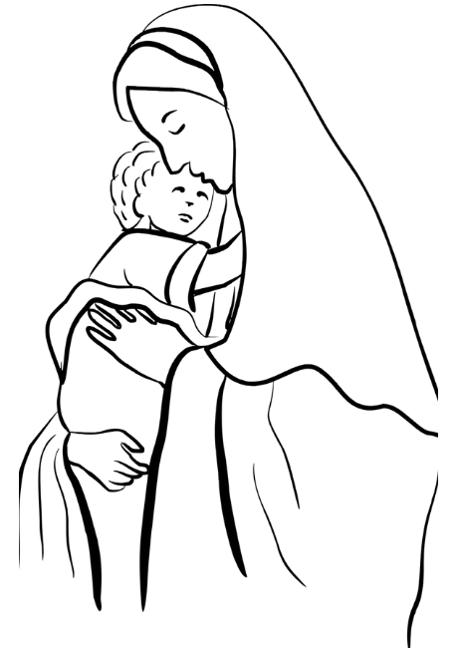
And the Word was made flesh.
And dwelt among us. Hail Mary…

Pray for us, O holy Mother of God.
That we may be made worthy of the promises of Christ.

Let us pray: Pour forth, we beseech Thee, O Lord, Thy grace into our hearts, that we to whom the Incarnation of Christ Thy Son was made known by the message of an angel, may by His Passion and Cross be brought to the glory of His Resurrection. Through the same Christ Our Lord. Amen.

……………………………………………………………………

The Notices

Lent 2026
Lent Study Group- looking at prayer will take place on Saturdays 11.00-12.00 with a simple soup lunch, (Volunteers needed for soup)
Stations of the Cross- Sunday Evenings 6pm (please see service times for weekly locations
Holy Week is Sunday 29th March – 5th April, please keep that week so that you can fully immerse yourselves in the wonderful celebration of this most important Week of the Christian Year.

S.S.C. Chapter Meeting is taking place St Peter’s on Thursday the 19th March. At this meeting we will be admitting a new priest to the society so we will be joined by the Provincial Secretary. As it is Lent the intention is to serve a Soup and Bread Lunch at 1.00pm. I need volunteers to help with this iof you are able to help please see fr David.

Bible Study at St Francis- Monday evenings through lent at 6pm at St Francis- lead by Ben Otley- we will be studying the Book of Exodus

Chrism Mass Thursday 26th March at 11.00 Exeter Cathedral. Transport is being arranged, there is a sign up sheet in Cloisters

Big Lent Walk This Lent Fr David is going to take part in the The Big Lent Walk, which involves walking 200km in 40 days. The purpose is to raise money to supply clean water to places in Ethiopia and Peru and is organised by Cafod. Thank you So much for those who have sponsored me so far.

Bins and Recycling- we have new bins in the cloisters area that are clearly marked as general waste and recycling- please make use of these bins correctly as we follow our Christian commitment of care and stewardship of God’s creation and environment.

Annual Parochial Church Meeting is on Sunday 19th April at 12.00noon

For Prayer

Those who have asked for our prayers…. Denise, Janice Allin, Leslie Porch,
Sheila Tucker, Tina Smart, Kathy Haydon, Bobby Lilicrap, June Brock,
Emma Addison, Georgie Maher, Ian Craggs, Brenda Alderson, Lois Tobin, Brenda Steed, Anne Lewis, Jenny Harvey, Jackie Morrison, Anna, Gwen Lamb, Anna Lynch, Helen Lewis, Val Bradden, Cynthia Way, Pauleen Stewart, Amelia Coughlan, Roger Lewis, Shaun Carrie, Fr Jon Bielawski, Catherine Samuel, Julian Davies, Fr Michael Brown.

Recently Departed-

Anniversaries of Death-
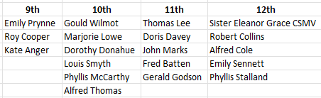
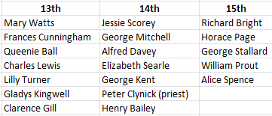

The Mission Community of St Peter and the Holy Apostles
St Peter, Wyndham Square + St Thomas, Royal Navy Avenue + St James-the-Less, Ham Drive
A Church of England Parish in the care of the Bishop of Oswestry
Parish Priest Fr. David Way SSC: 01752 240119 fr.davidway@gmail.com
.com
Mission Development Minister/ LLM/ Parish Ordinand: Ben Otley 07939800544 benotley.mission.plym@gmail.com

Parish Website: plymouthstpeter.co.uk ~ FOR MUCH MORE INFORMATION ON EVENTS, ETC.

This week’s services
Sunday 8th March  The Third  Sunday/Week  in Lent | 8.30am St Thomas Fr DW  10.00am St Peter Fr DW  6.00pm St Peter | Mass with Hymns  Sung Mass  Stations of the Cross
Monday 9th- Weekday of Lent | St Peter 10.00am Fr PL | Mass
Tuesday 10th- Weekday of Lent | St Peter 10.00am Fr DW | Mass
Wednesday 11th- Weekday of Lent | St Peter 10.00am Fr DW | Mass
Thursday 12th- Weekday of Lent | St Peter 10.30am Fr DW | Mass
Friday 13th- Weekday of Lent | St Peter 10.00am Fr ?? | Mass
Saturday 14th- Weekday of Lent | St Peter 10.00am Fr DW | Mass
Sunday 15th-  The Fourth Sunday/Week  in Lent  Laetare Sunday  (Mothering Sunday) | 8.30am St Thomas Fr DW  10.00am St Peter Fr DW  6.00pm St Gabriel | Mass with Hymns  Sung Mass  Stations of the Cross
St Peters is open daily 8.30am- 12noon- Place of Welcome, Place of Prayer.

Safeguarding: If you have any concerns regarding the safety of children and others who are vulnerable, regardless of age, you must tell the Duty Priest or our parish Lay Safeguarding Representative- Jackie Morrison- email randj49@gmail.com Tel 07848859124.
For online donations please scan the QR code

