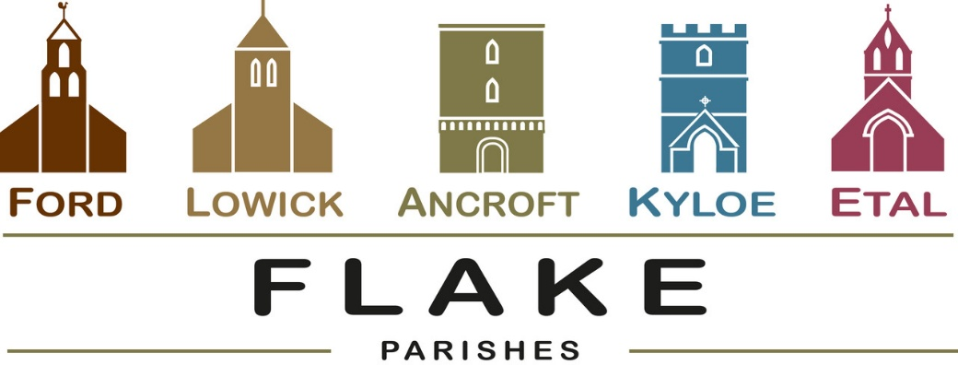
A very warm welcome to you, especially if you are visiting.
Please take this sheet home with you and use it as a basis for prayer.
Children may be at all our services.

Sunday 29th March 2026
Palm Sunday
All congregations worshipping together as Flake Churches
Ford 10.30am Palm procession meets in Ford Village
Ford 11am Holy Communion

Sunday 5th April 2026
Easter Day
See inside for details of services

Sunday 12th April 2026
Lowick 9.15 Holy Communion
Ford 11am Holy Communion

Sunday 19th April 2026
Lowick 9.15 Holy Communion
Ford 11am Holy Communion

Revd Charlotte Osborn (Vicar) 01289 388591 ceosborn@mail.com 07957 367457
Revd Alex Firman (Assistant Curate) 07935 732811
alex_firman@hotmail.co.uk
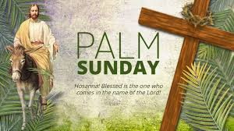
Palm Sunday marks the beginning of Holy Week as Jesus rides humbly on a borrowed donkey into Jerusalem, and to his death.
We are thankful for Tom Burn bringing Freddie with his visible
marking of the precious burden he carried that day, in the marking of the cross he has carried ever since.

Tonight
P 2 P is a 2hr contemporary musical. The music ranges from classical light opera to jazz ballads, soul and blues to rock and pop bringing together full chorus, duets, solos and ‘a capella’ singing. A narrator takes the audience through the performance, linking the music, with a ‘big screen’ media production offering a visual backdrop to the show. The story reflects on the last 7 days of Jesus’ life
Set in context between events over 2000 years ago and with music and media which represents the present day, Pilgrim Voice welcomes everyone to share in this unique musical experience.

Admission by ticket £10 Sunday 29th March 2026
6pm St Aidan’s Parish Church, Bamburgh, NE69 AE

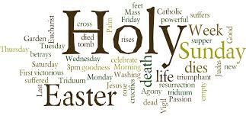

During Holy Week this year we will be following our traditional pattern of offering something every evening by way of a devotional journey to Good Friday and Easter Day.
Monday to Wednesday will be in the evenings in Lowick Vicarage at 7pm and consist of a series of short talks followed by Compline.
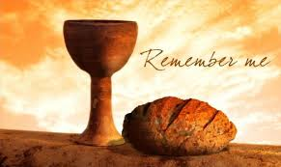
7pm Thursday April 2nd
Holy Communion with
Foot Washing
St Anne’s Church, Ancroft

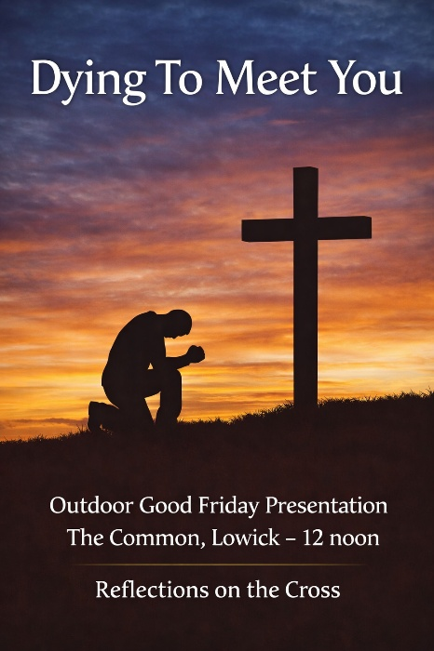

Good Friday

12 noon Lowick Common
An Outdoor Presentation
‘Dying to Meet You’

2pm Lowick Church
An Hour at the Cross

Holy Saturday: Easter Vigil
Ford Church 8pm

Easter Sunday

6.15am Sunrise Service West Kyloe
9.15am Lowick Holy Communion


10.45 am Ford Easter Egg Hunt
11am Ford Holy Communion

5pm Ancroft Easter Songs of Praise

End of Term School Services

Lowick and Holy Island Schools: Monday 30th March 10am for coffee while the children search for clues in the churchyard 10.30am Service
Ford School: Thursday 2nd April at 2.30pm in Ford Church.

Saturday 4th April, Lowick Village Hall 9-12pm Easter Holiday Club
See posters for details and registration


Any donations of flowers for Easter decoration at Lowick church very welcome – Saturday morning from 10am

For our prayers

Please continue to pray for all who suffer in body, mind or spirit, especially Heather Piper, Chloe French, George Hall, Gail Calder, Revd Sam Quilty, David and Revd Judith Dobson. We give thanks for the news of Andrew Watson’s remission.
We remember all who have recently died and those who mourn.
We pray for all who mark anniversaries of death at this time of year.

Parish Contacts

Ancroft Leigh Yorke 07716 116739
Etal Andrew Joicey 01890 820540
Ford Kathleen Holmes 07951 099668
Lowick Niall Cartlidge 07850 876246

Websites: www.achurchnearyou.com
Instagram: https://www.instagram.com/the_flake_churches/
Facebook: the_flake_churches

Other licensed clergy
Revd Margaret Sentamu 077871 204745, Canon Nick Sagovsky,
Revd Marion Penfold 01289 305664

