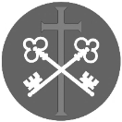
St Peter and the Holy Apostles, Plymouth- Sunday 15th March 2026
The Fourth Sunday of Lent/ Laetare Sunday (Year A)
(Mothering Sunday)
Welcome to the Parish Mass
Welcome to St Peters Church. This sheet provides all that you will need for today’s Mass. If you need any assistance before, during or after the service or need a large print copy of this order of service please speak to one of our welcome team. (identifiable by a lanyard)
Please respond to the words in non-italic Bold, The Hymns are sung by all. Please inform the people on the door when you enter if you require a Gluten Free Host
…………………………………………………………………………………
We Stand for The Entrance Hymn

1. Jerusalem the golden,
With milk and honey blest,
Beneath thy contemplation
Sink heart and voice opprest.
I know not, O I know not,
What social joys are there,
What radiancy of glory,
What light beyond compare.
2. They stand, those halls of Sion,
Conjubilant with song,
And bright with many an angel,
And all the martyr throng;
The Prince is ever in them,
The daylight is serene,
The pastures of the blessèd
Are decked in glorious sheen.
3. There is the throne of David,
And there, from care released,
The song of them that triumph,
The shout of them that feast;
And they who, with their Leader,
Have conquered in the fight,
For ever and for ever
Are clad in robes of white.
4. O sweet and blessèd country,
Shall I ever see thy face?
O sweet and blessed country,
Shall I ever win thy grace?
Exult, O dust and ashes!
The Lord shall be thy part:
His only, his for ever,
Thou shalt be, and thou art!

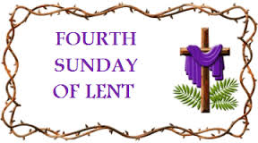
The Introductory Rite
In the name of the Father and of the Son and of the Holy Spirit. Amen.
Following the greeting we respond.
And with your spirit.
The Priest introduces the Mass
The Penitential Rite
Brothers and sisters, let us acknowledge our sins,
and so prepare ourselves to celebrate the sacred mysteries.

I confess to almighty God and to you, my brothers and sisters, that I have greatly sinned, in my thoughts and in my words, in what I have done and in what I have failed to do, through my fault, through my fault, through my most grievous fault; therefore I ask blessed Mary ever-Virgin, all the Angels and Saints, and you, my brothers and sisters, to pray for me to the Lord our God.

May almighty God have mercy on us, forgive us our sins, and bring us to everlasting life. Amen.

Either:
Lord, have mercy. Lord, have mercy.
Christ, have mercy. Christ, have mercy.
Lord, have mercy. Lord, have mercy.
Or:
Kyrie, eleison. Kyrie, eleison.
Christe, eleison. Christe, eleison.
Kyrie, eleison. Kyrie, eleison.

The Collect
Let us pray.
O God, who through your Word reconcile the human race to yourself in a wonderful way, grant, we pray, that with prompt devotion and eager faith the Christian people may hasten toward the solemn celebrations to come. Through our Lord Jesus Christ, your Son, who lives and reigns with you in the unity of the Holy Spirit, God, for ever and ever. Amen.

We sit for The First Reading- 1 Samuel 16:1b, 6-7, 10-13a

In those days: The Lord said to Samuel, ‘Fill your horn with oil, and go. I will send you to Jesse the Bethlehemite, for I have provided for myself a king among his sons.’
When they came, he looked on Eliab and thought, ‘Surely the Lord’s anointed is before him.’ But the Lord said to Samuel, ‘Do not look on his appearance or on the height of his stature, because I have rejected him. For the Lord sees not as man sees: man looks on the outward appearance, but the Lord looks on the heart.’ And Jesse made seven of his sons pass before Samuel. And Samuel said to Jesse, ‘The Lord has not chosen these.’ Then Samuel said to Jesse, ‘Are all your sons here?’ And he said, ‘There remains yet the youngest, but behold, he is keeping the sheep.’ And Samuel said to Jesse, ‘Send and get him, for we will not sit down till he comes here.’ And he sent and brought him in. Now he was ruddy and had beautiful eyes and was handsome. And the Lord said, ‘Arise, anoint him, for this is he.’ Then Samuel took the horn of oil and anointed him in the midst of his brothers. And the Spirit of the Lord rushed upon David from that day forward.

The word of the Lord. Thanks be to God.
The Responsorial Psalm- Ps 23(22):1-3a. 3b-4. 5. 6. ℟1

Response- The Lord is my shepherd; there is nothing I shall want.

The Lord is my shepherd; there is nothing I shall want.
Fresh and green are the pastures where he gives me repose.
Near restful waters he leads me; he revives my soul. R

He guides me along the right path, for the sake of his name.
Though I should walk in the valley of the shadow of death,
no evil would I fear, for you are with me.
Your crook and your staff will give me comfort. R

You have prepared a table before me in the sight of my foes.
My head you have anointed with oil; my cup is overflowing. R

Surely goodness and mercy shall follow me all the days of my life.
In the Lord’s own house shall I dwell for length of days unending. R

The second Reading- Ephesians 5:8-14

Brothers and Sisters: At one time you were darkness, but now you are light in the Lord. Walk as children of light, for the fruit of light is found in all that is good and right and true, and try to discern what is pleasing to the Lord. Take no part in the unfruitful works of darkness, but instead expose them. For it is shameful even to speak of the things that they do in secret. But when anything is exposed by the light, it becomes visible, for anything that becomes visible is light. Therefore it says, ‘Awake, O sleeper, and arise from the dead, and Christ will shine on you.’

The word of the Lord. Thanks be to God.

We Stand for- The Gospel Procession and Acclamation- John 8:12

Glory to you, O Christ, Glory to you O Christ, you are the Word of God, the Word of God, Glory to You O Christ.
Glory to you, O Christ, Glory to you O Christ, you are the Word of God, the Word of God, Glory to You O Christ.

I am the light of the world, says the Lord;
whoever follows me will have the light of life.
Glory to you, O Christ, Glory to you O Christ, you are the Word of God, the Word of God, Glory to You O Christ.

The Gospel- John 9:1-41

The Lord be with you. And with your spirit.
A reading from the holy Gospel according to N. Glory to you, O Lord.
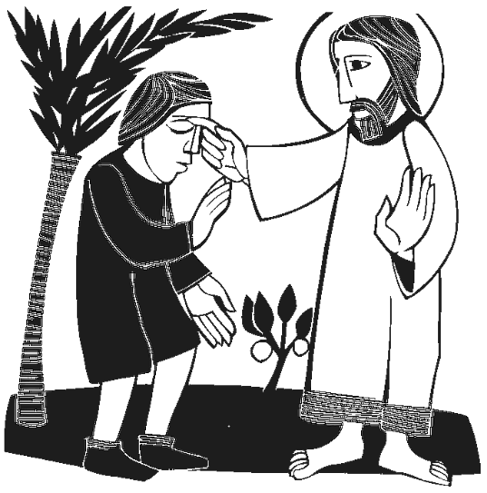
At that time: As Jesus passed by, he saw a man blind from birth. And his disciples asked him, ‘Rabbi, who sinned, this man or his parents, that he was born blind?’ Jesus answered, ‘It was not that this man sinned, or his parents, but that the works of God might be displayed in him. We must work the works of him who sent me while it is day; night is coming, when no one can work. As long as I am in the world, I am the light of the world.’ Having said these things, he spat on the ground and made mud with the saliva. Then he anointed the man’s eyes with the mud and said to him, ‘Go, wash in the pool of Siloam’ (which means Sent). So he went and washed and came back seeing.
The neighbours and those who had seen him before as a beggar were saying, ‘Is this not the man who used to sit and beg?’ Some said, ‘It is he.’ Others said, ‘No, but he is like him.’ He kept saying, ‘I am the man.’ So they said to him, ‘Then how were your eyes opened?’ He answered, ‘The man called Jesus made mud and anointed my eyes and said to me, “Go to Siloam and wash.” So I went and washed and received my sight.’ They said to him, ‘Where is he?’ He said, ‘I do not know.’
They brought to the Pharisees the man who had formerly been blind. Now it was a Sabbath day when Jesus made the mud and opened his eyes. So the Pharisees again asked him how he had received his sight. And he said to them, ‘He put mud on my eyes, and I washed, and I see.’ Some of the Pharisees said, ‘This man is not from God, for he does not keep the Sabbath.’ But others said, ‘How can a man who is a sinner do such signs?’ And there was a division among them. So they said again to the blind man, ‘What do you say about him, since he has opened your eyes?’ He said, ‘He is a prophet.’
The Jews did not believe that he had been blind and had received his sight, until they called the parents of the man who had received his sight and asked them, ‘Is this your son, who you say was born blind? How then does he now see?’ His parents answered, ‘We know that this is our son and that he was born blind. But how he now sees we do not know, nor do we know who opened his eyes. Ask him; he is of age. He will speak for himself.’ His parents said these things because they feared the Jews, for the Jews had already agreed that if anyone should confess Jesus to be Christ, he was to be put out of the synagogue. Therefore his parents said, ‘He is of age; ask him.’
So for the second time they called the man who had been blind and said to him, ‘Give glory to God. We know that this man is a sinner.’ He answered, ‘Whether he is a sinner I do not know. One thing I do know, that though I was blind, now I see.’ They said to him, ‘What did he do to you? How did he open your eyes?’ He answered them, ‘I have told you already, and you would not listen. Why do you want to hear it again? Do you also want to become his disciples?’ And they reviled him, saying, ‘You are his disciple, but we are disciples of Moses. We know that God has spoken to Moses, but as for this man, we do not know where he comes from.’ The man answered, ‘Why, this is an amazing thing! You do not know where he comes from, and yet he opened my eyes. We know that God does not listen to sinners, but if anyone is a worshipper of God and does his will, God listens to him. Never since the world began has it been heard that anyone opened the eyes of a man born blind. If this man were not from God, he could do nothing.’ They answered him, ‘You were born in utter sin, and would you teach us?’ And they cast him out.
Jesus heard that they had cast him out, and having found him he said, ‘Do you believe in the Son of Man?’ He answered, ‘And who is he, sir, that I may believe in him?’ Jesus said to him, ‘You have seen him, and it is he who is speaking to you.’ He said, ‘Lord, I believe’, and he worshipped him. Jesus said, ‘For judgement I came into this world, that those who do not see may see, and those who see may become blind.’ Some of the Pharisees near him heard these things, and said to him, ‘Are we also blind?’ Jesus said to them, ‘If you were blind, you would have no guilt; but now that you say, “We see”, your guilt remains.’

The Gospel of the Lord. Praise to you, Lord Jesus Christ.

We sit for The Homily

We stand The Creed
I believe in one God, the Father almighty, maker of heaven and earth,
of all things visible and invisible.
I believe in one Lord Jesus Christ, the Only Begotten Son of God, born of the Father before all ages. God from God, Light from Light, true God from true God, begotten, not made, consubstantial with the Father; through him all things were made. For us men and for our salvation he came down from heaven,
At the words that follow, up to and including ‘and became man’, all bow.
and by the Holy Spirit was incarnate of the Virgin Mary, and became man.
For our sake he was crucified under Pontius Pilate, he suffered death and was buried, and rose again on the third day in accordance with the Scriptures.
He ascended into heaven and is seated at the right hand of the Father. He will come again in glory to judge the living and the dead and his kingdom will have no end.
I believe in the Holy Spirit, the Lord, the giver of life, who proceeds from the Father and the Son, who with the Father and the Son is adored and glorified, who has spoken through the prophets.
I believe in one, holy, catholic and apostolic Church. I confess one Baptism for the forgiveness of sins and I look forward to the resurrection of the dead and the life of the world to come. Amen.
……………………………………………………………………………………………………..

We remain standing for The Prayers of the Faithful

Each biding concludes with the following said or sung-

Lord have mercy, Lord have mercy,
Lord have mercy on your people

The Priest Concludes the Prayers of the Faithful
……………………………………………………………………………………………………..
No collection is taken during the Mass, but there is a collection box at the back of church for you to give your financial contribution. All money collected helps towards the mission and ministry of our churches. If you would prefer, a card reading machine is available at the back of the church for your contribution.

The Offertory Hymn

1. Just as I am, without one plea
But that thy blood was shed for me,
And that thou bidd'st me come to thee,
O Lamb of God, I come.
2. Just as I am, though tossed about
With many a conflict, many a doubt,
Fightings within, and fears without,
O Lamb of God, I come.
3. Just as I am, poor, wretched, blind;
Sight, riches, healing of the mind,
Yea all I need, in thee to find,
O Lamb of God, I come.
4. Just as I am, thou wilt receive,
Wilt welcome, pardon, cleanse, relieve:
Because thy promise I believe,
O Lamb of God, I come.
5. Just as I am (thy love unknown
Has broken every barrier down),
Now to be thine, yea thine alone,
O Lamb of God, I come.
6. Just as I am, of that free love
The breadth, length, depth and height to prove,
Here for a season then above,
O Lamb of God, I come.

The Liturgy of the Eucharist
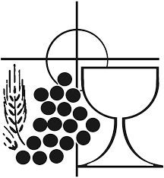
Pray, brethren (brothers and sisters), that my sacrifice and yours may be acceptable to God, the almighty Father.
May the Lord accept the sacrifice at your hands for the praise and glory of his name, for our good and the good of all his holy Church.

The Lord be with you. And with your spirit.
Lift up your hearts. We lift them up to the Lord.
Let us give thanks to the Lord our God. It is right and just.

The Priest continues with the Preface. The Sanctus is the said or sung:
Holy, Holy, Holy Lord God of hosts.
Heaven and earth are full of your glory. Hosanna in the highest.
Blessed is he who comes in the name of the Lord. Hosanna in the highest.

The Priest continues the Eucharistic prayer. The following is said or sung
The mystery of faith…. Save us Saviour of the world, Save us Saviour of the world, for by your cross and resurrection, you have set us free.

The Priest concludes the Eucharistic prayer.

Through him, and with him, and in him, O God, almighty Father, in the unity of the Holy Spirit, all glory and honour is yours, for ever and ever. Amen.

The Lord’s Prayer
At the Saviour’s command and formed by divine teaching, we dare to say:
Our Father, who art in heaven, hallowed be thy name; thy kingdom come, thy will be done on earth as it is in heaven. Give us this day our daily bread, and forgive us our trespasses, as we forgive those who trespass against us; and lead us not into temptation, but deliver us from evil.
Deliver us, Lord, we pray… and the coming of our Saviour, Jesus Christ.
For the kingdom, the power and the glory are yours now and for ever.

The Peace
Lord Jesus Christ, who said to your Apostles: Peace I leave you, my peace I give you,
look not on our sins, but on the faith of your Church, and graciously grant her peace and unity in accordance with your will. Who live and reign for ever and ever. Amen.
The peace of the Lord be with you always: And with your spirit.
Let us offer each other the sign of peace.
All are invited to make an acknowledgement to each other to mark the sign of the peace.

The Agnus Dei
All say or sing:
Lamb of God, you take away the sins of the world, have mercy on us.
Lamb of God, you take away the sins of the world, have mercy on us.
Lamb of God, you take away the sins of the world, grant us peace.

The Invitation to Communion

Behold the Lamb of God, behold him who takes away the sins of the world. Blessed are those called to the supper of the Lamb.
Lord, I am not worthy that you should enter under my roof, but only say the word and my soul shall be healed.

All who are regular communicants in their own tradition are welcome to receive the sacrament if you are not a communicant you are welcome to come forward at this point in the service to receive a blessing To indicate that it is just a blessing you require, please take this service sheet up with you. We have returned to offering the chalice at the time of communion but please do not feel any pressure to receive from the common cup as the church teaches that the sacrament is received fully in one kind. We request that you do not intinct (dip) your host in the Chalice but either take a sip from the cup or return directly to your seat. This is for reasons of good hygiene.

The Communion Hymn

1. Amazing grace! How sweet the sound
that saved a wretch like me.
I once was lost, but now I'm found;
was blind, but now I see.
2. 'Twas grace that taught my heart to fear,
and grace my fears relieved.
How precious did that grace appear
the hour I first believed.
3. Through many dangers, toils and snares
I have already come.
'Tis grace that brought me safe thus far,
and grace will lead me home.
4. The Lord has promised good to me,
his word my hope secures;
he will my shield and portion be
as long as life endures.
5. When we've been there a thousand years,
bright shining as the sun,
we've no less days to sing God's praise
than when we first begun.
We stand for The Prayer After Communion

Let us pray.
O God, who enlighten everyone who comes into this world, illuminate our hearts, we pray, with the splendour of your grace, that we may always ponder what is worthy and pleasing to your majesty and love you in all sincerity. Through Christ our Lord. Amen.
The priest may give some brief notices

The Concluding Rites and The Dismissal

The Lord be with you. And with your spirit.
Look upon those who call to you, O Lord, and sustain the weak; give life by your unfailing light to those who walk in the shadow of death, and bring those rescued by your mercy from every evil to reach the highest good. Through Christ our Lord.
And may the blessing of almighty God, the Father, and the Son, ✠ and the Holy Spirit, come down on you and remain with you for ever. Amen.
Go forth, the Mass is ended. Thanks be to God

The Final Hymn
1. For Mary, Mother of our Lord
God’s holy name be praised,
who first the Son of God adored,
as on her child she gazed.
2. Brave, holy Virgin, she believed,
though hard the task assigned,
and by the Holy Ghost conceived
the Saviour of mankind.
3. She gave her body as God’s shrine,
her heart to piercing pain;
she knew the cost of love divine,
when Jesus Christ was slain.
4. Dear Mary, from your lowliness
and home in Galilee
there comes a joy and holiness
to every family.

5. Hail, Mary, you are full of grace,
above all women blest;
and blest your Son, whom your embrace
in birth and death confessed.
The Angelus
The Angel of the Lord declared unto Mary. And she conceived of the Holy Spirit.

Hail Mary, full of grace, The Lord is with Thee; Blessed art thou among women,
And blessed is the fruit of thy womb, Jesus.
Holy Mary, Mother of God, Pray for us sinners,
Now and at the hour of our death.
Behold the handmaid of the Lord.
Be it done to me according to thy word. Hail Mary. . .
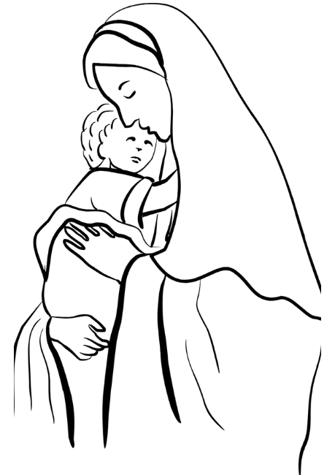
And the Word was made flesh.
And dwelt among us. Hail Mary…

Pray for us, O holy Mother of God.
That we may be made worthy of the promises of Christ.

Let us pray: Pour forth, we beseech Thee, O Lord, Thy grace into our hearts, that we to whom the Incarnation of Christ Thy Son was made known by the message of an angel, may by His Passion and Cross be brought to the glory of His Resurrection. Through the same Christ Our Lord. Amen.

……………………………………………………………………

The Notices

Lent 2026
Lent Study Group- looking at prayer will take place on Saturdays 11.00-12.00 with a simple soup lunch, (Volunteers needed for soup)
Stations of the Cross- Sunday Evenings 6pm (please see service times for weekly locations
Holy Week is Sunday 29th March – 5th April, please keep that week so that you can fully immerse yourselves in the wonderful celebration of this most important Week of the Christian Year.

S.S.C. Chapter Meeting is taking place St Peter’s on Thursday the 19th March. At this meeting we will be admitting a new priest to the society so we will be joined by the Provincial Secretary. As it is Lent the intention is to serve a Soup and Bread Lunch at 1.00pm. I need volunteers to help with this iof you are able to help please see fr David.

Bible Study at St Francis- Monday evenings through lent at 6pm at St Francis- lead by Ben Otley- we will be studying the Book of Exodus

Chrism Mass Thursday 26th March at 11.00 Exeter Cathedral.

Easter cards are available on the table in Cloisters, donations in the wooden box

Annual Parochial Church Meeting is on Sunday 19th April at 12.00noon

For Prayer

Those who have asked for our prayers…. Denise, Janice Allin, Leslie Porch,
Sheila Tucker, Tina Smart, Bobby Lilicrap, June Brock,
Emma Addison, Georgie Maher, Ian Craggs, Brenda Alderson, Lois Tobin, Brenda Steed, Anne Lewis, Jenny Harvey, Jackie Morrison, Anna, Gwen Lamb, Anna Lynch, Helen Lewis, Val Bradden, Cynthia Way, Pauleen Stewart, Amelia Coughlan, Roger Lewis, Shaun Carrie, Fr Jon Bielawski, Catherine Samuel, Julian Davies, Fr Michael Brown.

Recently Departed- Kathy Haydon

Anniversaries of Death-
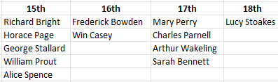


The Mission Community of St Peter and the Holy Apostles
St Peter, Wyndham Square + St Thomas, Royal Navy Avenue + St James-the-Less, Ham Drive
A Church of England Parish in the care of the Bishop of Oswestry
Parish Priest Fr. David Way SSC: 01752 240119 fr.davidway@gmail.com
.com
Mission Development Minister/ LLM/ Parish Ordinand: Ben Otley 07939800544 benotley.mission.plym@gmail.com

Parish Website: plymouthstpeter.co.uk ~ FOR MUCH MORE INFORMATION ON EVENTS, ETC.

This week’s services
Sunday 15th-  The Fourth Sunday/Week  in Lent  Laetare Sunday  (Mothering Sunday) | 8.30am St Thomas Fr DW  10.00am St Peter Fr DW  6.00pm St Gabriel | Mass with Hymns  Sung Mass  Stations of the Cross
Monday 16th- Weekday of Lent | St Peter 10.00am Fr PL | Mass
Tuesday 17th- St Patrick | St Peter 10.00am Fr RS | Mass
Wednesday 18th- Weekday in OT | St Peter 10.00am Fr DW | Mass
Thursday 19th- St Joseph spouse of BVM | St Peter 12.00 noon Fr DW | Mass
Friday 20th- Weekday of Lent | St Peter 10.00am Fr DW | Mass
Saturday 21st- Weekday of Lent | St Peter 10.00am Fr DW | Mass
Sunday 22nd-  The Fifth Sunday/Week  in Lent  Passiontide begins | 8.30am St Thomas Fr DW  10.00am St Peter Fr DW  6.00pm St Batholomew | Mass with Hymns  Sung Mass  Stations of the Cross
St Peters is open daily 8.30am- 12noon- Place of Welcome, Place of Prayer.

Safeguarding: If you have any concerns regarding the safety of children and others who are vulnerable, regardless of age, you must tell the Duty Priest or our parish Lay Safeguarding Representative- Jackie Morrison- email randj49@gmail.com Tel 07848859124.
For online donations please scan the QR code

