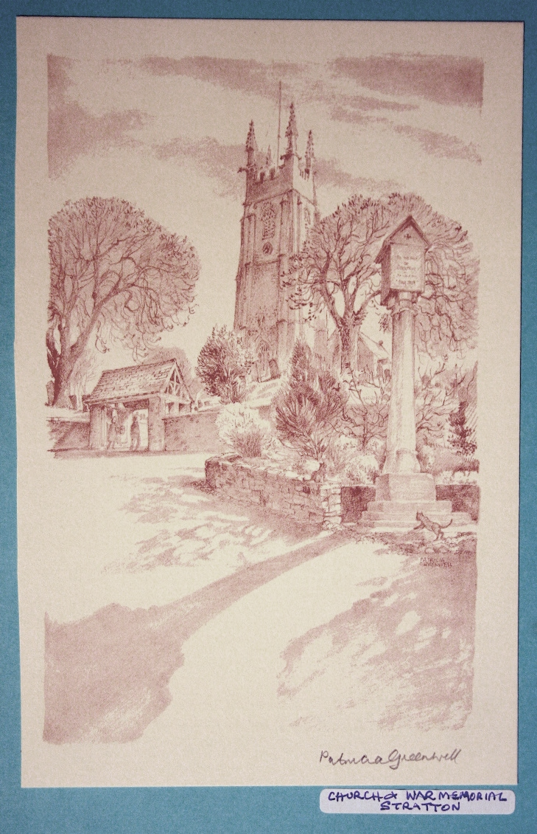 | The Parish Church  of St Andrew, Stratton  Priest in Charge  The Revd Teresa Folland  Tel: 01288 352599  e-mail: teresa.folland@gmail.com  Churchwarden  Mrs Diana Ohlson  Tel: 01288 354441  e-mail: dohlson24@gmail.com
APRIL 2026

Heavenly Father, you are the source of peace and unity. We come to you seeking healing where division has taken root. Mend broken bonds within families and communities. Replace bitterness with compassion, pride with humility, and silence with understanding. Teach us to listen with love and to forgive as You forgive us. May your Spirit guide us and the world toward reconciliation, restoring harmony where conflict once reigned. Help us to see one another through Your eyes – beloved, worthy and redeemed. Amen.

Services at St Andrew’s April 2026

Wed  1st | Christian Meditation 9.30am  Mass in Holy Week with Stations of the Cross 10.30am Officiant: Rev. Teresa Folland
Thur  2nd | Maundy Thursday 8.30pm Commemoration of the Last Supper followed by the Watch until 11pm. Officiant: Rev Jane Bradbury with Rev Teresa Folland and LWLs Sheila Waring and Val Barker
Fri  3rd | Good Friday 3pm  The Passion of Our Lord with Tenebrae  Officiant: Rev. Teresa Folland with LWL Val Hopper
Sat  4th | Easter Eve Vigil 8pm  Officiant: Rev. Teresa Folland
Sun  5th | Easter Sunday  Readings: Acts 10:34-43; Psalm 18:1-2, 18-24; Colossians 3:1-4; John 20:1-18 or Matt 28:1-10.  Parish Mass for Easter Day 9.30am – Officiant Rev Jane Bradbury.
Wed  8th | Christian Meditation 9.30am  Midweek Mass Wed. 10.30am – Officiant: Rev Richard Ward Smith
Sun  12th | 2nd Sunday of Easter  Readings: Act 2:14a, 22-32; Ps 16; 1 Peter 1:3-9; John 20:19-end  Parish Mass 9.30am – Officiant:Rev Richard Ward Smith
Wed  15th | Christian Meditation 9.30am  Midweek Mass Wed. 10.30am – Officiant: Rev Doug Adams
Sun  19th | 3rd Sunday of Easter  Readings: Acts 2:14a, 36-41; Psalm 116:1-3, 10-end; 1 Peter 1:17-23; Luke24:13-35  Morning Worship 9.30am – LWLs Judy Dunne and Val Hopper
Wed  22nd | Christian Meditation 9.30am  Midweek Mass Wed. 10.30am – Officiant: Rev Jane Bradbury
Sun  26th | 4th Sunday of Easter  Readings: Acts 2:42-end; Psalm 23; 1 Peter 2:19-end; John 10:1-10 Parish Mass 9.30am – Officiant: Rev Doug Adams
Wed  29th | Christian Meditation 9.30am  Midweek Mass Wed. 10.30am – Officiant: Rev Teresa Folland  New Bishop of St Germans  The Rev James Treasure has been confirmed as the next Bishop of St Germans and will be welcomed to the diocese at a special service on May 10th in Truro Cathedral.  The role of the Bishop of St Germans is the suffragan bishop for the diocese, working alongside the Bishop of Truro to support clergy, congregations and church projects throughout the county.  New Archdeacon Designate of Bodmin  The Revd Dr Helen Williams has been announced as being the new Archdeacon Designate of Bodmin and is expected to take up her post in the summer of 2026. She joins the Diocese of Truro leadership team from the Diocese of Salisbury. Her role will be to oversee the pastoral care and mission for parishes across eastern Cornwall.  Alpha: Explaining the Christian Faith  St Olaf’s Church, Poughill, is hosting an Alpha Course in the Old School Room, Poughill. It starts on Tuesday 14th April and runs for 12 weeks. Each session begins at 6pm with a meal, followed by a video and discussion time and ends at 8.30pm. There is no cost.  Alpha is for everyone who is curious and unpacks a big question of life and faith week by week. There is absolutely no pressure.  Come along and see what you think.  For further information contact Cherry and Dan Archer danandcherry@gmail.com 07851943707 or Rev Teresa Folland teresa.folland@gmail.com 01288 352599
Dates for your diary
Thurs 2nd April | Maundy Thursday Service 8.30pm at St Andrew’s
Fri 3rd April | Tenebrae Service for Good Friday 3pm at St Andrew’s
Sat 4th April | Easter Vigil 8pm at St Andrew’s
Sun 5th April | Parish Mass for EASTER DAY at 9.30am There will not be an Evensong Service today
Sun 12th April | Stall at Pendeen Car boot sale. Do come & support us.
Mon 13th April | M U Meeting 2pm at Stamford House
Tues 14th April | Alpha Course begins 6pm, Old School Room, Poughill
Thurs 16th April | Pastoral Comm. Meeting 10.30am 6 Old Drovers Way
Thurs 23rd April | LWL meeting 7.30pm at the Rectory
Tues 28th April | APCM in church at 7pm.
Thurs 30th April | Coffee Morning at Stamford House to raise funds for the Flower Festival. 10am – 12noon
Sun 10th May | Stall at Pendeen Car Boot sale pm. There will also be one on June 14^{th.} Do come & support us.

Thank You

Many thanks to all those who turned up on Saturday 7th March to give the Lych Gate a good Spring Clean. The whole area looks better and more inviting as the most used entrance way to the Church.

Thank you also to the stalwart few who formed a churchyard working party to clear some of the ivy overgrowth from the trees and walls on Saturday morning March 21st. We are grateful.

The East Window Conservation

‘The care of the Parish Church is a privilege rather than a duty. Everything should be done to the Glory of God and for the edification of His people’.
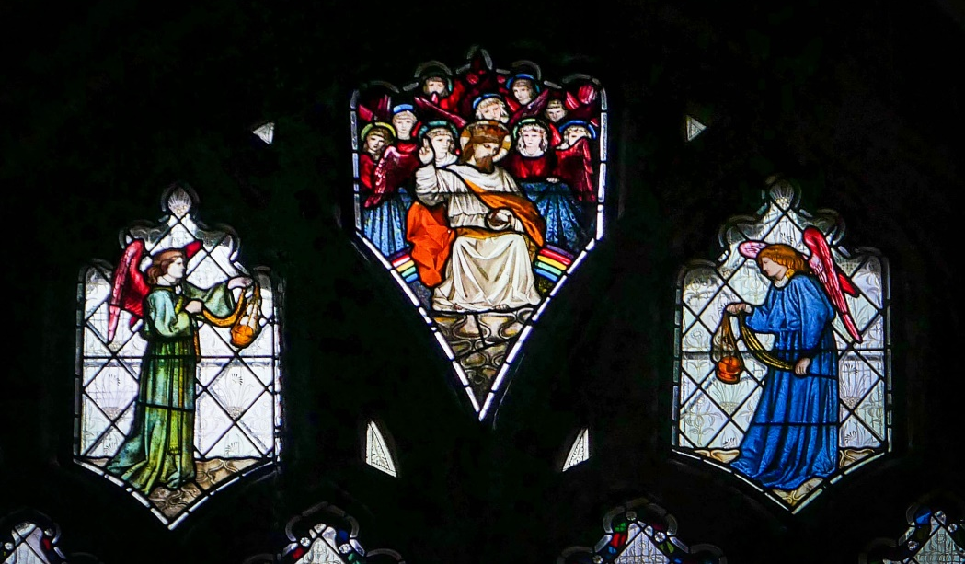
Canon A G Cooke, 1990, onetime Chairman of the DAC (Deanery Advisory Committee).
As promised last month, a little more about the East Window.
Since the window has been re-installed in its place in the Sanctuary above the High Altar at St Andrew’s, it has been admired by many of those coming to worship and several visitors, both local and those from further afield. Those who know the window well can appreciate and instantly notice the improvement. For the visitors who are not familiar with the window, it pleases for its aesthetic appeal and demonstrated skill and artistry. The colours are glorious. As I have said many times, a real treasure. To see the whole window at its best why not visit on a bright or sunny day - it is well worth the effort.
The church has managed to fundraise and obtain several grants towards the cost of this conservation work and to date there is about a £1000 shortfall if the last grant application comes to fruition. An amazing feat. We are so grateful to all who gave their support.

Flower Festival: 22nd – 24th May, For the Beauty of Flowers
This year our festival will celebrate the wonderful beauty and diversity of flowers.
The theme of ‘For the Beauty of Flowers’ is a chance to celebrate the wonderful colours and diversity of flowers that bring such joy to our lives.
You can let your imaginations run wild by choosing a particular flower that is special to you or creating an arrangement of one colour using as many different types of flowers as you like. You may like to do a different form of arranging such as Ikebana, cascade, or asymmetrical, or a simple vase. Arrangements big or small are welcomed. If you would like to be part of our celebration, please contact Sheila Waring. Email: waring626@btinternet.com or Tel: 01288 714338

Mothers’ Union


Last month on Mothering Sunday the MU decorated the lychgate as part of the 150th anniversary of the founding of the organisation. Our banner was on display and members were part of the service. This was a very happy occasion with flowers being given to members of the congregation.
We are delighted to welcome Geraldine Davey as a new member of the branch.
April Dates
Please note that our April meeting will be on Monday 13th April at 2pm at Stamford House, Stamford Hill. This is the second Monday of the month owing to the Easter bank holiday. We will be celebrating Spring and Eastertide.
April 23rd Mothers Union Open Afternoon at St Endellion’s Church 2pm – 4.30pm. There will be a speaker and time for fellowship. All welcome.
The May meeting will also be on the second Monday of the month due to a Bank Holiday.

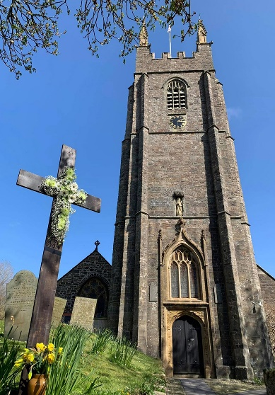
We wish all our readership, friends and families a very happy and blessed Eastertide

For the month of April 2026
We remember in our prayers all those living in:
Week beginning:
Sunday 5th | Stapleton Road, Traly Close, Catherine Close
Sunday 12th | Kernow Crescent, The Rowans, parts of Berries Avenue & of Briar Road within the Parish
Sunday 19th | St Annes, Grove, Thorn, Hele, parts of Kings Hill & Bedehaven Close within the Parish
Sunday 26th | Redwood Grove, Elm Drive, Elm Lea; parts of Holnicot Road within the Parish

Those who have asked for our prayers:
Allan Gouldson, Bella, Lyzette Bevan, Karen Hunting and Baby Henry and family, Gloria Braund.
We bring before God, especially at this time, all who work in our local hospitals, the inpatients and all undergoing investigations and outpatient treatment. We remember too those of our church family who are ill at home or housebound.
The recently departed: May they rest in peace and rise in glory.

For the month of April 2026
Those in our Year’s Mind:
Week beginning:
Sunday 5th | Kenneth Saunders, John Warne, Ellen Crookshank, Kevin Hogarth, Pauline Worth, Christopher Scott, Priest, Tessa Barlow, Ryan Lawrence, John Hambly, John Jones, Winifred Honey
Sunday 12th | Lynn Macmillan, Wilhelmina Carter, Murice Bailey, Maude Leach, Gertrude Durstan, Russen Thomas, Priest, Edward Humphreys, Lily Wosnitzka.
Sunday 19th | Orla Harman, Joan Heard, Florence Colwill, Raymond Foden, John Salkield.
Sunday 26th | David Harris, Andrea Evans, Derek Carter, Alan Barker, Graham Brett, Edward Davis, David Johns, Clifford Bryant, Anthony Blood

News Sheet Editors:
Val Barker Tel: 353435 and Sheila Waring Tel: 714338

If you have anything for inclusion in the next news sheet for please send it to the editors by the 10th of the month.
Please submit all documents in Calibri (Body) Font, size 12. Thank you.

