
Please stand, if able,
for this psalm let us all say it all together!

The Lord is my shepherd, I shall not want.
He makes me lie down in green pastures;
he leads me beside still waters;
he restores my soul.
He leads me in right paths
for his name’s sake.
Even though I walk through the darkest valley,
I fear no evil;
for you are with me;
your rod and your staff—
they comfort me.
You prepare a table before me
in the presence of my enemies;
you anoint my head with oil;
my cup overflows.
Surely goodness and mercy shall follow me
all the days of my life,
and I shall dwell in the house of the Lord
my whole life long.

Glory be to the Father and to the Son and to the Holy Spirit,
as it was in the beginning, is now and ever shall be,
world without end. Amen


Once again, we are asking everyone if they could please collect their change over Lent and then bring it in on Easter Day.
If you need a jar, there are some spare ones in church.

Thank you – together we can make a difference

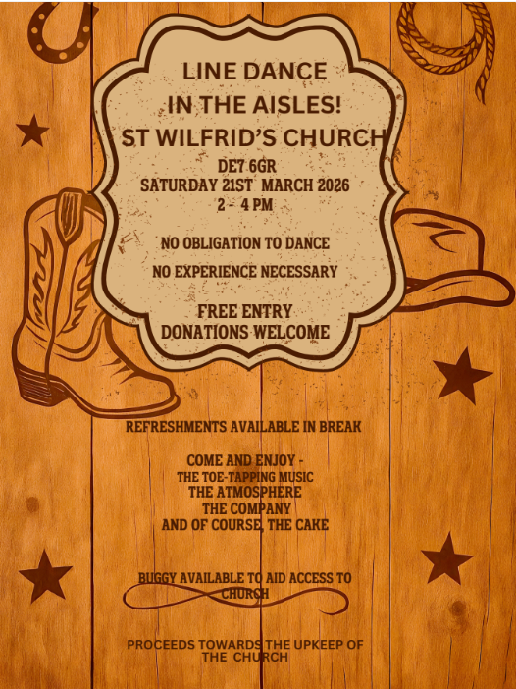

In our weekly prayers for our parish
This week we pray for God’s blessing on Little Hallam Hill, Lock Close & Longfield Lane.
Our 4pm services are now in Friendship House
until the end of March.
Distribution of Communion –currently the Priest will dip the communion wafer in the wine while we discern a safe way to bring the common cup back into worship, as we want everyone to feel included and safe. We also have gluten free wafers available.
Refreshments After the Morning Service
Please stay seated after the service and a hot drink will be brought to you in the pews. Do not get up and head to the back of church, it is becoming a hazard, and a risk as trays of hot drinks could be knocked over.
Church contact information
Contact: Rev’d Christine - revchristine@outlook.com
The Rectory, The Village, West Hallam, DE7 6GR
Landline 0115 646 1497
Rev’d Ailsa -revailsahunt@gmail.com
Tel - 07356064856

Churchwardens – Mrs Janet Wheeldon, -Tel: 0115 8771593
Mrs Linda Gregory – linda.gregory3@icloud.com
https://www.achurchnearyou.com/church/13402/
https://www.facebook.com/allsaintskirkhallam
All Saints Church
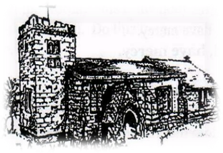
Kirk Hallam
Disabled Toilet in Friendship House.
Disabled Toilet in Friendship House.

Working with God to transform lives & communities.
Please can you ensure your mobile is on silence, or off during the service, it is affecting people with hearing aids and the loop system.

15th March – Mothering Sunday
10.00am CW Communion Service with Rev’d Christine & Eileen
3.00pm Building Faith at Community Centre
4.00pm Iona Holy Communion with Rev’d Christine

Forthcoming Events
Tues 17th 6.00pm Home Group in Friendship House
Weds 18th 9.30am Morning Prayer at UCAS
Weds 18th 6.30pm Lent Group at UCAS
Thurs 19th 3.30pm Funeral of John Baldwin at
St Andrew’s, Stanley
Thurs 19th 7.00pm PCC Meeting in church
Fri 20th 6.00pm Choir Practise in Friendship House
Sat 21st 10.00am Prayer Meeting in Friendship House
Tues 24th 1.00pm Funeral in church of Ann Bennett with
burial in churchyard

22nd – Fifth Sunday of Lent – Passiontide Begins
10.00am CW Communion Service with Rev’d Ailsa
4.00pm BCP Evening Prayer with Julie
“For I know the plans I have for you” declares the Lord, “plans to prosper you and not to harm you, plans to give you hope and a future” Jeremiah 29:11
It’s Good to Talk! If you spot that someone is missing, please pop a news sheet through their door, & if you’ve time, call for a chat - just to check they’re OK & to let them know that they are not forgotten!

