Palm 31:9 to 16
Please stand, if able, and join in with the verses in bold italics

Be gracious to me, O Lord, for I am in distress;
my eye wastes away from grief, my soul and body also.
For my life is spent with sorrow, and my years with sighing;
my strength fails because of my misery, and my bones waste away.

I am the scorn of all my adversaries, a horror to my neighbours,
an object of dread to my acquaintances;
those who see me in the street flee from me.
I have passed out of mind like one who is dead;
I have become like a broken vessel.
For I hear the whispering of many terror all around!—
as they scheme together against me, as they plot to take my life.

But I trust in you, O Lord;
I say, ‘You are my God.’
My times are in your hand;
deliver me from the hand of my enemies and persecutors.
Let your face shine upon your servant;
save me in your steadfast love.

Glory be to the Father and to the Son and to the Holy Spirit,
as it was in the beginning, is now and ever shall be,
world without end. Amen


Once again, we are asking everyone if they could please collect their change over Lent and then bring it in on Easter Day.
If you need a jar, there are some spare ones in church.

Thank you – together we can make a difference

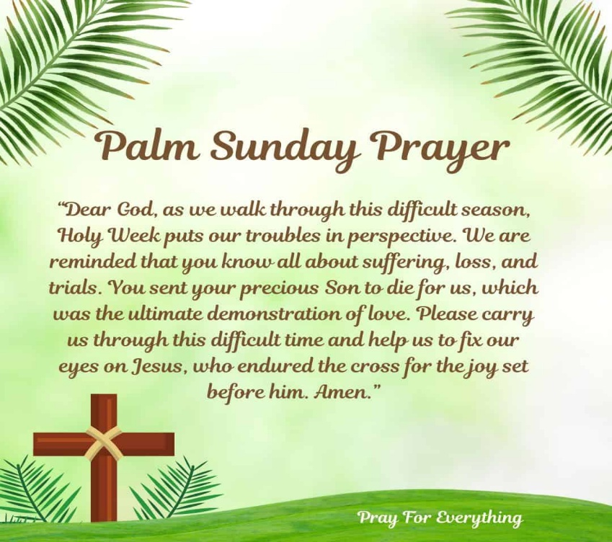

In our weekly prayers for our parish
This week we pray for God’s blessing on Lower Stanton Road, Macdonald Square & Marshall Way.
As from Sunday 12th April our evening services are
at 6pm and back in the church
Distribution of Communion –currently the Priest will dip the communion wafer in the wine while we discern a safe way to bring the common cup back into worship, as we want everyone to feel included and safe. We also have gluten free wafers available.
Refreshments After the Morning Service
Please stay seated after the service and a hot drink will be brought to you in the pews. Do not get up and head to the back of church, it is becoming a hazard, and a risk as trays of hot drinks could be knocked over.
Church contact information
Contact: Rev’d Christine - revchristine@outlook.com
The Rectory, The Village, West Hallam, DE7 6GR
Landline 0115 646 1497
Rev’d Ailsa -revailsahunt@gmail.com
Tel - 07356064856

Churchwardens – Mrs Janet Wheeldon, -Tel: 0115 8771593
Mrs Linda Gregory – linda.gregory3@icloud.com
https://www.achurchnearyou.com/church/13402/
https://www.facebook.com/allsaintskirkhallam
All Saints Church
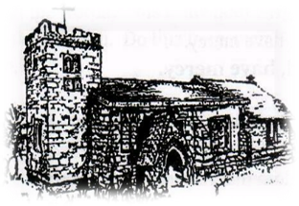
Kirk Hallam
Disabled Toilet in Friendship House.
Disabled Toilet in Friendship House.

Working with God to transform lives & communities.
Please can you ensure your mobile is on silence, or off during the service, it is affecting people with hearing aids and the loop system.
29th March – Palm Sunday
10.00am Iona Communion Service with Rev’d Christine
11.30am Palm Sunday Parade Service
4.00pm Iona Evening Prayer with Rev’d Christine & Martin

Forthcoming Events
Tues 31st 6.00pm Home Group in Friendship House
Weds 1st 9.30am Morning Prayer at UCAS
Weds 1st 10.00am Oliver House Care Home
Weds 1st 2.00pm Mothers’ Union in church
Weds 1st 6.30pm Lent Group at UCAS
Thurs 2nd 11.00am Maundy Thursday Service at
Derby Cathedral
Thurs 2nd 4.00pm Maundy Thursday Service at
Holy Trinity, Mapperley
Fri 3rd 2.00pm Hour By the Cross Service

5th April – Easter Day
6.30am Son Rise Service at Dale Abbey Arch
10.00am CW Communion Service with Rev’d Christine
“The Lord’s my shepherd, I shall not want’ Psalm 23:1
It’s Good to Talk! If you spot that someone is missing, please pop a news sheet through their door, & if you’ve time, call for a chat - just to check they’re OK & to let them know that they are not forgotten!

