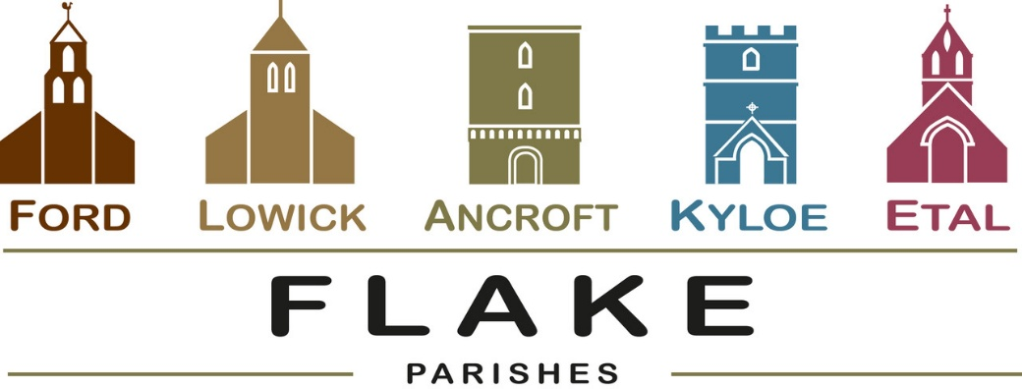
A very warm welcome to you, especially if you are visiting.
Please take this sheet home with you and use it as a basis for prayer.
Children may be at all our services.

Sunday 8th March 2026
Lowick 9.15 Holy Communion
Etal 11am Holy Communion

Sunday 15th March 2026
Mothering Sunday
Lowick 9.15 Holy Communion
Etal 11am Holy Communion

Sunday 22nd March 2026
Lowick 9.15 Holy Communion
Etal 11am Holy Communion with Baptism

Sunday 29th March 2026
Palm Sunday
All congregations worshipping together as Flake Churches
Ford 10.30am Palm procession meets in Ford Village
Ford 11am Holy Communion

Revd Charlotte Osborn (Vicar) 01289 388591 ceosborn@mail.com 07957 367457
Revd Alex Firman (Assistant Curate) 07935 732811
alex_firman@hotmail.co.uk
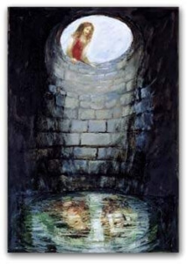

What might God be saying to us this morning through this gospel story?
What is the good news in this middle Sunday of our particular Lenten journey as we stop today to be refreshed?

As we gaze into the well, what do we see? Just our own refection or the face of Jesus Christ beside us?


Lent Study Group continues in Lowick Vicarage tomorrow from
7-8.30pm. We are using ‘Lentwise’ by Paula Gooder, Canon Chancellor of St Paul’s Cathedral London. Copies of these will be available at £10 each but are not necessary to follow the sessions.
Tomorrow’s session will consider some of the places where we can find light and wisdom for our spiritual journey.

- 9th March
- 16th March
- 23rd March

Lowick Soup Saturday 14th March Village Hall, 12-1.30pm

Middlemiss Lecture will take place on 22nd April 2026. Details soon.
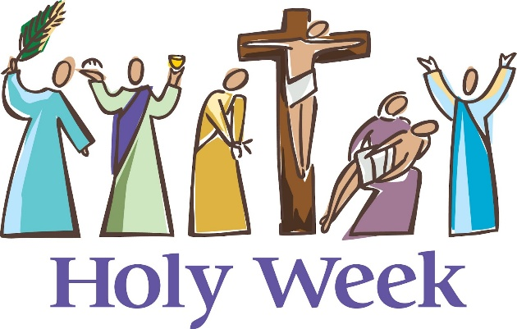
During Holy Week this year we will be following our traditional pattern of offering something every evening by way of a devotional journey to Good Friday and Easter Day.
Monday to Wednesday will be in the evenings in Lowick Vicarage and consist of a series of short talks followed by Compline.
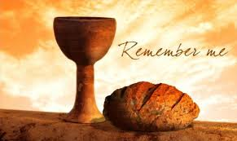

7pm Thursday April 2nd
Holy Communion with
Foot Washing
St Anne’s Church, Ancroft


Good Friday
12 noon Lowick Common
An Outdoor Presentation
‘Dying to Know You’
2pm Lowick Church
An Hour at the Cross

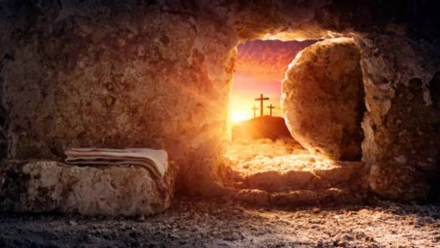
Holy Saturday: Easter Vigil
Ford Church 8pm
Easter Sunday
6am Sunrise Service West Kyloe
9.15am Lowick Holy Communion
11am Ford Holy Communion
5pm Ancroft Easter Songs of Praise
For our prayers

Please continue to pray for all who suffer in body, mind or spirit, especially Andrew Watson, Heather Piper, Chloe French, George Hall, Gail Calder, Revd Sam Quilty, David and Revd Judith Dobson, Christine Hammell, Kathleen Glenn, Catherine Herriott, and Joan (Amber’s other Grandmother).

We remember all who have recently died including Margaret, (Amber’s other grandmother) and those who mourn.
We pray for all who mark anniversaries of death at this time of year, for Judith Bell, John Waters.

Parish Contacts

Ancroft Leigh Yorke 07716 116739
Etal Andrew Joicey 01890 820540
Ford Kathleen Holmes 07951 099668
Lowick Niall Cartlidge 07850 876246

Websites: www.achurchnearyou.com
Instagram: https://www.instagram.com/the_flake_churches/
Facebook: the_flake_churches

Other licensed clergy

Revd Margaret Sentamu 077871 204745, Canon Nick Sagovsky,
Revd Marion Penfold 01289 305664

