
SPIRE & LIGHT United Churches
United Benefice of St Keverne, St Ruan with St Grade & St.Wynwallow (The Lizard)

*If you do not wish to receive these notices, please let your Churchwarden know*

15th March 2026
Lent 4

Mothering Sunday

Readings
Exodus 2:1-10 OR 1 Samuel 1:20-end
Psalm 34:11-20 OR Psalm 127:1-4
2 Corinthians 1:3-7 OR Colossians 3:12-17
Luke 2:33-35

9.30am – Holy Communion - St.Peter’s, Coverack
9.30am – Holy Communion - St.Wynwallow, The Lizard
11am – Morning Prayer - St.Keverne
11.15am – Family Service – St.Ruan, Ruan Minor

Next week – Sunday 22nd March -

9.30am – Morning Prayer - St.Peter’s, Coverack
9.30am – Holy Communion - St.Ruan, Ruan Minor
11am – Holy Communion – St.Keverne
11.15am – Café Church – St.Wynwallow, The Lizard

Open Deanery Synod Meeting
Monday March 16th, 7pm at Cury Village Hall.

The focus for the evening will be the different types of lay ministries and training available in our Diocese. The speaker will be Isaac McNish (Head of Ministry), with ‘local testimony’ from some of our own people here in the Deanery who have undertaken courses.
Please come - this meeting is open to all who are interested, not just Deanery Synod members.

Advance notice: Please note
The service of Holy Communion at St Keverne on Easter Day will now take place at the earlier time of 10am.

The Prayer Spot

At the start of this New Year in our Benefice, remind us we are all Brothers and Sisters in Christ brought to faith by the same saviour Jesus Christ with a duty to everyone in our benefice - those in church and those outside the church, we need to pray for them all. We also ned to pray for those in care homes and all their families and all who care for them, that they will receive the help they need to do all required of them. We pray for all NHS staff, for our own health centres and all clergy during this time of year. We pray that God will guide them in all they have to do. We belong to a benefice of six churches of the Lizard, Ruan, Grade, Cadgwith, Coverack , St Keverne - we have a duty of care to all those in our churches to be together in all we do in the name of Jesus Christ our Saviour. God has given us this great gift of prayer to pray for his help and guidance in our lives and the lives of others to ask him to be with us in all we do in his Name.
We pray for –
- those in our community who need God’s help in their lives which can sometimes be difficult.
- the people in the Ukraine who need God’s help in these difficult times. We pray for God’s presence in their lives
- all those who need hospital treatment, that God will be present with them and their families and will meet their needs
- the churches in our Benefice - that God will give us all the gift of love to share with all our church members
- for our Clergy, that God will guide them in all they do for us
We thank you Heavenly Father for those gifts given to us of forgiveness, kindness , justice, generosity and peace, all gifts to share with others.
Remember God is ever present in your life and will answer your prayers in Jesus wonderful name. Be blessed in all you do.
Faithful Father we begin today giving you thanks, your love endures for ever, it never fails. Though there are many ways which we have failed, we have not exceeded the supply of your mercy and grace. We thank you for revealing yourself to us through your word, as we open our bibles today, we pray you would hear our voice. We ask that your Holy Spirt would be at work in opening our ears to hear and our heart to receive your word. May we be transformed into your likeness, through Jesus Christ our Lord. Amen
Sam Buchanan

The Diocese of Truro’s Prayer Diary for this week

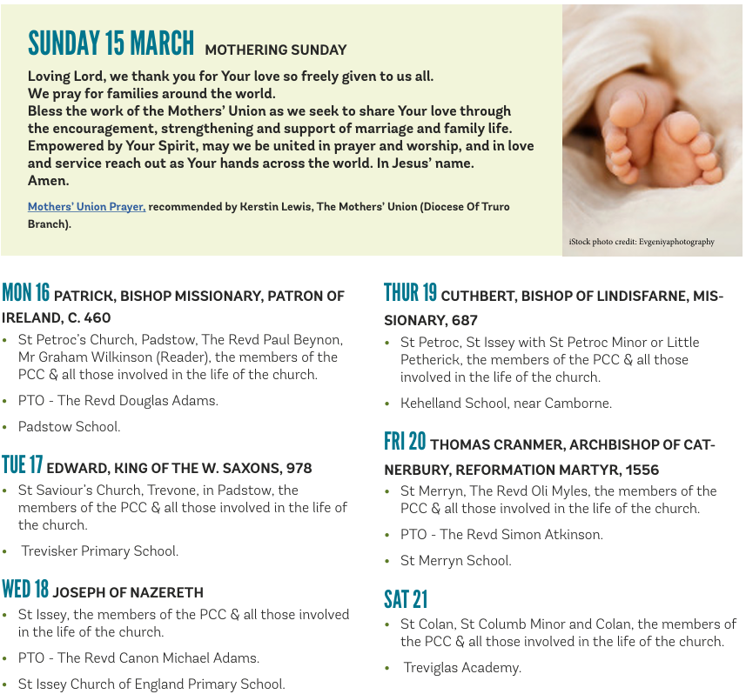

On the Way Prayers

“And his mother treasured up all these things in her heart” (Luke 2.51). Dear Lord as we celebrate Mothering Sunday let us just spend a moment giving thanks for our own mother, for all she gave us, for all we have subsequently passed on. “All I am I owe to my mother” (George Washington). We pray for our mothers and that they may be proud of us.

Loving God, we thank you for the family of the Church. We pray that all may find in her their true home; that the lonely, the marginalized, the rejected may be welcomed and loved. May our churches here in Kerrier provide a nurturing environment so that all can progress in their spiritual journey. And as we hold our Mothering Sunday Services we pray that we may attract more people to join us, to experience the power of your love. Let us pray for anything special we may have going on in our churches this weekend for Mothering Sunday.
We give thanks for family life – for the laughter, the ups and downs and the memories. Help us to show your love in our homes that they may be places of love, security and truth. Bless all parents and all who care for children. We pray for the work of the Mother’s Union and particularly for our branches in Kerrier and for the Refuges that are run in Cornwall. And we pray that we may soon find someone to help Susie with our children and young people’s work, confident that it will happen Lord, in your time. Let us always remember that children are not a distraction from the more important work – they are the most important work.

Now let us pray for anyone who needs our special prayers right now. Lord, as a mother comforts her child, so you will comfort us.
We pray for our world, which seems to be in such turmoil at the moment. Prince of Peace we pray for all world leaders, that they may realise the role they have in mothering the people of their nations. We pray for all women who are oppressed, all who are separated from their children, and all who have fled war zones with their children.
We give thanks for this beautiful place – for the lovely magnolia trees, blossoms, and even for the tender shoots of green leaves that are peeping out. May our hearts be warmed by the spring sunshine and comforted by the lengthening days, remembering that Lent means “to lengthen”. And as we continue our Lenten journeys, help us to grow/lengthen our knowledge of and our love for you.
Lord may we be wakeful at sunrise to begin a new day for you; cheerful at sunset for having done our work for you; thankful at moonrise and under starshine, for the beauty of your universe; and may we add what little may be in us to add to your great world. And now Lord bless each one of us as we go our different ways. Amen

