Palm 118
Please stand, if able, and join in with the verses in bold italics

O give thanks to the Lord, for he is good;
his steadfast love endures for ever!

Let Israel say,
‘His steadfast love endures for ever.’

The Lord is my strength and my might;
he has become my salvation.

There are glad songs of victory in the tents of the righteous:
‘The right hand of the Lord does valiantly;
the right hand of the Lord is exalted;
the right hand of the Lord does valiantly.’
I shall not die, but I shall live,
and recount the deeds of the Lord.
The Lord has punished me severely,
but he did not give me over to death.

Open to me the gates of righteousness,
that I may enter through them and give thanks to the Lord.

This is the gate of the Lord;
the righteous shall enter through it.

I thank you that you have answered me
and have become my salvation.
The stone that the builders rejected
has become the chief cornerstone.
This is the Lord’s doing;
it is marvellous in our eyes.
This is the day that the Lord has made;
let us rejoice and be glad in it.

Glory be to the Father and to the Son and to the Holy Spirit,
as it was in the beginning, is now and ever shall be,
world without end. Amen



Please can you bring in your jars full of change,
so we can send our donations to Water Aid.

Thank you – together we can make a difference

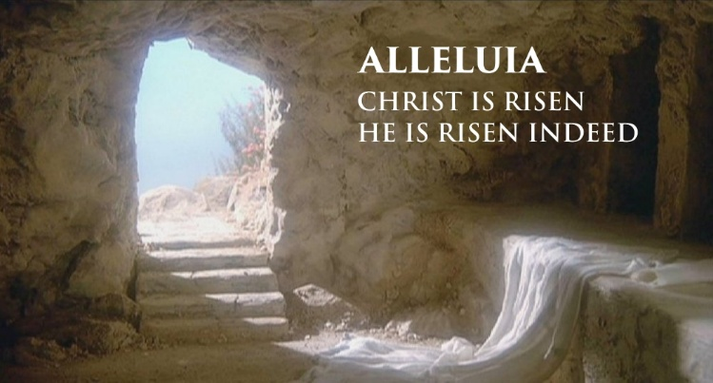
In our weekly prayers for our parish
This week we pray for God’s blessing on Meerbrook Place, Nursery Hollow and Nutbrook Crescent.
Rev’d Christine will be on leave from Easter Day afternoon until Saturday 11th April.
Distribution of Communion –currently the Priest will dip the communion wafer in the wine while we discern a safe way to bring the common cup back into worship, as we want everyone to feel included and safe. We also have gluten free wafers available.
Refreshments After the Morning Service
Please stay seated after the service and a hot drink will be brought to you in the pews. Do not get up and head to the back of church, it is becoming a hazard, and a risk as trays of hot drinks could be knocked over.
Church contact information
Contact: Rev’d Christine - revchristine@outlook.com
The Rectory, The Village, West Hallam, DE7 6GR
Landline 0115 646 1497
Rev’d Ailsa -revailsahunt@gmail.com
Tel - 07356064856

Churchwardens – Mrs Janet Wheeldon, -Tel: 0115 8771593
Mrs Linda Gregory – linda.gregory3@icloud.com
https://www.achurchnearyou.com/church/13402/
https://www.facebook.com/allsaintskirkhallam
All Saints Church
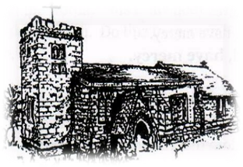
Kirk Hallam
Disabled Toilet in Friendship House.
Disabled Toilet in Friendship House.

Working with God to transform lives & communities.
Please can you ensure your mobile is on silence, or off during the service, it is affecting people with hearing aids and the loop system.

5th April – Easter Day
6.30am Son Rise Service at Dale Abbey Arch
10.00am CW Communion Service with
Rev’d Christine

No evening service

Forthcoming Events
Tues 7th 6.00pm Home Group in Friendship House
Weds 8th 9.30am Morning Prayer at UCAS
Fri 10th 6.00pm Choir in Friendship House
Sat 11th 10am Prayer Meeting in Friendship House

12th April – First Sunday After Easter
10.00am Iona Communion Service with Rev’d Alan
6.00pm Iona Evening Prayer –back in church
“Surely goodness and mercy shall follow me all the days of my life and I shall dwell in the house of the Lord forever’ Psalm 23:6
It’s Good to Talk! If you spot that someone is missing, please pop a news sheet through their door, & if you’ve time, call for a chat - just to check they’re OK & to let them know that they are not forgotten!

