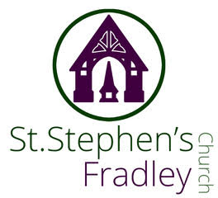


WEEKLY BULLETIN
29th March 2026 PALM SUNDAY
10.30am Family Communion with dramatic reading of the Passion Gospel and distribution of Palm Crosses
Welcome to our Worship today. If you are visiting for the first time, please introduce yourself so that we may welcome you personally. Refreshments are served after the service
ST. STEPHEN’S CHURCH IS OPEN 10am-3pm daily for Private Prayer and Reflection
Collect  True and humble king,  hailed by the crowd as Messiah:  grant us the faith to know you and love you,  that we may be found beside you  on the way of the cross,  which is the path of glory.  Readings  Liturgy of the Passion  Isaiah 50. 4-9a Philippians 2.5-11  Matthew 26. 14-27end  Post Communion  Lord Jesus Christ,  you humbled yourself in taking the form of a servant,  and in obedience died on the cross for our salvation:  give us the mind to follow you  and to proclaim you as Lord and King,  to the glory of God the Father.  * * * *  PCC Officers and Churchwardens- Please give your completed papers to Elizabeth as soon as possible  (Our APCM is on Saturday 26th April) | HOLY WEEK SERVICES  2nd April Maundy Thursday  7.30pm Eucharist with hand-washing .  Benefice Service at All Saints Alrewas  2pm An Hour at the Cross  Benefice Service at All Saints Alrewas  3rd April Good Friday   8.30am Holy Communion from the reserved sacrament, followed by breakfast.  10am Building the Easter Garden - Children welcome! We can’t build the garden without you!  Hot Cross buns and coffee will be served at 11am.  Sunday 5th April Easter Day  10.30am Family Communion  and blessing of the Easter Garden.  The Music Group will be leading music at this service  OTHER DIARY DATES  Tuesday 7th April  3.30pm Bowbrook Easter at Bowbrook Care Home  Wednesday 8th April  2-4pm Wednesday Welcome  Drop in for tea, cake and chat  Thursday 9th April  9.30-11am Events Committee Meeting
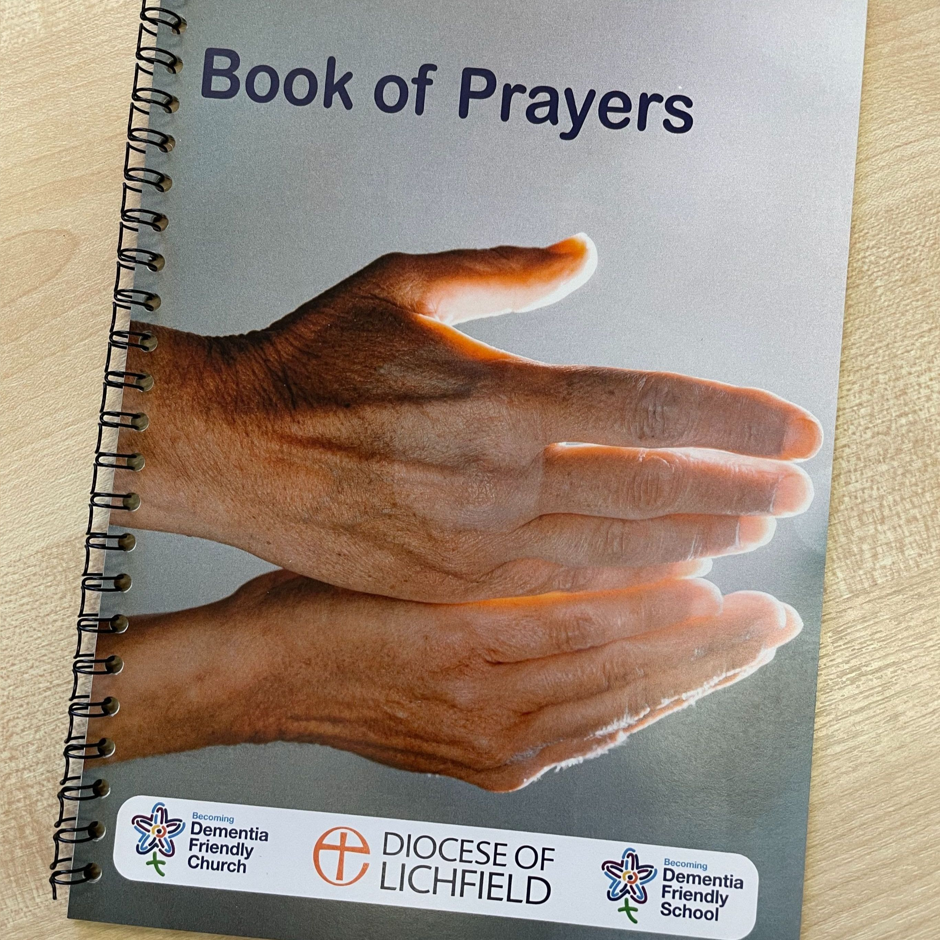  Dementia Friendly Prayers  20 page spiral bound ‘Book of Prayers’, with an illustration on one page and a prayer on the facing page is available for anyone who wants a copy. If you can make a donation, it gives the opportunity to ‘pay it forwards’, so that it can continue to print and share copies of these books. Please see our Dementia Champion, Jenny Summers.  Lichfield Cathedral's Dementia Champions Team is hosting the following events during 2026:  29 April | Easter Service  1 July | Songs of Praise Service  30 September | Harvest Thanksgiving Service  December | Christmas Service (tbc)  All of the above events will start at 10:45 and last approximately 40 minutes, followed by light refreshments. We look forward to seeing you there.  Raffle Prizes  We have several events coming up in the spring and would like to offer a Raffle as an additional fundraiser. Any donations of Raffle prizes would be gratefully received – especially Bottles!!
  The Acts 435 charity has money to give away to parishes!
  Starting in the Anglican church, back in 2009 with a pilot in York Diocese, Acts 435 currently partners with only 1% of Anglican churches. It is completely free to partner with Acts 435, which crowdfunds money to help people in parishes with specific needs such as a bed, a cooker or clothes.
  Acts 435 - giving to anyone who has need
  SAVE THE DATE
  Quiz Night and Fish & Chips
  Saturday 18th April 7pm – an imaginative quiz!! Tickets only £10 available from Carole Griffiths
  Teams of 4. If you haven’t got a team we will find you one!
  Friday 22nd May 5pm
  The Licensing of Revd Jonathan Nicholas to
  Alrewas, Fradley and Wychnor
  by The Rt Revd Dr Michael Ipgrave OBE
  Saturday 13th June 11am
  Dedication of the Memorial Light Box to all RAF Personnel Bishop Michael will officiate.

Notices for inclusion in the bulletin please email me by Tuesday of each week
Officeststephenfradley@gmail.com
Please take bulletin away with you
If you would like to support St Stephen’s Church at this time donations can be made via our Just Giving Page. We are grateful for donations large or small
https://www.justgiving.com/fundraising/ststephensfradley
Contact us
Associate Minister Revd Elizabeth Wall 01543 254891 Email: ayton265@gmail.com
Churchwarden Marian Derry 01283 791573
St Stephen’s Administrator Di Cooper 07930162991 officeststephenfradley@gmail.com

Find us on ACNY https://www.achurchnearyou.com/church/4123/
Facebook www.facebook.comststephensfradley

