Friday 20th March
Pew Sheet for 22nd March 2026
Revd. Clare 01327 260204 revclare@icloud.com
1pm Funeral at Woodford Halse

Sunday 22nd March
9.30am BCP Holy Communion at Wooodford Halse
11am Holy Communion at Bodddington
3pm Annual Church Meetings at Byfield village hall..Everyone welcome to attend to find out what has been happening in your parish and across the benefice.

Monday 23rd March
2pm Funeral at Aston le Walls

Wednesday 25th March
9.45am Morning Prayer at Byfield
11.15am Woodford Ecumenical Prayer Group.

Saturday 28th March
5-7pm Youth Church at Woodford Halse

Sunday 29th March – Clocks go forward!
10.45am Assemble for the Palm Sunday procession at the end of Main Street, Aston le Walls.
Walk to the Church for the Palm Sunday Holy Communion.

Monday 30th March
7pm Compline at Eydon

Tuesday 31st March
11.30am Funeral at Byfield
7pm Compline at Boddington

Wednesday 1st April
9.45am Holy Communion at Byfield
11.15am Woodford Ecumenical Prayer Group
7pm Compline at Woodford Halse

Thursday 2nd April
7pm Maundy Thursday Holy Communion at Byfield

Good Friday 3rd April
11am Family Service in Byfield village hall with hymns, readings and prayers followed by refreshments.
2.30pm Quiet meditation at Boddington
2.30pm Quiet meditation at Aston le Walls
3pm Reflective service at Woodford Halse

Lent 2026 – ‘Draw Near’

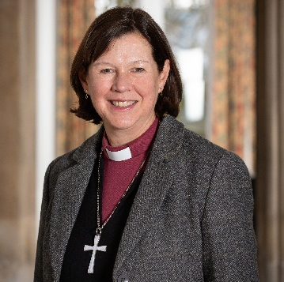
Lent is traditionally a time when Christians take time to reflect what it means to be a follower of Jesus and to prepare for the celebrations of Easter. This year, the Church of England has produced some materials under the heading, ‘Draw Near’, to help us develop some life-giving habits that will help us in our daily lives to draw nearer to Jesus.

Throughout the bible we read of people who encounter Jesus in amazing ways and whose lives are transformed. Often the story ends there, but of course, that is just the start of the journey. As followers of Jesus, we know that the journey continues as we build on our relationship with and understanding of God. Central to the journey lie certain habits that can help us: worshipping together, praying, reading and exploring the bible, sharing communion, offering service to those around us, and sharing the good news we have come to discover.

I wonder, this Lent, what you might focus on to deepen your own discipleship and nurture your spiritual life. As we draw near to God, he draws near to us and we can know his presence with us more fully. As Richard of Chichester prayed: ‘may we know thee more clearly, love thee more dearly, and follow thee more nearly, day by day.’


The Rt Revd Debbie Sellin
Bishop of Peterborough

