SUNDAY MORNING READING SHEET 8th March 2026 3rd Sunday of Lent

A Reading from Paul’s first letter to the Corinthians

For I received from the Lord what I also handed on to you, that the Lord Jesus on the night when he was betrayed took a loaf of bread, and when he had given thanks, he broke it and said, ‘This is my body that is for you. Do this in remembrance of me.’ In the same way he took the cup also, after supper, saying, ‘This cup is the new covenant in my blood. Do this, as often as you drink it, in remembrance of me.’ For as often as you eat this bread and drink the cup, you proclaim the Lord’s death until he comes. 1 Corinthians 11:23-26

GOSPEL

While they were eating, Jesus took a loaf of bread, and after blessing it he broke it, gave it to the disciples, and said, ‘Take, eat; this is my body.’ Then he took a cup, and after giving thanks he gave it to them, saying, ‘Drink from it, all of you; for this is my blood of the covenant, which is poured out for many for the forgiveness of sins. I tell you, I will never again drink of this fruit of the vine until that day when I drink it new with you in my Father’s kingdom.’
Matthew 26:26-29

LOOKING FORWARD, we will also be looking for donations of Easter eggs for the egg hunt on Easter Sunday, 5th April and chocolate items for a chocolate tombola at the Book Fayre, 2nd and 4th May. We are happy to take these at any time from now on so we can take advantage of any offers. Please leave all items in the kitchen. As always we ask that all food items have good dates on them as we cannot include out of date items! Thank you so much, the Events Committee.

UPCOMING EVENTS :There are a number of events coming up over the next few months to look forward to.
18th April - Cheese and wine evening 2nd & 4th May - Book Fayre 19th June - Hymns and PIMM’ s
20th June - Concert


If you wish to make a donation to the church, then please hold your
phone’s camera over this image then touch the link that appears:

Royston Parish Church
Where all are welcome and God’s love is shared
Sunday 8th March 2026 - 3rd Sunday of Lent

If you would like regular copies of the Notice Sheet emailed to you please email the Parish Office at admin@roystonparishchurch.org.uk

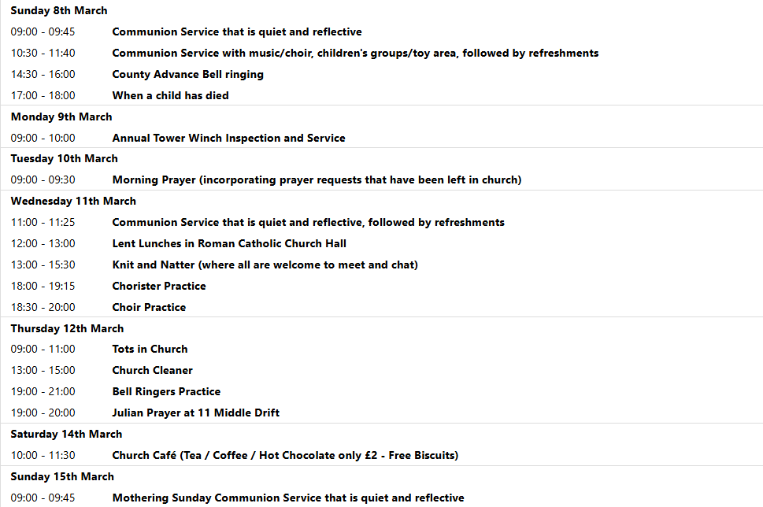

NOTICES
CHEESE and WINE PARTY: on SATURDAY 18th APRIL, 7:00PM at church. Ticket cost £12 and include cheese, crackers and a glass of wine or sparkling elderflower.Additional drinks available for a charge. Tickets must be purchased in advance for catering purposes- buy yours at
https://tickets.myiknowchurch.co.uk/gb/NzcwMi0yNw/t

We pray for all Christians worldwide:
For all Christians in Ireland; United Kingdom: England, Northern Ireland, Scotland, Wales
For all who worship at Bassingbourn Parish Church: Revd. Helen Orr
For the work of our mission partners: The Bible Society
Pray for the community of Royston:
For our local health centres
For our local Foodbank and all who will make use of it.
We pray for our world and ECO projects:
The 14th March is the International Day for Action for Rivers. We pray that the cleanliness of rivers is taken more seriously and that these essential resources are managed responsibly.
We pray for the sick and suffering:
1st March 8th March 15th March 22nd /29th March
Lee Cockerill Chris Christou Val Brown Peter Coates Pat Pritchard Paul & Pat Tidey Angie & Ken Rushall Margaret Green
Jackson Herbert Mike Brown Paula Walker Peter Foster Marion Keith & Elaine Edwards Gwen Simmons
Laura O’nyamul (On-Ya-Mul) Maria Turi Katie
Colin Fitch Peggy Dawes Janet McElney George N.
Ted Rayment
We pray for those who have died in the faith of Christ:
Deceased | Bereaved
Harry McDonald | Ruth, Family and friends
Jennifer Jones | Family and friends

We pray for those whose anniversaries fall at this time:
Martin Mulchaly, Chellis Hearn, James Woodall
NOTICES

BRING AND SHARE LUNCH - there will be a bring and share lunch in church after the APCM on Sunday 22nd March. All are welcome. Please bring an item of food to share.

A CALL FOR HELP IN PREPARING MOTHERING SUNDAY POSIES: Our flower arrangers are going to create posies which will be handed out during our services on Mothering Sunday in church on Saturday 14th March at 12.30pm. If you could lend a hand then please contact the Church Office. No previous experience necessary. You don't even need to consider that you have green fingers.

ELECTORAL ROLL: If you would like to join the Electoral Roll this year and you are not already on it, which enables you to vote at our annual meeting, please apply on this link: https://roystonparishchurch.org.uk/electoral-roll. To be completed by 7th March.

LENT LUNCHES IN AID OF CAFOD AND CHRISTIAN AID: Continues on 11th, 18th, 25th March. Venue - Roman Catholic Parish Centre, Melbourn Rd. - Entry for pedestrians and cyclists from School car park only. Lunches are served between 12 noon and 1pm
Donations for lunch: Suggested donation is £5pp. This will be distributed equally between Cafod and Christian Aid
FOR ALL THOSE WHO HAVE BEEN AFFECTED BY THE DEATH OF A CHILD- A SERVICE OF REMEMBRANCE AND THANKSGIVING
We are having a Service of Remembrance and Thanksgiving for those who have lost a child or who have been affected by the loss of a child of whatever age, however long ago, and no matter under what circumstances. The service will take place on Sunday 8th March 2026 at 5.00pm and will be followed by light refreshments in the church.
There is a special poignancy over the loss of a child, and finding support is crucial to a healing process. Coming together, in a place of peace and quiet such as the space we find in St John the Baptist Church can be especially helpful whatever our faith and whoever we are. Please feel free to invite families with whom you have had contact who have experienced the death of their child to come to this service. (It does not need to be a bereavement from just this past year, nor as a young child or baby but at any stage of life.) I also have some letters of invitation that you might like to pass onto anyone who might appreciate such a service. Also, if you or someone you know might wish for their own child to be remembered but is unable to come along, I have some small cards to fill in with the name of the child, and we will ensure that they are remembered during the service. Reg Bailey
CARBON FAST FOR LENT: Traditionally, Lent is a time when Christians fast and focus on God. You might also be interested in adding a “Carbon Fast” to think about our carbon footprint and ask if there is any excess or unnecessary use in our lives, and if any of that excess is acting as a distraction to our relationship with God. You can sign up at the website climatestewards.org/resources/carbon-fast-for-lent to receive a weekly e-mail with suggested activities. With a different focus each week, you’ll learn more, ask questions, and focus on what God thinks about these areas of our lives:
- Week 1: Delight in and responsibility for nature
- Week 2: Consumerism and shopping
- Week 3: Money and investments
- Week 4: Food waste and meat and dairy consumption
- Week 5: Transport and driving
- Week 6: Energy, electricity, and gas
- Week 7: Social media
CHURCH FLOWERS FOR EASTER: As usual, we will be arranging flowers in church for Easter. If you would like to make a donation towards the cost of the Easter flowers via a bank transfer, please contact Charlotte Wicks on email treasurer@roystonparishchurch.org.uk. Cash and cheque donations are also welcome if preferred. Cheques should be made payable to Royston PCC and can be given to either Clare Rice or Angela Sassoli. Your generous support for festival flowers is very much appreciated. Thank you.

