
SPIRE & LIGHT United Churches
United Benefice of St Keverne, St Ruan with St Grade & St.Wynwallow (The Lizard)

*If you do not wish to receive these notices, please let your Churchwarden know*

22nd March 2026
Passion Sunday/Lent 5


Readings
Ezekial 37:1-14
Psalm 130
Romans 8:6-11
John 11:1-45

9.30am – Morning Prayer - St.Peter’s, Coverack
9.30am – Holy Communion - St.Ruan, Ruan Minor
11am – Holy Communion – St.Keverne
11.15am – Café Church – St.Wynwallow, The Lizard


Next week – Sunday 29th March – PALM SUNDAY

11AM UNITED BENEFICE SERVICE OF HOLY COMMUNION AT ST. RUAN CHURCH, RUAN MINOR

6pm – St.Mary’s Palm Sunday Evening Praise

Advance notice: Please note
The service of Holy Communion at St Keverne on Easter Day will now take place at the earlier time of 10am.




The Prayer Spot

Heavenly Father, as we come to pray to you today, remind us of the love you have given us to share with others, that love given to us by you. Remind us we are a Benefice of four churches brought together by you to share with each other God's love and to remember we are all brothers and sisters brought to faith by the same God and his Son Jesus Christ who gave his life on the Cross for all of us.
Help us to remember those in need within our churches and community and how we can be there for them - it may just need an act of kindness to show you really care.

It says in 1 Peter 1 ‘Therefore prepare your minds for action, be self-controlled, set your hope fully on grace to be given to you when Jesus Christ was revealed to you. As obedient children of God, do not conform to evil desires you had when you lived in ignorance but just as he who called you is Holy so be Holy in all you do, for it is written to be Holy because I am Holy.’

Remember God has given you gifts to use in the need of others, use them well because everyone needs your help in our times of trouble. Be generous and full of God’s love, pray for all those in need of hospital treatment, that God will be present with them and for those who have the job of taking them and caring for them.

We praise you for your kindness shown to us all, for your endless willingness to forgive us when we fail you. We thank you for the love shown to us all as members of your flock, for being the shepherd who guides us through each day giving us all the help we need to care for others. Thank you for those wonderful gifts given to us of forgiveness, kindness, generosity and peace and of course that great joy of knowing your presence in our lives.

As I always tell you, God will be ever present in your prayer time and will answer all your prayers in the name of his son Jesus Christ. Be blessed by all you do in his wonderful name.

O God our father, grant that whatever happens to us today we may take it to you, if we have decisions to make, help us to ask for your guidance and grant us humility and obedience to take what you give to us. If we have problems to solve, help us to ask for you to shine your light upon them so we may see our way through them. If we have difficult things to do, help us to ask for strength so that we maybe enabled to do which we could not do ourselves. If we face temptations, help us to seek thy grace and remember that Jesus was tempted and is able to help us who are tempted. Help us to decide everything by thy will and to test everything by thy presence so that we may come to the days end without mistakes and without regrets through Jesus Christ our Lord. Amen

Maker of heaven and earth, you rule over all nations. As we think 0f your unfailing, eternal, enduring love, we look forward to the day when we will worship you in eternity. Your throne will be surrounded by people of every tribe, tongue and nation, and all testifying that you remained faithful, we will see that you have kept every promise you made, we will see your goodness and grace, we will be transformed by your glory, we would ask that we glimpse that glorious future as we pray today. Through the God the Father God the Son and God the Holy Spirit. Amen
Sam Buchanan
The Diocese of Truro’s Prayer Diary for this week

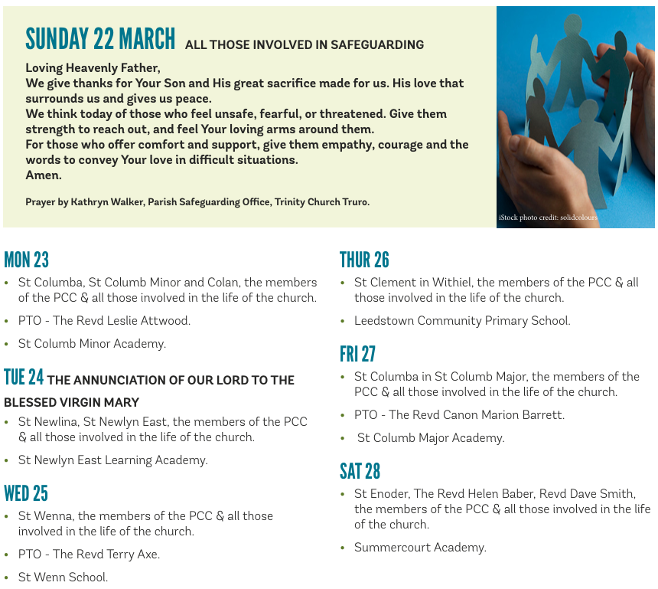

On the Way Prayers

“Then the angel showed me the river of the water of life, bright as crystal, flowing from the throne of God and of the Lamb through the middle of the street of the city. On either side of the river is the tree of life with its twelve kinds of fruit, producing its fruit each month; and the leaves of the tree are for the healing of the nations.” (Revelation 22 v1-2)

Dear Lord today we pray that the leaves of the tree will reach down and heal the nations of the earth, because at the moment so much of this planet seems in turmoil. We pray for all those places suffering with the agony of strife – Iran, Lebanon, Ukraine and Sudan. We pray for an end to greed that is currently engulfing other places and for all who are worried about their businesses and personal finances as a result.

We give thanks for the tree of life and for the abundance of life that is evident all around us this spring; for the trees that are gradually springing back to life, for the incredible primrose and celandine displays, for the longer days and the gift of light. We give thanks for the fruits of your creation and for all who farm our fields and fish our seas. We are blessed to live in the country, surrounded by farmland and the most beautiful coastline here in in Kerrier, but let us remember all those who work day in and day out to tend, preserve, and make it fruitful and sustainable. Our farmers need our prayers.

This Passion Sunday let us be mindful of the fact that you, Lord, taught, healed, performed miracles and had fun out in the open air, in the countryside, by the seashore, by the rivers and lakes and may we do all we can as churches to reach out beyond our buildings into our communities to spread the wonderful message of your love. Let us never forget that you gave your life out in the open air on a plain wooden cross, so that we may have everlasting life. Let us never miss an opportunity when we are out and about to demonstrate your love for each and every one of us. We give thanks for Wild Church that is spreading through our Deanery and for all who help with it. We give thanks too for Susie’s work in our midst and let us pray now for her.

We pray for all our clergy and lay ministers as we approach a very busy time in our church calendar. Lord give them all the resilience, enthusiasm and inspiration they need to lead us through this build up to Easter Day. Following the presentation on Lay Ministry at Deanery Synod, let us pray that more people will come forward to explore lay ministry in Kerrier.

And now let us take a moment to pray for anyone else who needs to feel the comfort of our collective prayers right now. May the leaves of the tree of life comfort all for whom we have prayed. Amen

