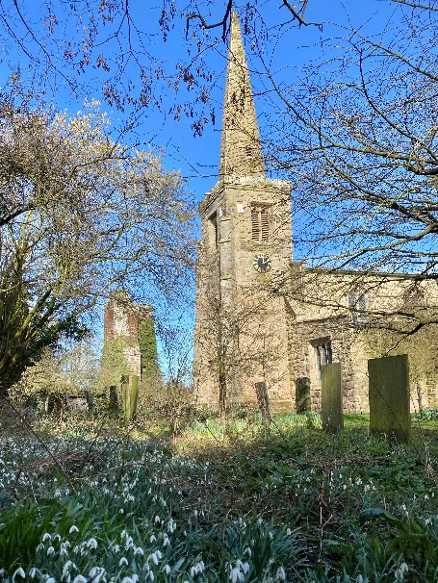
ST MICHAEL AND ALL ANGELS,
HAMSTALL RIDWARE

In the United Benefice of King’s Bromley, the Ridwares
and Yoxall

March 15th 2026
Mothering Sunday

PARISH NOTICES

UNITED BENEFICE SERVICE ROTA
 | Hamstall Ridware  St Michael and All Angels | Yoxall  St Peter | King’s Bromley  All Saints | Mavesyn Ridware  St Nicholas
March 15th  Mothering Sunday | 10.30 am  Parish Communion | 4.00 pm  Mothering Sunday Service | 10.45 am  Mothering Sunday Service | 10.30 am  Parish Communion
March 22nd  Passion Sunday | 10.30 am  Service of the Word | 9.00 am  Holy Communion | 10.30 am  Parish Communion
March 29th  Palm Sunday | 10.30 am  United Benefice Palm Sunday Procession and Communion at Hamstall Ridware
April 2nd  Maundy Thursday | 7.30 pm  Commemoration of the Lord’s Supper at King’s Bromley
April 3rd  Good Friday | 2.oo pm  Proclamation of the cross at Mavesyn Ridware
Please note that services of Holy Communion at 9 am follow the Book of Common Prayer and are said. Services at 10.30 will include hymns and other singing.
There are services of Holy Communion at 10.00 every Wednesday at St Peter’s, Yoxall (except February 25th) and on the first Thursday of each month at All Saints, King’s Bromley.
*******************
Rugeley Food Bank. Please do remember those who depend on Food Banks. They are needed now just as ever. If you wish to donate directly to Rugeley Foodbank at Rugeley Community Centre the Centre is open everyday to receive contributions. Alternatively, the Rugeley Food Bank welcomes financial contributions – see https://rugeley.foodbank.org.uk. Gifts can also be brought to St Michael’s and left in the box at the back of church near the font. If that is not convenient please contact Liz Carter on 07751 068181.
****************
Contact details: If you wish to contact the Rector, Jeremy Brading you can do so on revd@kbhmy.co.uk and Glenis Turner, the PCC Secretary and Benefice Administrator is on admin@kbhmy.co.uk. The churchwardens are Michael Elsom michael.elsom@btopenworld.com and John Ferguson clan.member1954@gmail.com Information about events at church can be found at our webpages at https://www.achurchnearyou.com/church/4451/ and https://kbhmy.co.uk/hamstall/
St Michael’s will continue to be open everyday (weather permitting) between 10.00 am until 4.00 pm. We will revert to shutting the church at 6.00 pm on March 29th 2026
PLEASE REMEMBER IN YOUR PRAYERS:
Those who are sick: Mary Mycock, Angela Perkin, Doug, David and Barbara Rudge, May Windley, Pam Payne, Frank and Margaret Finch, Chris Poole, Les Wood, Pat Lomax, Alison Scott and any known personally to you.
The family and friends of Brenda Perkin who has died in her 90th year. Brenda was a regular worshipper and helper at St Michael’s for many, many years until she became housebound. She will be remembered at a special service on Sunday April 19th ater which her ashes will be interred in the churchyard she loved.
Those who live and work in the Nursing, Care and Retirement homes in the villages both in and near the parishes of the United Benefice.
Using the Archbishops’ prayer for Ukraine at this time let us remember the people of that war-torn land:
God of peace and justice, we pray for the people of Ukraine today. We pray for peace and the laying down of weapons. We pray for all those who fear for tomorrow, that your Spirit of comfort would draw near to them. We pray for those with power over war or peace, for wisdom, discernment and compassion to guide their decisions. Above all, we pray for all your precious children, at risk and in fear, that you would hold and protect them. We pray in the name of Jesus, the Prince of Peace. Amen
As the situation in the Middle East continues to see military action remember all those in all the countries affected by it – whether nationals or visitors, whether in those countries or elsewhere and concerned for loved ones. Pray for wisdom on the part of the leaders of the nations involved and that hostilities and suffering may come to an end soon.
From the Diocesan Prayer Diary:
Monday 16th:
Lord, we bring before you today's retreat at Shallowford House in preparation for Holy Week and Easter; 'Hung on the Tree'. We pray for all those that are taking part, that the day will support them as they pause and reflect on both your journey and theirs. As we journey towards Easter, dear Lord, please help each of us find time to spend with you as we journey through the Lenten wilderness.
Tuesday 17th:
On St Patrick's Day we pray his 'Breastplate' prayer, and pray you will ever more stay with us and at work in us and through us;
Christ with me, Christ before me, Christ behind me, Christ in me, Christ beneath me, Christ above me, Christ on my right, Christ on my left, Christ when I lie down, Christ when I sit down, Christ when I arise, Christ in the heart of every man who thinks of me, Christ in the mouth of every man who speaks of me, Christ in the eye that sees me, Christ in the ear that hears me.
Friday 20th:
(Cuthbert, Bishop of Lindisfarne, Missionary, 687)
On St Cuthbert's day, we pray for the one church in the diocese dedicated to him, the 'church round the corner' at Donington in Edgmond and Shifnal Deanery. We pray for your hand of blessing to rest on this church, its sister ones in Albrighton and Boningale, and the communities they each serve.
LENT 2026
This very important season of the year for Christians continues with Rev’d Jeremy conducting a series of House Groups on Wednesday evenings. They are on every Wednesday at 7pm in St Peter’s Church, Yoxall. The title of the course is Answering God’s Call and the remaining sessions are be on March 18th and 25th .
ADULT CONFIRMATION CLASSES
Following on from the Lent Course, Rev’d Jeremy will be holding an Adult Confirmation Course on Wednesdays at 7 pm. These will start in May and anyone who is thinking of getting confirmed is welcome to contact him – and no doubt would want to come to the Lent House Group meetings as well.

St Michael’s encourages donations by means of this QR code and it will appear (all being well) on all our publications as an invitation to contribute to the important work of the church both
as a place of worship and a community asset where all can share in the wonderful place we have
inherited and wish to pass on to those who come after us.
Safeguarding of children and vulnerable adults. If you have any concerns please speak in complete confidence to the Parish Safeguarding Officer, Dr Paul Carter on 01889 504347 or the Diocesan Safeguarding Officer, Neil Spiring on 01543 306030.

